LECTURE NOTES ON
AUTOMOBILE ENGINEERING AND HYBRID VEHICLES



6TH SEMESTER

PREPARED BY
MICHAEL SUVEER(GF)
DEPT OF MECHANICAL ENGG



AUTOMOBILEENGINEERINGANDHYBRIDVEHICLES

NameoftheCourse:DiplomainMECHANICALENGINEERING
Coursecode: |  | Semester | 6th
TotalPeriod: | 60 | Examination | 3hrs
Theoryperiods: | 4P/W | Internalassessment | 20
Maximummarks: | 100 | EndSemesterExamination: | 80

- RATIONALE:
Automobiles are the principal mode of transport system. Their manufacture and maintenance gives a major scope for employment. Many entrepreneur pass outsgofor servicing ofautomobilesor trading/ manufacturing of auto components. Thus automobile engineering is an important subject to be in the regular curriculum of the mechanical engineering.
- COURSEOBJECTIVES:
Attheendofthecoursethestudentswillbeableto:
  - Understandautomobilechassis,transmission,breakingandfuelsystemetc.
  - Understandthebasicsofelectricvehiclekinematics.
  - Understandtheconceptsofhybridelectricvehicles.

C.TOPICWISEDISTRIBUTIONOFPERIODS
SlNo. | Topic | Periods
1 | Introduction&TransmissionSystem | 12
2 | Brakingsystem | 5
3 | Ignition&SuspensionSystem | 10
4 | CoolingandLubrication | 8
5 | Fuelsystem | 10
6 | HybridandElectricVehicles | 15

C.COURSECONTENTS
1.0 | INTRODUCTION&TRANSMISSIONSYSTEM:
1.1Automobiles:Definition,needandclassification:Layoutofautomobilechassis
withmajorcomponents(Linediagram)
 | 1.2ClutchSystem:Need,Types(Single&Multiple)andWorkingprinciplewithsketch
GearBox:Purposeofgearbox,Constructionandworkingofa4 speedgearbox
Conceptofautomaticgearchangingmechanisms
 | 1.5Propellershaft:Constructionalfeatures
 | 1.6Differential:Need,TypesandWorkingprinciple
2.0 | BRAKINGSYSTEM:
 | 2.1Brakingsystemsinautomobiles:Needandtypes
 | 2.2MechanicalBrake
 | 2.3HydraulicBrake
 | 2.4AirBrake
 | 2.5AirassistedHydraulicBrake

3.0 | IGNITION&SUSPENSIONSYSTEM:
 | 3.1DescribetheBatteryignitionandMagnetignitionsystem
 | 3.2Sparkplugs:Purpose,constructionandspecifications
 | 3.3Statethecommonignitiontroublesanditsremedies
 | 3.4DescriptionoftheconventionalsuspensionsystemforRearandFrontaxle
 | 3.5Descriptionofindependentsuspensionsystemusedincars(coil springandtension bars)
 | 3.6Constructionalfeaturesandworkingofatelescopicshockabsorber
4.0 | COOLINGANDLUBRICATION:
 | 4.1Enginecooling:Needandclassification
 | 4.2Describedefectsofcoolingandtheirremedial measures
 | 4.3DescribetheFunctionoflubrication
 | 4.4DescribethelubricationSystemofI.C.engine
5.0 | FUELSYSTEM:
 | 5.1DescribeAirfuelratio
 | 5.2DescribeCarburetionprocessforPetrolEngine
 | 5.3DescribeMultipointfuelinjectionsystemforPetrolEngine
 | 5.4DescribetheworkingprincipleoffuelinjectionsystemformulticylinderEngine5.5 Filter for Diesel engine
 | 5.6DescribetheworkingprincipleofFuelfeedpumpandFuelInjectorforDiesel engine
6.0 | ELECTRICANDHYBRIDVEHICLES:
 | 6.1Introduction,SocialandEnvironmentalimportanceofHybridandElectricVehicles
 | 6.2DescriptionofElectricVehicles,operationaladvantages,presentperformanceand applications of Electric Vehicles
 | 6.3BatteryforElectricVehicles,Batterytypesandfuelcells
 | 6.4Hybridvehicles,TypesofHybridandElectricVehicles:Parallel,Series,Paralleland Series configurations;6.5 Drive train
 | 6.6Solarpoweredvehicles

TRANSMISSION SYSTEM

EXPLAIN IN DETAIL ABOUT VEHICLE CONSTRUCTION, CHASSIS, FRAME AND BODY (OR) DRAW THE LAYOUT OF AN AUTOMOBILE AND INDICATE THE VARIOUS COMPONENTS.
An automobile is made up of mainlytwounits,theseareChassisandBody.
- ―Frame‖+―Basecomponents‖=―Chassis‖
- ―Chassis‖+―Body‖=―Vehicle‖ Chassis
- Avehiclearrangementwithoutbodyiscalledchassis.
- Variouscomponentsandsystemsofthechassisare
  - Thepower system -Powerunitsareclutch,gearboxtransmission,differential,Rearaxleshaft,universal joint &propeller shaft etc …
  - Runningsystem-Runningsystemsconsistsbrakes,wheels,frame,suspensionandsteeringsystem
  - Electricalsystem-Electricalsystemconsistsofstartingcircuit,chargingcircuit,ignition circuitlighting and horn circuit.
Body
- The purpose of the body is to provide accommodation to the driver and the passenger and to protect them against adverse conditions
COMPONENTSOFANAUTOMOBILE
Automobile consistsoftheBasicstructure, thePowerplant,thetransmissionsystem,theauxiliaries,the controls and the superstructure.
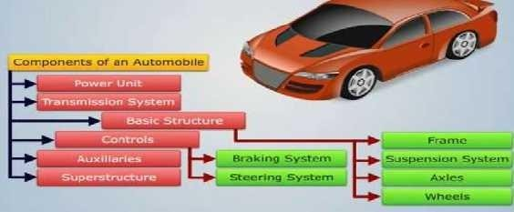

BASICSTRUCTURE:
- This is theunit on which areto be built the remainder of the units required to turn it into a power operated vehicle. It consists of the frame, the suspension systems, axles, wheelsandtyres.
THEFOLLOWINGMAINCOMPONENTSOFTHECHASSISARE
- Frame: itis madeup oflongtwo members called side membersrivetedtogether withthe help ofnumber of cross members.
- EngineorPowerplant:Itprovidesthesourceofpower.
- Clutch:Itconnectsanddisconnectsthepowerfromtheengineflywheeltothetransmissionsystem.
- GearBox-the energytransmitted will In effect change the speed, direction, or torque ofthe machine where it is installed.
- UniversalJoint-Theuniversaljointallowsthedriveshafttomoveupanddown,toallowforsuspension

travel. Some drive shaftsalso have slip joint theallows the drive shaftto make minor length changesasthe vehicle suspension height changes

- Propeller Shaft- shaft makesany vehicle move by connecting the rear differential to the engineand transmissionsystem.Itisamechanicalcomponentshapedlikeatubewhichallowsthetransmissiontothe differential.
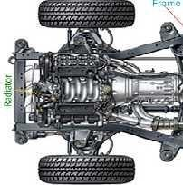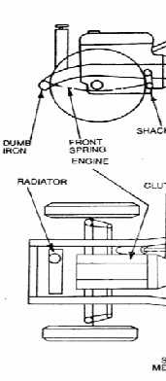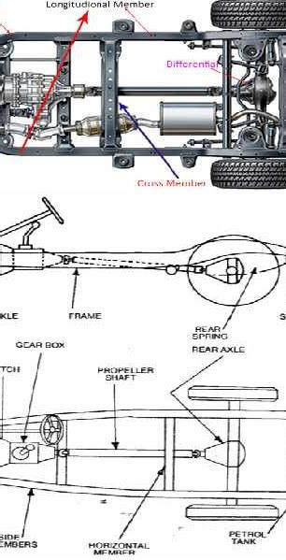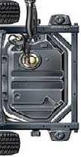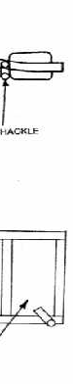
- Differential-Itisadevicethatsplitstheenginetorquetwoways,allowingeachoutputto spinatadifferent speed. The differential is foundonall moderncars andtrucks, andalso in manyall-wheel drives
SuspensionSystem
Functionofsuspensionsystem
- Tostablethevehiclefromshocksandvibrationduetoirregularroadsurface.
- Toreducedorpreventtheroadshockswhicharetransmittedonthevehicle Frame.
- Toregulatestabilitywhenvehicleisinmotion.
- Tomaintainpropersteeringgeometry. Location of suspension system
- Locationofsuspensionisinbetweenaxlesandchassis.

Axle
Therearetwotypesofaxles
- Liveaxle
- Dead axle Functionofliveaxle
- Live axle is the two half axle. In between them differential is attached, function of live shaft is to transmit the power from engine to wheel.
- Itcarriestheweightofvehicle. Function of dead axle
- Itcarriestheloadofengine.
- Whenbrakesareprovidedatfrontwheelsthenitwithstandsbendingortorsionalstresses.
- Itissupporttothewheels. Wheels and Tires
Functionofwheelsortire
- Tosupporttheloadofvehicle
- Toprovidecushionagainsttheshock
- Goodroadgripwhenweaccelerateorbreakingthevehicle.
- Tosustaintheloadofvehicle.
- Tocreatecontactwithroadsurface. Location
- Itlocateonfrontorrearaxle(dependsondriveusedinvehicle) Fuel System
- Thefueltank isfastenedtotherearofthe frameandisconnectedtothefuelpumpthroughmetaltubes.The exhaust pipeand muffler conducts the poisonous gases fromthe enginetotherear of the vehicle.
CoolingSystem
- A radiator is mounted on the chassis which is connected to the engine by rubber hoses to allow cooling water or coolant to circulate between radiator and engine. Fan, water pump and fan belt areother parts of the cooling system.
THEPOWERSOURCE/POWERPLANT
- There are various sources of Power for vehicle, the selection of power plantis depends on the type of vehicleused. In manypassenger vehicles, the internal combustion engine(IC Engine) is used.
- Now days the technology has been develop continuously, we can observed that some passenger cars also able to drive by electric motor and batteries. In this year porches is working on Porsche 618 two wheeler model which is electric drive; Porsche claims that it is able to achieve 160Ps power. Anyway it‘s not good point to discuss yet.
- Engineers worked on Hybrid vehicle, Hybrid vehicle is the fusion of IC engine and electric motor. The vehicle isable to use both IC engine as well as the electric motor.
TherearetwobasictypesofPower-plantofvehicleasfollows:
  - ICengine
  - Electricmotor
  - Hybrid(fusionofICengine&Electricmotor) Function of Power-plant / power source
- Togenerateapowerrequiredforpropellingthevehicle.
- Tocreateandtransmitthepowertotransmissionsystem.
- Itservesasaprimecomponentinautomobiletransmissionsystem. Location of Power-plant / Power source
- Intwowheeler bikeitislocatedbelowthefueltank.
- Infourwheeleritislocatednearthesidedoors.

THETRANSMISSIONSYSTEM
- It consists of a clutch, a gear box, a transfer case, a propeller shaft, universal joints, final drive, and differential gear.
- ThetransmissionsystemconsistsofClutch,Gear-Box,Propellershaftanddifferential.
- Clutch is used for enable the drives to transmit the power whenever required, it also has purpose to disconnect the drive from engine from road wheels. Generally we used Multi plate clutch and single plate clutch in vehicle.
- Gear-Boxisableto givevariousratio ofspeedtoachieverequiredtorquetoachievespeedofvehicle.Italso workedastorque converter forvehicle;Gearboxisabletotransmit tractive efforttothe wheelto propelthe vehicle. Generally we used Manual type, semi-automatic (DCT), Automatic transmission (hydraulic& pneumatic fusion kit) and CVT.
- Differential provides permanent reduction in speed, it is necessary because speed of engine has to be maintained at optimum level at all the times. It also adjusts the rotational speed of wheels at turning the vehicle.
- Universal joints are able to provide relative motion between engine and driving wheel due to flexing bad springs.
- FollowingfigureshownthefunctionofCVT.
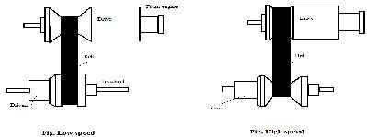
FunctionofTransmissionsystem:
- Todisconnectenginefromroadwheelswheneverrequired.
- Connecttheenginetodrivingwheelswithoutshock.
- Varythetorqueratio.
- Turnthedrivethroughrightangle.
- Work as torque converter. THE AUXILIARIES
- Theprinciplesoneoutofthisisthat,itiscommontoalmostalltypesofvehiclesi.e.,theelectrical equipment. This can be subdivided in 4 sub-systems.
- Supplysystem(batteryandgenerator)
- Batteryandmagnetoignitionsystem.
- Thestarter
- AncillaryDeviceseg.Drivinglight,Headlamp,Sidelight,Taillights,horn,anddirectionindicator. THE CONTROLS
Itisdividedintwotypes; Brake System
- Thecompletebrake system isincorporatedinthe chassis.Thebrakepedal controlsa master cylinder which is connected to brakes on each wheel by oil lines.
SteeringSystem
- Somepartsofthesteeringsystem(steeringgear)areboltedtotheframeandsome(steeringcolumn) connected to the body.

THESUPER-STRUCTURE
- In those cases, where frame-lessconstruction is not adopted, there must be separate super-structure i.e. the bodyattachedtotheframewhileincaseofframe-lessconstruction;thebodyperformancefunctionsofboth.
- Theshapeofbodydependsupontheultimateuseforwhichthevehicleismeant.Theshapes likeSUV, Sedan, Hatchback, Wagon, sport, mini vehicle, passenger, goods carrier etc.
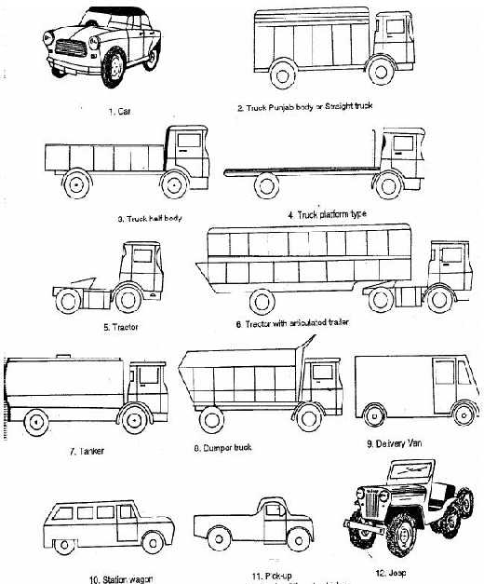
Theshapeofthebodydependsupontheultimateuseforwhichthevehicleismeant.
- CarBodyStyles
  - ClosedCars
- Saloon: Has two or four door,asingle compartment with two rows ofseats, oneat the frontandthe other at therear. There isa separateluggage spaceat therear ofat the front.
- Hatchback:Asaloonwithadooratthebackiscalledhatchback.

- Coupe:Inthistypethereisonlyonerowofseatsfortwopersons.Onlytwodoorsareprovided. Anordinary 'saloon' with roof-line at decreased height is also called coupe sometimes. The term G.T. (grand touring) added to 'coupe'meansa car of performance which is better than the average.
- Limousine:Drivingcompartmentisseparatedfromtherearcompartmentbyaslidingglassdivision.
  - Opencars
- Sports:Has two doors orless,is providedwith acollapsible hood,afoldflatwindscreenand removable side-screens.
- Convertible:Theroofisofsoft foldingtype and windows ofspecial wind-up design. With these provisions the car may be either open or enclosed.
  - Specialstyles
- Estate Car :A saloon car with the passenger roof extended right up to the rear end. Rear doorfor loading with rear seats usually collapsible.
- StationWagon:Wood-panelledbody inearlierdaysbutnowonlywitharesemblinglookoverthesteel structure. Rear doorsand seats for four or five persons.
- TransportVehicles
- Van : These are light transport vehicles. There are seats at the front and the luggage space at the rear. The sidedoorsareusually of sliding type. Therear door is used for loading or unloading.
- Truck: These are heavy goods commercial vehicles with all the axles attached to a single frame. Generally twin wheels are fitted on the non-steered axles. Depending upon the load capacity, there are two or more axles.
- Articulated vehicle: This is also heavy goods vehicle consisting of a tractor and a semi-trailer. The tractor provides the motive power while the trailer carries the goods. The two units are connected by means of a fifth-weel coupling.Thistypeofvehicle hassmallerturningcirclethanthe rigidtruck.Moreover,thetrailer being detachable, the tractor can directly move off after reaching with some other trailer without having to wait for unloading and re-loading. However, in theis there is less traction available. Moreover, steering is more difficult asthetrailer wheels do not followthe same path asthetraction wheels.
- Bus: These are used for carrying large number of people over short distances often in dense traffic. Not much space for luggage is provided, but there is adequate visibility for the passengers to know where they have to get down. Usually, there are two doors, the one at the rear for mounting and one at the front for gettingdown.Sometimes, the buses have two floors. Suchbusesare called double decker buses.
- Coach: these are used for transporting passengers over long distances and are, therefore, provided with luxurious interior with comfortable adjustable seats and amenities like video.

- EXPLAINTHECONSTRUCTIONOFVARIOUSFRAMESUSEDINAUTOMOBILESWITH NEAT SKETCH. (OR)
COMPARE THE MERITS AND DEMERITS OF A FRAMELESS CONSTRUCTIONWITH THOSE OF THE CONVENTIONAL FRAMED CONSTRUCTION. (OR)
EXPLAINTHE FOLLOWINGTERMS:(I)LOADDISTRIBUTIONINFRAMES(II) FRAMETYPES WITH SKETCH (III) FRAME MATERIALS (IV) FRAME TESTING. (OR)
EXPLAINWITHNEATSKETCHESTHEVARIOUSTYPESOFCHASSIS&DISCUSSTHEIR ADVANTAGES AND DISADVANTAGES.
- Chassisisa Frenchtermandwasinitiallyusedto denotetheframeparts or BasicStructureofthevehicle.It is the back bone of the vehicle.
- AvehiclewithoutbodyiscalledChassis.
- The components of the vehicle like Power plant, Transmission System, Axles, Wheels and Tyres, Suspension,ControllingSystemslikeBraking,Steeringetc.,andalsoelectricalsystempartsaremountedon

theChassis frame. It isthe main mounting for all the components including the body. Soit isalso called as Carrying Unit.
Functionofframe
- Tocarryloadofthepassengersorgoodscarriedinthebody.
- Tosupporttheloadofthebody,engine,gearboxetc.,
- Towithstandtheforcescausedduetothesudden brakingoracceleration
- Towithstandthestressescausedduetothebadroadcondition.
- Towithstandcentrifugalforcewhilecornering
Variousloadsactingontheframe
- Thebodyshouldbelight.
- Itshouldhaveminimumnumberofcomponents.
- Itshouldprovidesufficientspaceforpassengersandluggage.
- Itshouldwithstandvibrationswhileinmotion.
- Itshouldofferminimumresistancetoair.
- Itshouldbecheapandeasyinmanufacturing.
- Itshouldbeattractiveinshapeandcolour.
- Itshouldhaveuniformlydistributedload.
- Itshouldhavelongfatiguelife
- Itshouldprovidegoodvisionandventilation. TYPES OF CHASSIS FRAMES:
Therearethreetypesofframes
- Conventionalframe
- Integralframe
- Semi-integralframe
- TheConventionalframe
  - Pressed steel frame to which all the mechanical unitsare attached and on which the bodyis superimposed. (Italsocalledas―Separatebodyandchassistype‖,―Orthodoxtype‖)
  - Thebodyandchassiswillbeasseparateunit.
  - Boltsareusedtojointhebodyandchassistogether.
  - Theseparatepartofbodywillbeplacedoverthetopofthechassis.
  - Arubberblockwillbeplacedinbetweenthesetwopartstoavoidthevibration.
  - The conventional type building involves in building up ofa laddertype frame with two long side members interconnected by cross members at intervals.
  - Theunitslikeengine,gearbox,radiator,axles,steeringwheel,fueltankaremountedontheframe.
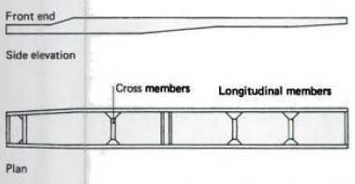
  - Thewholebodyandpassengerloadistransmittedtothechassisbymeansofspring.

  - Chassisshouldbebuilt strongsothatitcanwithstandtheweightofthebody
  - Thebasicunderbodystructureisfabricatedonlythinmildsteelcoldrolledchannelsections
  - Itisfullygalvanizedforcorrosionprotection
  - Itisprovidedwithcrossmembersandoutriggersatspecifiedintervals.
  - Thepillarandroofshocksaremadeofsheet steel.
  - Pillarsareboltedtothesolebaroftheunderstructure.
  - Theroofsticksareconnectedtothepillarsbystiffpressedsteelcornerbracketsandjoinedbysolidrivets.
  - Alltheinnerpanelsandwheelarchtrusspanelsaresheetsteelandsolidsteelrivetedtothepillars.
  - Alltheouterpanelsandroofpanelsarepopriveted. The frame sections are generally, used
    - ChannelSection-Goodresistancetobending
    - TabularSection-GoodresistancetoTorsion
    - BoxSection-GoodresistancetobothbendingandTorsion
    - I-section
    - T-section
    - Z-section
    - L-section
    - Tophatsection
    - Boxwithrebate
    - I-sectionwithflange
    - H-sectionforpillar
    - Y-section
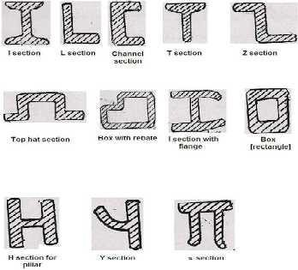
    - Π-Section
Advantage
  - Thisisusedinheavyvehicle.
  - Thisisofsimpleconstruction.
  - Thechangeofdesigningandthealterationofframelengthiseasy.
  - Servicingiseasyincaseofanydamage.
  - Thereisnoneedformoreexpenditureforpreventingcorrosion.

Disadvantage
  - Theweightoftheframeismore;duetothisthevehiclespeedisdecreased.Morefuelisalsorequired.
  - Sincethefloorheightismore,thecentreofgravityfromthegroundwillalsobemore.Duetothis,the stability will be decreased.
- Integralorframelessconstruction(Monocoque)
  - The body structure combines the functions of body and frame. The frameless construction is possible only in the case ofclosed car, since the roof, screen pillars and rear panel are essentially load-taking parts ofthe structure.
  - Monocoque, meaning'single shell' in French, is a construction technique that utilizes the external skin to support someor most of theload.Thetechnique mayalsobe called structuralskin or stressed skin.
  - Thesemi-monocoqueisahybridofamutuallyreinforcingtensileshellandcompressivestructure.
  - Unitarybody/unitbody-usesasystemofboxsections,bulkheadsandtubestoprovidemostofthe strength of the vehicle, to whichthe stressed skinaddsrelativelylittle strength or stiffness.
  - Inintegral busconstruction, abasestructureisformed with4long Sidemembers, crossmembers, outriggers and wheel arch supports.
  - Units like engine, gear box, axlesetc are mounted on the flexible Under structure, which is fabricated bywelding.
  - Theseunderstructuresarepaintedwithsuitablecolorstopreventcorrosion.
  - The body pillars which are ring frames are attached to the two extreme Side members called sole bars bybolting.
  - ThepanelingisdoneasperspecificationstogivegoodintegralStructure.
  - The under and body structure act as a single structure to carry the Load. Thus for a given load the integral structure will withstand more stresswhich indicatesthat every memberofthe structure issharingthe load.
Theframelessconstructionhasthefollowingadvantagesovertheconventionalframedconstruction
  - Reducedweightandsavinginfuelconsumption.
  - Lowmanufacturingcost.
  - Duringcollision,thebodyabsorbstheshockduetoimpactandprovidingsafetytothepassengers.
  - Lowerbodypositionandincreasedstabilityoftheautomobile.
  - Theseadvantagesareaccompaniedbythefollowingdisadvantagesalso:
  - Reductionofstrengthanddurability.
  - Economicalonlyifframelessconstructionisadoptedinmassproduction.
  - Increasedcostofrepairsincaseofdamagetobodyduringaccidents.
  - Toplesscarsaredifficulttodesignwiththeframelessconstruction.

DesignofIntegralBus Chassisunderstructure
  - Unit weights like engine, gear box,radiator,steeringbox, batteries and fuel tank actingaspointloadsat the mounting points.
  - Weightofunderstuctureconsideredasuniformlydistributedload.
  - Consideringtheverticalandlateralbending,momentiscalculatedandasectionrequiredtocarrytheweights is decided allowing for a reservefactor depending on the road conditions.
Chassisbodystructure
  - Bodyweightconsideredasuniformlydistributedload.
  - Payloadconsideredasuniformlydistributedload
  - Consideringbending,torsionandcombinationofboth,thebodystructureisdesignedallowingfora reserve factor depending in the road conditions.

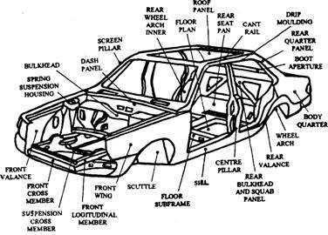
Advantages
  - Lightinweightcomparedwithconventionaltypeofbodyconstruction.sofuelconsumptionisless.
  - Easyentry/exitandlowerfloorheightistobeachieved.
  - Greaterstrength.
  - Freefromsqueaksandrattlescausedbytheworkingofboltedjointswhichareabsentinthisconstruction.
  - Reductioninheatinthedriverandpassengerarea.
  - Lownoiseandvibrationlevel.
  - Loweredwindscreenlevelandbettervisibilityfordriver.
  - Assemblingofcomponentiseasy.
  - Mainlythistypeisusedincarconstruction. Disadvantages
  - Whenacarisinvolvedinanaccident,itismoreexpensivetorepairthelargepanelsections.
  - Thereisagreaterliabilityofinjurytothedriver.
  - Itismoreexpensivetointroducechangesinbodystylingtokeepabreastofthetimes.
  - Initialcostismore.
  - Thickgaugematerialshouldbeused.
  - Moremoneyisrequiredtoavoidcorrosion.
- Semi–IntegralFrame
  - In some vehicles half frame is fixed in the front end on which engine gear box and front suspension is mounted. It has the advantage when the vehicle is met with accident the front frame can be taken easily to replacethe damaged chassis frame.Thistypeof frameisused in someof the Europeanand American cars.
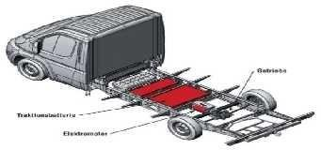

VariousTypesofFrame Ladder Frame
  - So named for its resemblance to a ladder, the ladder frame is the simplest and oldest of all designs. It consists merely oftwo symmetrical rails, or beams, and cross member connecting them.
  - Originally seen onalmostall vehicles, the ladder frame wasgradually phased out on carsaroundthe1940s in favor of perimeter framesand is now seen mainly on trucks.
  - This design offers good beam resistance because of its continuous rails from front to rear, butpoor resistancetotorsion or warping ifsimple, perpendicular crossmembersareused. Also, thevehicle'soverall height will be higher duetothe floor pan sittingabovethe frameinstead of inside it.
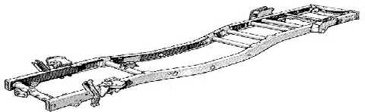
Backbonetube
  - Backbonechassisisatypeofanautomobileconstructionchassisthatissimilartothe
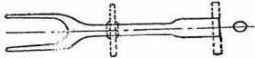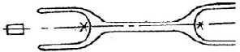Body-on-frame design. Instead of a two-dimensional ladder type structure, it consists of a strong tubular backbone(usuallyrectangular incross section) that connectsthe front and rear suspensionattachment areas. A body is then placed on this structure.
PerimeterFrame
  - Similar to a ladder frame, but the middle sections of the frame rails sitoutboard of the front and rear rails just behind the rocker panels/sill panels.
  - Thiswasdonetoallowforalowerfloorpan,andthereforeloweroverallvehicleinpassengercars.
  - This was the prevalent design for cars in the United States, but not in the rest of the world, until theuni- body gained popularity and is still used on US full frame cars.
  - Itallowed for annual model changesintroducedin the1950sto increase sales, but without costly structural changes. In addition to a lowered roof, the perimeter frame allows for more comfortable lower seating positions and offers better safetyin the event of a side impact.
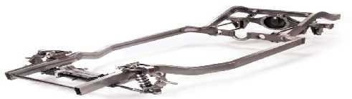
  - However, the reason this design isn't used on all vehicles is that it lacks stiffness, because the transition areas from front to center and center to rear reduce beam and torsional resistance, hence the use of torque boxes, and soft suspension settings.

Superleggera
  - An Italian term (meaning"super-light") for sports-car construction using a three dimensional frame that consists of a cage of narrow tubes that, besides being under the body, run up the fenders and over the radiator, cowl, and roof, andunder therear window; it resemblesa geodesic structure.
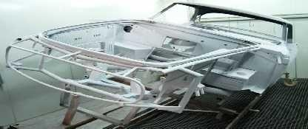
  - Thebody,whichisnotstress-bearing,isattachedtotheoutsideoftheframeandisoftenmadeofaluminum.
Unibody
  - By far the most common design in use today sometimes referred to as a sort of frame. But the distinction still serves a purpose: if a unibody is damaged in an accident, getting bent or warped, in effect its frame is too, and the vehicle undrivable.
  - If the body of a body-on-frame vehicle is similarly damaged, it might be torn in places from the frame, which maystill be straight, in which casethevehicleis simpler and cheaper torepair.
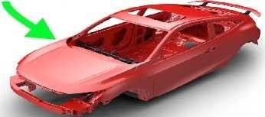
Subframe
  - The sub frame, or stub frame, is a boxed frame section that attaches to a unibody. Seen primarily on the front end of cars, it's also sometimes used in the rear. Both the front and rear are used to attach the suspension to the vehicleand either maycontain the engine andtransmission.
  - Themostprolificexampleisthe1967-1981ChevroletCamaro.
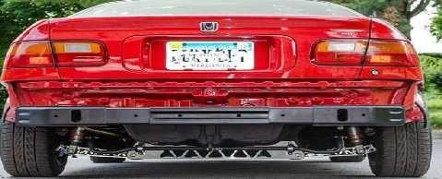

X-frame
  - Thisisthedesignused forthe full-sizeAmericanmodelsofGeneralMotorsinthelate1950sand early 1960sinwhichtherailsfromalongsidetheengineseemedtocrossinthepassengercompartment,each continuing to the opposite end of the cross member at the extremerear ofthe vehicle.
  - Itwasspecificallychosentodecreasetheoverallheightofthevehiclesregardlessoftheincreaseinthe size ofthetransmission and propeller shaft humps, since eachrowhadto cover framerailsas well.
  - Severalmodelshadthedifferentiallocatednotbythecustomarybarbetweenaxleandframe,butbyaball jointatopthe differential connectedtoa socketina wishbone hingedontoa crossmember ofthe frame.
  - TheX-framewasclaimedtoimproveonpreviousdesigns,butitlackedsiderailsandthusdidnotprovide adequate side-impact and collisionprotection. This design was replaced byperimeter frames.
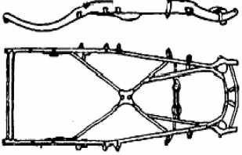
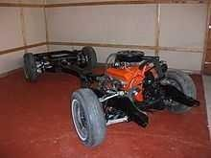
X-Frame RollingX-framechassis
FrameMaterial
- Carbon–0.25–0.35%
- Manganese–0.35–9.725%
- Silicon–0.30%(maximum)
- Nickel–3%
- Phosphorous–0.05%(maximum)
- Sulphur–0.5%(maximum)

EXPLAINTHE VERIOUSTYPESOFENGINE
DRIVESOFAUTOMOBILESANDMENTIONTHEMERITSANDDEMERITSOFEACHDRIVE.
Someoftheimportantdrivesofautomobilesmaybeclassifiedasfollows:
- Frontengine-Rearwheeldrive
- Rearengine-Rearwheeldrive
- Frontengine-Frontwheeldrive
- Fourwheeldrive
- FrontEngineRearWheelDrive
  - Rear wheel driveplacesthe engineinthe front ofthe vehicleandthedriven wheelsarelocatedattherear,a configuration known as front-engine, rear-wheel drive layout.
  - In this layout a front mounted engine-clutch-gear box unit drives a beam type rear axle supported on leaf springs through a propeller shaft with two universal joints. With the help of coil springs, the front Wheels are independently sprung
  - Thislayoutisoneoftheoldestlayoutswhichremainunchangedformanyyears.

Advantages
  - Evenweightdistribution:Balancedweightdistributionbetweenthefrontandtherearwheelsproviding good handling characteristics.
  - Foreasyfrontwheelsteeringmovementenàneoccupiesthereducedwidthbetweenthewheelarches.
  - Largeluggagespaceisprovidedbehindtherearseat.
  - Maintenanceandaccessibilityofengine,gearboxiseasyandthecontrolovertheaccelerator,clutch,choke simple.
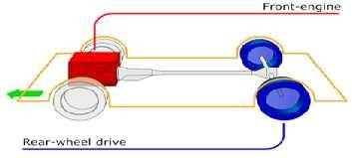
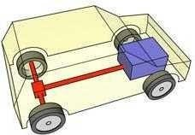
  - Radiatorcoolingisnatural(byair)sodecreasesthepowerrequired forcooling. Better braking
  - efficiency:Themoreevenweightdistributionhelpspreventlockupfromwheelsbecomingunloaded Disadvantages:
  - Reducesbackseatslegroomspace,
  - Atunnelisneededforthepropellershaft,
  - Reducesbootspace,
  - Heavierandmoreexpensive.
  - Ifstuckinmudorsnowitishardertodriveawaythanina frontwheeldrivecar.
- RearEngineRearWheelDrive
  - Thislayoutconsistsofplacingtheengine,clutchand gearboxintheback.Sotakingthespaceoftheboot. In these type of layout more than 50% of the weight is on the rear axle.
  - Thenecessityofthepropellershaftiscompletelyeliminated.Theclutch,gearboxandengineandfinal drive form a single unit.
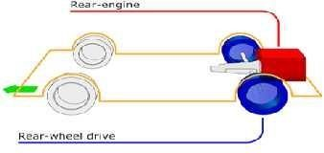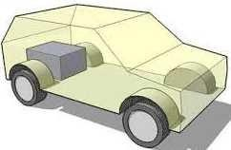
Advantages
  - Excellenttractionisavailablewhileclimbinghills.
  - Alargerpassengerspaceisavailableforthegivenlengthofbody.
  - Verycompactandaccessiblepowerandtransmissionassemblyisprovided.
  - Lotofweightatthebackimprovesaccelerationandbraking,rearwheelsanddiscbrakescanbedesignedto takea bigger amount of braking due to the weight distribution tothe rear end.
  - Passengersarecomfortablefromenginenoise,heatandfumes.

  - Frontofthevehicleprovidesgoodvisibilityandbydesigningthebodytoaerodynamicshapegivesgood streaming lining.
Disadvantages
  - Athighspeed,relativelyhighproportionsofweightattherearaxlewillmakethecarunstableat speed. There is a strong tendency for the vehicle to oversteer.
  - Thespaceatthefronthastobereducedtoallowforthesteeringlockofthefrontwheel.
  - Spaceutilizedforenginecompartmentiswasted.
  - Difficultieswiththearrangementoftheenginecoolingsystem.Naturalcoolingofradiatorisnotpossible. Power requirement increases. Compact engine, clutch and gearbox makeservicing moredifficult.
  - Thewheels getsturntoosharplyduetotendencyofthevehicletooversteer.Thisnecessitatestheturningof the steering wheel in the opposite direction to make the correction bydriver.
- FrontEngineFrontWheelDrive
  - Thistypeofarrangementprovidesoptimumpassengerspaceandaflatfloorlineresultinginatransverse under floor-longitudinal engine position.
  - Thepropellershaftlengthisreducedorneglectsthepropellershaft.
  - Goodgripwithroadsurfaceduetoengineweightatfront.
  - Powerrequiredforthecoolingisreduced.Whenthevehicleistobe‗steerin‘tothecurve,itprovide
‗under-steer‘characteristics,whichisalwayspreferred.
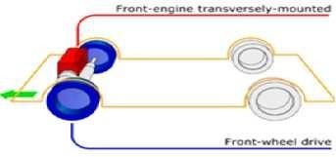
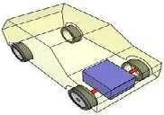
Advantages
  - FWDcarshavebettertractionwhilemovingontheslipperyroadslikesnow-coveredroadsbecausethe engine is mounted above or near the front axle.
  - Thesevehicleshavecompactdesignastheentirepower-packfitsatthefrontofthevehicle.
  - Duetotheabsenceofpropellershaftandtransmissiontunnel,thesecarshavemoreinterior space.
  - Light-weighttransmissionreducescurbweightofthevehicle.
  - As the front wheels of these vehicles receive engine power, they 'pull' the vehicle instead ofa'push' from the rear. Thus, passengers feel more stability in these vehicles.
Disadvantages
  - Tyre wear onthesevehiclesisuneven. Fronttyreswearout faster comparedtoreartyresbecauseofuneven weight distribution.
  - While drivingonroadswith high slopesor during sudden acceleration, frontwheels mayexperiencelossof grip due to weight shift.
- FourWheelDrive
  - Inthisarrangementallthefourwheelsofthe vehicleare drivenbytheenginethusmakingtheentirevehicle weight available for traction.
  - These four wheel drive vehiclesare very useful onHill station ifone ofthe wheel slipping or skiddingthen theotheraxle wheeltransmitthetractive forcetothe vehicle.The steering ofthe four wheel driveishardto operate compared with other type of drive.

Advantages
  - Tractionisnearlydoubledcomparedtoatwo-wheeldrivelayout.
  - HandlingcharacteristicsinnormalconditionscanbeconfiguredtoemulateorRWD.
  - Givessufficientpower,theseresultsinunparalleledaccelerationanddrivabilityonsurfaceswith lessthan ideal and superior engine braking on loose surfaces.
Disadvantages
  - Themanufacturingcostofthevehicleishigh.
  - Morecomponentandcomplicatetransmission.
  - Increasedpower-trainmass,rotationalinertiaandpowertransmissionlosses.
  - Increasedfuelconsumptioncomparedto2WD.
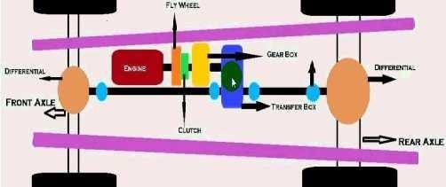
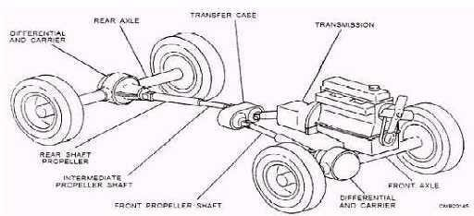

- Mid-Engine,RearWheelDrive
  - Thistypeofenginelayoutplacestheenginebetweenthetwoaxlesandtherear wheelsaredriven. weightis equally distributed between front and rear wheel
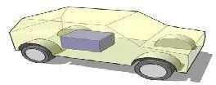
Advantages
  - Goodaccelerationbecauseofbackweighttransfer.

  - Efficientbraking.
  - Neutral handling. Disadvantages
  - Whenacceleratingsomesteeringislost.
  - Requiremorespace.
  - Noback seats.
  - Difficultieswiththecoolingsystem. Rear engine, all wheel drive (4WD) :
Similarcharacteristicsasrearengine,rearwheeldrive.Andotheradditionalas: Advantages
  - Betterweightdistribution.
  - Moreneutralreactions.
  - Bettertractiononbendsandslipperyroadsurfaces. Disadvantages
  - Heavier.
  - Moreexpensiveanddifficulttodesignandbuild. Front engine, all wheel drive(4WD) :
Similarcharacteristicsasthefrontengine,rearwheeldrivePlus. Advantages
  - Betterhandlingcapacity.
  - Better acceleration. Disadvantages
  - Itincreasesweightandmanufacturingcostcomparewithfrontenginelayouts.
  - Lossofsomespaceinthebackseatslegsroom.

Differentiatebetweenfrontandrearmountenginevehicle:
FrontmountEngine(F),RearmountEngine(R)
  - F:Travellingisfasterandsaferascomparetorearmountengine. R: Travelling is less fast and safer than front mount engine.
  - F:Thisenginevehiclehasgoodroadadhesionduetolargevehicleweightcarryingondrivingwheel. R: This engine vehicle havinglessroad adhesion as compared to front mount engine.
  - F:Thisengineprovidelesspassengercomfortcomparedtorearmountengine.
R:Thisengineprovidesbetterpassengercomfortduetoreducenoise,heatandfumes.
  - F:Itprovideshighfloorresultsinmorepassengerspaceascomparedtorear engine.
R:Itprovideslessfloorarearesultinmorepassengerspaceduetodispensingwithpropeller shaft.
  - Frontenginevehiclesprovidenaturalaircooling. Rear engine required powerful fan.
  - F:Inthisengineascomparedtotherear enginethevehiclesarelessaffected.
R:Inthisengine,therearwardconcentrationofweightcausesthevehiclemoreaffectedbyside
  - F:Chanceofwheelskiddingisless.
R:Chanceofwheelskiddingismore.
  - Front engine vehicles visibility is poor. Rearenginevehiclesvisibilityisgood.

Mostofthemoderncarsarefrontwheeldrive
  - Thistypeofarrangementprovidesoptimumpassengerspaceanda flatfloorlineresultinginatransverse under-floor-longitudinal engine position.
  - Thepropellershaftlengthisreducedorneglectsthepropellershaft.

  - Goodgripwithroadsurfaceduetoengineweightatfront.
  - Thechanceofwheelskiddingandslippingisverymuchreduced.
  - Naturalair-coolingoftheradiatorduetomotionofvehicle.
ArticulatedVehicles
  - Thesevehicleshavingadetachabletrailersupportedona platformonthetractorunitareusedtocarryheavy loads which must not exceed gross train weight.
  - Thetrailertractorconnectionisalsocalledthefifth wheel.Itmaximumpermittedladenlengthandweightis 15 meters and 20 tones or less than four wheel vehicle. No time will be waste in loading or unloading as several trailers are available.
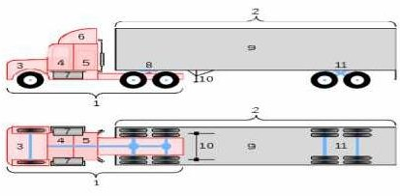
HeavyCommercialVehicles
  - Theseheavyandrobustvehiclesusedforhaulagepurposearepoweredbyadieselengine.
  - Its gross vehicle weight (g.v.w.) is more than 3 tonnes. It required twin tyres fitted side by side onthe rear wheels for carrying heavyloads. Sometimes, moreaxlesareadded for very heavyloads.
  - Allthepowerandtransmissioncomponentsarearrangedinadrivercompartment.Dependinguponthe requirement theymay be openor closedbody.The open bodyvehicles areknownaslighttruck or pick up.
LefthandandRightanddrives
  - In different countries, the automobiles are driven on different sides ofthe road, In United Kingdom and all the countries, which were once colonies oftheBritishRule.The vehiclesare driven ontheleft hand side of the road.
  - In all other countries of the world, normally vehicles are driven on theright hand side of the road. For better drivingcontrol, thevehicledriversmust benearer tooneanother whilepassingor crossing. Similarly for safety consideration, the drivers must beinthe centre of the road while driving.
  - Therefore,twotypesofvehiclesaremanufactured.
  - Left hand drive: The steering is fitted on the left hand side of the automobile and such vehicles are convenient to drive in countries followingright hand driverules,e.g. U.S.A., Russia,Europeancountries.
  - Right hand drive: The steering is fitted on the right hand side of the automobile and such vehicles are convenient to drivein countriesfollowing left hand driverules, e.g. U.K.,India,Pakistan. However,though rare, left hand cars also driven in such countries.
FrontwheelsteeringRearwheeldrive
  - Accesstotheengineisveryeasy.
  - Slowing down of the water circulation causing cooling troubles can be avoided and long hose connections can be saved due to situating oftheradiator inthe main air stream.
  - Thisarrangementhelpsminimizethelinkagebetweentheclutch,gearboxandengine.
  - Theangularityofthepropellershaftiskepttominimumandthereisnoneedofjointsduetotheshaft length.

EXPLAINTHEVARIOUSFORCESACTIONGONTHEBODYANDITSAERODYNAMICS AFFECTS. (OR) RESISTANCES TO VEHICLE MOTION
Thefollowing forcesactonvehicleinmotion:
Aerodynamicdrag:.
- Aerodynamicmeansthebehavioroftheairmotionrelativetothecarbody.Aerodynamicdragisalsocalled as air resistance.
- Airdragforceactsinthedirectionofvehiclemotion.
- The total aerodynamic drag of a vehicle includemany factors such as profile drag (57%), induced drag (8%), skin friction (10%), interference drag(15%) and cooling and ventilation drag(10%).
- Stream line of air flow around the vehicle should be continuous and separation of the boundary layer with its attendant vertices should be avoided. Skin drag coefficient should be decrease by smooth and well- polished of body surface.
- The accessoriessuch as mirror, door handle aerialsand badges which project outward from normal surface of body produce interference drag and projection below the vehicle such as axle, propeller shaft, tow bar also contribute interference drag hence such projection should be avoided.
Aerodynamiclift
- Itistheverticalcomponentoftheresultantforcecausedbythepressuredistributiononthevehiclebody.
- Theaerodynamicliftandpitchingmomentareundesirableeffects.Theaerodynamiclifttendstoreducethe pressure between the tyreand the ground. This causes the loss of steering on the frontaxleand loss of traction on the rear axle.
- Pitching causes rear wheel lift offthe groundand reduces availabletraction. Itis therocking chair or rotatingactionaboutthetransverseaxisthroughthevehicleparalleltoground.Duetopitching,thefront suspension moves out of phase withtherear resulting inrocking effect ina vehicle.
Sideforce
- Theimbalanceofthewheelduetocentrifugalforceactsonthevehicleduringturningwhichproducesa side thrust.
- Tosustainthatforce,theplaneofthewheelmakes someanglewiththedirectionofmotionofthevehicle. This is achieved by the direction of tyre which is flexible.
- Theangleformduringtakingturntosustainthesidethrustisknownasslipangleandtheforceproduceto counter acts the side thrust is called as cornering force.
Yawingmovement(Bouncing)
- Itis vertical movement of the complete body.When complete body of vehicle goes upand down whichis knownasbounceorbouncing.Dependinguponthemovementoffront endorrearendthebounceisknown as front end bounce or rear end bounce.
Rollingmovement
- Itisthemovementofa vehicleaboutitslongitudinalaxisproduceddueto centrifugalforceactduring cornering.
- Theretardingandcornering forcesareappliedatroadlevels butthe centre ofgravityofa vehicle isata certain height.During cornering, a turning couple isproducedabout thelongitudinal axis ofthe vehicle owingtocentrifugal forceactingat centreofgravityandforcesactingatthepointofcontactofroadand tyre patch. This results in a motion known as rolling.
- Acombinationofrollingandpitchingiscalleddiagonalpitch. Remedies:
- Inordertocontrolalltheabovesuspensionmovements;antirollerbar,stabilizer,pitchandrollcontrolbars, hydraulic systems, mechanical levelling devices etc. are provided to vehicles.
Aerodynamics
- It is a branch of dynamics concerned with studying the motion ofair, particularly when it interacts with a solid object, such as an Automobile, airplane wing, etc.

- Aerodynamics, from Greek ἀήρ aer (air) + δυναμική (dynamics), is a branch of dynamics concerned with studying the motion of air, particularly when it interacts with a solid object, such as an airplane wing. Aerodynamicsisa sub-field offluid dynamicsand gasdynamics,and many aspectsofaerodynamicstheory are common to these fields.
- The term aerodynamics is often used synonymously with gas dynamics, with the difference being that "gas dynamics" applies to thestudy of the motion of all gases, not limited to air. Modern aerodynamics only dates back to the seventeenth century, but aerodynamic forces have been harnessed by humansfor thousands of years in sailboats and windmills, and images and stories of flight appear throughout recorded history, such as the Ancient Greek legend of Icarusand Daedalus.
- Fundamental concepts of continuum, drag, and pressure gradients, appear in the work of Aristotle and Archimedes. Forces of flight on an airfoil
FundamentalConcept
- Understandingthemotionofairaroundanobject(often calleda flowfield)enablesthe calculationofforces and moments acting on the object. In many aerodynamics problems, the forces of interest are the fundamentalforcesofflight:lift,drag,thrust,and weight.Ofthese,liftanddragareaerodynamicforces,i.e. forces due to air flow over a solid body.
- Calculation of these quantities is often founded upon the assumption that the flow field behaves as a continuum. Continuum flow fields are characterized by properties such as velocity, pressure, density and temperature, which may be functions of spatial position and time.
- These properties may be directly or indirectly measured in aerodynamics experiments, or calculated from equations for the conservation of mass, momentum, andenergy in air flows. Density, velocity, and an additional property, viscosity, areused to classifyflowfields.
  - AirResistance
  - Gradientresistance(Vehicleweightbutdependonthespeedofthevehicle)
  - RollingResistance
  - Miscellaneousresistance
    - Roadcharecteristics
    - vehiclespeed
    - Tyrecharecteristics
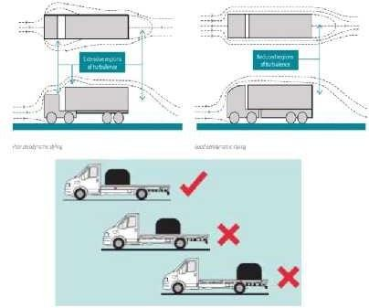

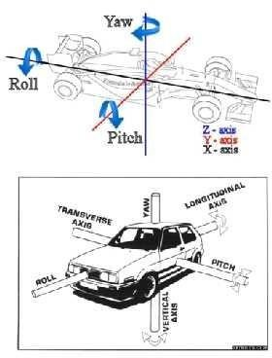
Forcesandmomentsactingonavehicle
AirResistance:
- Thisistheresistanceofferedbyairtothemovementofavehicle.
- The air resistance has an influence on the performance, ride and stability of the vehicle and depends upon the sizeand shape ofthe body of the vehicle, its speed andthe wind velocity.
- Thelastterm should betakenintoaccount when indicated,otherwise it can beneglected. Hencein general, air resistance,
RollingResistance:
Themagnitudeofrollingresistancedependsmainlyon
- thenatureofroadsurface,
- thetypesoftyreviz.pneumaticorsolidrubbertype,
- theweightofthevehicle,and
- thespeedofthevehicle.

FORCESACTINGONVEHICLE:
- Dragforce(Fx)-AlongthevehicledirectionProfiledrag,interferencedrag,skinfriction,coolingand ventilation system drag.
- Crosswind(Fy)-alongsideorlateraldirectionAsymmetricflowofairaroundthevehiclebody
- Lift force(Fz)–vertical forceactingfromthebottomofthevehicle.Becauseofpressuredifferencebetween top and bottom of the vehicle.
MOMENTSDUETOFORCES:
Momentscreatedbyforcesactingonthevehicle
- Pitchingmoment–Createdbydragorliftforceabouty-axisandreducesthetractioninthe wheels
- Yawingmoment-Createdbycrosswindaboutz-axis
- RollingMoment–Createdbycrosswindaboutx-axis

CLASSIFICATIONOFAVEHICLECHASSISISBASEDONTHEPOSITIONOFTHEENGINE ON THE CHASSIS.
- Fullforwardchassis
- SemiForwardchassis
- Engineatcentrechassis
- Engineatthebackchassis
- Conventional chassis Full Forward:
- Mostlypowerisgiventothefrontwheelshencereducescomponents
- Problemofvisibility&Costlybecauseoftransaxle
- PartofChassisportioncannotbeutilizedforcarryingpassengersandgoods
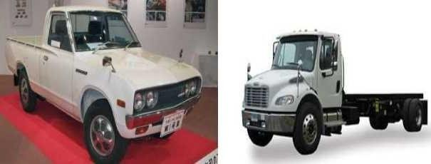
SemiForward:
- Halfportionoftheengineisinthedrivercabinandremaininghalfisoutsidethecabinsuchasintatatrucks
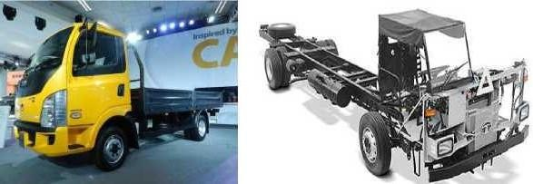
- Inthisarrangementapartofthechassisisutilizedforcarryingextrapassengers
EngineatCentre:
- Driveisgiventotherear
- Fullspaceofthechassisfloorcanbeused(RoyaltigerworldmasterbusesinDelhi)
- Ifusedincarsitlimitsthecartobeatwo seater.
- Luxury/Sportscarsusethislayout.

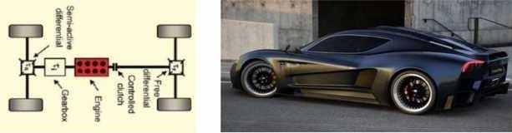
Engineattherear/back:
- Reducedcomponents
- Costlybecauseoftransaxle
- Witheliminationofpropellershaftthecentreofgravityloweredgivingstabledriving
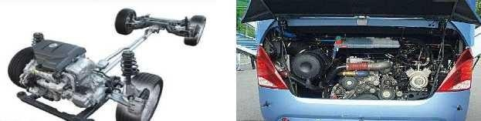
- Betteradhesiononroadspeciallywhenclimbinghill.

EXPLAIN INDETAIL ABOUTTHE VARIOUS COMPONENTSOF ENGINEWITH NEAT SKETCHES.
Basicenginepartswithitspictures
- In this post, we will discuss the engine parts. As you know that an engine is a machine designed to convert one form of energy into mechanical energy.Heat engines burn a fuel to create heat which is thenused to do work. The engine has two types one is the internal combustion engine and another one is external combustion engine.
- Theinternalcombustionengineisthoseheatenginesthatburntheirfuelinsidetheenginecylinder.
- Externalcombustionenginesarethoseheatenginethatburnstheirfueloutsidethecylinderengine.
- Theenginemostessentialpartof automobileindustriesorwecansaythattheengineistheheartofan automobile.
Termsconnectedwithi.c.engines
- Bore:Theinsidediameterofthecylinderiscalledbore
- Stroke:Thelineardistancealongthecylinderaxisbetweentwolimitingpositionsiscalledstroke.
- Top Dead Center( T.D.C.):the topmost positionof the piston towardscoverendsideof thecylinderis called T.D.C.
- Bottom deadCenter(B.D.C.):Thelowest positionofthe piston towardsthe crank end side ofthe cylinder is called B.D.C.
- Clearance Volume: The volume contained inthecylinder abovethetop ofthe piston , when the piston isat top dead center , is called the clearance volume.
- SweptVolume: The volumeswept through by the piston in moving between T.D.C. and B.D.C, is called swept volume or piston displacement.
- CompressionRatio:ItistheratioofTotalcylindervolumetoclearancevolume

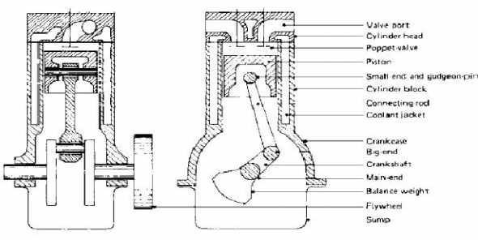
- The functionand construction ofeach engine parts ofaninternal combustion engineare explained.Thekey to the engine are as follows:

Themainenginepartsare asfollows:
  - CylinderBlock
  - CylinderHead
  - CrankCase
  - OilPan
  - Manifolds
  - Gasket
  - CylinderLiner
  - Piston
  - PistonClearance
  - PistonRing
  - ConnectingRod
  - PistonPin
  - CrankShaft
  - CamShaft
  - Flywheels
  - EngineValves
- Poppetvalve
- Sleevevalve
- Rotaryvalve
  - Governers

Cylinderblock
  - Fig shows a simple sketch of the cylinder block.It is the basic framework for the engine. and one of the mainin engine parts.Cylinder block, cylinder headand crankcasethese threepartsformthe foundationand main stationary body of the automobile engine.

Acylinderblockconsistsofthreeparts:
  - Thecylinderinwhichthepistonslidupanddown.
  - Theportoropeningforthevalves.

  - Thepassagesfortheflowofcoolingwater.
Constructionandworking:
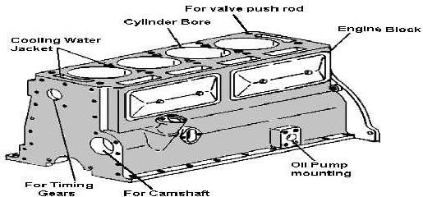
  - Thecylinderblockisusuallymadeofgreycastironoraluminumanditsalloys.
  - Whilethecrankcaseisfixedtoitsbottom.Apartfromtheseotherpartsliketiminggearwaterpump, ignition distributor, flywheel, fuel pump etc., are also attached to it.
  - Passagesareprovidedinthecylinderwallsforthecirculationofcoolingwater.
  - Matingsurfacesoftheblockarecarefullymachinedtoprovideaperfectsealingsurface.
  - Cylinderblock alsocarrieslubricationoil to variouscomponentsthrough drilled passagescalledoil galleries.

CylinderHead
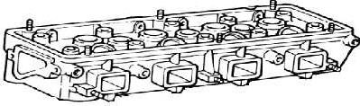
Anothertypeofenginepartsiscylinderheaditisjointbetweenthecylinderheadandcylinder block.
Construction:
  - Itisusuallymadeupofcastironandaluminumalloy.
  - Thetopofthecylinderiscoveredbya separatecastpieceknowasthecylinderhead.
  - Thecylinder headisattached to the cylinder block bymeans ofstuds fixed totheblock Gasketsareused to provide a tight, leak-proof joint between the head and block.
  - Itcontainsacombustionchamberaboveeachcylinder.
  - Italsocontainsvalveguides,valveseats,ports,coolantjacketsandthreadedholesforsparkplugs. It incorporates passages for the flow of cooling water.
Applications:
  - The cylinder head castsintegrallywith cylinder blocks also be done ina few casesusuallyinracing carsto obtain a gas-tight joint.
  - Thedetachableheadtypesaremoreadvantagesthantheintegralconstruction.
  - However, forcertainheavy-dutyenginerequireshighcoolingratessuchasinracingcarscopperalloys may be used.
Dependinguponthevalveandportlayout,thecylinderheadmaybeclassifiedintothreetypesasfollows:
    - Loopflowtype

    - Offsetcrossflowtype
    - Inlinecrossflowtype
Loop flow type: In the loop, flow types the inlet and the exhaust manifolds are on the same side, which facilitates preheating of the intake air.
Offset cross flowtype:Offset cross flowtypesthe inletand the exhaust manifoldsare placed on different sides of the cylinder head.
Inline cross flow type:In line cross-flow type, the valveis positioned transversely andusually inclinedto each other, while the inlet and the exhaust manifolds are on different sides of the cylinder head. This arrangement gives better performance, but it is costlier.

Crankcase
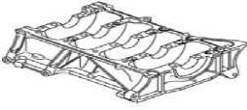
Theoilpanandthelowerpart ofthe cylinder block togetherarecalledthecrankcase.Itisthebottomportionof the cylinder block, in which the crankshaft is fitted.
Construction:
  - This isa rigidconstructionmadeof greycastironoraluminum.Eitheritcanbe castintegrallywiththe block or can be cast separatelyandattached to the block with bolts.
  - The crankcase is shaped simplylike a box having no bottom.Oil pan or sump forms the bottom half ofthe crankcase.
Working:
  - Thefunctionofthecrankcaseistoprovidesupportforthemainjournalsandbearingofthecrankshaft, rigidly maintaining thealignment oftheir axes ofrotation under various engine loads.
  - Thecrankcaseissupportedinthecrankcasethroughanumberofbearingcalledthemainbearing.

Oil Pan
Thebottomhalfofthecrankcaseiscalledtheoil pan or sump.Itisattached tothe crankcasethroughsetscrews and with a gasket to make the joint leak proof.
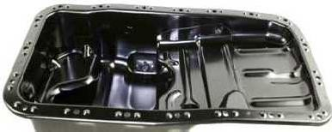
Theoilpanservesasareservoirforthestorage,coolingandventilationofenginelubricatingoil.
At the bottom ofthe oil sump, a drain plug is provided to drain out the dirty oil at the time of oil replacement. Generally, the sumpis made ofpressed steel sheet or aluminum alloycastingisused.
Thevariousfunctionsoftheoilpanasfollows.
  - Tostore theoilfortheenginelubricationsystem.
  - Oilpanusedtocollectthereturnoildraining
  - Toserveasacontainerforimpuritiesorforeignmatters

  - Oilpanprovidesforcoolingofthehotoilinthesump.
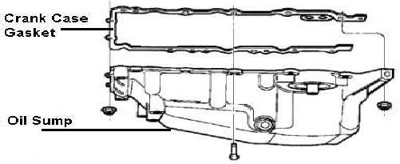
Working:
  - The oilpump in the lubricatingsystemdraws oilfromtheoilpan andsends it to allworkingparts in the engine.
  - Theoildrainsoffandrunsdownintothepan.
  - Thusthereisaconstantcirculationofoilbetweenthepanandtheworkingpartsoftheengine.

Manifolds
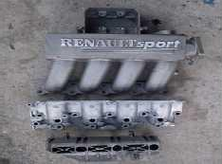
There are separate sets of pipes attached to the cylinder head which carry the air-fuel mixture and the exhaust gases. These are called manifolds. It is generally made of cast iron so that it is able to withstand the high temperature of the exhaust gases.
Construction:
  - Itconsistsoftheairintake,throttlebody,intakemanifoldflangefortail-pipeandflangeforacarburettor.
Working:
  - Theair goesintotheair intaketravels through, throttle bodyintotheintake manifoldand fromthereit goes into the engine through the cylinder head.
  - Theinletmanifoldcarriestheair-fuelmixturefromthecarburettortothecylinders.

  - Theexhaustmanifoldisthesetof system.

Gaskets
pipescarryingexhaustgasesfromthecylinderheadtotheexhaust

Gasketsareusedtoprovideatightfittingjointbetweentwosurfaces.
Gasketsarefoundin:
  - thejointbetweenthecylinderheadandthecylinderblock
  - Betweencrankcaseandoilpan.
  - Betweenthecylindersblockandmanifold.

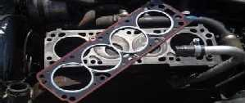

Thevariousmaterialsusedforgasketsare:
  - Cork
  - Asbestos
  - Rubber
Someoftherequirement/propertiesofthegasketasfollow:
  - Conformity:Thegasketsshouldconformtothematingsurfaceswhichmayhaveroughnessorwarpage.
  - Resistance:Itshouldhaveresistancetohighpressures,extremetemperatureandvibrations.
  - Impermeability:Thegasketmustbeimpermeabletothefluid.
  - Resistancetochemicalattack:thegasketshouldhaveresistanttothechemicalssuchasfuel,productsof combustion, coolant and engine oil.
  - Provisionofapertures:Thegasketmusthaveaperturesforanystuds,bolts,openingetc.,
Someofthegasketsproducedbythefuel-proUSAasfollows:
  - Cylinderheadgaskets.
  - Oilpangaskets.
  - Manifoldgaskets.
  - Pumpgaskets.
Followingimportantgasketsareusedinautomobileengines:
  - Copper-asbestosgasket.
  - Steel-asbestosgasket.
  - Steel-asbestos-coppergasket.
  - Singlesteelridgedorcorrugatedgasket.
  - Stainlesssteelgasket.
- Cylinderliners
These are cylindrical shapes used in the cylinders to avoid the problem of cylinder wear. It is one of the most important functional parts to make up the interior of an engine. These can bereplaced after they worn-out. These are made of special alloy iron containing silicon, manganese, nickel and chromium. Usually, these are cast centrifugally. These liners resistance to wear and corrosion. These liners are of the oil hardening type and offer considerably longer life for the engine.
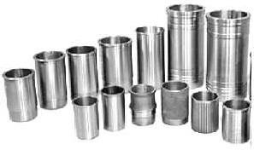
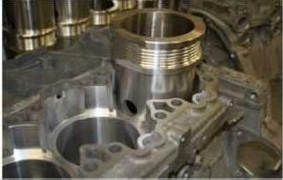

Cylinderlinersareoftwotypes:
Drylinersandwetliners.Let‘stakethedetailview.
Dryliners:
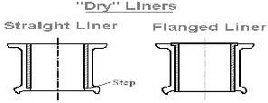
Construction:The constructionofa dryliner isshownin the fig.Thisliner ismadeinthe shape ofa barrel with a flange atthetop whichkeeps itinto position.The entire outer surface bearsagainstthe cylinder block casting and hence these are it be machined accurately at both outer and inner faces. The liner should not be too loose, otherwise, theheat dissipation becomes poor becauseof theabsence of good contact withthecylinder block.
Wetliners:
These liners will be in direct contact with the cooling water at their outer face. Thus, These liners need not be machinedveryaccuratelyattheoutersurface.However,theyhavebeenmachinedaccuratelyattheinner

surface.Theyareresistingcorrosion aluminium at their outer surface.
withcontinuouscontactwithcoolingwater.andtheycoatedwith

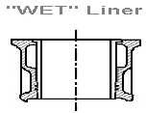
Construction:
- Atthetop,thelinerisprovidedwithaflangewhichfitsintothegrooveinthecylinderblock.
- Atthebottomofthelinerisprovidedwithagroove,generallythreeinnumber.
- Themiddlegrooveisleftemptyfordrainageforanywaterthatmayleakfromtheupperring.
- Andinthetopandbottomonesareinsertedpackingring,madeofsyntheticrubber.
Comparisonofthedryandwetliner:
DryLiners
- Drylinersmaybeprovidedeitherintheoriginaldesignorevenafterwards.
- Theconstructionofcylinderblockverycomplicated.Thecoolingeffectisnotverygood.
- Accuratemachiningofdrylinersforperfectcontactwiththecylindercastingisessential.
- Inthistype,itcannotbefinishedbeforefitting.Aleak-proofjointisnotnecessary. Wet Liners
- Wetlinershavetobeincludedintheoriginaldesign.Theconstructionofthecylinderblockissimple.
- Thecoolingeffectisbetterbecausethelinerwillhavedirectcontactwithcoolingwater.
- Accuratemachiningisnotessential.Inthistype,theycanbefinishedbeforefitting.
- Aleak-proofjointshouldbemadebetweenwetlinerandcylinderblock.

Pistons
Pitons are most important engine parts compared to other. The piston is a cylindrical plug that moves up and down in the cylinder. It helps to convert pressure energy obtained by the combustion of fuel into useful mechanical power andit transfer this power to the crankshaft through the connectingrod.
- ThehighestpositionofthepistonreachesinthecylinderiscalledtheTopDeadCentre(TDC)and
- ThelowestpositionitreachesiscalledtheBottomDeadCentre(BDC).
Itisprovidedwithpistonsringabout3to5provideagoodsealbetweenthecylinderwallandpiston.

Theefficiencyandeconomyoftheengineprimarilydependontheworkingofthepiston. The material used for the piston is mainly.
- Cast iron,
- Aluminiumalloy.
- Nowadaysaluminiumalloysarewidelyused.Itmaybeeithercastorforged.

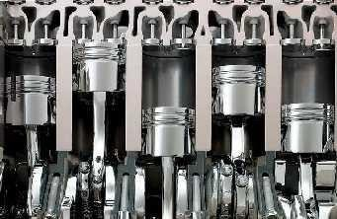
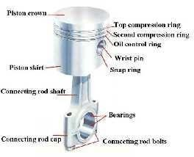
Thepistonmustpossessthefollowingqualities:
- Rigidlytowithstandhighpressure
- Lightinweight,toreducethereciprocatingmasstoperformathigherenginespeed.
- Goodheatconductivity.
- Lessnoisewhileoperating.

Pistonclearance
The piston is usually a small in diameter than the bore of the cylinder. The space between the cylinder and the cylinder wall is called the piston clearance. This piston clearance provides a space for a layer of lubricant between the piston and cylinder wall to reduce friction.
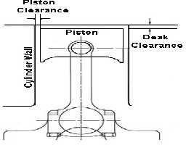
Generally,pistonclearanceis
- 0.025mmto0.100mm.
Properclearanceshouldbemaintainedbetweenthepistonandthecylinderwall.
- Iftheclearance istoo small,there willbea lossofpower fromexcessive friction, more wear, seizingofthe piston in the cylinder.
- If the clearance is too much, piston slap will result. Piston slap means sudden tilting ofthe cylinder as the piston moves down during the power stroke.

It prevents piston seizure due to high temperature. If there is on clearance then it is not possible toreciprocate piston inside the cylinder.
Functionsofpiston:
someoftheimportantfunctionofthepistonasfollows
- Totransmitthepowerdevelopedbyfuelcombustiontothecrankshaftthroughtheconnectingrod.
- Toforma sealsothathigh-pressurecombustiongasesdonotescapetothecrankcase.
- Toserveasa supportforthesmallendoftheconnectingrod.
- Tosuckthechargeandpushouttheexhaustgases.
ConstructionalFeatures:
Thecross-sectionofapistonisshowninthefig.
- Thetopofthepistoniscalledheadorcrown.
- Towards the top of the piston, afew grooves arecut to house the piston rings. The bands left between the grooves are known as lands.
- Thepart ofthe piston belowtheringiscalled Skirt isprovided with bossesontheinsideto supportthepiston pin (Gudgeon pin).
- Thedistancebetweentheaxisofthepistonpinandthetopofthepistoncrowniscalledcompressionheight.
Typeofpistons:
Thevarioustypesofpistonsareclassifieddependingontheshape,design,operation.Theimportanttypesofthe piston as follows.
  - CastPistons
  - Forgedpistons
  - CastSteelPiston
  - BI-metalpiston
  - Two-piecepiston
  - Oil-cooledpistons
  - Anodizedpiston
  - Tinnedpistons
Pistonmaterials:CastIron,Aluminium,Lo-ExAlloy,Invar,Steelalloy.
Protectivecoating:Cadmiumplating,AnodisedPistons,Tinnedpistons,Chromiumplating.

PistonRings
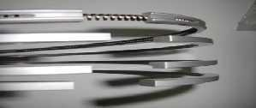
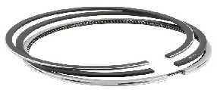
Piston ringsare fittedintothegrooves of the pistonto maintaina good seal betweenthe pistonandthe cylinder wall.Thenumber ofpistonringsused isabout2 to 4 compressionringsand 1 to2 oil controlring wasused but in modern designthe number ifringsusuallythree out of which one isthe oil control ring.
Thefunctionofpistonrings:
- Toformasealforthehighpressuresgasesfromthecombustionchamberenteringintothecrankcase.
- Toprovideeasypassageforheatflowfromthepistoncrowntothecylinderwalls.
- Tomaintain sufficient lubrication oil on cylinder wallsthroughout the entirelengththe piston travel, hence it minimizes the cylinder wear.
Construction:
Figshowedthepistonringconstruction:

- Theringisgenerally castindividuallyand machined carefullysothat when inthepositionitisableto exert uniform pressure against the cylinder walls.
- Agaphasbeencutattheend.
- Inpractice,thepistonringendgapwheninstallediskeptabout0.30to0.35mm.
- Thegapisalmostclosedwhenthepistonisinsidethecylinder,sothatpistonandcylinder. The piston ring end gap may be:
- Butttype
- Tapertype
- Laptype
Materialforpistonrings:
Thematerialgenerallyusedforpistonringsis
- fine-grainedalloycast ironcontainingsiliconandmanganese. It has goodheatandwearsresistingqualities. Chromium plated rings are also used for the top ring, which is subjected to thehighest working temperatures and the corrosive action of the combustion products.
TypesofPistonRings:
Mainlytherearetwotypesofpistonringsasfollows.
- Compression rings:Fig shown a simple sketch of Compression rings. these rings effectively seal the compression pressure and the leakage of the combustion gasses. these are fitted in the top grooves. They also transfer heat from the piston to the cylinder walls.
- Oil control rings: TheFigure showsa simple sketch of oil control ring. The main purpose of the oil ring isto scrape the excess oil from the liner and return it back to the oil sump during the downward and upward movement of the piston. It prevents the oil from reaching the combustion chamber. One of two oil control ringsisusedina piston. Iftworingsareused one has fittedaboveandother is fittedbelowthegudgeonpin inthepistonTheseringsareprovidedwithdrainholesor slots.these slotsallowthe scraped oiltoreachinto the oil sump through the piston holes.
Readalso:PistonRingMaintenance–marineinsight.com

ConnectingRod
Fig showed a connecting Rod. It is fitted in between the piston and crankshaft. The main function of the connecting rod is to convert the reciprocating motion of the piston into the rotary motion if the crankshaft. It must be light and strong enough to withstand stress and twisting forces.
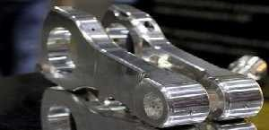
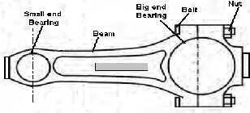
Construction:
- TheconnectingrodusuallyhasI-beamcross-sectionandismadeofalloysteelofduraluminbydrop forging.
- NowadaysitisalsocastfrommalleableorspheroidalgraphiteC.I.
- Thesmallendoftheconnectingrodhaseitherasolideyeusedtoconnectthepistonbythepistonpin.
- Thebigendoftheconnectingrodisalwayssplitisusedtoconnectthecrankpinofthecrankshaft.

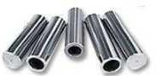
PistonPin
The piston pin isalso called wrist pin or gudgeon pin.Itisused for connectingthe small end ofthe connecting rod and the piston.
Construction:Itismadehollowtoreduceweightanditismadefromcasehardenedsteel. Mainly there are three types of piston pins as follows.
- Setscrewtypespistonpin.
- Semi-floatingpistonpin
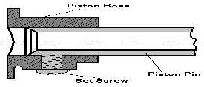
- Fullyfloatingpistonpin
Above Fig shown Set screw type piston pin, This pin is fastened to the piston to the piston by a SET SCREW such that the connecting rod end swivel has required by the combined reciprocating and rotary motion of the piston and crankshaft.

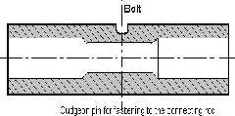
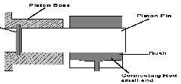AboveFigshowntheSemi-floatingpistonpin,Itisfastenedtotheconnectingrodwithaclampscrew.
Above Fig shown Fully floating piston pin. The pin floats in both the piston bosses and the small end of connectingrod. Itis prevented from comingin contact withthe cylinder wall bytwo circlips.

Crankshafts
Thecrankshaftistheenginecomponent fromwhichthepoweristaken.Itisoneofthemainpowertransmission sources in all engine parts. The Crankshaft is the first part of the power transmission system in which the reciprocating motion ofthepistonis converted intotherotatingmotion with thehelp of connectingrod.
Construction:
- Thecrankshaftismadeofcastingorforgingofheattreatedalloysteelandismachined.
- Acrankshaftconsistsofcrankpins,weds,balancingweightandmainjournalsandoilholes.
- Thebigendoftheconnectingrodisconnectedtothecrankpinofthecrankshaft.

- 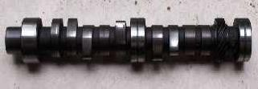Centre to centre distance between thecrankpin and crankshaft is halfofthe piston displacement during the stroke.
Thusonecompleterevolutionofthecrankshaftmakestwostrokesofthepiston.
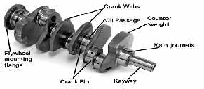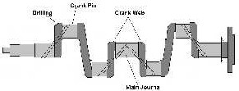
Thepartsofthecrankshaftinsidethemainbearingarecalledmainjournals.
- Balancingweightsareprovidedontheoppositesidewedforbalancing.Thecrankshafthasdrilledoil passagesthrough which oil flowthe mainbearing totheconnecting rod bearings.
Thefrontendofthecrankshaftcarriesthreedevicesthat
- Agearthatdrivesthecamshaft,
- Thevibrationdampertocontroltorsionalvibration,and
- Thefanbeltpulley.Thispulleydrivestheenginefan,waterpump,andgeneratorwithaV-belt.
Therear end of the crankshaft carries flywheel.The flywheel tendstokeep the crankshaftrunningat constant. Next,totherearend,themainjournalandoilsealisfitted.Insomeengine,oilreturnthreadsareprovided which return the lubricating oil to the sump.
Thecrankshaftsaregenerallyoftwotypes,
- Inonepiecetype,allthepartsareintegralandareformedbydropforgingandthenmachining.
- Inbuild-uptype,thecrankpinsandjournalsarefastenedtothecrankwebs.

CamShaft
Acamshaftisashaftonwhichcamsaremounted.Acamisadevicethatchangestherotarymotionofthe camshaft into thelinear motion ofthe follower. A camshaftis responsible for the opening ofthe valves
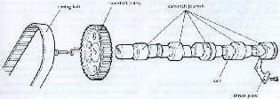
Construction:
- A camshafthas anumberofcams along thelength,twocams foreachcylinder,one tooperate theinletvalveand the other the exhaust valve.
- Inaddition, thecamshaft hasan eccentric to operatethe fuel pumpand gear to drivetheignition distributor and oil pump.
- Thecamshaftisdrivenbythecrankshaft.Thecamshaftgearhastwiceasmanyteethasthegearonthe crankshaft.
- Camshaftmadefromforged alloysteel.This gives1:2gearratio,thecamshaftturns athalfthespeed ofthecrankshaft.
Working:
- Thus, everytwo revolutions ofthecrankshaft produceone revolution othecamshaft andoneopeningandclosing ofeachvalve, in the four-cylinder engine.
- Thus there is correct opening and closing of the valves takes in relation to the position of the piston in the cylinder.
Therearethreetypesofcamshaftdrivemechanismasfollows,
- Geardrive.

- Chaindrive.
- Beltdrive.

Flywheel
Theflywheelusedinatransmissionsystemofavehicle.
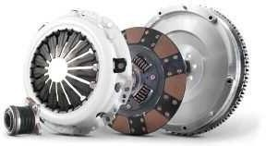
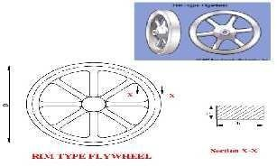
Construction:
- A flywheelisaheavysteelwheelattachedtotherearend ofthecrankshaft.
- Thesizeoftheflywheeldependsuponthenumberofcylindersandtheconstructionoftheengine.
Working:
- Duringthepowerstroketheenginetendstospeedupandduringtheotherstrokes, ittendstoslowdown.
- Theinertia oftheflywheeltendstokeeptherunningofthecrankshaftata constant speed.Hencetheengine speed is maintained constant.

EngineValves
Engine valves are essential to control the timing of air-fuel mixture entry into the cylinder and combustion products out of the cylinders.
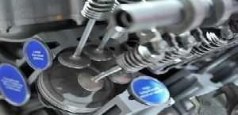
Construction:
- Thesearelocatedattheinletandoutletopeningofthe enginecylinder.
- Thevalvesfitonthevalveseatsintheirclosedposition. There are three types of engine valves as follows,
- Poppetvalve
- Sleevevalve
- Rotaryvalve
Poppetvalve
This is the most widely used valve in automobile engines. The poppet valve is given the name because of its motion of popping up and down.Its constructionis very simple.This isalso calleda mushroom valve, because of its shape.

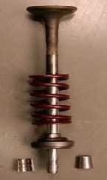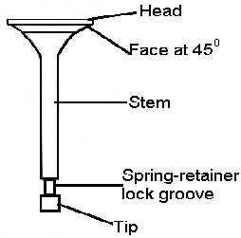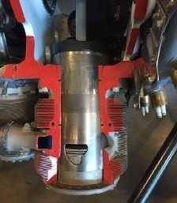
Construction:
    - Itconsistsofaheadandastem.The valve faceusuallywithanangleof30°to45°isgroundperfectly, sinceit has to match with the valve seat for perfect sealing.
    - Thestemhasaspringretainerlockgrooveandthestemendisincontactwithcamforupanddownmovementsofthe valve.

SleeveValve
Thesleevevalveasthenameimplies,thatitisatubeorsleevekeptbetweenthecylinderwallandthepiston.
Construction:
    - Theinnersurfaceofthesleeveactuallyformstheinnercylinderbarrelinwhichthepistonslides.
The sleeve isin continuous motion andadmitsand drives out the gases byvirtue ofthe periodiccoincidenceof port cut inthe sleeve with ports formed throughthe main cylinder casting.
Advantages:
    - Simpleinconstruction.
    - Sleevevalvesaresilentinoperation.
    - Thereisnoisebecausethereisnonoisemakingpartslikevalvecams,rackerarm,tappetsvalvesetc.,
    - Thetendencyofdetonationisless.
    - Coolingisveryeffectiveasthevalveisincontactwithwaterjackets.
Disadvantages:
    - Highoilconsumptionforlubricationasalargerareaofsleevesurfacetobelubricated.
    - Cleaningoftheportsandthevalveiscomplicated.

Rotaryvalve
Fig showed a simple sketch ofRotary Valve. There are many types ofrotary valves. The figure shows the disc type rotary valve. It consists of a rotating disc which has a port. While rotating, it communicates s alternately with the inlet and exhaust manifolds.
Advantages:
    - Rotaryvalvesaresimpleinconstruction.
    - Thesevalvesaremanufacturedatcheapercosts.
    - Theyaresuitableforhigh-speedengines.
    - Stressesandvibrationsarelesscomparedtopoppetandsleevevalves.
    - Theyaresmoothinoperationandareuniformandnoise-freeoperation.
Disadvantages:
    - Itisdifficultiesinpressuresealingbetweentherotarydiscandcylinder.
    - Efficientvalvelubricationisdifficult.

Materialsforvalves:
    - Thematerialsusedforinletandexhaustvalvearegenerallydifferentbecauseofthedifferentoperating conditions to which valves are subjected.
    - Silico-chromesteelisthematerial generallyusedforinletvalves.Forexhaust valvesmolybdenumasadded to the silico-chrome.
    - Therecentmaterialsforexhaustvalveareaustenitesteelandprecipitationhardeningsteelisgenerallyused.

Governor
In petrol engines, the carburettor control both air and fuel supply to the engine cylinder under speed and load conditions. They vary the supply of air-fuel mixture to meet given condition. But in the diesel engine, the governor is used to keep the engine speed within limits.
- Themain functionsof a governor are to regulate the supply of fuelthrough somemechanism so thatthe engine speed remains within its range.
Working:
- Onincreasedload,theenginespeeddecreases.
- Whentheloaddecreases,theenginespeedincreases.
Without a governor, the engine speed increases at lighter loads and the dynamic stresses damage the engine parts. The governor which is set for a particular engine speed operates a mechanism such that more fuel is injected to increase the engine power.
Governor, in this case, operatesthe mechanismtoreduce the supply of fuel in the engine.It is essentialto keep the engine speed within limits.
TypesofGovernor:
- MechanicalGovernororTorquecontrolGovernororCentrifugalgovernor.
- PneumaticGovernor.
- HydraulicGovernor.
Whynotdieselenginesarenotpreferredincommercial?
TimingGears:
- TimingGearsThesegearsdrivethecamshaftfromthecrankshaft.
- Diesel engines, because they have much higher compression ratios (20:1for atypical diesel vs. 8:1for a typical gasoline engine), tendtobe heavier thanan equivalent gasoline engine.
- Dieselenginesalsotendtobemoreexpensive.
- Diesel engines, because of the weight and compression ratio, tend to have lower maximum RPM ranges than gasoline engines .This makes diesel engines high torqueratherthan high horsepower, andthat tendsto make diesel cars slow in terms of acceleration.
- Dieselenginesmustbefuelinjected,andinthepastfuelinjectionwasexpensiveandlessreliable
- Dieselenginestendtoproducemoresmoke.
- Diesel enginesare harderto startin cold weather,and ifthey containglow plugs,diesel engines canrequire you to wait before starting the engine sothe glow plugs can heat up.
- Dieselenginesaremuchnoisierandtendtovibrate.
- Dieselfuelislessreadilyavailablethangasoline Advantages diesel engines:
- The two things working in favor of diesel engines are better fueleconomy and longer engine life. Both of these advantages meanthat, over the life ofthe engine, you willtend to save moneywitha diesel.
- However, youalsohavetotaketheinitialhigh cost oftheengineintoaccount. You havetoownandoperate a diesel engine fora fairlylongtime beforethe fueleconomyovercomestheincreased purchaseprice ofthe engine.
- The equation works great in a big diesel tractor-trailer rig that is running 400 miles every day, but it is not nearly so beneficial in a passenger car

TURBOCHARGER
A Turbocharger is a device that is used to increase the power ofthe engine or one can say efficiency of engine by increasing the amount of air entering into the combustion chamber. More air into the combustion chamber means more amount of fuel will be admitted into the cylinder and asa result one will get more power from the same engine if the turbocharger is installed in it.

TURBOCHARGERANDITSWORKING
  - Many people confuses between the TURBOCHARGER and SUPERCHARGER. The function of the supercharger is same as that of turbocharger but the supercharger is driven mechanically by theengine, often withthe help ofbelt connectedtothe crankshaft, whereasturbochargerispowered bya turbinedriven by the engine‘s exhaust gases.
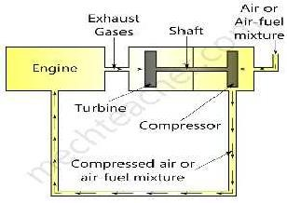
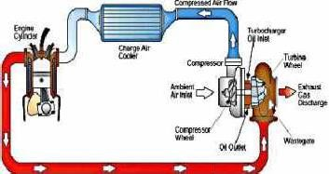
  - Turbocharger is considered more efficient than the superchargers as they are using the wasted energy of exhaust gases for its power source.
OPERATINGPRINCIPLEOFTURBOCHARGER
  - Theamount ofengine thatactually goesinto the engine‘s cylinder ,compared with the theoreticalamount if the engine could maintain the atmospheric pressure ,is called volumetric efficiency and the aim of turbocharger isto improve an engine’s volumetric efficiency by increasing density ofthe intake gas.
  - Theturbocharger‘sdrawstheair fromatmosphereandcompressesitwiththehelpofcentrifugal compressor before it enters into the intake manifold at increased pressure. This results in more amount of air entering into the cylinders on each intake stroke. The centrifugal compressor gets power from the kinetic energy of engine’s exhaust gases.

Theturbochargerhasthreemaincomponents

  - Theturbine,whichisalmostaradialinflowturbine.
  - Thecompressorwhichisalmostacentrifugalcompressor.
  - Thecentrehubrotatingassembly.

WORKINGOFTHETURBOCHARGER
  - Aturbocharger mainly consists of two main sections: the turbine and the compressor. The turbine consists ofturbinewheelandtheturbinehousingwhosepurposeistoguidetheexhaustgasesintotheturbinewheel.
  - The kinetic energy of the exhaust gases gets converted into the mechanical after striking it on turbine blades. The exhaust outlet helps the exhaust gases to get exit from the turbine.

  - The compressorwheelin turbocharger isattached to a turbine with the help ofsteelshaftandasthe turbine turns the compressor wheel, it draws the high-velocity, low pressure air stream and convert it into high- pressure, low –velocity air stream.
  - Coolairenterstheengine'sairintakeandheadstowardthecompressor.
  - Thecompressorfanhelpstosuckairin.
  - Thecompressorsqueezesandheatsuptheincomingairandblowsitoutagain.
  - Hot,compressedairfromthecompressorpassesthroughtheheatexchanger,whichcoolsitdown.
  - Cooled,compressedairentersthecylinder'sairintake.Theextraoxygenhelpstoburn fuelinthecylinderat a faster rate.
  - Sincethecylinderburnsmorefuel,itproducesenergymorequicklyand can sendmorepowertothewheels via the piston, shafts, and gears.
  - Wastegasfromthecylinderexitsthroughtheexhaustoutlet.
  - Thehotexhaustgasesblowingpasttheturbinefanmakeitrotateathighspeed.
  - Thespinningturbineismountedonthesameshaftasthecompressor(shownhereasa paleorangeline).So, as the turbine spins, the compressor spins too.
  - Theexhaustgasleavesthevehicle,wastinglessenergythanitwouldotherwise.

Benefitsofusingaturbocharger
  - Turbochargerincreasesthevolumetricefficiencyoftheengine.
  - Itincreasestheoutputpowerproduced.
  - Itreducestheintakeoffuelorair-fuelmixture.
  - Itallowstheenginetoworksmoothlyinvariousambientconditions.
  - Thekineticenergyofexhaustgasesisfedbacktotheengineandusedbeneficially.

SUPERCHARGER
  - The purpose of the supercharger is to create extra power in the car engine while it is connected to it. The supercharger is a large pump that compresses and forces air into the engine to increase thehorsepower of thevehicle.Car racersuse superchargersintheir vehicles duringraces for faster and better performance.
  - It isan affordable and reliable choice for creating extra horsepower. Though there are many expensive cars available with engines with more horsepower, the use of supercharging is proven to be a cheaper and affordable choice.

TheWorkingofSupercharger
  - When an engine is started, supercharger forces air into the cylinders increasing per minute rotations of the cranks. As rotations increases and the crank begin to spin faster, more air is pushed into the impellers of supercharger creating more power in the engine.
  - This results in complete and efficient combustion of fuel. The mounting of superchargers increases the performance of the engine moreboost being created everytime air is forced bythe supercharger.
  - Goat PerformanceProductshave someof the best and high-class superchargers, which can providea boost tothe engineand make your vehicles behavenothinglessthana supercharged commodore.
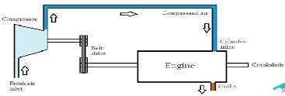

Advantagesofsupercharging:-
  - Higherpoweroutput.Thiswaswholepointofstudying&installingsuperchargers.
  - Reduced smoke from exhaust gases.Theextraairpushedintocylinder,helps the air tocompletecombustleading to lesser smoke generation.
  - Quickeraccelerationofvehicle.Superchargerstartsworkingassoonastheenginestartsrunning.Thiswaythe engine getsa boost even at the beginning leading to quicker acceleration.
  - Cheaperthanturbocharger.
Limitations:-
  - Drawspowerfromengine.Thoughtheoverallmechanicalefficiencyisincreasedbutitconsumespowerfrom the engine.The same job is done bya turbocharger without consuming extra power !
  - Increasedheatgeneration.Theengineshouldhaveproperheatdissipationsystemsaswellasitshouldbeableto withstand thermal stresses !
  - Inducesstress.Theenginemustholdupagainstthehighpressure&biggerexplosionsgeneratedinthe cylinder.Ifthe engineis not designed consideringthese stresses, it maydamage the piston head.

SUPERCHARGERS TURBOCHARGERS
Superchargersarebasically Turbosaredevicesconsistingboth-turbine&a
Extrapoweristobesupplied. Doesn'tneedextrapower.
Theydrawpowerfromengine. Theyextracttheirpowerfromtheexhaustgases.
Theyareconnectedtotheintake Sincetheyareacombinationofturbine&a
Suitableforengineswithsmaller Suitableforengineswithhigherdisplacements.
Superchargersstartworkingas Turboswon'tstartoperatinguntilsufficientamountof
Lessefficient,sinceitdemands Moreefficient,asitdrawsit'spowerfromtheexhaust
Superchargerscostless. Turbosarecostly.
Easymaintenance. Difficulttomaintain,sincelotofheatgetsgenerated&
Nolag,Powerdeliveryis Turbotakestimetospinuptospeed.Hence,there'sa
Greateraccelerationcouldbe Higherspeedscouldbeachieved.

- EXPLAINTHEFOLLOWIGFILTERSBRIEFLY.
- AIRFILTER
- OILFITER
- FUELFILTER
AIRFILTER
- As the air filter is Heart of any Engine Assembly so air filter reduces maximum amount of unwanted air particulars. Which helps to increase the performance of an engine?
- A particulate air filter is a device composed of fibrous materials which removes solid particulates such as dust, mold, and bacteria from the air. A chemical air filter consists of an absorbant or catalyst for the removal ofairborne molecular contaminants suchas volatile organic compounds or ozone.
- Air filters are used in applications where air quality is important, in building ventilation systems and in engines.
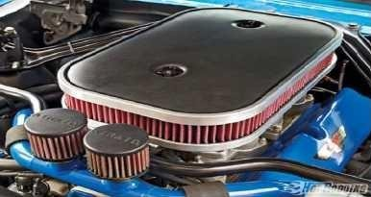
Needforairfilter
- A particulate air filter is a device composed of fibrous materials which removes solid particulates such as dust, mold, and bacteria from the air.
- Achemicalairfilter consistsofanabsorbant orcatalyst fortheremovalofairbornemolecular contaminants such as volatile organic compounds or ozone.
- Airfiltersare usedinapplicationswhereairqualityisimportant,inbuildingventilationsystemsandin engines.

History
- FirstAirfilterfoundedby―NormMcdonald‖In1869whichisusedinfirst―FordEngine
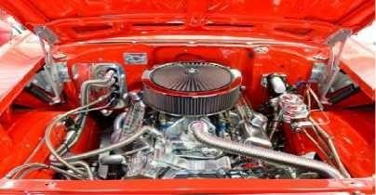

RAWMATERIALS

- Rubber
- Polypropelenematerial
- Wood
- Steel Manufacturing Process
- Paperrolling
- Punching
- Squeezing
- Molding&Pouringrubber
- PaintingwithPaperAssembly
- SprayingLubricant
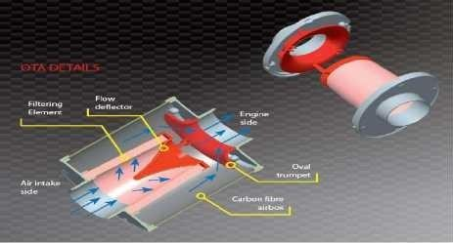
- Finishing
TypesofAirfilters
- FlatFilters.
- RoundFilters.
- OilImprignatedFilters.
- ConicalShaped Advantages
- MaximumEfficiency
- Supplyofturbulent&CleanAir
- AvoidPiston&cylinderwear
- Increasefuelefficiency
- MaximumPerformanceinlessfuelConsumption
- ActasCylinder
- ReducesotherMaintainace
- A normal car engine uses about 100-200 Cu ofair a minute , and a filter is essential to prevent particles of dust or dirt, blocking air jet.

OILFILTER
- removesmostoftheimpuritiesthathavebeenpickedupbytheoilasitiscirculatedthroughtheengine
- Thefilterismountedoutsidetheengineandisdesignedtobereadilyreplaceable Two basic filter element configurations
- thecartridge-type
- thesealedcam-type

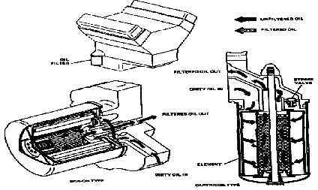

Cartridge-typefilterelementfitsintoapermanentmetalcontainer
- The elementischanged easily by removing the cover fromthe container when this type offilterisused Sealed cam-type filter element is completely self-contained, consisting of an integral metal container and filter element.
- ThistypeoffilterisscrewedontoitsbaseandisremovedbyspinningitofFilterMediumMaterials
- mostpopularautomotivefiltermediums
  - Cottonwaste
  - resin-treatedpaper
- Theyareheldinplacebysandwichingthembetweentwoperforatedmetalsheets
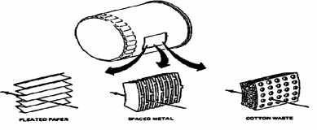
  - layersofmetalthatarethinlyspacedapartforheavy-dutyapplications
Filter System Configurations. Two-filter system configurations
- Thefull-flowsystem
- Bypasssystem.Operation Full-flow system
- Themostpopularincurrentautomotivedesign
- Alloilinafull-flowsystemiscirculatedthroughthefilterbeforeitreachestheengine
- It incorporate a bypass valve in the oil filter to allow the oil to pass through the element in the event it becomes clogged. This will preventthe oil supply from being cut offtothe engine.

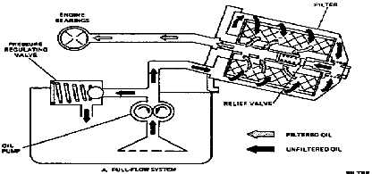
Bypasssystem
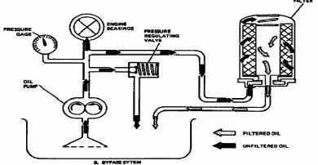
- Divertsonlya smallquantityoftheoileachtimeitiscirculatedandreturnsitdirectlytotheoilpanafter it is filtered.

FUELFILTER
- Afuelfilterisa filterinthefuellinethatscreensoutdirtandrustparticlesfromthefuel.Theyarenormally madeinto cartridges containinga filter paper. Theyare foundin most internal combustion engines
- Fuelfiltersserveavitalfunctionintoday'smodern,tight-toleranceenginefuelsystems.Unfilteredfuelmay containseveralkindsofcontamination,forexamplepaintchipsanddirtthathasbeenknockedintothetank whilefilling, or rust causedby moistureina steel tank.Ifthese substancesarenotremovedbeforethefuel enters the system
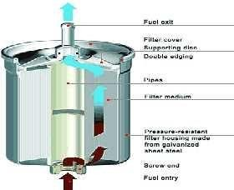

- EXPLAINTHECLASSIFICATIONOFICENGINES.
ClassificationofICEngines:
TheclassificationofICEnginesisasfollows.
- NumberofStrokes
- TypeofIgnition
- BasicEngineDesign
- WorkingCycle
- Fuelused
- MethodofFuelSupply
- MethodofCooling
- CylinderArrangement
- EngineSpeed
- MethodofCharging
- Lubrication
- Applications
DetailedclassificationofICEngines:
TheDetailedclassificationofICEngineswaspresentedbelow.
- NUMBEROFSTROKES:
FOURSTROKEENGINES
Thefourstrokesofa4 strokeenginegobythename– Suction/Intake Stroke :-
  - Inthisstroke,thepiston movesfromTDCtoBDC[(TopDeadCentre–thefarthestpositionofpistontothe crankshaft) to(Bottom Dead Centre– the nearest position of piston tothe crankshaft)].
  - Thepistonmovesdownwardsuckingtheair-fuelmixturefromtheintakevalve.
Keypoints:-
Intake valve – OPEN Exhaustvalve–CLOSED Crankshaftrotation–180°
CompressionStroke:-
  - Here,thepistonmovesfromBDCtoTDCcompressingtheair-fuelmixture.Themomentumofflywheel helps the piston to move upwards.
Keypoints:-
Intake valve – CLOSED Exhaustvalve–CLOSED
Crankshaftrotation–180°(total=360°)
  - PowerStroke:-
  - Thesecondrotationofcrankshafthasbegunasitcompletesonefullrotationduring compression stroke. Powerstrokebeginswiththeexpansionofair-fuelmixtureignitedwiththehelpofspark plug.Here,the piston moves fromTDC to BDC. This stroke produces mechanical work torotatethecrankshaft.
Keypoints:-
Intake valve – CLOSED Exhaustvalve–CLOSED
Crankshaftrotation–180°(total=540°)
  - ExhaustStroke:-
  - AgainthemomentumofflywheelmovesthepistonupfromBDCtoTDCtherebydrivingtheexhaustgases outside through the exhaust valve.
Keypoints:-
Intakevalve–CLOSED

Exhaustvalve–OPEN
Crankshaftrotation–180°(total=720°)

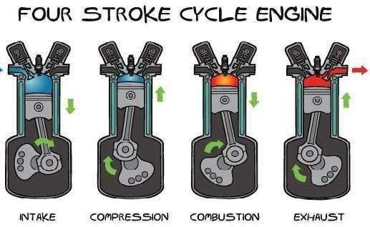
TWOSTROKEENGINES
Workingof2strokeengine:-
DownwardStroke:-
  - FirstthepistonismoveddownsidefromTDCtoBDCtoletthefreshairenterintothecombustionchamber. The fresh air-fuel mixture getsintothe combustionchamber through crankcase. Crankshaft rotation– 180°
UpwardStroke:-
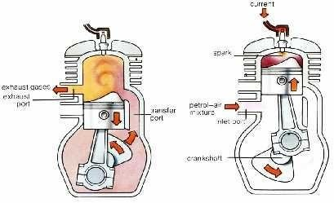
  - Here happens all the magic. The piston is pushed up from BDC to TDC. The fuel-air mixture gets compressed &spark plugignitesthemixture.Asthemixturegetsexpanded, thepiston movesdown.During up stroke, the inlet port is opened. While this inlet port is opened, the mixture gets sucked inside the crankcase. When the mixture is pushed up into the combustion chamber during the previous up stroke, a partial vacuum is created as no mixture is left behind in the crankcase.This mixture is ready to go into the combustion chamber during down stroke but remains in the crankcase until the piston goes up till TDC. Crankshaft rotation – 360°

- BASEDONTYPEOFIGNITION
  - SparkIgnitionEngines:SparkIsGeneratedthroughanExternalSource
  - Compression Ignition Engines: Air Is Heated to a Sufficiently High Temperature Because ofHigh Compression Ratio
ClassificationofICenginesbasedontypeofignition
BatteryIgnitionsystem
In a battery ignition system a battery is used to provide energy for ignition. It is work as storage ofenergy and charged bydynamo, whichis driven byengine.It converts chemical energy to electric energy.
Two types of batteryused in spark ignition system, lead acid battery and alkaline battery. The first one is used in light duty commercial vehicle and the other one is used in heavy duty commercial vehicle. It is housed in primary side of ignition coil.
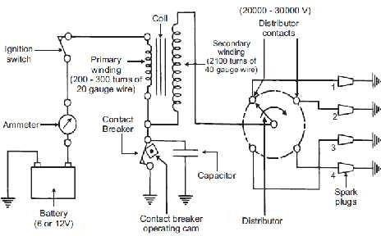
MagnetoIgnitionsystem
A magneto is a small electric generator which is rotate by the engine and is capable of produce a very high voltage and does not need batteryasa source of external energy.
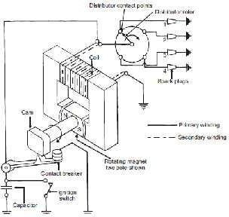
The magneto contains both primary and secondary winding thus it does not require a separate coil to boost up the voltage required to operate the spark plug.

ElectronicIgnitionsystem
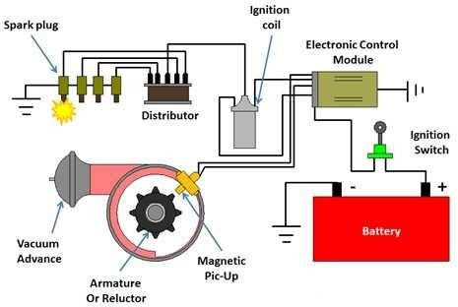

  - Electronicignitionsystemisthetypeofignition systemthatuseselectroniccircuit, usuallybytransistors controlledbysensorstogenerateelectronicpulseswhichinturngenerate.Better sparkthatcaneven burn the lean mixture and provide better economy & lower emission.
- BasicEngineDesign:
  - ReciprocatingEngines
  - RotaryEngines(WankelEngine)
- WorkingCycle:
  - EnginesworkingonOTTOCycle(SIEngines)
  - EnginesworkingonDIESELCycle(CIEngines)
- Fuelused:
  - GasolineorPetrolEngines
  - CompressedNaturalGas(CNG)Engines
  - DieselEngines
- FuelSupply:
  - Carburetedtype-FuelsuppliedthroughCarburetor
  - Injectiontype-Fuelsuppliedthroughinjector.FuelinjectedintothecylinderjustbeforeIgnition.
- MethodofCooling
  - Cooling Is Essential for the Satisfactoryand Healthy WorkingOfthe Engine(Otherwise Results In Engine Seizing)
  - TwoTypesofEngineCoolingInPractice
ClassificationofICenginebasedontypeofcooling
- Aircooledengines
Air-cooledenginesrelyonthecirculationofairdirectlyoverhotpartsofthe enginetocoolthem
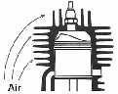.

- Watercooledengines
Water cooling is a method of heat removal from components and industrial equipment. As opposed to air cooling, water isused astheheat conductor. Water cooling is commonly used for cooling internal combustion engines.
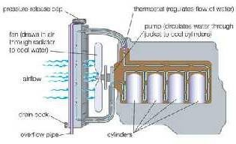
Naturewatercooledsystem(forcedcirculation)
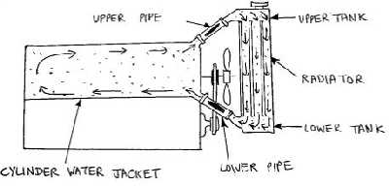
Thermosiphonwatercooledsystem
- TypeOfCylinderArrangements
- V- Engine
- OpposedCylinderEngine
- OpposedPistonEngine
- RadialEngine
- X-typeEngine
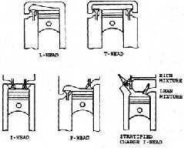
- H-typeEngine

- ClassificationBasedOnEngineSpeed
- LowSpeed–upto500rpm
- MediumSpeed–500to1000rpm
- HighSpeed–above1000rpm
- Classification Based On Method of Charging ClassificationofICenginesbasedonmethodofcharging Naturally aspirated engines
Anaturallyaspiratedengineisaninternalcombustionengineinwhichoxygenintakedependssolely
onatmospheric pressureand does not rely onforced inductionthrough aturbochargeror asupercharger.Many sports cars specifically use naturally aspirated engines to avoid turbo lag.
Superchargedengines
A supercharger is an air compressor that increases the pressure or density of air supplied to an internal combustion engine. This gives each intake cycle of the engine more oxygen, letting it burn more fuel and do more work, thus increasing power.
ClassificationBasedOnlubricationsystem
Thevariouslubricationsystemsusedforlubricatingthevariouspartsofengineareclassifiedas
- Mistlubricationsystem
- Wetsumplubricationsystem,and
- Drysumplubricationsystem. Mist lubrication system:
Mist lubrication systemisa very simple type oflubrication.In this system,the small quantity oflubricating oil (usually2to3%)ismixedwiththefuel(preferablygasoline).Theoilandfuelmixtureisintroducedthroughthe carburetor. The gasoline vaporizedand oil inthe form of mist entersthe cylinder via the crank base.The dropletsofoil strikethe crank base.Thedropletsof oil strikethecrank base, lubricatethemainand connecting rod bearingsand therest of the oil lubricates the piston, piston ringsand cylinder.
The systemis preferredin two stroke engines where crank baselubricationis not required. Ina two-stroke engine,thechargeispartiallycompressedina crank base,soitisnotpossibletohavetheoilinthecrankbase. This systemis simple,low cost and maintenance free becauseit does not requireanyoil pump, filter, etc.
However,ithascertainseriousdisadvantages.Therefore,itisnotpopularamongthelubricationsystem.Its disadvantages are the following:
- Duringcombustionintheengine,somelubricatingoilalsoburntanditcausesheavyexhaustandforms deposits on the piston crown, exhaust port and exhaust system.
- Sincethelubricatingoilcomesincontact withacidicvapoursproducedduringthecombustion,itgets contaminated and may result in the corrosion of the bearings surface.
- Whenthevehicleismovingdownhill,thethrottleisalmostclosed,andtheenginesufferslackof lubrication as supply of fuel is less. It isa veryserious drawback of this system.
- Thereisnocontroloverthesupplyoflubricatingoiltotheengine.Innormaloperatingconditions,the two-stroke engines are always over-oiled. Thus consumption of oil isalso more.
- Thissystemrequiresthoroughmixingofoilandfuelpriortoadmissionintotheengine.Itrequireseither separate mixing or use of some additives.
Wet-sumplubricationsystem:
In the wet-sump lubrication system, the bottom of the crank case contains an oil pan or sump that serves as oil supply, oil storage tank and oil cooler. The oil dripping from the cylinders, bearingsand other parts, fall under gravity back intothe sump, from whereit is pickedup by pumpand recirculatedthroughthe engine lubrication system. There are three varieties in wet-sump lubrication system. They are:
- Splashlubricationsystem
- Splashandpressuresystemand

- Pressurizedlubricationsystem.
SplashlubricationSystem:
Splashlubrication systemisused on small, stationary four-stroke engines.Inthissystem, the cap ofthe big end bearingontheconnectingrodisprovided witha scoopwhichstrikesanddipsintotheoil-filledthroughatevery revolution ofthe crank shaftand oilis splashed all over the interior ofcrank case intothe piston and over the exposed portion of the cylinder is shown in the figure below.
Aholeis drilledthroughtheconnectingrodcapthrough whichtheoilpassestothe bearingsurface.Oil pockets are provided to catch the splashed oil over all the main bearings and also the cam shaft bearings. From these pocketsoil passesto the bearingsthrough drilled hole.The surplusoil dripping from the cylinder flowsback to the oil sump in the crank case.
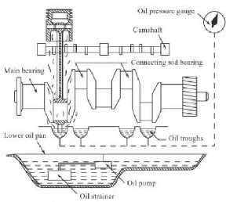
Splashandpressurelubricationsystem:
Splash and pressurelubrication systemiscombination of splash and pressuresystemas shown in below figure. Inthis system,thelubricatingoilissuppliedbya pumpunder pressuretomainandcamshaftbearings.theoilis also directed in the form of spray from nozzle or splashed by a scoop or dipper on the big end to lubricate bearingsat the bigendof theconnectingrod, crank pin, gudgeon pin, piston ringsand cylinder.
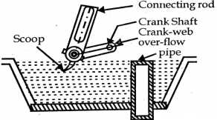
Pressurizedlubricationsystem:
In pressurized lubrication system, thelubricating oil is supplied by a pump under pressureto all partsrequiring lubrication as shown in below figure. The oil under the pressure is supplied to main bearings ofthe crank shaft and camshaft.Holesdrilled through the main crank shaft bearingsjournals, communicateoil to big end bearing and small end bearings through the hole drilled in the connecting rod. a pressure gauge is provided to confirm the circulation of oil to various parts.

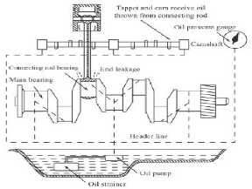
Thissystemprovidessufficientlubricationtoallpartsandisfavouredbymostoftheenginemanufacturers. This is used in most heavy duty and high-speed engines.
Dry-sumplubricationsystem:
In dry-sump lubrication system, the oil supply is carried from an external tank. The oil fromthe sump is pumped by meansofa scavengingpumpthroughfilterstotheexternal storagetank.theoi fromthestoragetank is pumpedto engine cylinder throughand oil cooler.Theoil pressure mayvaryfrom3 to 8 bar.
Thedry-sumplubricationsystemisgenerallyusedforheavy-dutyengines.

- ClassificationBasedOnApplications:
  - Motorcycleengine
  - Automobiles
  - EarthMovers
  - Locomotiveengine
  - Marineengine
  - Aeroengine
  - PrimemoversforElectricGenerator

EXPLAINTHESINGLEPLATECLUTCHWITHNEATSKETCH.
  - Clutch is mechanical device which is used to transmit rotating motion or torque from one shaft to another shaft when required.
  - Clutch providesatemporary connection betweeninputandoutput shaft. Clutch liesbetweentheengineand the gear box.
  - We can easily connect and disconnect the power transmission from one shaft toanother by means ofclutch as we do in automobiles while changing gear we press clutch lever to disengage the shafts andafter change thegear weagain releaselever for engagement.Depending upon thenumberoffriction contact surfacesthe friction clutches as single or multi plate clutches. Here we studyabout single plate clutch.
  - Itisatypeof friction clutch in which poweristransmitted by meansoffriction between thecontact surface usually called clutch plates.
  - Asnamesuggesta clutch consistsofonly one clutch plate with both sidefriction lining (frictional surface). These surfaces have high Coefficient of friction. Single plate clutch also called dry clutch because no lubricant is used as coolant.
Construction:
  - A single plate clutch is consisting of various parts; for proper working. They arearranged in a systematical order. Mainly it consists ofa clutch plate with both side friction lining and some other parts which helpsin the proper functioning of a clutch like flywheel, pressure plate, thrust bearing, hub, springs and input mechanism for engaging and disengaging of clutch.
  - Clutch plate is attached with the hub between flywheel and the pressure plate, it moves axially on driven shaft. In singeplateclutch; clutch plate should havebothsidefrictionliningbecauseit is mountedbetween pressure plate and flywheel, friction isresponsible for the torque transmission.
  - The pressure plate is attached with the flywheel and springs. Pressure plate helps to push the clutch plate towards the flywheel. A lever is attached to thrust bearings with some mechanism on driven shaft which transmits input and output motion from clutch pedal.
  - We candividedifferentpartsofsingleplateclutchasdrivingsidepartsanddriven side parts.Clutchplateis junction between the both sides. In driving side flywheel is attached to engine and driven members are pressure plate, springs, thrust bearings and liver etc.
Followingarethedifferentpartsusedinsingleplateclutch:
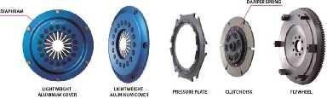

Clutchplate:

  - Insingleplateclutchonlyoneclutchplateisused.Clutchplateismaincomponentofclutches.Itisthindisc typemetallicplatehavingbothsidefrictional surfaces. Frictional surfacesonplatemust beofsuchmaterial to provide friction for transmitting torque without sleeping. The coefficient of friction of contact surfaces should be high for proper connection without slipping. Clutch plate is assembled in between flywheel and pressure plate.
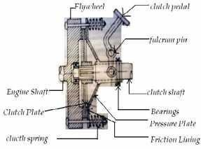
Pressureplate:
  - Thepressureplate which is generally madeup ofcast iron.It helpsinapplyingpressure onclutchplatesto maintainthepropercontactbetweenthesurfacesofflywheelandclutchplatebymeansofspringwhichare attached to it.
Springs:
  - Springsare used to maintain the pressure on pressure plate for proper connection between clutch plate and flywheel and prevent the slipping of contact surfaces.
Flywheel:
  - Flywheelisattachedto engine output andits other side comes in contact with clutch plate when pressure is applied by the pressure plate.
Operatingmechanism:
  - Thisincludes foot pedal, linkage, bearingandlever etc. All thesecomponentsare connectedina sequence. Foot pedal islocated insidetheautomobiles; a lever mechanismisattached with foot pedal which transmit the motion from pedal to spring by means of thrust bearings.
Working:
  - Working of single plate clutch is very simple. A mechanism is responsible for the engagement and disengagement ofclutch. We easily engageand disengagethetorque transmitting shafts just byapply some force on the paddle of automobile.
  - A lever is attachedto the paddle which is responsible for the force transmission from the paddle. When pedalis pressed springis compressedand engineis freeto move withoutanyload.Leverisattachedin such amanner whenwepressthe clutchpaddlethrustbearing movesforwardandpressureplatemovesbackward or it moves away from the flywheel; due to this the connection between the clutch plate and flywheel released and shafts are disengaged. This time we can easily change gearsin case of automobiles. Again if we want to engage the shafts just release the clutch paddle; then springs attached to the pressure plate push the pressure plate forward.

  - Clutch plate is mounted between the pressure plate and flywheel on the hub. Clutch plate has both side friction lining that‘s why it mounted in between pressure plate and flywheel and helps in torque transmission.
Advantages:
  - The working of the single plate clutch is smooth i.e. the engagement and disengagement isvery smooth in operation
  - Less slip occursinit; slip is occurs onlyat the time ofengagement after engagement no slip occursand the functioning becomes very smooth.
  - Powerlossesareveryless.
  - Less heat generates because only single plate is used. Heat generation creates problem inpower transmission and can damage the working parts.
  - Sometimes it works as a safety device and prevent the damage in running parts if input torque/power exceed therequiredtorquethen slipoccursbetweentheclutch plateand contact surfacebecauseit workson a specific range of torque.
  - Singleplateclutcheshavequickoperationandrespondfast.
  - Norequirementofcoolantbecauselessisgeneratedthereforetheyarecalleddryclutches. Disadvantages:
  - Ithaslesstorquetransmittingcapacity
  - Ithasbiggerinsizeevenfortransmittinglesstorque.
  - Itrequireshighmaintenancebecausetheyaredryclutchesanditisnecessarytopreventthemfrom moisture or any leakage of lubricant/oil in machinery.
  - Singleplateclutcheshavehighwearandtearrateandhavelesssmoothengagement.
Applications:
  - Theseareusedinlargesizeautomobileswhereradialspaceisnotconstrainsuchastrucksandcars.
  - Thisisallaboutsingleplateclutchworkinganditsparts.Ifyouhaveanyqueryregardingthisarticle,ask by commenting. If you like this article, don‘t forget to share it on social networks. Subscribe our website for more informative articles. Thanks for reading it.

EXPLAINTHEMULTI-PLATECLUTCHWITHNEATSKETCH.
  - From 2 wheeler like bike to 4 wheeler like cars we often hear the term ―Clutch‖ whenever we talk about gears or gear shiftinginanautomobile,as weknow to shiftthe drive from hightorque to highspeed or vice versa weneedto presstheclutchpedalthanonlythe gear shift becomespossiblebutthequestionarise what doesthisclutchdo?Whyitissoimportantpartofanautomobilevehicle?Thebasicansweris―Aclutchisa device that is used to transmit fluctuating rotation between 2 shafts‖ but how it is done? Still remains unanswered let‘s find out the answer by discussing the Multi-plate clutch, A type of clutch used in many vintage cars and in bikes.
  - A multi-plate clutch isa type of clutch in which the multiple clutch plates are used to make frictional contact with the flywheel of the engine in order to transmit power between the engine shaft and the transmission shaft of an automobile vehicle.
  - Amulti-plateclutchisusedinautomobilesandinmachinerywherehightorqueoutputisrequired.
  - In bikes and scooter multi-plate clutch is used due to the limitation of compact gearbox used in bikes and scooter.

WhatistheNeedofaMulti-PlateClutch?
  - As we know a clutch is the most important integral part ofa power train as it is used to transmit the power from engine shafttothe transmission shaft for further shiftingthe drive torequiredtorque or speed output.
  - Where there is a need of high torque output like in pick-up truck, a single plate clutch fails to provide that much frictional force(between flywheeland clutch plates) thatisrequired to providesuch ahigh torque, so in heavy vehicle like pickup trucks multi-plate clutches are used.
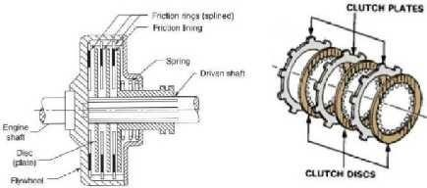

MainPartsoftheMultiPlateClutch
    - The main components of all the clutches used in automobile vehicle are almost same but with some modifications, so let‘s discuss the main parts of differenttypes of multi-plate clutchesused.
SpringTypeMulti-PlateClutch
- PressurePlate
  - A plate attached to the splined sleeves which are further attached to the pedal fulcrum such that when the clutch pedal is pressed, the sleeves attached to the pedal fulcrum moves outwardwhich in turn moves the pressure plate attached with this splined sleeve.
  - This pressure plate used in clutch applies pressure over the clutch plates with the help of thrust springs that helpsthe pressureplate to maintain its frictional contact with the clutch plates.
- ClutchPlate
  - Theinner frictional surface of the clutch plate makes contact with the flywheel and the outer frictional surfacemakesfrictionalcontactwiththepressureplatewhosemovementisoperatedbytheclutchpedal.
  - In multi-plate clutchmultiple clutch plates are used inwhichnumber of clutch plates are placed over each other whichinturn increases the frictional force required for engagement ofthe clutch.
- ThrustSprings
  - These are the springs used behind the pressure plate and the stiffness of these springs is used by the pressure plate to maintain the frictional contact with the clutch plates which in turn maintain the clutch engagement.
  - Numbersofthrustspringsareplacedovertheoutersurfaceofthepressureplateincircularfashion.
  - The force applied by the driver over the clutch pedal istransferred to these thrust springs which in turn causes movement of these springs and the disengagement ofthe clutch occurs.
- ClutchPedal

  - A clutch pedal operated by the driver of the vehicle is used to control the engagementand disengagement of the clutch.
  - When the clutch pedal is pressed the fulcrum attached with its inner end rotates which in turn causes movement in the splined sleeves through which the pressure plate attached and with this movement of splined sleeve disengagement of the clutch occurs.
- SplinedShaft&InnerSplinedSleeves
  - A outer splined transmission input shaft isused over which the complete clutch assemblythat includes clutch plates,pressureplate ,inner splined sleeve , clutch casingis placedandrotates withit.
  - The inner splined sleeve which isattached to the pressure plate in multi-plate clutch,The movement of this sleeve is controlled by the clutch pedal.
  - Thetoandfromovementofthisinnersplinedsleevecausesengagementanddisengagementofthe clutch.
- Flywheel
  - Though this is the part of the engine but we can also consider it as a part of clutch system as the transmission of power from engine output shaft to the transmission shaft is obtained by the frictional contact between the clutch and the flywheel of the engine.
DiaphragmClutch
  - Allthe parts of the diaphragm clutchand the spring type clutch is same but the modification is made in thespringused for engagement and disengagement oftheclutch. Let‘s discussabout it.
- DiaphragmSpring
  - In diaphragm type clutch system the thrust springsused in spring type clutch isreplaced with a special diaphragm type springs.
  - Thisdiaphragmspringisa circular springhavingnumber offingerslike finsat itscentral surfacewhich looks like a inflated diaphragm.
  - Duringengagement thesefingerlike finsofthediaphragmspringremainsintheinflatedshapewhichin turnappliespressureoverthepressureplateandmaintainthefrictioncontactbetweenthepressureplate, clutch plates, and flywheel respectively.
  - Whentheclutchpedalispressedthesefingerlikefinsofthediaphragmspringmovesjustlikeadeflated diaphragm which in turn removes the pressure over the pressure plate and disengagement of the clutch occur.
HydraulicorAutomaticMulti-plateClutch
  - All the component of the hydraulic type multi-plate clutch is almost same as the diaphragm clutch but the modification is made in its operation that is.
  - In this type of clutch the engagement and disengagement of the clutch is controlled by the hydraulic device (eg- torque converter) controlled with the accelerator pedal and is coupled with the diaphragm type multi-plate clutch.
  - Noclutchpedalisrequiredinthistypeofmulti-plateclutch. Working
  - Theworkingofthemulti-plateclutchcanbebestunderstoodbydiscussingthesimplespringtypemulti-
plate clutch Engagement of Clutch

  - Duringtheengaged stateoftheclutchi.e.whentheclutchpedalisnot pressed,Thethrustspringsdo not move due to whichthe stiffnessprovided bythese springs maintainsthe pressure overthepressureplate having friction lines on its inner surface.
  - Duetothispressureoverthepressuresurfacethefrictional contact between thefriction linesofpressure plateandthe frictionlinesofmultipleclutchplatesismaintained dueto which frictional forceisapplied over the flywheel.
  - Due to this frictional force the frictional contact between the multiple clutch plates and the flywheel is maintained which in turn finally provides clutch engagement.
DisengagementofClutch
  - Whenthe clutchpedalispressedthefulcrumattachedatitsinnerendrotatesdue whichtheinnersplined sleeve through which the pressure plate is attached moves outward which in turn applies pressure over the thrust springs.
  - Due to this force the thrust springs moves which in turn release pressure over the pressure plate and finallythe frictional force between pressureplate, clutchplate andthe flywheel is removed.
  - Duetothisremovalofthefrictional force, frictional contact betweenthepressureplate, clutchplateand flywheel breaksand finally the disengagement of the clutch is obtained.
  - Indiaphragmtype multi-plateclutchallthe workingisalmostsamethelittledifferenceisthatinsteadof thrust springs, diaphragm springisused for engagement anddis engagement ofthe clutch.
  - In automatic type multi-plate clutch the working differs as the operation of engagement and disengagement of the clutch is made automatic through the hydraulic device operated with the accelerator pedal which is coupled withthe diaphragm type multi-plate clutch.
Advantages
  - Increasedtorquetransmissioncapacity.
  - Highlyreliable.
  - Suitableforheavyvehicles.

EXPLAINTHECONECLUTCHWITHNEATSKETCH.
  - The development of a family starts with a old grandfather‖ very rightly said as with the introduction of the transmission in an automobile vehicle, development of a device that can transfer fluctuating power (rotational motion) between 2 shafts became essential due to which various researches had been done and finally the engineering minds ofthat era came up with a system which is known as Clutch or more specifically a Cone clutch.
  - The modern clutches we use today in vehicle are the progeny (descendent) of the cone clutch. The continuous modification in this field has led us to the developmentof the modern automatic clutch which is the boom in the automobile industry. So let‘s know more about the great grandfather of the clutches i.e. cone clutch.
  - Aconeclutch―oldestofall‖Isatypeofclutchsysteminwhichtwomatingmembersknownasthemale member and the female member designed in shape of cones are used, due to the mating of these 2 members frictional force due to the frictional contact between them is generated results in torque or power transmission between them.
  - Theengagement anddisengagement ofthe maleand female member ofthe cone clutchis controlledby the clutch pedal.

  - Due to the large frictional area of contact and also due to the cone like shape of the male and female member of the cone clutch, This clutch system transmit high torque between the engine and the transmission shaft dueto whichit was widely used inheavy vehicles.
NeedofaConeClutch
  - As the clutch system is responsible for the torque or power transmission between the engine and the transmission shafts which makesittheone ofthe most important part ofanautomobile vehicle.
  - Thisgivesrisetothedevelopmentoftheconeclutch,soweneedconeclutchesbecause-
  - Engine has its limitation to give a certain amount of torque and speed due to which a transmission was introducedand coupled with the engine shaft for this coupling between2 shafts i.e. engine shaftandthe transmission shaft cone clutch was used which made it possible to obtain different torque and speed ratios by connecting and disconnecting the above 2 shafts.
  - Duetothehighfrictional forceofcontactandduetothecompleteinterlockingbetweenthemaleandthe female member of the cone clutch, this clutch enables high torque transmission, even higher than the single plate clutch.
  - In cone clutch ,The efforts need tokeep the clutchengaged withthe flywheel oftheengineislessasthe small axial force is required for engagement of the clutch, that is why they had been used in wide applications where high torque was the first priority.
  - Due to its simple design as compared to other types of clutches which made it cost effective, they were widely used in small industries.
  - As they provides high torque which is the need of some low speed off road vehicles specially off road all terrain vehicles, theyare still usedin some motor sporting off road vehicles.
  - Due to their proper interlocking between female and the male clutch , cone clutchesare used in various manual transmissions as a synchronisers.
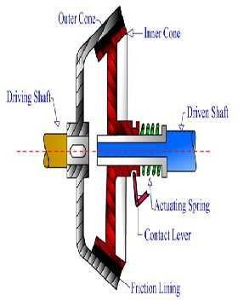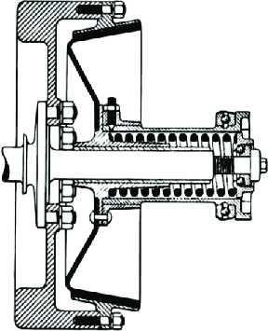

MainComponents
  - Female Cone- It is the part of a cone which is connected to the flywheel of the engine and also rotates with it, this cone is having inner cutting cone shaped groove over which the male cone interlocks and make frictional contact with it in order to engage the drive.
  - Male Cone-It is the part ofa cone clutch which is connected to the transmission shaft and is machined in the shape ofa solid cone over which frictional material isattached.When the clutch pedal isreleased, Male cone makes contact with the female cone due to the spring action provided by the released spring behind it and the engagement of the drive takes place.
  - Spring – Normal thrust spring located behind the maleconeisused for engagement and disengagement of the clutch. When the clutch pedal is pressed, thrust spring compresses and the disengagement of the clutch takes placeand thereleasing of clutch pedal expandsthisspring due to which engagement ofthe clutch takes place.
  - Shafts- The female cone which is directly attached to the flywheel is mounted over a solid shaft. The male cone on the other handis mounted over the splined shaft.
  - Sleeves- Sleeves having inner splines attached to the male cone mounted over the splined shaft is used for the to and fro motion of the male cone.
  - Pedal– A clutch pedal operated by the driver is used for input regarding the engagement and the disengagement of the clutch. When the pedal is pressed, The pedal effort is transferred to themale clutch through the fulcrum attached at its other end which in turn compresses the spring and disengagement of the clutch takes place.
  - Flywheel- It is the part of the engine used to store the engine output it can be considered the part of a clutch system as the female cone oftheconeclutchis attachedtothe flywheel and rotates with it.
WorkingofConeClutch Engagement
  - When the clutch pedal is released the fulcrum attached to the other end of the pedal rotates and pushes the attached sleeve through which the male cone isattached outwards,which in turn interlocksor make contact withthe female clutchand finallythe engagement ofthe clutch takes place.
  - The stiffness provided by the thrust spring mounted behind the male clutch is used for continuous engagement of the clutch.
Disengagement
  - When thedriverpressesthepedalinordertochangegearthefulcrum attachedrotateswhich inturn pullsthe outer sleeve along with the male clutch attached to it.
  - Due to thispullaction provided by theclutchpedal,the thrustspringmountedbehind themale cone compresses and finallythe disengagement ofthe clutch takes place.
Application
  - Aleather-doubleconeclutchwasusedinMercedes37/90PSin1914.
  - MercedesGrandPrixRennwagenuseddoubleconeclutchin1914.
  - Coneclutchesareusedinvariousmanualtransmissionsassynchronisers.
  - Theyareusedinvariousheavymachines. Advantages
  - Normalforce acting on the contactsurface is largerthan the axialforce reduces the effortrequired to operate the clutch.

Disadvantages
  - A small amount of wearon cone surface results in considerable axial movementof the male conefor which it will be difficult to allow

EXPLAINTHECENTRIFUGALCLUTCHANDSEMI-CENTRIFUGALCLUTCHWITHNEAT SKETCH.
CENTRIFUGALCLUTCH
  - CentrifugalClutchistype ofclutch in which centrifugal forceisusedto connect engine drive shaft with the shaft oftransmission. It is placed in between the engine flywheel and transmission system. Its main function is to connect the engine shaft with the transmission shaft. It works more efficiently at higher speeds.

MainParts
Themainpartsofcentrifugalclutchare
  - Shoes:The shoes are of sliding types which slides in the guide ways. It consists offriction lining atthe endand this friction lining makes contact with the drum during engagement.
  - Spring:Springisusedtodisengagetheclutchwhentheenginerotatesatlower speed.
  - Spider or guides: The spiders are mounted on the driver (engine) shaft or motor shaft. The spiders are equally spaced. Equally spaced means, if they are four guides than each guide is separated from each other by 90 degree. The sliding shoes are kept in between these guides and each guide is holding a spring.
  - Friction lining: The outer surface of sliding shoes has friction lining. It helps in making grip with the inner surface of the drum.
  - Drum: The drum of the clutch act as housing which encloses all the parts of the clutch that includes slidingshoes, guides, springs etc.Itisconnectedtothedrivenshaftofthetransmissionsystemor chains or belt.

WorkingPrinciple
  - Itsworkingistotallydependsuponthecentrifugalforcecreatedbythedrivingmember(engineor motor).
  - Thecentrifugalforceisusedtoengagetheclutchwithdrivenshaft.Astheenginestartsrotating,it produces a centrifugal force which makesthe sliding shoesto move outward.
  - Thefrictionliningoftheshoesgetsconnectedtotheinnersurfaceofthedrumanditstartsmoving.
  - Sincethe drum is connected tothedriven shaft, so the power is transmitted from the engine shaft to the transmission shaft and finally to the load.
WorkingofCentrifugalClutch
  - As the engine rotates, the inside assembly of the centrifugal clutch starts rotating but drum remains stationaryandnopoweristransmitted.Atlowerspeed,thecentrifugal forceproducedisnotsufficientto overcome the spring force.So the clutchremains disengaged.Butasthe speed increases,the centrifugal force also increasesand nowthe centrifugal force becomes greater than the spring force.
  - As the centrifugal force becomes greater that the spring force, this allows the sliding shoes to move outward against the spring and get engaged with theinner surface ofthe drum.

  - Thedrumstartsrotatingandtransfertherotatingpowerfromtheenginetothedrivenshaftofthe transmission.
  - Whentheloadontheengineincreases,itsspeeddecreasesanddisengagestheclutch.
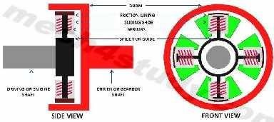
Advantages
- Itissimpleandrequireslessmaintenance.
- Itisinexpensive.
- Sinceitisautomatic,soitdoesnotneednecessarycontrol mechanism.
- Itsengagementspeedcanbecontrolledbyselectingappropriatespring.
- Ithelpstopreventtheenginefromstalling. Disadvantages
- Thereisalossofpower initduetoslippingandfriction.
- Itisnotcapableoftransferringhighamountofpoweranditshoesslipinheavyloadcondition.
- Itexperiencesoverheatingproblem.
- Itsengagementdependsuponthespeedofthedrivingshaft.
Application
- Centrifugal clutch is mainly used in lawn movers, mopeds, go karts, mini bikes, chainsaws etc. Itis also used in some paramotors and boats to keep the engine running during stalling and disengage loads during starting and idling.
- IfyoufindthisarticleinformativeandusefulthanshareandlikeitonFacebook

SEMI-CENTRIFUGALCLUTCH:-
- A semi centrifugalclutch is used to transmit power from high powered engines and racing car engines where clutch disengagements requires appreciable and tiresome drivers effort.
- The transmission of power in such clutches is partly by clutch springs and rest by centrifugal action of an extra weight provided in system.Theclutch springsserveto transmit thetorqueup to normal speeds, while the centrifugal force assists at speeds higher than normal.
- Besidesclutch,pressureplateandsplinesshaftitmainlyconsistsof:
  - Compressionspring(3numbers)
  - Weightedlevers(3numbers)

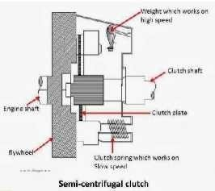
- At normal speeds when the power transmission is low the spring keeps the clutch engaged, the weighted levers do not have any pressure on the pressure plate. At high speed, when the power transmission is high the weights fly off and levers exert pressure onthe plate which keeps the clutch firmly engaged. Thus instead ofhaving more stiffspringsforkeepingthe clutch engaged firmlyathigh speeds, theyarelessstiff, so that the driver may not get any strain in operating the clutch.
- When the speed decreases, the weights fall and the levers do not exert any pressure on the pressure plate. Onlythe spring pressure is exerted on the pressure plate whichis sufficient tokeeptheclutch engaged.

EXPLAINTHETORQUECONVERTERWITHSUITABLESKETCH.
  - A torque converter is a type of fluid coupling which isused totransfer rotating power from the engine of a vehicle to thetransmission. It takesplace of mechanical clutch inanautomatic transmission.
  - Themain functionofit is toallowtheloadtobeisolatedfromthemainpower source. It sitsinbetweenthe engineand transmission. It has the same function as the clutch in manual transmission.
  - As the clutchseparates the engine from the load when itstops, in the same way it also isolates the engine from load and keep engine running when vehicle stops.
Itsmainfunctionsare:
  - Ittransfersthepowerfromenginetothetransmissioninputshaft.
  - Itdrivesthefrontpumpofthetransmission.
  - Itisolatestheenginefromtheloadwhenthevehicleisstationary.
  - Itmultipliesthetorqueoftheengineandtransmitsittothetransmission.Italmostdoublestheoutput torque.
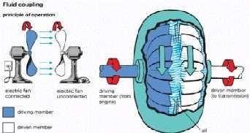
WorkingPrinciple

  - Forunderstandingtheworkingprincipleoftorqueconverter,let‘staketwofans.Onefanisconnectedtothe power sourceand other is not connected with power source. When first fan connected to the power source starts moving, theair from it flows to the second fan which is stationary.
  - Theair fromthe first fanstrikesonthe bladesofthe second fananditalsostartsrotatingalmostatthe same speed to the first one. When the second fan is stopped, it does not stop the first one. The first fan keeps rotating.
  - On the same principle the torque converter works. In that the impeller or pump acts as first fan which is connectedtothe engineandturbineactas the second fan whichis connected tothetransmission system.
  - When the engine runs, it rotates the impeller and due to the centrifugal force the oil inside the torque converter assembly directed towards the turbine. As it hits turbine blades, the turbine starts rotating. This makes the transmission system rotate and the wheels of the vehicle moves. When engine stops, the turbine also stops rotating but the impeller connected the engine keeps moving and this prevent thekilling of engine.
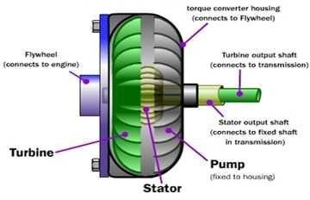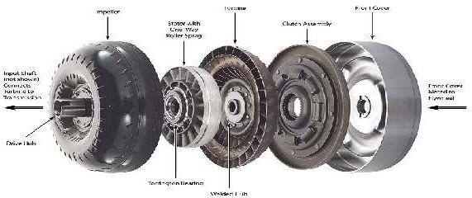MainParts
Thetorqueconverterhasthreemainparts
- ImpellerorPump
  - The impeller is connected to the housing and the housing connected to the engine shaft. It has curved and angled vanes. It rotates with the engine speed and consists of automatic transmission fluid. When it rotates with the engine, the centrifugal force makes the fluid moveoutward.

  - The blades of the impeller are designed in such a way that it directs the fluid towards the turbine blades. It actsascentrifugal pumpwhichsucksthefluidfromtheautomatictransmissionanddeliversittotheturbine.
- Stator
  - The statorislocatedin betweentheimpellerandturbine.The main function ofthe stator isto givedirection tothereturning fluid from theturbine, so that the fluid enterstotheimpeller inthedirection ofits rotation.
  - As the fluid enters in the direction of the impeller, it multiplies the torque. So stator helps in the torque multiplication by changing the direction of the fluid and allows it to enter in the direction of the impeller rotation.
  - Thestator changesthedirectionoffluidalmostupto90degree.Thestatorismountedwithaoneway clutch thatallows rotatingitin one directionand preventing its rotation in other direction.Turbine is connected to thetransmission system ofthe vehicle. Andthe stator is placed in between the impeller andturbine.
- Turbine
  - Turbine is connected to the input shaft ofthe automatic transmission. It ispresent at the engine side. It also consistsofcurvedandangledblades.Thebladesoftheturbineare designed insucha waythatitcanchange the direction of the fluid completely that strikes on its blades.
  - Itisthe changeinthedirectionofthefluidthatforcesthebladesto movein thedirectionoftheimpeller. As theturbinerotatesthe input shaftofthetransmissionalsorotatesandmadethe vehicleto move.The turbine is also has a lock up clutch at its back.
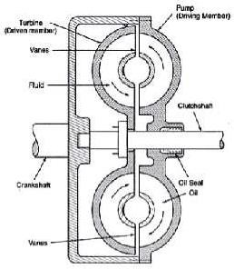
  - The lock up clutch comes into play when the torque converter achieves coupling point. The lockup eliminates the loses and improves the efficiency of the converter.

➢

WorkingofTorqueConverter
Ithasthreestagesofoperations
  - Stall: During stall (stop) conditionof the vehicle, the engine is applying power to the impeller but the turbine cannot rotate. This happens, when the vehicle is stationary and driver haskept his foot on the brake paddle to prevent it from moving. During this condition maximum multiplication of torque takesplace. As thedriverremovesitsfootfromthebrakepaddleandpressestheacceleratorpaddle,theimpellerstarts

moving faster and this set the turbine to move. At this situation, there is a larger difference between the pumpand turbine speed. The impeller speedis much greater than the turbine speed.
  - Acceleration: During acceleration, the turbine speed keeps on increasing, but still there is large difference between the impeller and turbine speed. As the speed of the turbine increases the torque multiplication reduces.Duringacceleration ofthe vehiclethetorque multiplicationislessthanthatisachievedduring stall condition.
  - Coupling:Itisa situation whentheturbineachievedapproximately90 percentspeedoftheimpellerandthis point is called coupling point. The torque multiplication seizes and becomes zero and the torque converter behavesjust like a simple fluid coupling. At the coupling point the lock up clutch come into play and locks theturbine to theimpeller ofthe converter.Thisputs theturbineandimpeller to move with the same speed. Lock up clutch engages only when coupling point is achieved. During coupling the stator also starts to rotate in the direction of the impeller and turbine rotation.
Note:
  - Themaximumtorquemultiplicationtakesplaceduringstallingcondition.
  - The stator remains stationary before coupling point and helps in the torque multiplication. Asthe coupling attained, stator stops torque multiplicationand startsrotating with the impeller andturbine.
  - Lockup clutchengageswhencouplingpointisachievedandremovesthe powerlossesresultingin increased efficiency.
Advantages
  - Itproducesthemaximumtorqueascomparedwiththevehicleequipped withclutch.
  - Itremovestheclutchpedal.
  - Itmakesthejobofdrivingavehicleeasier. Disadvantages
  - Itsfuelefficiencyislowascomparedwiththevehiclewithmanualtransmission. Application
  - Thetorqueconverterisusedinthevehiclethatisequippedwiththeautomatictransmission.Itisalsoused
inindustrial powertransmissionsuchasconveyer drives,winches,drillingrigs,almostall modern forklifts, construction equipment, and railway locomotives.
  - Itisusedinmarinepropulsionsystems.

EXPLAINTHEFLUIDCOUPLINGWITHSUITABLESKETCH.
  - Fluid coupling is also known as hydraulic coupling is a hydrodynamic device which is used to transfer rotational power from one shaft to another by the use of transmission fluid. It is used in automotive transmission system, marine propulsion system and in industries for power transmission. It is used as an alternative for the mechanical clutch.
  - It was discovered by Dr. Hermann Fottinger. He patented his discovery of fluid coupling and torque converter in the year 1950.
MainParts
Itconsistsofthreemaincomponents
  - Housing:Itisalsoknownastheshell.Ithasoil-tight sealaroundthedriveshaft.Italsoprotectstheimpeller and turbine from outside damage.

  - Impeller or pump:It is a turbine which is connected to the input shaft and called as impeller. It is also known as pump because it acts as a centrifugal pump.
  - Turbine:It isconnectedtotheoutputshafttowhichtherotationalpoweristobetransmitted.
  - The impeller is connected to the prime mover (internal combustion engine) which is a power source. The turbine isconnected to the output shaft where rotation power is needed to be transmitted. The impeller and turbine is enclosed in an oil-tight sealed housing. The housing consists of transmission fluid.

WorkingPrinciple
  - The working principle of fluid can be easily explained by the taking two fans in which one is connected to the power supply and other is not.
  - When the powerswitch is ON, the air from the first fan is starts to blow towards the second fan (which is not connected to the power source).
  - Initially when the first fan is blowing at lower speed, it does not able to drive the second fan. But as the speed of the powered fan increases, the speed of air striking the blades of second fan also increases and it starts to rotate.
  - After sometimeitacquiresthesamevelocityofthatofthefirst fan.Onthesameprinciplethefluidcoupling works. In that the impeller act as first fan and the turbine act as second fan. Both impeller and turbine enclosed in an oil tight housing.
  - Theimpellerisconnectedtheinput shaftoftheprimemoverandtheturbinewiththeoutputshaft.Whenthe impeller ismoved by the primemover, the fluid in housing experiencescentrifugal forceand dueto curved vanes ofthe impeller the fluid directed towards the turbine blades.
  - As the fluid strikes the turbine blades it starts rotating. With the increase in the speed of impeller, the velocity of the turbine increases and becomes approximately equal to the impeller speed. The fluid after passing through the turbine blades again return to the impeller.
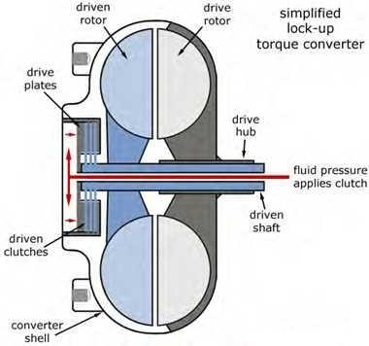

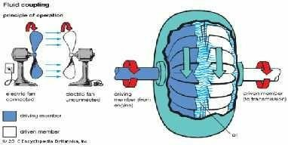

WorkingofFluidCoupling
  - As the prime mover moves, it rotates the impeller of the coupling. The impeller acts as a centrifugal pump and throwsthe fluid outward and directsit towards the turbine blade.
  - As the high moving fluid strikes the turbine blades, it also starts rotating, after striking on the blades, the direction of the fluid is changed and it is directed towards the impeller again. The blades of turbine are designed in such a way that it can easily change the direction ofthe fluid. It is the changing ofdirection of the fluid that makes the turbine to rotate.
  - As the impeller speed increases, the speed of the turbine also increases. After sometime the speed of both impellerandturbinebecomesequal.Inthiswaypoweristransmittedfromone shafttoanotherbytheuseof fluid coupling.
  - In same way torque converter works but the difference is that it has stator placed in between impeller and turbine for torque multiplication.
Application
  - Itisused in automotiveindustries forthe transmission ofpower from the engineto the wheelas alternative of clutch.
  - Itisusedinmarinepropulsionsystems.
  - Itisusedinvariousindustriesforthepowertransmission.

EXPLAINTHEWORKINGOFSLIDINGMESHGEARBOXWITHNEATSKETCH.
  - ―Oldisgold‖ veryrightlysaidaswhenit comestoanautomobileoldinventionsarethesourceofimproved technologywhichweare usingtoday.One ofthose inventionsisSliding mesh gearbox which gave risetoa very essential system of an automobile i.e. transmission system or gearbox. But from where did the idea come from? How does it work? Let‘s just find out.
  - The idea of a transmission system is given by French inventors Louis-Rene and Emile Levassor who invented the world‘s first ever transmission system with 3-speed sliding mesh transmission in 1894 which was the boom in the automobile industry.
  - Sliding mesh gearbox is a transmission system that consists of various sets of gears and shafts that are arranged together in an organised fashion and the shifting or meshing ofdifferent gear ratiosisdone by the sliding of gears towards right and left over the splined shaft with the help of a gear lever operated by the driver.

NeedofSlidingMeshTransmission
  - Introduction of an IC engine had led to the introduction of an automobile that was the replacement of the horse carriage which was used as the travelling medium by the people in early 18th century, but still the automobilewaslackingbehind whenit cameto facethechallenges(turns, elevations, roughnessetc.) given by the the roads as there was no such mechanism fitted in early vehicles that could provide different torque and speed ratios as demanded by the road conditions.
  - In 1894 the first transmission system named Sliding mesh transmission system was introduced which was designed to provide different speed andtorqueratios to overcome thoseroad challenges.
Thevariousproblemsolvedbythistypesofgearboxare-
  - Fuelconsumptionofanautomobileincreasedastheloadontheengineisdecreasedorsharedbythe intermediate system known as sliding mesh gearbox.
  - Due to the varying torque ratios provided bythis gearbox, the automobile vehicle is made to go to the hill stations which was not possible earlier.
  - Time taken to reach the destination was decreased as overall speed ofthe vehicleincreased due to the high speed ratios provided by it.
  - Reverseofthecarmadepossiblewiththeintroductionofthistransmissionsystem.
  - Jamming of vehicle due to the rough road conditions was solved after the introduction of the sliding mesh gear box.

ComponentsofaSlidingMeshGearbox
- Shafts–Slidingmeshgearboxconsistsof3shaftsthatare-
  - Main shaft- It is the shaft used as an output shaft in a sliding-mesh over which the sets of gears with internally splined grooves are arranged in an organised fashion. The outer surface of this shaft is made splined sothatthe gears can easilyslide over this shaftin order to mesh with theappropriate gear.
  - Clutch shaft- It is the shaft that is used to carry engine output to the transmission box with the help of engaginganddisengagingclutchwhichismountingattheengineend,gearorapairofgearismountedover this shaft which is used to transmit rotational motion to the lay shaft.
  - Lay shaft- It is the shaft having gears mounted over its outer surface and is in continuous rotation with the clutch shaft as one gear of this shaft is always in contact with a gear on the clutch shaft, it is used as a intermediate shaft( between main shaft and clutch shaft )that providesthe meshing of the gears ofthe main shaft in order to transmit appropriate output to the final drive.
- Gears–2typesofgearwereusuallyusedinslidingmeshgearbox.
  - Spur gear- This is the type of gears having straight cut teethes over its surface, straight teethes proving maximum meshing area.
  - Helical gear-Thisisthetypeofgearin whichtheteethesare cuttedinangularfashionunlikespurgearsthis type of gears are smooth and less noisy.
- Gearlever-Itisthe selecting mechanismoperated bythedriverinordertoselecttheappropriategearratio, this liver is connected to the main shaft along with the selector forks.
WorkingofSlidingMeshGearbox
- The shifting of gears is obtained by the meshing of the gears on the main shaft with the gearson the lay shaft by right or left sliding of gears on the main shaft in order to obtain appropriate gears, lets understand the working of 3- speed 1-reverse transmission used in earlyautomobile vehicles.

First gear
- First gear provide maximum torque at low speed which is obtained when the smallest gear on the lay shaft meshes with the biggest gear onthe main shaft in order toprovide high torque.
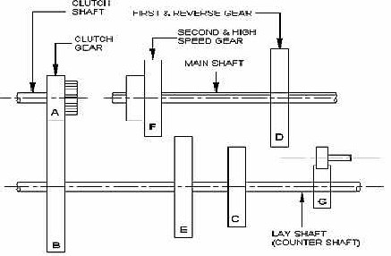
Secondgear
- Second gear provideslesstorqueand higher speedthan first gearand isobtained whenthe middlesizegear of the main shaft meshes with the second smallest gear on the lay shaft and high speed and second high torque is transmitted to the final drive.
Thirdgear
- Thirdgearprovidesmaximumspeedand minimumtorquetothefinaldriveandisalsoknownashigh speed gear or top gear in sliding mesh gearbox, this gear is obtained when the smallest gear of the main shaft meshes with the biggest gear of the lay shaft. Or we can say that the drive obtained maximum speed of the clutch shaft.
Reversegear
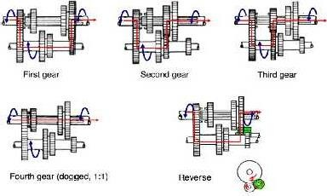
- When the reverse gear is selected, the rotation of the output shaft is reversed which is made possible by usinganidler gear between the main shaftandlay shaftthatchangestherotationofthe outputshaftandthe vehicle starts moving in reverse direction.

Application
Itistheoldesttypeofgearboxusedinearly19smodelsofcars..Someofthemare-
  - Alfa12HPusedslidingmeshgearboxwith4-speedmanualtransmission.
  - Fiat6HPused3-speedmanualtransmission.
  - Mercedes35HPused4-speedmanualtransmission
  - RenaultVoituretteusedmanual3-speedtransmission.

EXPLAINTHEWORKINGOFCONSTANTMESHGEARBOXWITHNEATSKETCH.
  - Constant mesh gearbox is used for the smooth working of an automobile. They are used to increase the rotatingforce(Torque); this isaccompaniedbya reduction in speed. It is a type of manual transmission.
  - The invention of earliest manual gear system can be traced back to the nineteenth century. Thereare multiple gear ratios present which provides various torque and speed ratio. Along with this, the reverse mechanism is also present. These manual transmissions which are developed recently contain all the gears mesh at any given point of time.
  - In technical terms, it can be defined as a gearbox in which all the gears are always in a state of mesh. The gearsremain fixed at their original positions. The gearswill remain engaged at all times. Learn more about its construction, working, advantages, disadvantages and applications in this article.
Construction:
Itismadeupoffollowingcomponents:
- CountershaftorLayShaft:
  - This shaft is in direct contact with theclutch and the main shaft. Keeping in mind according to the gear ratio,the speedofthecounter shaft maybelessthatthespeedoftheengine.Thegearratiocanbedefinedas theratio oftheteeth ofdriven gear to the teeth of the driver gear.
- Mainshaft:
  - Thisshaftoperatesthespeedofthevehicle.Thepowerismadeavailabletothemainshaftthroughthegears from the counter shaft. Thisis done in accordance with the gear ratio.
- Dogclutch:
  - Dog clutch is special feature ofconstant mesh gearbox.It isused for the coupling ofanytwo shafts.Thisis done byinterference. Usinga dog clutch, various gears can be lockedto the outputand input shafts.
- Gears:
  - The main work of the gears is the transmission of power between the shafts. If the gear ratio is more than one, the main shaft will work at a speed that is slower than the counter shaft, and vice versa. The arrangement of both reverse, as well as forward gears is present.
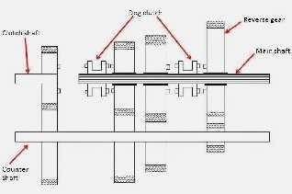

Working:
Forwardgearselection:
  - From the inputshaft, the powerstarts flowing and is divided intofour parts.Eachpartgoes to one of the output gears, namely first, second,thirdand fourth.Gearratios canbe obtained for each ofthem.
  - This can be done bythe proper slidingofdog clutch over theteeth ofthe selected gearwheel. After thisthe path of the energyflow completes. Thishappens due to the locking movement ofthe output shaft.
Reversegearselection:
  - Thepowerwillflowfromtheinputshafttothereversegears.Thepoweristhentransmittedfromthe reverse gear tothereverseidler. Theidler wheel will changethe direction of therotation.
  - In the case of forwarding direction gear selection, the output gears will rotate ina direction opposite to the inputgears. Butinthe case ofreverse gear selection, the rotationis in the samedirectionastheinput shaft.
Thestepsaretakentochangeanygearintheconstantmeshgearboxsystem:
  - The first step when one wants to modifythe gear would be the pressing of the clutch. After this comes the neutral state ofthe vehicletobeachieved. Proper optimization ofthe engine‘s speedis required.
  - After the neutral gear, one moves forward to the first gear.The first gear. This process isknown as double clutching. Inefficiencyin performingtheabove steps mightlead toa harsh and gnashing sound.
Advantages:
  - Thefirstandforemost benefit oftheconstantgear meshistheutilization ofhelicalgears.Thedoublehelical gears andthe helical gearsare extremely beneficial owingtotheir quieter operatingcapabilities
  - There are various conditions which might cause harm. In the case of constant mesh gearbox, any harm is suffered entirely by the dog clutch teeth. The teeth belonging to thegear wheels remain intact. This is not the case for sliding mesh gear box.
  - Theothergearboxesarenoisyandcreateanunwanteddin. Disadvantages:
  - Itislessefficientthantheothersduetohighermeshteeth.Skillisrequiredforit.
  - Thedoubleclutchmeshisrequired.Thisisrequiredtohavethespinningmovementsoftheshaft. Application:
  - Someofthevehicleswhichusethistypeofgearboxesarefarmtrucks,motorcycles,andheavymachinery.
  - Itisveryevidentthattheworldtodayis fullof vehiclesandreliesonthismodeoftransport.Theavailability ofsuch mechanismslikeconstant mesh gearbox which createless noiseand are cost effectiveisa boon for the people. If you like these articles don‘t forget to share it on social networks. Subscribe our website for more informative articles. Thanks for reading it.

EXPLAINTHEWORKINGPRINCIPLEOFSYNCHROMESHGEARBOXWITHNEAT SKETCH.
  - Modification in a component keep occurring until the ideal or near to ideal state of the component is not achieved so with thisthoughtin mind engineerskeep onresearching on manualtransmission to getthe best out of it, which leads the researchers from the General Motors to the development of synchromesh gearbox or transmission system in 1928, this system overcame the limitations oflater transmission system and gave theanswers to all the transmission related question, let‘s find moreabout it.
  - Synchromesh gearbox or transmission system is a type of transmission system in which the dog clutches fromtheconstant meshgearboxisreplacedwiththespecial shiftingdevicesknownassynchromeshdevices which makesthe system compact and also provide smooth and noise free shifting of gears .

  - In synchromesh transmission the pair of gears which has to be used for final transmission of output first bringinfrictional contact withthesynchromeshdeviceandthenfinalselectionoftheappropriategeartakes place.
  - It usually comes with the5-speed 1-reversemanual transmission configuration for example- Maruti Suzuki swift.
  - Withsuitablemodificationinshiftinglevermechanismsynchromeshgearboxisalsousedinracingcarslike formula-1, because of its quick and smooth response.

WhydoweNeedSynchromeshGearbox?
  - Since, theintroduction ofthe transmission system from sliding meshto constant mesh various modification is made in both the systems to make them smooth ,less noisy and to make theshifting response quick, though the constant mesh overcame the important limitations of sliding mesh gearbox like double-de- clutching, wear and tear but still hasits own limitations, let‘s discuss them:
  - The response to the shifting of gears in the constant mesh gearbox is not quick as the dog clutches used in constant meshgearbox hasto mesh withtherotating pair of gears which is nota quick task.
  - There is a lack of mechanism in constant mesh gearbox that can bring all the rotating shafts that are clutch shaft, main shaftandlayshaftat the samerotating speed, whichisresponsible for theharsh shifting.
  - Theteethesofthedogclutchesshowswearandtearwhichinturnincreasesthemaintenanceofthesystem.
  - The shifting in constant mesh gearbox is a noisy process as the dog clutches has to make contact with rotating gear pair.
  - The constant mesh gear box is not compact as compared to synchromesh gearbox.These problems lead General Motors to develop synchromesh gearbox which is still used in almost 52% of the automobile vehicles on the road today.

MainComponents
- Shafts–Justlikeconstantmeshgearbox,thereare3shaftsusedinsynchromeshgearbox-
  - Main shaft- Same asconstant mesh a splined shaft isusedasthe output shaft over which the synchronizers and gears are mounted.
  - Layshaft-Itistheintermediateshaftoverwhichgearswithsuitablesizeand
  - Teethesaremountedandisusedtotransmittherotationalmotionfromclutchshafttothefinaloutputshaft.
  - Clutch shaft- It is the shaft used as an input shaft in gearbox as it carries the engine output to the gearbox, same as the constant mesh gearbox
- Gears-Therearenormally2typesofgearsusedinthis–
  - Helicalgears-Thesegearsarehavingangularcutteethesoveracylindricalmetalflank.
  - Bevelgears–Thesegearsarehavingangularcutteethesoveraconicalmetalflank.
- Synchronizers –They are the special shifting devices used in synchromesh gearbox whichhas conical grooves cut over its surface that provide frictional contact to the gears which is to be meshedin order to equalise the speed ofmain shaft,lay shaftand clutch shaft which in turn provides smooth shiftingofgears.
- Gearlever – Itisthe shiftingleveroperated bythedriverandisusedtoselecttheappropriategeari.e.1,2,3, 4, 5 or reverse gear.

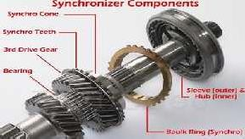
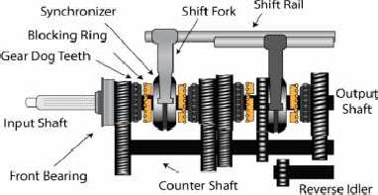
Working

Selectinggearsinsynchromeshgearboxissomewhatsameasconstantmeshgearboxthatare-
First gear
  - Whenthe driver push orpull the gearleverin order to selectthe firstgear which givesthemaximumtorque and minimum speed and is used to move the vehicle from its initial state, the synchromesh device attached with the pair of meshed gears having biggest gear of the main shaft and smallest gear of the lay shaft equalizes the speed of the shafts by making frictional contact with the pair and finally the first gear is obtained.
Secondgear
  - Thisisthe gear having lower torque and higher speed than first gear and is obtained when the pair of gears having second largest gear of the main shaft and second smallest gear of the lay shaft is meshed by the corresponding synchromesh device.
Thirdgear
  - Thisgearhavinghigherspeedandlowertorquethansecondgearisobtainedwhenthecorresponding synchromesh device attached to the pair of gear having intermediate size gear of main shaft andintermediate size of gear of lay shaft makes contact.
Fourthgear
  - It is the second highest speed gear which is obtained when thecorresponding synchromesh deviceattached to the pair of meshed gears having second smallest gear ofmain shaft and second largest gear of the lay shaft makes contact.

Fifthgear
  - It is the highest speed and lowest torque gear which transmit the maximum speed ofthe clutch shaft to the main or output shaft and is obtained when the corresponding synchromesh device attached to the pair of meshed gear having smallest gear ofmain shaft andlargest gearoflay shaft makes contact.
Note – In some vehicle like ktm duke 390cc over drive is attached which directly obtained the output from theclutchshaftandtransmittothefinal drive whenthevehicleisona longrunwith high speedor whenthe vehicle is going down the hill.
Reversegear
  - Itis the gear thatreverses the direction ofthe output shaft which in turn reversethe direction of the vehicle with the help of the idler gear which is usually fit in the middle of the lay shaftand main shaft and is obtained whentheidler gear makes contact withthe gears onthe main shaft and layshaft.
Note – The reverse gear does not have any synchronizer mechanism, so the gearbox shaft rotation is completely stop before engaging the reverse gear.
Application
  - Ithasa wideapplicationasalmost50%ofthevehicleontheroadusedsynchromesh gearbox,someofthem are-
  - InMarutiSuzukiswiftitcomeswith5-speed1-reversemanualtransmissionconfiguration.
  - Itisusedinbikeslikektmduke390cc.
  - Most of therace cars like formula-1 uses synchromesh gearbox with suitable modification in shifting lever asthey required sudden shifting ofgearsfrom high torque to high speed because they have to race onto the zig-zag track having sharp turns.

EXPLAINTHEWORKINGPRINCIPLEOFEPICYCLICGEARBOXWITHNEATSKETCH.
  - ―Automatic is the new need of the 21st century‖ yes it is, when it comes to human comfort various researches is being done to decrease the human effort in operating the machines though the manual transmission has its own benefits but some people findit causes fatigueto the driver in operatingthe clutch and shiftinggearcontinuously duringadrivewhichraisesquestionslikewhydoweneedclutch?Whythere are limited torque and speed ratios? , Which leads to the introduction of automatic type gearbox named Epicyclic gearbox.
  - An Epicyclic gearbox is an automatic type gearbox in which parallel shafts and gears arrangement from manual gear box are replaced with more compact and more reliable sun and planetary type of gears arrangement and also the manual clutch from manual power train isreplaced with hydro coupled clutch or torque convertor which in turn made the transmission automatic.
  - Theideaofepicyclicgearboxistakenfromthesolar systemwhichisconsideredtotheperfectarrangement of objects.
  - The epicyclic gearbox usually comes with the P N R D S a (Parking, Neutral, Reverse, Drive, and Sport) mode whichis obtained by fixing of sun and planetary gears accordingtothe need ofthe drive.
WhydoWeNeedEpicyclicTransmission?
  - Whenit comesto luxury,human comfort becomesthe first priority, sincein manualtransmissiondriver has to press and release the clutch pedal and shifts gears continuously for shifting the drive from high torque to high speed and also the sliding and meshing of lots of mechanical components is there in manual transmission which raises many problems that are-

  - In countrieslikeIndia thereisa problem oftraffic whichrequiredsudden shifting ofgears fromhightorque to high speed whichinturn requirescontinuousengagementand dis-engagementoftheclutch which causes fatigue to the driver.
  - Poor fuel economy is the problem seen with the synchromesh manual transmission as there is the loss of energydue to the movement oflots of components andalso over raving ofaccelerator isalso seeninit.
  - Since, the parallel shafts with mounted gears and meshing devices areused in manual transmission so size of the gearbox becomes the problem.
  - When we talk about manual synchromesh transmission we can have maximum of 6 gear ratios but it is found that a car requires more than 6 gear ratios in a long run.
  - If we take an example of the latest manual transmission system i.e. synchromesh gearbox in which the shifting of gears is obtained by sliding and meshing of synchronisers with the constantly meshed pairs of gears which causes wear and tear to the transmission system.
  - Also in manual transmission the shifting of gear is a noisy process. So with these problem in mind General Motors developed the first automatic transmission in 1930 by using epicyclic gear train with hydraulic coupling which was boom in the luxury cars world.
ComponentsofEpicyclicGearbox
  - Ringgear-Itisa typeofgear whichlookslikea ringand have angularcutteethesatitsinner surface,andis placed in outermost position in en epicyclic gearbox, the inner teethes of ring gear is in constant mesh at outer point with the set of planetary gears ,it isalso known as annular ring.
  - Sungear-It isthe gear withangular cutteethesandisplacedin the middleofthe epicyclicgearbox;the sun gear is in constant mesh at inner point with the planetary gears and is connected with the input shaft of the epicyclic gear box.
Oneormoresungearscanbeusedforachievingdifferentoutput.
  - Planet gears-Theseare small gearsusedin betweenringand sun gear ,the teethesof the planetgearsarein constant mesh with the sun andthering gear atboth the inner and outer pointsrespectively.Theaxis of the planet gears are attached to the planet carrier which is carrying the output shaft of the epicyclic gearbox.nThe planet gears canrotateabouttheiraxisandalsocanrevolvebetweentheringandthe sun gear just like our solar system.
  - Planet carrier- It is a carrier attached with the axis of the planet gears and is responsible for final transmission of the output to the output shaft.The planet gearsrotate over the carrier and the revolution of the planetary gears causes rotation of the carrier.
  - Brake or clutch band-The deviceused to fixtheannular gear, sungearand planetary gearand is controlled by the brake or clutch of the vehicle.

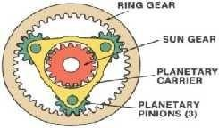

WorkingofEpicyclicGearbox
  - The working principle of the epicyclic gearbox is based on the factthe fixing any of the gears i.e. sun gear, planetary gears and annular gear is done to obtain the required torque or speed output. As fixing any of the above causes the variation in gear ratios from high torque to high speed. So let‘s see how these ratios are obtained
Firstgearratio
  - This provide high torque ratios to the vehicle which helps the vehicle to move from its initial state and is obtained by fixingtheannular gear whichin turn causesthe planet carrier torotate withthe power supplied to the sun gear.
Secondgearratio
  - This provides high speed ratios to the vehicle which helps the vehicle to attain higher speed during a drive, these ratios are obtained by fixing the sun gearwhich in turn makes the planet carrier the driven member and annular the driving member in order to achieve high speed ratios.
Reversegear ratio
  - This gear reverses the direction of the output shaft which in turn reverses the direction of the vehicle, this gear is achieved by fixing the planet gear carrier which in turn makes the annular gear the driven member and the sun gear the driver member.
Note- More speed or torque ratios can be achieved by increasing the number planet and sun gear in epicyclicgear box.
Application
  - Epicyclicgeartrainisusuallyusedinautomaticvehicleswiththehydraulicclutch.
  - EpicyclicgearboxisusedinautomaticmodelofAudi A4
  - ItisusedLamborghiniGallardo.ItisalsousedinpowertransmissionbetweenI.C engineandelectricmotor, so it also has its uses in hybrid cars.

S.No | ManualTransmission | AutomaticTransmission
1. | Inthemanualtransmissiontheshiftingof the gears is done by the driver. | Intheautomatictransmissiontheshiftingof gears is done by the  caritself.
2. | Thecostofthemanualtransmissioncars is less. | Thecostofautomatictransmissioncarsis much higher than the MT  cars.
3. | Themaintenancecostisless | Themaintenancecostishigh
4. | Itdoesnotrequireactivecooling. | Itrequiresactivecoolingduetooverheating problem.
5. | Thefuelefficiencyofmanual  transmissionismore.Itdependsupon the driving skills of the driver. | Thefuelefficiencyislessascomparedwith the manual transmission.
6. | Thedesignissimpleandlesscomplex. | Thedesignismorecomplexdue to number of components.
7. | Differentsetsofgearsarepresenttoget different gear ratios. | Samesetofgearsproducesallofthe different gear ratios.
8. | Manualtransmissioncarsarenoteasyto drive. | Carswithautomatictransmissionaremuch easier to drive.

9. | Highskilleddriverisrequiredtodrive MT cars. | LessskilleddrivercanalsodriveATcars.
10. | Requiresmoreattentionofthedriverto operate manual transmission  cars. | Notmuchattentionisrequiredtooperate automatic transmission  cars.
11. | Clutchpedalisusedtoshiftthegears. | Noclutchpedalisthere,automaticshifting of gears takes place  accordingtothespeedofthecar.
12. | Itdoesnotallowmultitaskingduring driving. | Itallowsmultitaskingduring driving.
13. | Itgivesyoumorewaysto control your car. | Itdoesnotprovideyoumorewaysto control your car.
14. | Inmanualtransmissioncarsthereisthree pedals to operate  thecar.Thesethreepedalsareofclutch, brakes and acceleration. | Intheautomatictransmissioncarsthereis two pedals to operate  thecar.Thesetwopedalsareofbrakeand accelerator.
15. | Ithaslowresalevalue. | Ithashighresalevalue.
16. | Itisnoteasiertodriveonsteephills. | Itiseasiertodriveonsteep hills.
17. | TheMTcarsaredifficulttooperatein high density traffic area due  tomanualchangingofgears. | TheATcarsareveryeasierto  operateinthehighdensitytrafficareadue to automatic changing of gears  bythecaritself.

EXPLAINTHEPRINCIPLEANDWORKINGOFADIFFERENTIALWITHANEATSKETCH.
  - Adifferential isa mechanical device capableoftransmitting torqueand makerotation through three shafts, oneas input and other twoareas output for different speed as vehicle makes turn.
  - Thedifferentialallowseach ofthe driving wheelstorotateat different speeds, while supplying equaltorque to each of them. The differential is found on all modern cars and trucks, and also in many all-wheel-drive vehicles.
  - These all-wheel-drive vehicles need a differential between each set of drive wheels, and they need one betweenthefrontandthe back wheelsaswell, becausethefront wheelstraveladifferentdistancethrougha turn than the rear wheels.
Purpose
  - A vehicle's wheels rotate at different speeds, mainly when turning corners. The differential is designed to drive a pair of wheels with equaltorque while allowingthemtorotateat different speeds.
  - In vehicles withouta differential, such asracing motor both driving wheels are forced torotateat the same speed, usually on a common axle driven by a simple chain-drivemechanism. When cornering, the inner wheel needs to travel a shorter distance than the outer wheel, so with no differential, the result is the inner wheel spinning and/or the outer wheel Dragging, and this results in difficult and unpredictable handling, damage to tires and roads, and strain on the entire drivetrain.
  - Theproblemwassolvedin1827 byPequerofFrancewhoinventedthedifferential.Thismechanismrotates the wheels at different speeds, while maintaininga drive to both wheels.
VariousPartsofthedifferential
  - PinionDriveGear:Ittransferspowerfromthedriveshafttotheringgearmainlyhavinghelicalgearonit.

  - Crown wheel/ring gear: Ring gear transfers power from pinion gear to the differential caseassembly. Ring gear reduces the gear ratio that helps in increasing the torque value. Crown wheel and pinion gearare meshes with hypoid gear orientation. A hypoid gear is a style of spiral bevel gear whose main variance is that the mating gears'axes do not intersect. Thehypoid gear is offset from thegear center, allowing unique configurations and a large diameter shaft. The teeth on a hypoid gear are helical, and the pitch surface is best described as a hyperboloid.
  - Spider/planetgear: spider gearsareconnectedattheend ofthecross-pinthattransferspower fromring gear to side gear. The spider gear liesat the heart ofthe differential, and special mention should be made about its rotation. The spider gear is free to make 2 kinds of rotations: one along with the ring gear (rotation) and the second on itsown axis(spin).Thistwo kinds of rotationsare shown in figure.
  - Cross-pin: It link the spider gear with the crown wheel so spider gear can make rotation through crown wheel.
  - Side/sun gear: It transfer power from spider gear to rear axles and help both wheels to turn independently when turning.
  - Differentialcaseassembly:Itholdstheringgearandothercomponentsthat drivetherearaxle. Construction of differential gear:
  - Differentialisanarrangementofgearswhichworktogetherandallow thevehicle totakeaturnsmoothly.
Inthedifferential,bevelpiniongearisfixedtothepropellershaftwhichrotatesthecrownwheel.
  - The crown wheel has another unit called the differential unit. It consists of two bevel gears (sun gear) and two bevel gears (planet gear). The bevel gears are in contact with the half shaft of the rear axle. When the crown wheelisrotating,itrotatesthedifferentialunit.Thebevel(sun)gearsofthedifferentialrotatethetwo shafts.
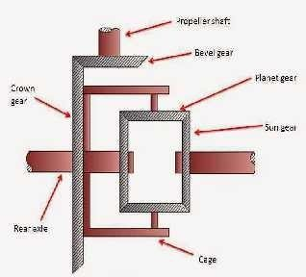

Workingofdifferentialgear:
Now let‘s see how the differential manages to rotate the side gears at different speeds as demanded by different driving scenarios. Consider three different cases
  - Vehiclemovesinstraightdirection
  - Vehicletakesrightturn

  - Vehicletakesleftturn
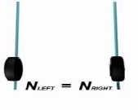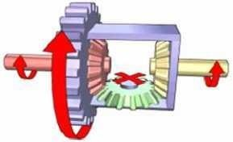Vehiclemovesinstraightdirection
  - In this case, both right and left wheel have to travel same distance so same speed is require. Input torque is applied to the ring gear(blue), which turnsthe entire carrier (blue), providing torqueto both side gears(red and yellow), which in turn may drive the left and right wheels.
  - If the resistance at both wheels is equal, the spider gear (green) does not spin, and both wheels turn at the same rate.The spider gearrotatesalong with the ring gear but does notrotate onits ownaxis. Sothe spider gear will push and make both the side gears turn, and both will turn at the same speed. In short, when the vehicle moves straight, the spider-side gear assembly will moveasa single solidunit.
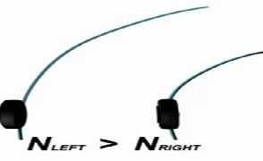
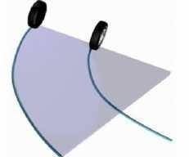
Vehicletakesrightturn
Travellingdistanceofwheelsduringrightturn
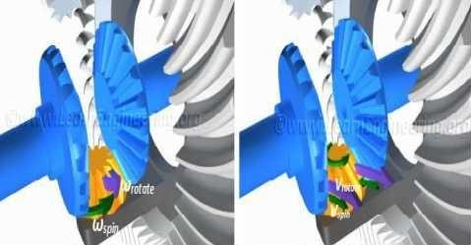
Directionofrotationofspidergearduringrightturn

  - Nowconsiderthecasewhenthevehicleistakinga rightturn.Inthiscasea certainamount oftensionwould build up when cornering as the outside wheel tries to rotate quicker that the inside wheel due to the bigger arc of travel.
  - The spider gear playsa pivotalroleinthiscase. Along withtherotationoftheringgearitrotates onitsown axis. So, the spider gear is has a combined Rotation. Here during right turn left wheel have to travel more thantheleft wheelsothe speed orrequiretoleft wheelismore.Whenproperly meshed,the sidegear hasto have the same Peripheral velocity as the spider gear.
  - Whenthe spider gearis spinning as wellasrotating, peripheral velocity on theleft side ofspider gearisthe sum ofthe spinning and rotational Velocities. But on the right side, it is the difference ofthe two, since the spinvelocityisintheoppositedirection on this side. This factis clearlydepictedinFig.This meanstheleft sidegear will have higher speedcomparedtotheright side gear.Thisis the waythedifferential manages to turn left and right wheels at different speeds.
Vehicletakesleftturn
  - Now consider the case when the vehicle is taking a left turn. Here the right wheel have to travel more distance thanleft wheel that require morerotational speed ofthe wheel.
  - Inthis casethe speed of spider gear is inopposite direction as compare to previous case shownin figure So the speed ofthe right sun gear will more because of sum of spinning and rotational velocity of spider gear and contrast to the left side gear. This meansthe right side gear will have higher speed compared totheleft side gear.
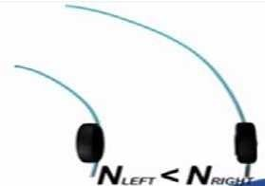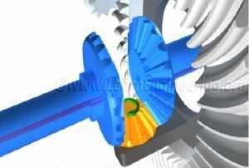
Travellingdistanceofwheelsanddirectionofrotationofspidergearduringleftturn Use of more Spider gears
  - In order to carry a greater load, one more spider gear is usually added. The spider gears should spin in oppositedirectionstohavethepropergear motion. Afour-spider-geararrangementisalsoused for vehicles with heavy loads. In such cases, the spider gears are connected to ends of a cross bar, and the spider gears are free to spin independently.

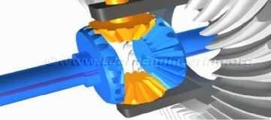
Doublespidergeararrangement
OtherfunctionsoftheDifferential
  - Apart from allowing the wheels to rotate at different rpm differential has 2 more functions. First is speed reductionatthepinion-ringgearassembly.Thisisachievedbyusingaringgear whichishavingalmost4 to 5timesnumber ofteethasthatofthepiniongear.Suchhugegearratiowillbringdownthespeedofthering gearinthe sameratio.Sincethe power flowatthe pinionandringgeararethe same, sucha speedreduction will result in a high torque multiplication.
  - Onespecialty ofthering gear,theyarehypoidgears.Thehypoidgearshavemorecontactarea compared to theother gear pairs and will make sure that the gear operation is smooth.
  - Theother functionofthe differentialistoturnthepower flowdirection by 90 degree.In whichthepoweris transmitted to differential by main shaftand that power furthertransmitted torear axles thatare mountedat 90 degree with the main shaft.

EXPLAINTHETYPESOFREARAXLEDRIVEWITHSUITABLESKECTH.
  - Therear driveaxleconnectsthedifferentialsidegearstothedrivewheels.Theaxlemayor may notsupport the weight of the vehicle. Rear axlesare normally induction hardened for increased strength.
  - Thereareseveraltypesofrearaxledesigns: semi floating,three-quarter floating,andfull floating.However the semi- and full-floating typesare the most common. Most automobiles use the semi floating type, whereas four-wheel drive vehiclesand trucksuse full floating axles.

SEMIFLOATINGAXLE
  - The semi floating axle is used in passenger vehicles and light trucks. In vehicles equipped with this type of axle,the shaft,aswellasthehousing, supportsthe weight ofthevehicle.Theinnerendoftheaxleiscarried bythesidegearsinthe differentialhousing.Thisrelievestheaxleshaftsofthe weightofthe differentialand the stresses caused by its operation that are taken by the axle housing. The inner ends of the axle transmit onlyturning effort, or torque, andarenot acted upon byanyother force.
  - Theouterendiscarried byabearinglocatedbetweentheshaftandthehousing. Ataperedrollerofball-type bearing transfers the load from the shaft to the housing. The axle shafts take the stresses caused by turning, skidding, or wobbling of the wheels.
  - The axle shafts are flanged or tapered on the ends. When the tapered axle is used, the brake drum and hub are pressed onto the shafts, using keys to prevent the assemblies from turning on the shafts. In some cases, the outer ends of the shafts may have serrations or splines to correspond with those on the drum and hub assembly. Shouldtheaxle break with thistype ofaxleassembly, the wheel canseparate fromthe vehicle.

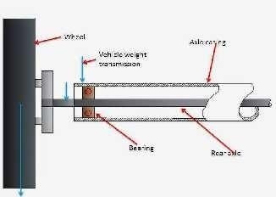

Advantages
  - Thesemifloatingaxleisthesimplestandcheapestandtheyarewidelyusedincars.

Disadvantages
  - The axle has to be designedfor carrying higher loads i.e. they are of higherdiameterforthe same torque transmitted by other types of axle supporting.

FULL-FLOATINGAXLE
  - The full-floating axle is used in many heavy-duty trucks. The drive wheel is carried on the outer end of the axle housing by a pair of tapered rollerbearings. The bearings are located outside the axle housing. In this way, the axle housings take the full weight of the vehicle and absorb all stresses or end thrust caused by turning, skidding, and pulling. Onlytheaxle shaft transmits torque fromthe differential.
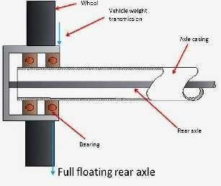
  - Theaxleshaftisconnectedtothedrivewheelthroughaboltedflange.Thisallowstheaxleshafttobe removed for servicing without removing the wheel.

Advantages
  - Theseareveryrobusttypeandareusedforheavyvehicles.
  - Axleshaftcarryonlythedrivetorquesotheirfailuredoesnotaffectthevehiclewheels.
  - Vehiclecanbetowedwiththebrokenaxleshaft.
  - Axleshaftcanbereplacedbywithoutjacking.

Disadvantages

  - Costliesttypeofaxlesupporting.

THREEQUARTERFLOATINGREARAXLE:
  - In this axle bearing are on the outer side of casing between the wheel and the axle casing. The wheels are fitted at the end ofthe axle by means ofa key, bolt or nut. The weight ofthe vehicle is supported partly by the axle casing and partly by the axle. The main advantage of this type of axle over the half floating axle is that the major part of the load is taken by the axle casing and not by axle. Axle only takescare of the rotating and transmits the power.
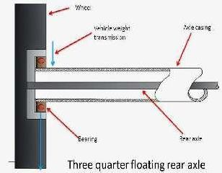

Advantages
  - Atonetimethisaxletypewascommonlyusedforcarsandlightcommercial vehicles.

Disadvantages
  - Theseaxlesarenolongerpreferred.insteadsemifloatingaxlesareused.

Functionsoffinaldrive:
  - Transmitsthedrivethroughanangleof900.
  - Gearsdowntheenginerevolutiontoprovidea‗directtop‘ gearratio.Inthecaseofcarsafinaldriveratioof approximately 4:1 is used. Bevel or worm gears are employed to achieve the various functions of the final drive.

EXPLAIN IN DETAIL WITH NEAT SKETCHES ABOUT HOTCHKISS DRIVE AND TORQUE TUBE DRIVE.
HOTCHKISSDRIVE:
  - TheHotchkissdriveissimplestand mostpopularformofrearaxlesuspension.
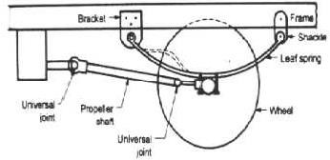

  - Hotchkiss drivecombines the springingand positioningorlocating oftherearaxle.Itusesa rigidaxle with leaf spring mounted at its extremitiesas far apart as possible on the rear axle.
  - TheHotchkiss drive consists ofa leaf springand a propeller shaft withtwo universaljointsand one sliding joint.
  - Thefrontendoftheleafspringispivotedinpinofbracketwhichisboltedtothevehicleframe.
  - Whilerearendoftheleafspringissupportedinswingingshacklewithantifrictionbushmaterial.
  - Theleafspringsareboltedrigidlytotherearaxlecasingatmiddle.
  - Thespringtakesweightofbody,torquereactionanddrivingthrust.
  - The driving and braking torquesare absorbed through the front half ofthe rear leaf spring shown by dotted line.
  - During drivingand braking, thebevel pinion changestheposition so thelength andangleof propeller shaft changeswhich willbeadjustedbyuniversaljointand slidingjoint.Thereforeifonlyoneuniversaljointisat the front end, then the propeller shaft may bend or damage.
  - Toavoidthis,anotheruniversaljointisprovidedatrearend.
  - Whenthe vehicle comesacrossa bump or shocks,therear axle movesupand downand it hasto move in a circle with front spring supported at the frame as centre.
  - During this movement of rear axle, the length of the propeller shaft changes which will be adjusted by sliding joint.

TORQUETUBEDRIVE:
  - Intorquedrive,thepropellershaftisenclosedinahollowtube.
  - Thetubeisrigidlyboltedtothedifferentialhousingatoneendandisfastenedattheotherendtothe transmissionthrougha somewhat flexiblejoint(universal joint) situatedinspherical cup fixedtotheframe.
  - Thetorquereactionanddrivingthrustaretakenupbytorquetube.
  - Whenthe vehicle comes across a bump or shocks, the centre line ofthe bevel pinion shaft will not be shift and always passes through the centre of spherical cup.
  - Hence,onlyoneuniversaljointisrequiredatfrontendandnouniversaljointattherearend.
  - Thetubeincorporatesbearing,whichsupportthepropellershaft.
  - Itisusuallylocatedbetweenthe(transmission)gearboxandthepropellershaft.
  - Noslidingjointisrequiredinthepropellershaft.
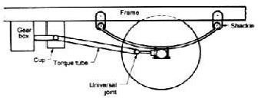

  - In many cars a pair of truss rods is attached between the rear axle housing and the transmission end of the torquetube.Thetorquetubeandthetrussrodbrace thedifferentialhousing topreventexcessive differential housing movement.
  - Inthisdrive,theleafspringstakesonlythesidethrustbesidessupportingweightofthebody.

EXPLAININDETAILWITHNEATSKETCHESABOUTREARAXLECASINGS.
  - Splittype.
  - BanjoorSeparatecarriertype
  - SalisburyorIntegralCarriertype.

SPLITTYPE
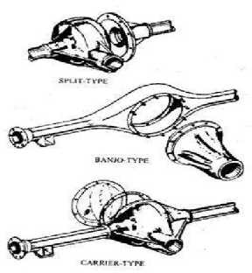
  - The axle casing is made in two halves and then bolted together for assembly. But the main disadvantage is whole rear axle has to be removed as a unit and reassembled in case of a fault. This kind is no longer used now.

BANJOORSEPARATECARRIER
  - Axleis madeasa single pieceThe complete differentialunitis separateunitand is boltedtotheaxlecasing and the two shafts are put from two sides.
  - Incaseofrepairtheshaftscanbetakenfromtwosidesanddifferentialcanberemoved easily.

SALISBURYORINTERGRALCARRIERTYPE
  - This is similar to the banjo type except that the permanent housing tubes are pressed and welded onto the sides.
  - Thisisthemostcommonlyusedkindofrearwheeldrivencars.

EXPLAININDETAILWITHNEATSKETCHESABOUTFINALDRIVEGEARS.
  - Finaldriveisusedtoprovideapermamanentspeedreductionandtoturnthedrivethrough90degree.
  - Thereductionratioprovidedbythefinaldriveis4:1forcarsand10:1forheavyvehicles.
  - Thereductionrationupto7:1 can be donein single stageandabove that is doneintwo stages. Thisis done to reduce the size of the gear and to improve the ground clearance.
  - Finaldrivecanbebevelpinionandcrownwheelorwormandwormwheelarrangement.

TYPESOFGEARSFORFINALDRIVE
  - StraightBevelGears.
  - SpiralBevelGears.

  - HypoidBevelGears
  - WormandWormWheelArrangement.

Straightbevelgears
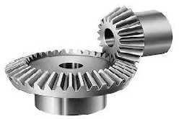
  - Thegearshavestraightteeth.

Advantages
    - SimplestandCheapest

Disadvantages
    - Uneventransmissionduetocontactofsinglepairofteeth.
    - Lessloadcarryingcapacity.
    - Noisyandhighlevelsofwear.

Spiralbevelgears
  - Spiralbevel gearshave curvedteeth sohavegreater number ofteeth in contact.The geartooth have sliding motion also in between.
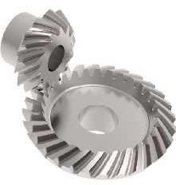

Advantages
  - SilentRunning.
  - Theyareabletotakemoreloads.

Hypoidgears
  - The structure ofthe teeth have hyperboloid in shape. Hyperboloid isobtained byrotatinga hyperbola Abut an offset axis.
  - The gears transmit motionat right at right angles but the axis of the gears don‟t intersect but they lie at an offset distance.

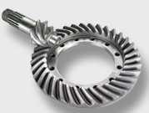

Advantages
  - The hypoid gears permita lower position ofthe propeller shaftandallow morelower chassis height orless chassis height as the case may be.
  - Hypoidgearsincreasestheloadscapacityofthegears.

Disadvantage
  - Expensivedifficulttoassembleandneedspeciallubricantduetothegreaterslidingactionbetweenthe

Wormandwormwheel
  - Wormisa singleor multi startedthread whichdrivestheworm wheel whichhasteeth overtheperipheryof the wheel.
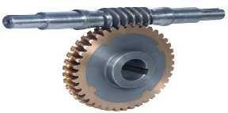
  - Highergearratiosarepossibleinwormandwormwheelarrangement.

Advantages
  - WormandWorm wheelarrangementisparticularlyusedinheavyvehiclewherehigher gearratiosof greater than 6 needed
  - Strongandefficientdrive
  - Singlestagereductionisonlynecessaryforhighergearratiosalso.
  - Wormgearsgivelowchassisheightormoregroundclearanceasthecase maybe.

Disadvantages
  - Highercostandmoreweightthanbevelgear
  - Mechanicalefficiencyislowerthanbevelgearforsinglestagereduction
  - Lubricationisdifficultwithoverheadworm.

WHATISDRIVELINE? WHATISPROPELLERSHAFT,UNIVERSALJOINT ANDSLIP JOINT?
  - Whenanengineproducespowerandclutchandtransmission convert itintorequiredtorque,someassembly is neededto carrythis torquetodrivingaxle or usuallytorear axle. Thisassemblyis known as drive line.

  - Adrivelineconsist one or moredriveshaft (propeller shaft), universal joints, and slip joints. Varioustypes of propeller shaft, universal joint, and slip joints are used to carry engine power from the transmissionbox to the driving wheels. These are the main components of drive shaft

Propellershaft:
  - The propeller shaft is a driving shaft which connectsthe transmission main shaft to the differential of the real axle. It transmits the power from gear box to rear axle with the help of universal joints. The propeller shaft is also known as drive shaft. It performsthe following function:
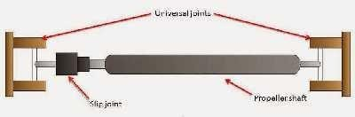
  - Toreceivethepower fromthegearboxoutputshaftandwithoutanychangein speedtransmitittotheinput pinion ofthe differential for onward transmission totherear axleand rear wheels.
  - To cope with the difference in line with the level of the gear box output shaft and the differential input pinion shaft. The propeller shaft has to operate at varied lengths and varied angles. The engine of the automobileissomewhatrigidlyattachedtothe frame by springs. Asthe vehicle movesontheroadthereare jerks and bumps due to which the springs expand and contract.
  - Thischangestheangleofdrivebetweenthepropeller shaftandthetransmissionshaft.Thedistancebetween thegear box and differential also changes due tothe movement ofthe springs.
  - Sothepropeller shafthasto meetboththeangularchangecomingbetweenthegearboxanddifferentialand change in length ofthe distance between the gear box and differential.
  - The propeller shaft is also not on the same line as the gear box output shaft but it runs to the rear axle at an angle because the level of the rear axle is lower than the gear box. So to adjust angular motion universal jointsare provided andtoadjust for thechangeinlength ofthe propeller shaft,a slipjointis provided.
  - The propeller shaft hasto withstandthe torsional stressesofthe transmittingtorque,andyet it must belight andwellbalancedsothatvibrations willnotoccurathighspeed.Soitisusuallymadeofa strongsteel tube.

Universaljoint:
  - Auniversaljointallows drivingtorque to be carried throughtwo shafts that areat anangle with each other. Asimpleuniversal joint consist twoY- shaped yoke, oneon thedrivingshaftandother on the driven shaft.
  - The fourarmsofspiderareassembledinneedle bearingsinthetwoyokes.Thedrivingshaftand yokeforce the spider torotate.The other two trunnions of the spider then cause the driven yoketorotate.
  - When the two shafts are at an angle with each other, the needle bearings permit the yokes to swing around onthetrunnionswitheachrevolution. Asimpleuniversaljointdoesnottransmitthemotionuniformlywhen the shafts are operating an angle.
  - Because ofthis, two universal jointsareused in a vehicle, one between the gear boxand the propeller shaft and other between the propeller shaft and the differential pinion shaft.

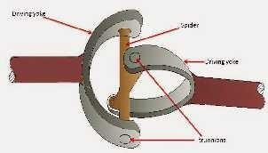

Slipjoint:
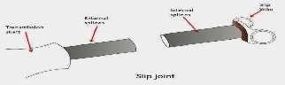
  - Slipjoint isattached to the driven yoke in order the increase or decreasethelength of propeller shaft.It has outsidesplinesontheshaftandmatchinginternalsplinesinamatinghollowshaft oryoke.Whenassembled thesplinescausetheshaftstorotatetogether whilethey canmove backand forth.Thischangesthelengthof propeller shaft.
  - Today we have learnt about propeller shaft, slip joint and universal joint. If you have any query regarding thisarticle, don‘t forget to shareit on social networks. Subscribeour website for moreinformativearticles. Thanks for reading it.

VARIABLEVELOCITYJOINT

CrossandRollerUniversalJoint
  - The crossand roller design isthe most commontype ofdrive shaft U-joint. It consists offour bearing caps, four needleroller bearings, a cross or journal, grease seals, and snap rings.
  - The bearing caps are held stationary in the drive shaft yokes. Roller bearings fit between the caps and the cross to reducefriction. The cross is free to rotate inside the caps and yokes. Snap rings usually fit into grooves cut inthe caps or the yoke bores to securethe bearing caps and bearings.
  - There are several other methods of securing the bearing caps in the yokes. These are bearing covers, U- bolts, and bearing caps.
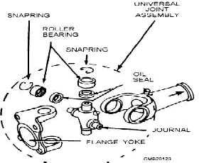
Crossandrolleruniversaljoint-disassembledview.

BallandTrunnionUniversalJoint
  - The ball and trunnion universal joint is a T-shaped shaft that is enclosedin the body of the joint shown in fig. The trunnion ends are each equipped with a ball, mounted in needle bearings. and move freely in grooves in the outer body of the joint, in effect, creating a slip joint. Compensating springs at each end of the drive shaft hold it in a centered position.
  - Variations in length is permitted by the longitudinal movement of the balls in the body grooves. Angular displacementisallowed byoutward movementofthe ballsonthetrunnion pins.Thistype ofuniversaljoint is recognized easily bythe flexible dust boot that coversit.
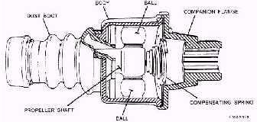
Ballandtrunnionuniversaljoint

Double-CardanUniversalJoint
  - Thedouble-cardanuniversaljointusestwo crossandrollerjointsintandem to forma singlejointThejoints are linked through a centering yoke that works in conjunction with a specially designed spring-loaded centering ball. The components are contained within the centering coupling yoke.
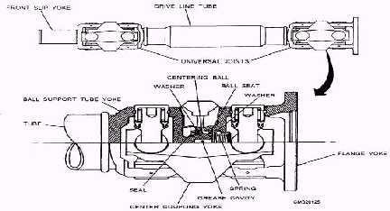
  - Astheshaftsrotate,theactionofthecenteringballand yokeactsto maintainanequallydivideddriveangle between the connected shafts, resulting in a constant drive velocity
Double-cardanuniversaljoint

CONSTANTVELOCITY(CV)JOINTS
  - The speed fluctuations caused by the conventional universal joints do not cause much difficulty in the rear- wheel drive shaft where they have to drive through small angles only. In front-wheel drives, the wheelsare crampedupto30 degrees in steering. For thisreasonvelocity fluctuations present a serious problem.
  - Conventionaluniversal jointswould cause hard steering, slippage,and tire wear each time the vehicleturns a corner. Constant velocity joints eliminate the pulsations because they are designed to be used exclusively to connect the front axle shaft to the driving wheels. .
  - Basic operation of a CV joint is as follows: The outboard CV joint is a fixed joint that transfers rotating power from the axle shaft to the hub assembly.

  - TheinboardCVjointisaslidingjointthatfunctionsasaslipjointinadriveshaftforrear-wheeldrive vehicles.
  - TheconstantvelocityjointsyouwillnormallyencounteraretheRzeppa,Bendix-Weiss,andtripodtypes.

RzeppaConstantVelocity(CV)Joint
  - The Rzeppa constant velocity (CV) joint is a ball-bearing type in which the balls furnish the only points of driving contact between the two halves of the coupling. A Rzeppa CV joint consists of a star-shaped inner race, several ball bearings, bearing cage, outerraceor housing, anda rubber bootasshown in fig.
  - The inner race (driving member) is splined to the inner axle shaft. The outer race (driven member) is a spherical housingthatisanintegral part oftheouter shaft;the ballsand ball cageare fitted betweenthetwo races.
  - The close spherical fit between the three main members supports the inner shaft whenever it isrequired to slidein the inner race, relievingthe balls ofany duty other thanthetransmission of power.
  - The movement oftheballsiscontrolledbytheballcage.Theballcage positionsthe balls ina planeatright angles to the two shafts when the shafts are in the sameline. A pilot pin, located in the outer shaft, moves the pilot and the ball cage by simple leverage in such a manner that the angular movement of the cage and balls is one half ofthe angular movement of the driven shaft.
  - For example, when the driven shaft is moved 20 degrees, the cage and balls move 10 degrees. As a result. theballs oftheRzeppa joint are positioned, fromthetop view, to bisect the angle formed.
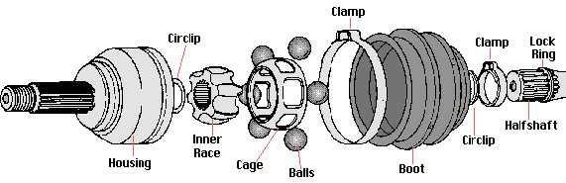
Rzeppaconstantvelocity(CV)joint.

Bendix-WeissConstantVelocity(CV)Joint
  - The driving contact remains on the plane that bisects the angle between the two shafts; however, it is the rolling friction between the four balls and the
  - The Bendix-Weissconstant velocity (CV) joint also usesballsthat furnish points of driving contact, but its construction differs from that of the Rzeppa in that the balls are a tight fit between two halves of the coupling and that no cage is used.
  - The center ballrotates ona pininserted intheouter raceand servesasa locking medium for the four other balls. Universaljointhousingthatpositionstheballs.Whenboth shaftsareinline,thatis,atanangleof180 degrees, the balls lie in a plane that is90 degrees to the shafts.
  - Ifthe driving shaftremains inthe originalposition,any movement ofthe driven shaft will causetheballsto move one half of the angular distance. For example, when the driven shaft moves through an angle of 20 degrees, the angle between the two shafts isreduced to 160 degrees.
  - The balls will move 10 degreesin the same direction,and theanglebetween the driving shaftandthe plane in which the balls lie will be reduced to 80 degrees. This action fulfills the requirement that the balls lie in the plane that bisects the angle of drive

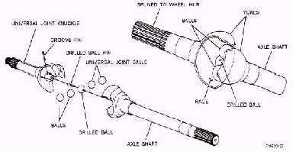
Bendix-Weissconstantvelocity(CV)joint

TripodJoint
  - A tripod or ball and housing CV joint consists of a spider, usually three balls, needlebearings, outer yoke, and boot.Theinner spider is splined to the axle shaft withtheneedle bearingsandthree balls fittingaround the spider. The yoke then slides over the balls. Slots in the yoke allow the balls to slide in and out and also swivel.
  - During operation, the axle shaft turns the spider and ball assembly. The balls transfer power to the outer housing.Sincetheouterhousingisconnectedtotheaxlestub shaftorhub,powerissentthroughthejointto propel the vehicle.
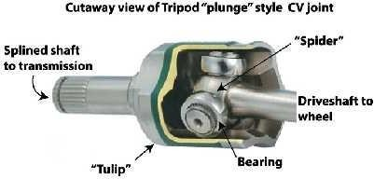

EXPLAINTHECONSTRUCTION,WORKINGANDAPPLICATIONOFOVERDRIVE.
  - Anoverdriveisamechanismthatallowsanautomobiletocruiseatsustainedspeedwithreducedengine RPM, leading to better fuel economy, lower noise, andlower wear.
  - Itismountedattherearendofthegearbox.
  - Thegearratioprovidedbyanoverdriveunitis30%morethanthedirecttopgear.
  - Theunitconsistsofanepicyclicgeartrain.
  - Theplanetcarrierisconnectedtotheoutputshaftofthegearbox.
  - Whenthesungearislockedtotheoutput shaftofthegearbox,theplanet carrierrotatesaboutthesun gear.
  - Theringgearrotatesmoreslowlythanplanetgearthusgivingmoreratiothanthedirectdrive.
  - Overdriveisusedinsomesportscarsandluxurycars.
  - An Overdrive may be most easily described as an extra, or normally fifth, gear, and although it may technically be used to make a vehicle go faster, that does not realise its correct potential. Indeed, with somecarsbeingequippedwithmoreenginepowerthanstoppingability itmayevenbedangerousto

misuseitinthis way. Ifanoverdrive isusedtoreduce enginerevolutions when cruising speed has been attained in top gear, the benefits are numerous.

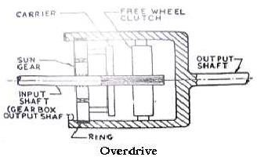

- Probablythe most obvious of these is the fuel saving. In normal use this can be expectedto be of the order of ten percent, but with care may be pushed up to well in excess of fifteen percent and if the fuel consumption / engine speed graph were linear, a comparative steady speed test should give twenty eight percent saving - butof course life doesnot consist of linear graphsand steadystate conditions!
- A less immediately obvious benefit is the potential engine and transmission wear reduction. As the car travels further, with an overdrive fitted, for the same number of engine revolutions as without, the engine and gearbox must wear out more slowly.
- This not only extendsthe life of valued components, but putsoffthe ugly day when a full power train strip down makes inroads into the bank balance.
- The third benefit is even less quantifiable, but is perhaps the most pleasing aspect of using an overdrive. It dependsless on theoryand calculationandmore onthediscerningdriverandthelocalCountyCouncil.Itis not only the cars that have developed over the years, but the roads that they run on are now straighter, less interrupted and smoother, and although even early cars may be capable of a respectable turn of speed, they possiblyhad littlechance of doing so for more than short burstson most of the roads oftheir time.
- Today, however, whatwith junction modifications and the straightening out of bends, even British"B" roads willusuallyallow a reasonable cruising speed for a reasonable period of time- relatively.The use of

anoverdrivethenallowstheenginetorelaxonthelongerstraightrunsand, pleasure of driving.
hopefully,enhancesthe

- The unit used by Tim Payne Overdrive Designs Ltd is the "Laycock J" or "2XP" type as was manufactured by LaycocksofCoventry,and whichisstillin production today.Thisisa well provendesignofmany years standing and has been fitted to numerous types of vehicle.
- It isan epicyclic gearing arrangement, , with a cone clutch either locking the input shaft to the output shaft for direct drive, or locking the centre gear to the case, thereby dictating that the gears on the input shaft rotate not only around their own axis, but also around the inner gear, so forcing the output shaft to rotate faster than the input.

- Thisis pleasant fromanengineeringaspectastheloadsare distributed withinthegear structure,andnot via mainsupport bearingsasisthecasewithaconventionalfixedcentregeararrangement. Acamisattachedto the input shaft and this cam operates a hydraulic pump, the lubricating oil doubling up as the hydraulic power medium.
- Whentheoperatingswitchmakes contact,asolenoidisactuatedwhichmovesavalveallowingthe hydraulic pressure to engage the cone clutch via a pair of pistons.By the addition of a flanged input shaft and frontclosingplate theunitismadeupintoa selfcontainedgearbox, complete withbreather, filler,level and drain plugs. The closed unitis then mounted in acarrying cradle and this is suspended on two rubber mountsonacrossbarwhichclampstothevehiclechassis.Athirdsupportingpointisthedriveshaft connecting the overdrive to the gearbox. This shaft includes either a stainless steel flexible coupling, or asingleuniversalorHooksjoint.Boththesecouplingsgiveexcellentaxialalignmentwhilstallowingan element of angular offset, as may be experienced by chassis flex
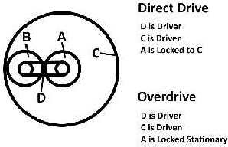

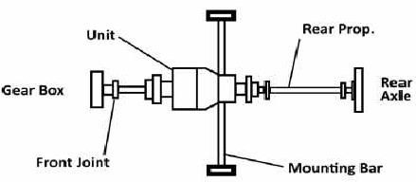
- This fitting arrangement borrows something from the principle of the three legged stool; it is inherently stableand compact and themounting pointsdo not run away fromtheir responsibilitiesby overloading one of their fellows.
Overdrivelayout
- Although thiswaschosen asthe most suitableconfiguration, a thorough understanding oftheinteraction of the components and some precise machining is required to ensure the assembly of a unit which is smooth and reliable. A conventional prop. shaft then runs from the rear of the overdrive to the rear axle of the car. To allow the speedometer to work correctly in all gears including overdrive, the speedometer drive at the rear ofthe unit isused, and attached to the existing cable via an adaptor box.
- Theadaptor boxis calibrated toalsotakeinto accountany variationsintyre size or axleratioand canallow for anycalibration drift which mayhave creptinto the speedometer instrument over time.
- The main criteria for fitting an overdrive are that there is sufficient room under the car, and that there is a minimumof38"ofprop.shaft.Havingsaidthat,developmentisunderwayforasystemforuseonthe

Torque tube Silver Ghost and Phantom I cars. The same principle is used, but with the overdrive mounted inside a "Torque Box" which replaces the front half ofthe Torque tube.
- It is a policy to avoid, as far as possible, altering the vehicle components, so allowing the car to be easily returned to original condition with no evidence that it had been "tampered with". With the 3 1/2 and 4 1/4 Derby models it is necessary to drill a hole for mounting an interlock switch near the gear lever, but this would never be done without theapproval ofthecustomer. Certainly cutting prop. shafts, welding brackets onto the chassisand modifying the bodywork are definitely not considered to be options. Only high quality componentsareusedand, as far as possible, partsare nickel plated or powder coat painted.

DISCUSSINDETAILABOUTTHEDIFFERENTTYPESOFWHEELSANDTIRESWITH RESPECT TO CONSTRUCTION, ADVANTAGES AND DISADVANTAGES.
WHEELS
  - Wheelscanbedefinedas―adiscorspokewithhub(revolvingaroundaxle)atcentre&hasa rimaroundthe outside of disc for mounting the tyre‖.

Necessityofwheel’s
  - Wheelmustsustainvehicle&passengerload.
  - Itprovidescushioningeffect&copeswithsteeringcontrol.

Requirementofwheel’s
  - Itshouldbelightinweight
  - Itshouldbepossibletoremoveormountthewheeleasily.
  - Itmustbebalancedbothstatically&dynamically.
  - Wheelsmaterialshouldnotdeteriorate.Itmusthavebettercorrosionresistance.
  - Itshouldhavegoodloadcarryingcapacity;itmustresistbending,tensile,compressive&torsionalstresses.
  - Cushioningeffectisnecessarytoabsorbshockload(duetoroadirregularities)&dampthevibrationfaster.

Type’sofwheels
  - Therearethreetypesofwheels,namely
    - Pressedsteeldisc
    - wheelWirewheel
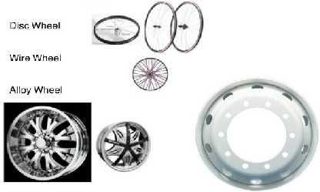
    - Lightalloycastorforgedwheel.

PressedSteelDiscWheel:
  - Pressessteeldiscwheelsconsistoftwoparts,
    - Steelrim
    - Pressedsteeldisc

Constructionofpresseddiscwheelisasbelow
  - Therim&discmaybeintegral,permanentlyattached orattachable(abovefigureshowsdiscweldedto rim).
  - Therimhasawell,whichallowsthetyretogoovertheedgeofoppositesideofrim.
  - A5°taperisgivenatedgeofrimonwhichtyreseats.

  - Pressedsteeldiscperformsfunctionofspokes.

  - Ventilationslotsareprovidedondiscforbettercoolingofbrakedrums.
  - Holesareprovidedonpresseddisc&rimformountingofwheel&airvalveresp.
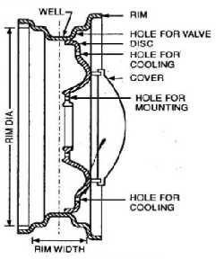

Discwheel
Features
  - Presseddiscwheelaresimpleindesign
  - Thesewheelsarerobustindesign.
  - Thesewheelshaveeconomicalprices.
  - Bettercoolingispossibleinthistypeofwheels.

Application
  - Thesewheelsareusedinheavymotorvehicle(tuck,tractor‘setc.)&car‘s.

WireWheel
  - WireWheelshaveSeparatehub,whichisattachedtorimthroughno.ofwirespokes.
  - Variouscomponentsofwirewheelsareasfollows:
    - Spoke
    - Hub
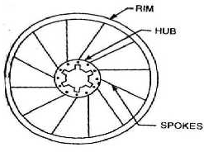
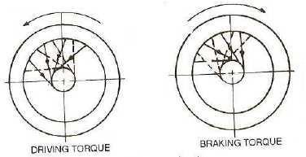
    - Rim

Wirewheel Arrangementofspokes

Spokes
  - Spoke‘soneendofspokeishookedtohubwhileotherendisattachedtowheelrim
  - Spokecarriesvehicles&passengersweight.Ittransmitsdriving&breakingtorque&withstandssideforces while cornering ( i.e :-cornering load & side thrust)

Hub
  - Hubisprovidedwithinternalsplines&ismountedontheaxleshaft.
  - Oneendofspokeishookedtohub end.

Rim
  - Rimhasholesatthecentreforattachingspokes.
  - Theonlydisadvantageofthisrimsare,tubelesstyrecannotbemountedonitbecauseofholesontherim.

Advantagesofwirewheels
  - Wirewheelsarelightinweight
  - Wirewheelsprovidebettercoolingofbreakdrum.
  - Theyhavehighstrength.
  - Theyhavebetterchangeabilityasonly1nutneedstobeopenedformounting&dismountingofwheel.

Application:-
  - 2wheelers&bicycles

LightAlloyCastorForged wheel
  - Automobile isuse of wheel made from Aluminum & magnesium alloy. These wheels are lighter than steel wheels.
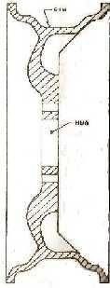
Lightalloywheel

Advantages
  - Lightalloywheelsarebetterconductorofheat,whichhelpstodissipateheatgeneratedbybreaking.
  - Widerrimsarepossibleinthiswheelswhichimprovesstabilityoncornering
  - Castorforgedwheelsneedtobemachinedyetithelpstomaintainclosetolerance.
  - Thesewheelsarelighterascomparedtosteel wheels.

  - Magnesiumalloyhavehighimpact&fatiguestrength,sotheycanstandvibration&shockloads.
  - Aluminumalloyareeasiertocastorforged&arelesspronetocorrosion.

Disadvantage
  - Theonlydisadvantageofthiswheelis,theyhavehighlypriced.

Application
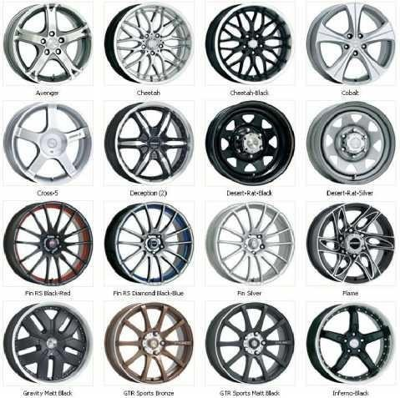
  - Castwheelsareusedincars&Forgedwheelsareusedinheavydutyvehicles.

Rims Necessity
  - Rimisoutercircularpartofwheelonwhichtyreismounted&supported.
  - Typesofrimsareasfollows
    - Wellbaserim
    - Flatbaserim
    - Semidropcentrerim.
    - Flatbasedividedrim

Wheelbaserim
  - Thistypeofrimisusedforpassengercartyres.Thewellenablestyretopassovertheedgeofoppositeside of rim.
  - Thetyregetslockedtorimoninflation,a slighttaper(5°)isprovidedforthispurpose.

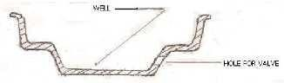

Wheelbaserim
Flatbaserim
  - Theflangeatoneendisheldinpositionbypushingbypushingtheflangesinward.Thistyrecanbe mounted & removed easily.
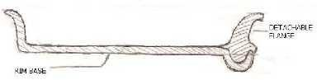
  - Flat basedrimareusedintyresofheavydutyvehicles.
Flatbaserim

Semidropcentrerim
  - Thistypeofrimisusedinlightcommercialvehicles.Itgivesadvantageofbothwellbase&flatbaserim.
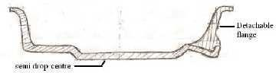
  - Thedetachableflangemakestyreremovaleasy, whileslighttaperhelpsthetyrelock onrim.
Semidropcentrerim

Flatbasedividedrim
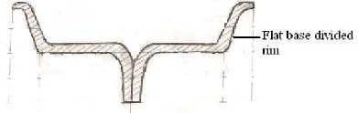
Flatbasedividedrim
  - Flatbasedividedrimsareintwo sections,whichareboltertogether.Thisrimsareusedinmilitary&heavy duty applications

TYRES
  - Tyre isa cushion provided with an automobile wheel. It consist of outer cover(i.e.:-tyre proper) which has tube inside. This tyre tube is mounted on wheel rim.

Necessityoftyre
  - Tyrereducesroadshocks&providescushioningeffect.
  - Tyreisresponsibleforimprovedtraction(i.e.:-betterfrictionbetweentyre&roadsurface)

PropertiesoftyreorRequirementoftyre

Requirementoftyre‘sareasfollows.
  - Load carrying capacity:-Tyre should be able to carry weight of vehicle& passengerwithout distortion.Tyre must resist bending, tensile, compressive & torsional stresses.
  - Cushioning:-Tyreshould absorbshockloadscaused due to due road irregularities&damp thevibration faster.
  - Uniformwear:-Uniformwearreducestyreskidding&vibrationduetoroadirregularities.
  - Non–Skidding:-Tread pattern must besuch that tyre must not skid. Thetyre must have high coefficient of friction
  - Powerconsumption:-Tyremusthavelowrollingresistance&thereforemustconsumeleastpowerof engine.
  - Noise:-Tyrenoisemustbeminimum.Itdependsontreadpattern&typeofroad.
  - Balance:-Thetyremustbestatically&dynamicallybalancedoritmaycausewheelwobbling.
Apartfrom above properties a tyre mustprovide betterdurability,good abrasive resistance,safety& have low cost.

Typesoftyres
  - Pneumatictyresareof2types
    - Conventionaltubetyre
    - Tubelesstyre

Conventionaltubetyre
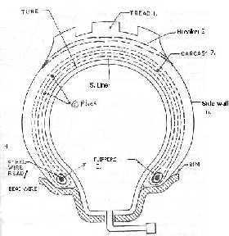
Conventionaltyrewithtube

Tread
  - Theshouldertoshoulderportionoftyrethatcomesincontactwithroadsurfaceisknownastread.
  - Its primary functionisto transmit driving & breakingtorque.Tread are bonded on carcass & material used are natural or synthetic rubber.

Breakers
  - Top two plies of tyre are known as breakers. This plies are widely spaced to help in spreading the shocksfrom road & to prevent radial growth oftyre during inflation.

Carcass/Casing

  - Carcassismadeupoflayersofcordimpregnatedwithrubber.Thenumberoflayersofcordvaries accordingto theuseof tyre(carcass have4-6 plies, heavy duty vehicles have 22 plies).
  - Carcassbearsshockload,sidethrust&vehicle‘sweight.

Flippers
  - Anumberoflayersofadditionalcordsarewoundaroundbeadwiredforextrastrength&avoidstress concentration.
  - Flippersarewounduptosmalldistanceonthe sidewall.

Sidewall
  - Itservesasprotectivecoveringtocarcass,butitissubjectedtomaximumflexing action,creatinglarge amount of heat building.

Beads
  - Coil ofwiresrepresentthebead.Anumberofhighlytensilesteel wireswhicharebuiltintheedgeoftyrein order to give strong edgesto press against the inner edge oftherim.
  - Thispliesofcordarefastenedtothem&thereforeserveasmetalfoundationoftyre.\

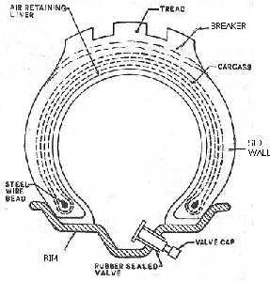
Tubelesstyre
SectionofTubelesstyre

Construction
  - Thematerial&designofcarcass&treadremainssimilartotubedtypetyre.
  - Theinsideofcasingislinedwithsoftrubberliningwhichformsanairtightsealwithrim,itisknownas
―air-retainerliner‖.Thisliningretainstheair&sealsitselfonbeingpuncture.
  - A―nonreturnvalve―is fittedtorimthoroughwhichtheairis forcedinsidethetyre.

Advantages
  - Temporarypuncturerepairs aremadewithoutremoving thewheel.Arubberplugis insertedatplaceof puncture.
  - Tyredeflatesslowly;airisretainedforlongerperiodevenafterbeingpunctured.
  - Tubelesstyresarelighterinweight&runcoolerthantubelesstyre.
  - Tubelesstyreimpartsmoreresistancetoimpactload.

  - Betterairsealingqualitiesareobtained.
  - Ithassimplerassembly,onlytyrehastobefittedoverrim(notube).

Disadvantages
  - Theonlydisadvantageofthistypeoftyreis,itsunsuitableforspooked&corrodedwheel‘s.

Tyrematerial
  - Basicconstituteoftyreareasfollows
    - Rubber-naturalorsynthetic.
    - Cordofstabilizerbelt.
    - Steelforhightensilesteelbeadwires.

Rubber-naturalorsynthetic
    - Naturalrubber:-Itwasusedtoimpregnatethecarcasscottoncords.
    - Styrene butadiene rubber (SBR):-SBR wasused to impregnate on nylon cords. It provides better road grip, better abrasive resistance & smooth ride.
    - Poly butadiene (PB):-PB is mixed with SBR&additives like carbon black, oil& sulphur imparts anti wear, anti-skid & anti heat properties.
  - Cordofstabilizerbelt:Thematerialusedisrayon,Terylene,glassfibreorsteel.Steeliscommonlyusedin case of radial tyre belt.
  - Steel for high tensile steel beadwires: Bronze plated highly tensile steelwire is used, onwhichspecial rubber is insulated. Above given are material used for varioustyre component.

Carcass
  - Carcassis main structure ofwire whichtakesstresseswhileoperation&tyreisnamedonthebasisofcarcass used.
  - Therearethreetypesofcarcass
    - Crossplytype
    - Radialplytype
    - Beltedbiastype

Crossplyorbiasplytype:
  - Inthistype,theplycordarewovenatanangle(30-40°)totyreaxis.
  - Thereare2layerswhichruninopp.directionasshowninfigure.
  - Thisconstructionallowscarcasstoretainitsstrengthduringtyrerotationprovidescomfortableride.
  - Thuscarcassisabletoresiststressescausedduetosuddenacceleration,Cornering%breaking.
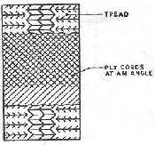
Crossplyorbiasplytype

Radialplytype
  - Inthisstructureplycordsruninradialdirection(i.e.:indirectionofthetyreaxis)

  - Over this basic structure run a number of breaker strips in circumferential direction. The material for breaker strip must be flexible but in extensible so that no change of circumference takesplace with change in amount of inflation.
  - Breakersarewidelyspacedtohelpinspacedtohelpinspreadingshocksfromroad&preventradialgrowth.
  - Theinextensiblebreakerstripsprovideslateral&directionalstability.
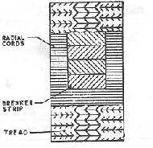
Radialplytype

Beltedbiastype
  - Thisisacombinationofcrossply&radialplystructure.
  - Thebasic structureiscrossplyover whichrunanumber ofbreakerbelts.Thisbeltimprovescharacteristics of bias ply tyre to a large extent.
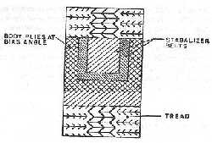
Beltedbiastyre

Featureofbeltedbiastyre
  - Thestressesincarcassarerestricted&treadareaisstabilizedduetobelts.Thisincreasestirelife.
  - Breakerbeltholdsthetreadflatteragainstroadsurface&providessaferide.
  - Beltincreasesresistanceoftyreforcuts&punctures.

Advantage
  - Treadsofradialplyoffersbetterstiffness&resistanceresultinginbettergrip.
  - Radialplyhavelongertreadlife.
  - Radialplyprovidebetterbreakinggrip.
  - Radialplyhavebettersteeringcharacteristicsascomparedtocrossply.

ComparisonbetweenRadialply&Crossply
S.No | Radialplytyre | Crossplytyre
1 | In radial ply type, the cords of tyre run in radial direction | In cross ply type, alternate layers of cords run in opposite direction
2 | Thecordplyarewoveninradialdirectionoftyre | Thecordplyarewovenatangle(30-40°)tothe

 | axis | tyreaxis
3 | Radialtyreareprovidedwithbreakerstrip,thusa continuousflat contact is possible with road  surface | There isnobreakerstrip inthis tyre. Thus continuousgripwithroadsurfaceisnotpossible
4 | Thistyrehaslowrolling resistance,thusbetter fuel efficiency | The crossplyhasmorerollingresistanceascompared to cross ply
5 | Thistyreprovidesbetterdirectionalstability | Thistyrehaswobblingcharacteristics
6 | This tyre has greater sidewall flexibility&treads stiffness | Sidewallflexibility& tread stiffness is lesser as compared to radial ply tyre.
Tread
  - Treadcanbedefinedas―ShouldertoShoulderwidthofthetyrethatcomesincontactwiththeroad surface‖.

Necessityoftreads
  - Itimprovestyreabilitytotransmitdriving&breakingtorque.
  - Itprovidesstability&nonskiddingcharacteristictotyre.
Straighttread:Itprovidesbetteradhesion,goodgrip&bettersteeringstability.
Crosstread:tprovidesbettergripbutithasrapid,irregularwear&noisyrunning
Square tread -It provides straight &sideway grip but it hasirregular wear on hard road has noisy running Combinationtread-Itiscombinationofcross&straightpattern.Ithasgoodwearresistance&steering characteristics. Application-trailer & farming application.
Vpatter–Deepgroovepattern–thesetyreareusedonrough&loosesurface,givingmaximumgrip& sideway stability.
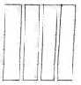
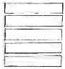
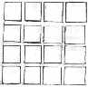
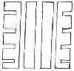
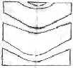
Straighttread crosstread squaretread combinationtread Vpattertread
Application-Tractor‘srearwheel.

TyreInflation
  - Theinflationpressureisrecommendedbythevehiclemanufacturerdependingupontyresize,speed&load.

Underinflationcausesthefollowingdefects
    - Uneventreadwear,morewearattyresides.
    - Lackofdirectionalstability.
    - Increasedrollingresistanceleadingtoincreasedfuelconsumption.
    - Excessiveflexingofsidewallcausesbuildup.
    - Thevalvemayberippedoutduetotyrepunch.

Overinflationcausesthefollowingdefect
    - Reducedtreadcontactareawithroadsurface.
    - Reducedtyregrip.
    - Reducedimpactresistance.
    - Increasedvibrationresultinginuncomfortableride.
    - Increasedstressesmaycausestreadseparation&crackinthesidewall

WITHNEATSKETCHEXPLAINTHEVARIOUSPARTSINAFRONTAXLEASSEMBLY.(OR) EXPLAIN THE DIFFERENT TYPESOF STUB AXLE WITH NEAT SKECTH.
  - Front axle carries the weight of the front part of the automobile aswell as facilitates steering and absorbs shocks due to road surface variations.
  - Thefrontaxlesaregenerallydeadaxles,butareliveaxlesinsmallcarsofcompactdesignsandalsoin case of four-wheel drive.
  - Thefrontaxle is designedtotransmittheweightof the automobilefromthe springs tothefrontwheels, turning right or left as required.
  - To prevent interference due to frontengine location, and for providing greater stability and safety at high speedsbyloweringthecentreof gravityoftheroadvehicles,theentirecentreportionoftheaxleisdropped.
  - A live front axlecontains the differential mechanism through which the engine power flows towards thefront wheels.
  - Forsteeringthefrontwheels,constantvelocityjointsarecontainedintheaxlehalfshafts.
  - Without affecting the power flow through the half shafts, these joints help in turning the stub axles around the king-pin.

Frontwheelsofthevehiclearemountedonfrontaxles.
  - Itsupportstheweightoffrontpartofthevehicle.
  - Itfacilitatessteering.
  - Itabsorbsshockswhicharetransmittedduetoroadsurfaceirregularities.
  - Itabsorbstorqueappliedonitduetobrakingofvehicle.
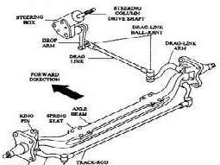
FrontAxle

AXLE
  - Axles are also an essential component of an automobile. There are two types of axles: The one which transmits power to the wheel is known as live axle and the one which does not transfer any power and acts like a beam is known as a dead axle
  - Axles are an important component of a car. All cars have two main axles in it: front axle and dead axle. Apart from this, there is a stub axle which is not found in every car. Axles are a kind of shaft which freely rotates on its desired axes, the axes connecting centers of opposite side of wheels. Axles are used to rotate the wheels of a car. Sometimes, other mechanical componentsarealso mountedonaxles.

DEADAXLE
  - Deadaxlesarethoseaxles,whichdonotrotate
  - Theseaxleshavesufficientrigidityandstrengthtotaketheweight.

  - Theendsoffrontaxlearesuitablydesignedtoaccommodatestub axles.
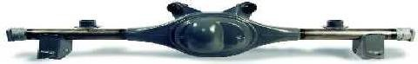

LIVEAXLE
  - Liveaxletransmitspowertowheelscomingfromthedifferential.Oramechanicalengineerwillcallita
‗primemover‘.
  - The live axle is in a two halfaxles both of which are combined with a differential using the universal joint. Each half ofa jointis connectedtoits corresponding wheelsusing constant velocityjoint (CV). Therole of CV joint isto facilitate vertical as well as pivot motions ofa wheel assembly.
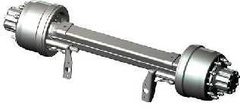

STUBAXLE
  - The front wheelsare mounted on the stubaxle, which are connectedto the frontaxle by means ofking pin. Thestubaxlesarethe forgingof3per cent nickelsteelandalloysteelscontainingchromiumandvanadium.
  - The stub axle turns on the pin which is a light drive fit in the axle beam eye located and lockedby a taper pin or some similar arrangement.

TYPESOFSTUBAXLES
  - Elliot
  - ReversedElliot(Mostcommonlyused)
  - Lamoine
  - Reversedlamonine
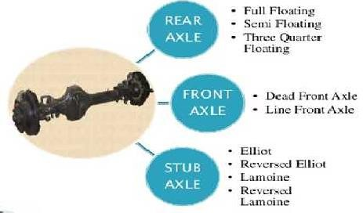
Typesofaxles

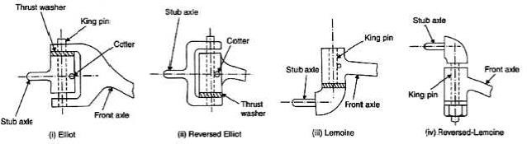
Typesofstubaxle
Elliotstubaxles
  - Inthistypetheaxleisa singlerigid‗I‘shapedbeam witha provisiontofitthestubaxleatitstwoends.The end ofthe axle is Elliot shaped (U-shaped) with two eyes.
  - Thestubaxleismountedinbetweenthetwoeyeswithathrustbearingatthetopendofthestubaxle

ReversedElliotstubaxle
  - Inreversed elliot type stubaxlethearrangement isreversed. The axle beam is mountedin between the two eyes of the stub axle with a thrust washer at the bottom ofthe axle.
  - Itiscommonlyusedinvehiclebecauseofthefollowingreasons.
    - Itiseasier tomanufacture
    - Loadexertedbythestubaxleisequallydistributed
    - Duetoequallydistributedloadsteeringloadsteeringiseasy.

Lemoinetypestubaxle
  - In this type, instead ofayoke type hinge, an L-shaped. Spindle is attached to the end of the axle by means of a pivot.
  - Thestubaxleismountedonthebottomoftheaxlebeam.Itisusedintractors.

ReversedLemoinetypestubaxle
  - Inthis type of stubaxle, the arrangement isreversed. Hencethe stubaxleis mounted onthetop oftheaxle beam

FrontAxleConstruction
  - TheaxlebeaminuseisofIorH-sectionandismanufacturedfromalloyforgedsteelforrigidityand strength.
  - As compared to dead front axles, a totally different type of swiveling mechanism is used on the live front axle.
  - Toconnectthewheelhubaxleswithdrivingaxleshafts,constantvelocityjointsareused for the vehicles fitted with the front live axles.
  - Tracta,Rzeppa(orSheppa)onBendixconstantvelocityoruniversaljointsarenormallyused.

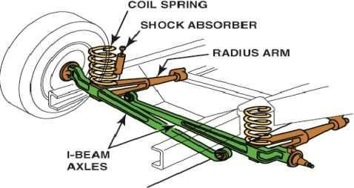
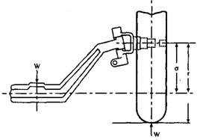

Loading
  - Frontaxlesaresubjectedtobothbendingandshearstresses.
  - Inthe static condition, theaxle maybe considered asa beam supported verticallyupwardat the ends i.e. at the centre ofthe wheelsand loaded verticallydownwardat the centres of the spring pads.
  - The vertical bending moment thus caused is zeroat the point of supportandrises linearlyto a maximumat the point of loading and then remains constant.
  - Thusthemaximumbendingmoment=Wl,Nm Where, W = The load on one wheel, N
I=thedistancebetweenthecentreofwheelandthespringpad,m

EXPLAINTHEWHEELALIGNMENT,FACTORSOFWHEELALIGNMENTANDFACTORS PERTAINING TO WHEELS WITH NEAT SKECTH.
WHEELALIGNMENT

Positionofthesteeredwheelstoachievethefollowingistermedwheelalignment
  - Directionalstabilityduringstraightaheadposition
  - Perfectrollingconditiononsteering
  - Recoveryaftercompletingtheturn

Theredifferenttypesofalignment
  - Thefront-endalignment
  - Thrustanglealignment
  - Four–wheelalignment
    - Duringthefrontwheelalignment,onlyfrontaxleanglesaremeasuredandadjusted.

    - This type of alignment is alright for vehicle having a solid rear axle, but confirming that the rear are positioned directly behindthe front tyresisalsoimportant, which isdone withthrust anglealignment.
    - However , all vehicle do not have fully adjustable parameter, some vehicle require after market kits to allow sufficient adjustment to compensate for accident damage or for change in alignment due to the installation of lower springs.
    - It also has to be remembered that the alignment has tp be done only when the vehicle carries the specified

Thrustanglealignment
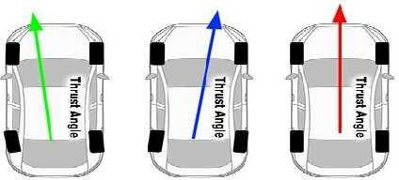
Four–wheelalignment
  - In the panel above, the red line represents the thrust angle, which should run at a right angle through the length of the car relative to the centre line oftherear axle, andif this settingis correct,the front wheels are aligned to this line.
  - However, ifthe center line oftherearaxleis notatrightangles withthethrustline,themisalignedrearaxle (as shown by the green and blue lines) will force the rear wheels not to follow the front wheels, and continual counter steering is required to keep the vehicle moving in a straight line. Thrust line adjustment therefore involvesrealigning the rear axle with thethrust line to ensure that the rear wheels run inthe same lineasthe front wheels without the need to applya corrective steering input.
  - The image above shows all the adjustments required to ensure that all the wheels on a vehicle are properly alignedtoeachother,aswellastothecenterlineofthevehicle,whichiscommonlyreferredtoasthe―thrust line‖.
  - Although this type of procedure is most commonly performed on powerful high-end sports cars to ensure that the car‘shandling characteristicsarenot compromised, many ―ordinary‖ carscan benefit greatly from this procedure as well. If the procedure is performed by a suitably qualified technician, this procedure produces the best results in terms of alignment accuracy.

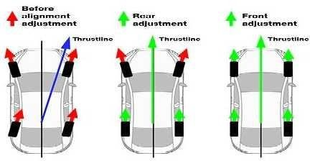

FactorsofWheelAlignment
  - Wheelalignment,sometimesreferredtoasbreakingortracking,ispartofstandardautomobilemaintenancethat consists ofadjusting the angles of wheelsto the car manufacturer specifications.
  - The purpose ofthese adjustments is to reduce tirewear, and to ensure that vehicle travel is straight and true (without "pulling" to one side). Alignment angles can also be altered beyond the maker's specifications to obtain a specific handling characteristic.
  - Motorsportand off-road applicationsmay call for anglesto beadjusted wellbeyond "normal", fora variety of reasons.
  - An increasing number of modern vehicles have advanced driver assistance systems (ADAS) such as electronic stability control, anti-lock brakes, lane departure warning, adaptive cruise control and traction control. These systems can be affected by mechanical alignment adjustments. This has led many manufacturerstorequire electronic resets for these systemsafter a mechanical alignment is performed
    - Toe-inandtoe-out
    - Goodsteering,handlingandvehicle,itisalsonecessary
      - setback(thedistanceb/wplacingofthefronttyres)
      - thethrustangle
    - Factorspertainingtowheels
    - Steeringgeometry
    - Steeringlinkage
    - Suspensionsystem
  - Toe-In:It is theamount by which front wheelsare set closertogether in frontthan attherear when viewed fromthetop. It is doneso that wheelsmove perfectly straight under normal condition. It does not exceed 3 mm.
  - Toe-Out:Itistheamountbywhich front wheelsare setapartin frontthanattherear whenviewed fromthe top.Initiallydoneinfront wheeldrive toavoidtendencytotoe-in.Itistheinherenttendencyinrear wheel drive.
  - Setback: - Set back is defined, where one of the front wheels is sittingback (relative to the wheel on the other side).Frontsetbackisameasurementreferencingthefrontwheelstoalineplacedperpendiculartothe vehicle centerline. ... Positive setback indicates that the right front wheel is setback further than the left. Negative setback refers to the left front wheel being further back than the right.

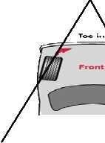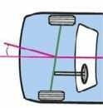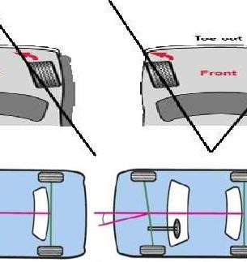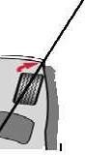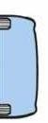
Positivesetback Negativesetback

ThrustAngle
  - The thrust angle is an imaginary line drawn perpendicular to the rear axle's centerline. It compares the direction that the rear axle is aimed with the centerline of the vehicle. It also confirms if the rear axle is parallel toits front axle andthat the wheelbase on both sides ofthe vehicle is the same.
  - If the thrust angle is not correct on a vehicle with a solid rear axle, it often requires a trip to the frame straightening shop to correctly reposition the rear axle.
  - Avehicle withindependent rearaxles mayhaveincorrecttoe-inortoe-out on both sidesoftheaxle, or may have toe-in on one side and toe-out on the other. The suspension on each side of the vehicle must be adjustedindividuallyuntil it hasreachedtheappropriate toe setting for its side of the vehicle.
  - An incorrect thrust angle is often caused by an out-of-position axle or incorrect toe settings. So in addition to the handling quirks that are the result ofincorrect toe settings, thrust angles can also cause the vehicle to handle differently when turning one direction vs. the other
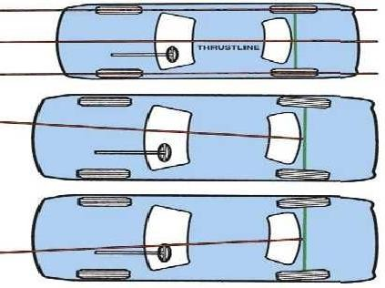

FactorsPertainingToWheels
Balance of wheels - If the wheels are not in dynamic balance, the wheel wobble may result, which influences steering control.
Inflationoftyres–the steeringsystemisdesigned foraparticularrollingradius.Variationofairpressurefrom the standard prescribed will change the rolling radius.
Brakeadjustment-Ifthebrakeisnotadjustedproperly,itcanpullthevehicletoonewhilebraking.

SKETCHANDEXPLAINVARIOUSSTEERINGGEOMETRIES.
  - Camber
  - Kingpininclination(steeringAxisInclination)
  - CombinedangleandscrubRadius
  - Castor
  - Toe–inorToeout
  - Toechangeorbumpsteer

Camberangle
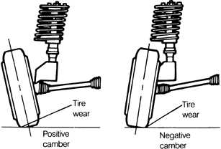
Camberangle

  - Camberangle istheangle betweenthe center line ofwheel & the vertical line when viewed from front side ofa vehicle. It usually varies from +2 degree to -2 degree.
  - The camber angle has influences on the tyres ability to generate lateral forces. A camberedrolling pneumatic wheel produces a lateral force in the direction of the tilt. This force is referred to as ‗Camber thrust‘ when it occurs at zero slipangles(e.g. steering straight ahead).
  - Camber affects the aligning torque, making the wheels wanting to point straight ahead even when not rolling, due to distortion of the tyres footprint. The effect of this is rather small and tends to be cancelled with increasing slip angle.
  - Cambering the wheel also leads to an increase in the lateral force produced by the wheel when cornering. Camber changes as the wheel moves up and down. This change has a linear range and a non-linear range. Lateral forces increase in the linear range of the tyre. If the linear range is exceeded the additive effects of the camber inclination decreases, this effect is called Roll-off.
  - Therefore the difference in lateral force when comparing a cambered wheel and a non-cambered wheel is small, around 5-10% at maximum slip angle (e.g. very hard cornering). The difference is muchlarger at zero degrees slip angle (e.g. straight ahead) dueto the camber thrust.

  - The effects of cambering the tyre are bigger for a bias ply tyre than a radial ply tyre. For radial tyre the camber forcestendsto fall ofat camber anglesabove5° whilethe maximum force due to camber for a bias ply racing tyre occurs at smaller angles.
  - Camber is measured with a caster camber gauge and is usually easily adjusted with shims or adjustable upper a-arms. Always check the toe when making camber or caster adjustments. This should be done with the driver and any ballast.
  - Theamount ofstatic camberthat you shouldrunisa result oftesting,tyretemperature measurements, front suspension geometry etc.
  - Settingthecamberto0°willminimizingtherollingresistance.
    - PoorCambersettingswillcause:
      - Excessivetyrewear.
      - Cambersettingssettoextremescanreducethebrakingabilityofthecar.
  - Positive camber: When top side of the wheel is tilted away from the vehicle it is called positive camber. Positive camber is usually preferred for ATV (Automated Transfer Vehicle), heavy& public transport vehicles with rigid axle suspension because the wheels straighten out when heavily loaded vehicle is set in motion.
  - NegativeCamber:Whentopsideofthewheelistiltedtowardsthevehicleitiscallednegativecamber.
- Negativecamberincreasestheareaofcontactpatchthusincreasingtractionforce&tyregrip enabling high speed driving.
- Tyrewearisless&uniformascomparedtopositivecamber.
- Negativecamberangleincreasescorneringforcehelpingthedrivertoturnvehicleeasily.

Kingpininclination(steeringAxisInclination)
  - SteeringAxisInclination(SAI)isalsoknownasKingPinInclination(KPI).
  - The ‗Steering Axis‘ is the axis around which the wheel assembly swivels as it turns to the right or left. It‘s formed by drawing a line through the upper and lower ball joint pivots. This axis is not necessary centered on the tyre contact patch. Ifyou view this as from the front it is inclined inwards at the top. ‗Steering Axis Inclination‘ istheanglein degrees between the‗steeringaxis‘ and vertical.
  - Steering axis inclination (SAI) causes both front wheels to gain positive camber as they steer away from center. This acts with caster to provide self-centering of the front wheels. This gives the car straight line stability.
  - Withthewheelsinthestraight-aheadposition,thestubaxlesarealmosthorizontal.
  - As the wheels turn to either side, SAI causes the stub axles to decline and the ends. In order for this to happen the inside end of the stubaxle must riseandthis inturns raises the frontof the car.
  - The massof the vehicle pushes down on the stub axles, so when the steering wheel is released, the wheels are pushed back to the central position.
  - Withoutanyinclination, no self centering would occur.The mass ofthevehicle would notresistthe wheels from being pivoted by the bump (Bump Steer). The steering would be hard to control and straight line stability would be very low.

SteeringAxisInclinationEffects
  - Withpositive‗SpindleLength‘,thecar willberaisedupasthewheelsareturned.Thereisanincreaseinthe steering moment at the steering wheel. Regardless of whichway thefront wheelsareturned,the larger the Steering Axis Inclination angle is, the more the car will be raised. Without any caster, this effect is symmetrical from side to side.Theraiseofthe car hasa self-aligning effect ofthe steeringatlow speeds.
  - SAI affectsthe‗Steer Camber‘. Thisiswhena wheel leanswhenthewheelsaretuned(positivecamber for positive SAI angles). The amount of this is small but not to be neglected, especially for a vehicle making tight high speed turns.

  - If the driving or braking force is different on the left and right side (due to wheel spin orskidding), there will be an induce steering torque proportional to the scrub radius. This will be felt by the driver at the steering wheel. Under acceleration this is often called ‗TorqueSteer‘.
  - The distance from the ‗Steering Axis‘ to the wheel centre plane measured horizontally at axle heightis called ‗Spindle length‘.
  - Steering axis inclination brings the pivot point close to the center of the tyre contact patch at the road surface. It intersects withthe camber line drawn through the tyre and the wheel.
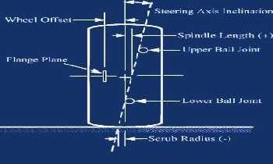

  - If these 2 lines intersect at the center of the tyre, at the road surface, then the vehicle is said to have zero offset, or zero Scrub Radius.
  - If they intersect above the road surface, then ithas negative offset or Scrub Radius (shown above). The anglebetweenthesteeringaxisinclinationandthe camberlineiscalledthe includedangle.Itisa diagnostic angle.
  - Iftheyintersectbelowtheroadsurface,thenithaspositiveoffsetorScrubRadius(shownbelow)
- Steering axis inclination is set by the dimensionsof the upright and therefore not adjustable once defined.
- Steering Axis inclination is usually kept below 8°since too much SAI causes a lot ofrising ofthe front axle when steering.

IncludedAngle:
  - The sum of the camber and SAI angles ina front suspension. This angle is measured indirectlyand is used primarily to diagnose bent suspension parts such as spindlesand struts.

CombinedangleandscrubRadius
  - Itistheangleformedintheverticalplanebetweenthewheelcentrelineandkingpincentreline.
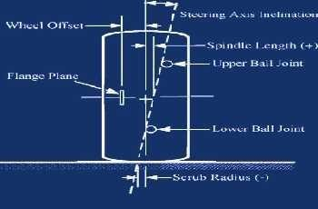
  - Itisalsosaidasthecombinedangleofcamberandkingpininclination.

- The scrub radius is the distances in front view between the Steering Axis and the centre ofthe tyre contact patch where both would theoretically touch the road.
- The―steeringaxis‖isthelinebetweenthetoppivot pointofthehubandthelowerballjointofthehub.The inclination of the steering axis is the angle of inclination from vertical and is known as SAI (Steering Axis Inclination) or KPI (King Pin Inclination).
- If the steer axis intersection point is outboard of the center of the contact patch it is negative, if inside the contact patch it is positive.
- Large positive values of scrub radius, 4 inches or 100 mm or so, were used in cars for many years. The advantage ofthis isthat thetyre rollsasthe wheel is steered, which reduces the effort when parking.
- On a rear-wheel-drive vehicle with positive scrub radius, the vehicle‘s forward motion and the friction betweenthetyreandtheroadcausesa forcewhichtendsto movethe frontwheelsback,keepingthevehicle heading straight ahead.
- This also allows greater width in the engine bay, which is very important in some compact sports cars. During braking, on any type of drive, if braking effort is greater on one side of the vehicle than the other, positive scrub radius will cause the vehicle to veer towards the side with the greater effort. It therefore requires much higher driver involvement and also competence to maintain control and stop the vehicle being tugged into puddles.
- Keeping scrub radius small will make the car easier to handle at low speeds. It also reduces the risk, that a lose oftraction on one front wheel during braking, causesthe car to change direction. Ifthe scrub radiusis small thenthe contact patchis spun in place when parking, whichtakes a lot more effort.
- The advantage of a small scrub radius is that the steering becomes less sensitive to braking inputs, in particular. However, zero scrub radius, under hard braking, causes the suspension to be skittish because varying road conditions created varying amounts oftorque (both positive and negative) around the steering axis. Therefore, some amount of scrub radius, positive or negative, is preferred. Having a small amount of scrubradius,under hard braking,generatesa smallbitoftorquetoa predictableside.Whilethistorqueisn‘t desirable, it‘s predictable and relatively not−affected by changes in road conditions, which makes the steering smooth.
- An advantage of a negative scrub radius is that the geometry naturally compensates for split braking, or failure in one of the brake circuits. Vehicles with a diagonal-split brake system have negative scrub radius built intothe steering geometry. If onehalf of the brake system fails,then the vehicle willtendtopull upin a straight line.
- Negative scrub radius also provides centre point steering in the event of a tyre deflation, which provides greater stability and steering control in thisemergency situation. If you hit a puddleat speed on one side of the car, with negative scrub radius the torque on the steering will steer you away from the puddle. This balances the effect of drag on one side ofthe car.

CasterAngle
  - InthesideviewtheinclinationoftheSteeringAxis(alsoknownaskingpinaxis)iscalled‗CasterAngle‘.
  - If the ‗Steering Axis‘ doesn‘t passthroughthe centre of the wheel thenthereis a side view ‗Steering Axis Offset‘present.Thedistancefromthesteeringaxistothecentreofthetyrefootprintiscalled‗Trail‘or
‗Caster offset‘.
  - Casterangleandtrailareofimportancewhendesigningthesuspensiongeometry.

Theeffectstoconsiderare:
  - Astrailisincreasedmoresteeringtorqueoreffortisneeded.
  - Casteranglewillcause thewheeltorise andfallwithsteer.Thiseffectisopposite fromside toside and causes roll and weight transfer. Leading to an over-steering effect.
  - Casteranglehasapositiveeffect onsteer-camber.Withpositive casterangletheoutside wheel will camber ina negativedirectionand theinner wheel ina positivedirection, causing both wheelstoleanintotheturn.

  - The sizeofthe mechanical trail due to caster maynot betoo large comparedtothePneumatic trail fromthe tyre. The pneumatic trail will approach zero as the tyres reaches theslip limit. This will result in lowering the self-centering torque that is present due to the lever arm between the tyres rotation point at the ground andthepoint ofattack forthelateral force.Thiswillbeasignaltothedriverthatthetyreisnearbreakaway. This―breakaway signal‖ maybelost ifthemechanical trailislargecomparedtothepneumatictrail.
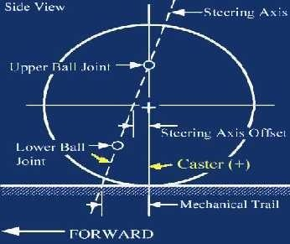

  - Caster is measured in degrees by using a caster camber gauge.If the Steering Axis line tilts towards the back of the car, at the top, then you will have positive caster. If the line tilts forward then you would have negative caster.
  - Positivecasterprovidesthedirectionalstability.
  - Too much positive caster will make the steering effort difficult; however power steering will allow you to run more.
  - Negativecasterrequireslesssteeringeffortbutcancausethecartowanderwhendrivinginstraightlines.
  - The caster angle has positive effects during cornering but too much caster causes weight transfer that will have an over-steering effect.
  - Thepossibilitytoadjust the camber angle from0°toabout -4°willbe very helpful duringthetestingofthe car.
  - Settingthecamberto0°minimizingtherollingresistanceduringacceleration.

Slipangle
  - Eventhoughthenameusestheword―slip‖,thischaracteristichasnothingtodowithslippingorskidding.
  - Slip angle is the angular difference between the direction of the tyres‘ contact patch with the road and the direction of the wheel rim. A non-zero slip angle arises because of deformation in the tyres‘ carcass and tread. A slipangleresults froma combination of tyre sidewall flexand tyre traction.
  - When a wheel travels in a direction other than the one its contact patch is pointing, then you have a SLIDE angle rather than a slipangle. A carin fact travelsin the direction ofthe contact patch and not the direction of the wheel rim.
  - Toseetheaffect whilstthe car isstationary issimple. Small movementsof the steering can be made before traction is broken and the wheel actually turns. This is due to the tyres flexing. As the slip angle increases, moreofthecontact patchisslipping.Eventually, solittleofthecontact patchisslipping,thattractionislost and the tyre begins to slide. Slide traction increases linearly virtually until traction is lost, then increases more gentlyallowing the driver some degree of control before final loss oftraction.

  - Unlike the rearaxle,if alargeamountofslipyoucanadjustthesteeringtokeepthecartraveling inthe desired direction. This situation isknowna ‗Understeer‗.
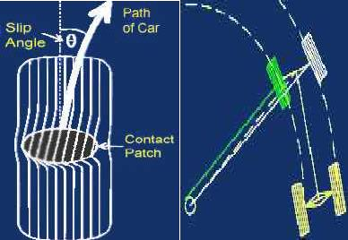
Slipangle

  - It can be seen in the diagram left that both rear wheels have a large amount of slip and inside front tyre is also generating slip.
  - Increasingtheslipanglesatthereartendsmakethecarlooser(oversteer).Likewise,reducingtheslip anglesat therear can beinterpreted bythe driver as makingthe car feel‗tighter‘.
  - Increasing theweighttransfertowardsthefront,increasestheslip anglesontheforntwheels.Thismay require a larger steering wheelangle (Understeer).Reducing weighttransfer will havethe opposite effect.

Itemsthateffectweighttransferandslipare:
  - Springrates
  - Springlocations
  - Swaybarrate
  - Weightdistribution
  - BrakeBalance
  - Heightoftherollcenters
  - rollstiffness
  - Additionofananti-rollbar

Whatelseeffectsslipangles?
  - Accelerationandbraking(primarilybecauseofweighttransferandtoe-anglechanges)
  - Tyreprofilesize
  - Camber – More camber equalsgreater camber thrust. Camber thrust attemptstoturnyour wheel intoa turn inthe direction of lean. Therefore more camber thrust gives smaller slipangles.
  - As passenger cars are often only exposed to low lateral accelerations, Ackermann steering is set-upto ensure that all wheels roll freely with no slip angles because the wheels are steered to track a common turn centre.
  - Race cars can operate at high lateral accelerations and therefore all the tyres operateat significant slip angles and the loads on the inside wheels are much less than the outside wheels due to the lateral load transfer.
  - Racecarsuse Parallel or even Reverse Ackermann, as low speed steering geometry would causetheinside tyre to be dragged along at much higher slip angles than needed. This would result in raised tyre temperatures, slowing the car down due to slip induced drag.

ToeIn/ToeOut
  - Theamount oftoe is expressed in degrees,as theangle from parallel ofthe front wheels. Sometimes Toe is expressedas the difference between thetrack widthsofthe leadingand trailing edges ofthe front wheels.
  - Toe adjustment can be used to overcome handling difficulties in the car. Rear toe-out (independent rear suspension) can be used to improve the turn−in. As the car turns in the load transfer adds more load to the outside wheel and the effect is in an over-steer direction. The amount of static toe in the front will depend on factors such as Ackermann steeringgeometry, rideandroll steer, compliance steer and camber.
  - For minimum tyre wear and power loss, the steering wheels should be paralleland point directly ahead whenthe car isrunningina straightline.Toe settings have similar effects whenappliedtotherear wheels.
  - Excessivetoe-inortoe-outcausesthetyresto scrub, since theyarealwaysturnedrelativeto the direction of travel.
  - AnglesofToearesetinconjunctionwithAckermanngeometrysosetsteeringperformanceinbends.
  - Before makinganyToeadjustments, make sure the steeringisstraight ahead. Fora truelyaccurate method, measure the both steering arms to identical mirrored parts ofthe chassis.

Toesettingsaffectthreemajorareasofperformance:
  - Tyrewear
  - Straight-linestability
  - Cornerentryhandlingcharacteristics.

ToeAngles:
  - ForavehicletohaveZeroToebothfrontwheelswouldbeparallelandpointingdirectlyforward.
  - ForavehicletohaveToeINtheleadingedgesofbothwheelsarepointedslightlytowardseachother.
  - ForavehicletohaveToeOUTthetrailingedgesofthefrontwheelsarepointedslightlytowardseachother
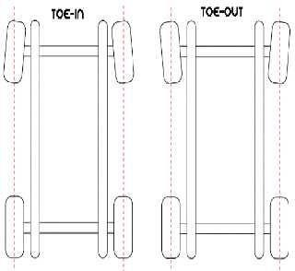

SowhyhaveToe?
  - Minimum tyre wear and power loss are achieved with zero toe, so why have any toe angles at all? Toe settings have a major impact on directional stability.
  - Toe settings become a tradeoff between the straight−line stability (toe-in) and the quick steering response (toe-out) and tyre wear. Driving a passenger car with low straight line stability can be very tiresome, but racing cars sacrifice a bit of stability on the straightaway for a sharper turn−in to the corners. Therefore, passenger cars are generally set up with a small amount of toe-in, while race cars are often set up with toe−out.

  - FormoreinformationonToeseeAckermannGeometry
  - Bumpsteeristhechangeintoeangleduetowheeltravel.

ToeIn
  - With the steering wheel centered, toe−in causes the wheels to tend to roll along paths that intersect each other. Underthiscondition,the wheelsareatoddswitheach other,andnoturnresults.The vehicle wantsto drive in a straight lineand the steering would naturallytryto self centre.
  - When the wheel on one side ofthe car encountersa bump, that wheel ispushed rearward about its steering axis. This action also pulls the other wheel in the same direction. If it‘s a minor disturbance, the disturbed wheel will steer onlya smallamount, sothat it‘srolling straightaheadinstead oftoed-in slightly.
  - With slight steering inputs, the wheels have absorbed the irregularity without significantly changing the direction of the vehicle. In this way, toe-in enhances straight-line stability.
  - Passenger cars are usually equipped with soft rubber bushes. Distortion in these bushesactually allowsthe wheels to track parallel and reduce tyre wear.
  - Racing cars on the other hand have joints with spherical bearings with optimum rigidity, thus a road car requires greater toe-in.
  - Asmall degree oftoe−in ona car with positive camber will canceltheturning tendency caused by camber, reducing wear and rolling resistance.
- ToeInpromotesstraightlinestability.
- Toomuchtoe-incausesacceleratedwearattheoutboardedgesofthetyres.

ToeOut
  - Toeoutpromotesaveryquickandlightfeelingsteeringresponse.
  - The front wheels are aligned so that if a steering wheel hit a bump the vehicle will tend to turn towards it. Any minute steering angle beyond the perfectly centered position will cause the inner wheel to steer in a tighter turn radius than the outer wheel. Thus, the car will always be trying to enter a turn, rather than maintaininga straightlineoftravel.Soit‘sclearthattoe−outencouragestheinitiationofa turn,whiletoe-in discourages it.
  - Front wheeldrivecarswithindependent suspensionareoften setup witha bit oftoe-out on therear wheels, asthisinducesabitofover-steerto counteractthegreatertendencyoffront-wheel−drivecarstounder-steer. Doingthis ona rear wheel drive car could cause excessive over-steer,particularlywhenpower is applied.
  - Asmall degree oftoe−out for car with negative camber willcanceltheturningtendency caused bycamber, reducing wear and rolling resistance.
- Toeoutpromotesaveryquickandlightfeelingsteeringresponse.
- Toomuchtoe-outcauseswearattheinboardedges.

SKETCHANDEXPLAINSTEERINGMECHANISM.DEDUCEANEXPRESSIONFORTRUE ROLLING OF A STEERING WHEEL.
  - Ackermann angle steering geometry solves the problemof wheels on the inside and outside of a turn needingto scribe circles of different radii. Ackermann is often mis-spelt Ackerman.
  - RudolfAckermann(1764–1834)wasthepatentagentforGermanhorsedrawncoachbuilders
―Lankensperger‖.They submittedapatentin1818,butEramusDarwin wassaidtohavehadprior claimto the invention in 1758.
  - TheAckermansteeringgearmechanismconsistofcrosslink―CD‖connectedtotheshortaxels―AL‖and
―BM‖ofthetwofront wheel throughthesortarms―AC‖and―BD‖ formingbell craneleversLACDand BMCD respectively .
  - When the vehicle is taking a turn, the inside wheel must follow a tight curve than the outside wheel .When thevehicleisrunningstraightthecrosslink―CD‖isparallelto―AB‖theshortarms―AC‖and―BD‖both make angle to the horizontal axis of chassis.
  - Theangles0andareshowninfigure.Thevalueofb/Lisbetween0.4to0.5.

  - Forcorrectsteering Cot –cot = b/l.
  - In Ackerman steering gear,therearethree positionsto be observed in fact. The value of will be different as thevehicleis running straight, vehicleis takinga left turn andvehicleis takinga right turn.
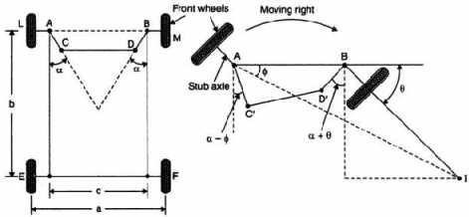
Forstraightdrive ForRightdrive
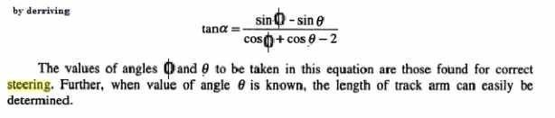
  - Passenger cars have a steering geometry somewhere between True / Pure Ackermann steering and parallel steering while it‘s common among race cars to use Reverse Ackermann. By using True / Pure Ackermann steering on passenger cars, or other vehicles only exposed to low lateral accelerations, it is ensured that all wheelsroll freelywithno slipanglesbecause the wheelsare steered to track a common turn centre.
  - Race cars are often operated at high lateral accelerations and therefore all tyres operate at significant slip angles and the loads on the curve inner wheels are much less than the curve outer wheels due to the lateral load transfer.
  - Tyres under low loads require less slip angle to reach the peak of the cornering force. Using a low speed steering geometry on a race car would cause the curve inner tyre to be dragged along at much higher slip angles than neededand this would onlyresult in raisesintyretemperature and slowing down the car dueto the slipangleinduceddrag. Thereforerace cars oftenuse parallel steer or even reverse Ackermann.
  - The inside wheel on a bend will need to turn more the outside wheel. In turning a tighter circle, the inside wheel will complete less revolutions.
  - Too much Ackermann angle from True, will make the car loose on turn exit or will cause premature tyre wear.Too much Ackermann canover−heat theleft front tyre sothatit will not perform ona longjourney.
  - Excessive Ackerman can sometimes be seen by the wear pattern on the left front tyre. If you see a grain patterninthetyre surfaceortheleftfronttyreseemveryhotyou maywant toconsiderreducingtheamount of Ackermann.
  - Therightamount of Ackermann will helpthroughthe middle ofa turn. Finetuning car handling is possible throughchangesinAckermann.Acarthatisoverlytightthroughthemiddleofa bend canbecuredbymore Ackermann. Too much can slow the car down as your Engine power is used to overcome tyre drag. Tyre wear may also be an issue.

  - It isimportant to remember that adjusting Toe angles will affect Ackermann Geometry. It isalso important to understand the difference between increased Toe Out and More Ackermann as many reference sources often confuse the two.
  - Before taking any Ackermann measurements you must insure that ride height is set, weight percentages correct, driver weight accounted for, bump steer set, camber and caster set, air pressure set etc…. All of these factorswill haveaneffect onAckermannmeasurementsandgettinga stable‗BasePoint‘asreference is very important.
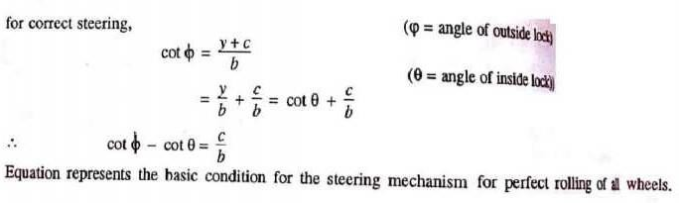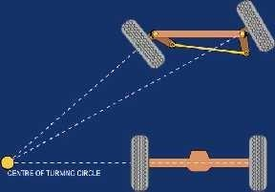
True/PureAckermannSteering

True/PureAckermann−ZeroToeOnTurnIn
  - True Ackermannsteering geometry is definedby angling thesteering armsso that aline drawn between both theking pinand steeringarm pivot pointsintersects with the centreline oftherear axle.
  - As thisgives trueAckermannsteeringgeometry,thereis noToeAnglechangeonthe insidewheel(the wheel is aligned with the circumference of the circle.
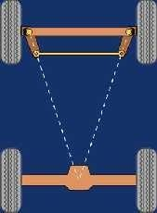

TrueAckermannandZeroToeIn:
  - Moderncarsdonotuse‗Pure‘Ackermannanglesastherearemanyotherfactorstotakeintoaccount.
  - Zerotoe(wheelspointingstraightahead)andTrue/PureAckermannwillresultwithbothtyresbeing aligned with the circumference of the circle or arch of corner.
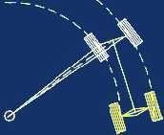
2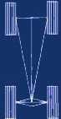
TrueAckermannandToeIn:
  - Bothofthewheelsarebeingtoed−inrelativetothecircumferenceofthecircularpaththeyareactually following.
  - Theinnerwheelistryingtoscribealargercircumferenceandtheouterwheelasmallerone.
  - 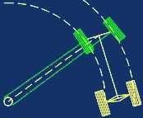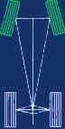Thissituationis known as ‗ParallelAckermann‘.IfLessAckermannanglewas introducedthesituation could be pushed into ‗reversed ackermann‘.
TrueAckermannandToeOut:
  - Both of the wheels arebeing toed−outrelative to the circumference of the circularpath they are actuallyfollowing.
  - 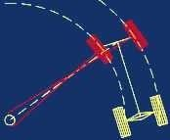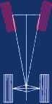Theinnerwheelistryingtoscribeasmallercircumferenceandtheouterwheelalarger one.

MoreAckermannAngle−ToeOutOnTurnIn
  - MoreAckermannisachievedbyanglingthesteeringarmstowardsthecentralaxis, sothatthepointof intersection is forward of the centre line of the rear axle.
  - This steering geometryachievesgreater angular inequalityoftheturned wheels, which generatesToeOUT on the front inside wheel. The inside wheelis tryingtoturntighter circlethan it needsto.
MoreAckermannandZeroToe:

  - ZeroToeand More Ackerman will resultin the inside wheeltryingto followa smaller diameter circle than it actuallydoes. Theinside wheel istoed-in relative tothe actually circular path.

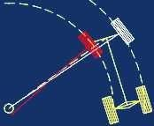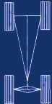
MoreAckermannandToeIn:
  - By precisely adjusting the toe in angle, the inside wheel could scribe a circumference true to the path it actually follows. The outside wheel is toed−in and istrying to follow a smaller circle than it‘s actual path. Theinside wheel has less toe-in than‗True Ackermann and ToeIn‘.
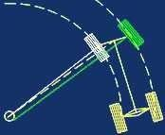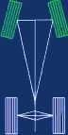
MoreAckermannandToeOut:
  - With toe angle set to out and More Ackermann will result with the a larger inequality between the turned fronttyres.Theoutside wheel istoed-outandtryingto followa larger circumferencethanthe circular path.
  - The insidewheelalso toed-out and istrying to follow a smaller circle than itactuallyis. The outside wheel has increased toe-out over ‗True Ackermann and Toe-Out‘.
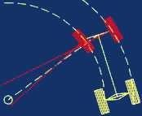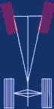

LessAckermannAngle−ToeInOnTurnIn
  - LessAckermannanglecanbesetonasteeringset−up,whichinvolvesadjustingtheangleofthepivot points onthe steering arms sothat the point ofintersection isbehind the centreline oftherear axle.
  - SomeracecarsuseReverseAckermanngeometrytocompensateforthelargedifferenceinslipangle betweentheinner and outer front tyres while corneringat high speed.
  - The useof suchgeometry helps reduce tyre temperatures during high-speedcornering but compromises manoeuvring in low speed manoeuvres.
LessAckermannandZeroToe:
  - Less Ackermann and Zero Toe In will result in progressive Toe In on the inside wheel. The Inside wheelwilltryto follow a greater circle thanitactuallydoes.This situation can approach Parallel Ackermann.

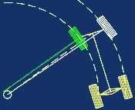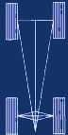
LessAckermannandToeIn:
  - Both of the wheels are being toed−in relative to the circumference of the circular path they are actually following.
  - The inner wheel is trying to scribe a larger circumference and the outer wheel asmaller one. The inner wheel has increase toe-in over ‗True Ackermann and Toe In‘ above. This situation is known as ‗Reverse Ackermann‘.
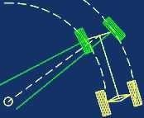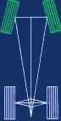
LessAckermannandToeOut:
  - By precisely adjusting Toe Out the inside wheel could scribe a path true to circumference of the circular path itisactually following.Theoutside wheelistoed−out relativeto thecircumferenceofthecircular path itisactuallyfollowing.Theinsidewheelhaslesstoe-outthan‗TrueAckermannandToe-Out‘.
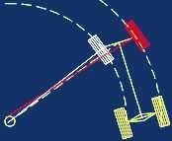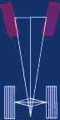

Davissteeringmechanism
  - The Davis steering gear has sliding pairs, whereas the Ackerman steering gear has only turning pairs. The sliding pair has more friction than the turning pair. Therefore the Davis steering gear will wear out earlier and become inaccurate after certain time.
  - Although, the Ackerman steering gear is not mathematically accurate except in their position, contrary to the Davis steering gear which is mathematically correct in a position
  - However,AckermansteeringgearispreferredtoDavissteeringgear
  - Davis steering Gear : The Davis steering gear mechanism consist of a cross link ―CD‖ sliding parallel to another link ―AB‖ anditsconnectingtothe stubaxles ofthetwofront wheelsbymeansoftwosimilar bell crane levers ―LAC‖ and ―MBD‖ pivoted at ―A‖ on the ―B‖ respectively. The cords link ―CD‖ slides on the bearingand carriespinsatitsends―C‖and―D‖.Theslideblocksarepivoted onthesepinsandmovewith the turningof bellcrane levers as the steeringwheelis operated.Whenthe vehicle is running straight,the

gearissaidtobeinmidposition.TheshortArms―AC‖and―BD‖areinclinedatanangleof―90+0C‖to theirstubaxles―AL‖and―BD‖respectively
  - Tan=c/2l
  - Wherec=AB=distancebetweenthepointsoffrontaxles.l=wheelbase
  - Therangeofc/lis0.4to0.5.Hencetheangle―‖liesbetween11.3ºand14.1º
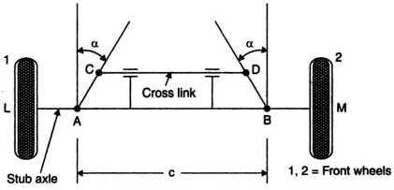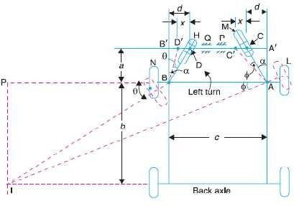
Davissteeringmechanism
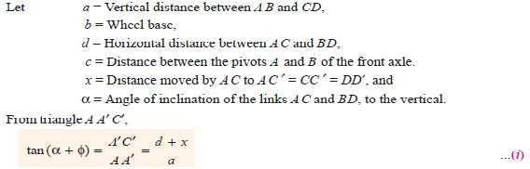

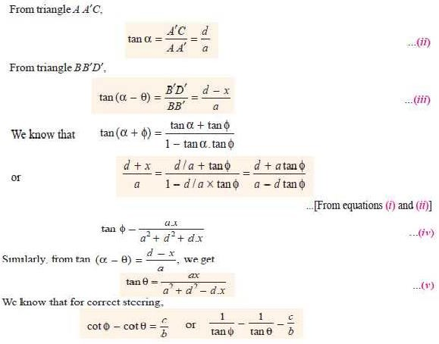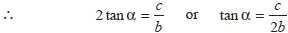
AckermanVsDavis
  - ThewholemechanismofAckermansteeringmechanismisonthebackofthefrontwheels.(Turningpair)
  - WhereasinDavissteeringmechanism,itisinfrontofthewheels.(Slidingpair)
  - TheAckermansteeringmechanismismostlyusedbecausethetruerollingisachievedbytheinstantaneous center

VEHICLEHANDLING
- Factorsaffectinghandling
- Commonhandlingproblems
- Practicalcompromises
- Effectsofmodificationsandadjustments
- Factorsaffectinghandling
  - Weightdistribution
    - handlingisimprovedbylowercenterofgravity
    - Front-heavyvehiclestenttoundersteerwhilerearheavyvehiclestenttooversteer

Polarmomentofinertia
    - RollpolarMOIincreasesthetimetakentosettledownandfollowthesteeringaftercornering

    - YawpolarMOItendstokeepthedirectionofthecarchangingatconstant rate
    - PitchpolarMOIcontributestobumpsteer.ThusaheavybumperwouldincreasepitchMOIandso has to be avoided

Suspension
    - Thespringrate,damping,straightaheadchamber,camberchangewithwheeltravel,rillcenter height and vibration modesand the flexibility of the suspension elements,affect the vehicle handling

Rigidityoftheframe
    - Rigidityisseeninhelphandling

Unsprungweight
    - Unsprung weight is cushioned fromroad shocks only by thetyres, which have limited internal damping.Thus the wheel bounce is only poorly damped by shock absorbers due to which high unsprungweightreducesroadhandlingandincreasesunpredictablechangesindirectiononrough roads

Wheelbaseandwheeltruck
    - Largewheelbaseincreasesresistancetofront/backweighttransfer,whilesidewaysweight– transfer resistance is provided by the wheel track.

Wheelandtyres
    - Largertypes,softrubberandmorestiffcordsincreaseroadhandlingandimprovehandling.
    - Thedepthoftreadaffectsthewaterremovalefficiencyoftyresonwetroads.
    - Ingeneral,increasethetyrepressurereducestheirslipangle,butforgivenroadconditionsand loading,there isan optimum value of the pressureat which holdingis best.

Steering
    - Rackandpinionsteeringisconsideredthebestforhandling.
    - Steeringgeometrychangesduetoroadbumpsmaycausefront wheelstosteerinadifferent direction, thus deteriorating handling.
    - Back lash and excessive friction inthe steering mechanismalsoaffectsthe vehicle handling adversely.Steeringprecisionisparticularlyimportantoniceorhardenedsnowwherethelimiting slip angle is smaller than on dry roads.

Throttleandbrakes
    - The weight transfer takes place inrearward direction duringacceleration, which would cause oversteer.Thisisoppositeofthetendencyofthevehicletoundersteerduringnegotiatingatight curve. Eitherofthesetwo effects may dominate depending uponthe conditions.
    - Usinglowgearwhilegoingdownsteephills,maycausesomeoversteer.
    - Duringbraking,forwardweighttransfertakesplacewhichwouldfavourundersteer.Howeverthe effect due totype of road surface isalsoadded to it, which makestheresult unpredictable. Most modern cars counter this byvarying the distribution of braking in some way.

Aerodynamics
    - Aerodynamicsforcesareproportionaltosquareoftheairspeed. Assuchtheseareimportantathigh vehicle speed.Negativelift downwardforceusedon manyracing carsandalsoonmanypassenger cars to improve road handling

Miscellaneous
    - Positionandsupportforthedriver.
    - Roadcondition

Commonhandlingproblems
  - Understeer
    - Thedrivercancompensatebyturningthesteeringwheelalittlemore,butroadhandlingisreduced and vehicle behavior is less predictable.

Oversteer
    - Thedriverhastorectifybysteeringawayfromthecorner.However,thistendencymaybeusefulin assisting steering sometimes when the driver chooses it applying power.

Bodyroll
    - Thetendencyofthevehicletorolloutduringturns,interfaceswiththedriverscontrolandalso causes delay in negotiating the turn.

Weighttransfer
    - Duringcornering,theweighttransfertakesplacefromtheinnersidewheelstotheoutersidewheels, which may result in oversteer depending upon various conditions.

Response
    - During negotiating corners, the response slows down. Sidewaysacceleration does not start immediatelywhenthesteeringisturnedanddoesnotstopimmediatelywhenthesteeringisreturned to straightahead.This occurs due to bodyroll, high slipangletyres,and yaw &rollangularinertia.

Practicalcompromises
- Inboardbrakesimprovebothhandlingandcomfort,buttakeupmorespaceandaredifficulttocool
- Largeenginestendtomakevehiclesfrontorrearheavy
- Wishbonefrontsuspensiongivesbetterhandling,becauseofgreaterflexibilityfortheengenderersto choose steering geometry. However, it takes more spaces
- Fortyredesign,factorsfavoringfueleconomy,stayingcoolathighspeeds,ridecomfortandlonglife, all tend to reduce road- holding

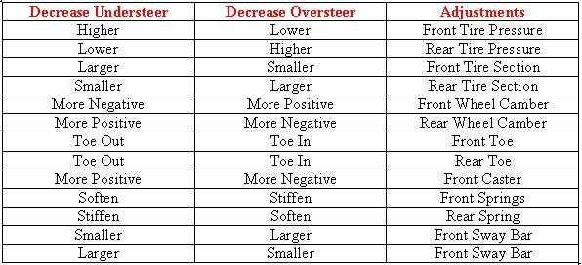
Effectsofmodificationsandadjustments

- EXPLAINTHESTEERINGLINKAGEWITHSUITABLESHETCH.
Primaryfunctionofthesteeringsystemistoachieveangularmotionofthefrontwheelstonegotiateaturn.
Thisisdonethroughlinkageandsteeringgearwhichconverttherotarymotionofthesteeringwheelinto angular motion of the front road wheels. Secondary functionsof steering systemare:
  - Toprovidedirectionalstabilityofthevehiclewhengoingstraightahead..
  - Toprovideperfectsteeringcondition,i.e.,perfectrollingmotionoftheroadwheelsatalltimes.
  - Tofacilitatestraightaheadrecoveryaftercompletingaturn.
  - Tominimizetyrewear.

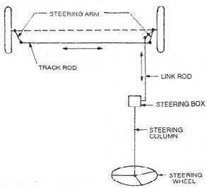Tillrecentlyallvehiclesweresteeredbyturningthefrontwheelsinthedesireddirections,withtherear: wheels following. However, latelyall-wheel steering has been designedand employed in some selected vehicles. Here only
Frontwheelsteeringwouldbediscussedwhichisbeinguseduniversallytilltoday. The requirements of a good steering system are:
  - Thesteeringmechanismshouldbeveryaccurateandeasytohandle.
  - TheeffortrequiredtosteershouldbeminimalandmustnotbeTiresometothe driver.
  - Thesteeringmechanismshouldalsoprovidedirectionalstability.ThisImpliesthatthevehicle.Shouldhave a tendency to return to its straight ahead Position after turning.

Themaincausesofstiffsteeringinclude
  - Insufficientlubricationoftheking-pinsorsteeringlinkage
  - Tyrepressuretoolow,
  - Wheelsoutoftrack,toe-innotcorrect,and
  - Stiffnessinthesteeringcolumnitself,causedbylackoflubricantorovertightening.

Componentsofsteeringsystem-Steeringlinkages
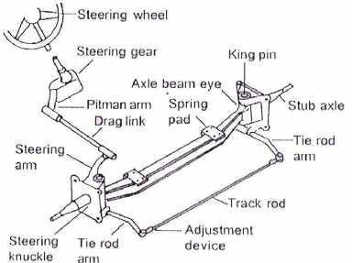
Steeringlinkage
  - Thesteeringlinkageisaconnection ofvariouslinksbetweenthesteeringgearboxandthefront wheels.The motion ofpitmanarm ofsteering gearbox is transferredtothe steeringknuckles of the front wheels through the steering linkage.
  - When the steering wheel is turned to the left or right , the pitman arm swings from one side to the other. This movement of the pitman arm gives angular movement to the front wheels through the steering linkage.
  - The most commonly use steering linkage is conventional steering linkage. The pitman Arm (droparm)isconnecteddirectlybya connectinglinknamelydraglink toa steeringknucklearm attached to the left hand steering knuckle. The motion is carried across from this arm to a steeringarmon theright side steeringknuckle by meansof therod. Thedraglink and drop arm (Pitman Arm) are mounted on the left side of the frame.
  - In some designsthedraglink isconnectedbetweenthe droparmandright steeringknuckle arm by locating drop arm beneath the steering gear.

  - In direct crosstype steeringlinage, the pitmanarm(Drop Arm) isconnecteddirectlytooneand oftherod whichitsturnis connectedtoanother.Theother endsof therods areconnectedto the steeringarms.

Understeering,oversteeringandTurningRadius
  - While taking a turn, the wheels are not always pointing in direction in which the vehicle is moving, due to distortion of tyre tread. The angle between the wheel inclination and the path taken bythe wheel is known as ―Slip angle‖. When the slip angleis greater at the rear than of the front, the vehicle tends to ―over steer‖ the vehicle is to turn into the curve more than the driver intended.
  - Whentheslipangleissmallerattherearthanatthefront,thevehicletendsto―understeer‖.
  - Theunder steer is most commonly preferred because correction by the driver involvesrotating the steering wheel a little more in the direction of the turn.
  - It can be noted that the slip angle is affected by the road camber side winds, tyre inflation and variations in the load on either the front or rear axle.
  - Turing Radius : Turning radius is the radius of the circle on which the outside frontwheel moves when the front wheelsareturned to their extreme outer position.
  - This radius is 5 to 7m for buses and trucks. The turning radius is usually proportioned to the wheel base of the vehicle , because the maximum rotation of the steering knuckle is seldom more than 35 degrees.

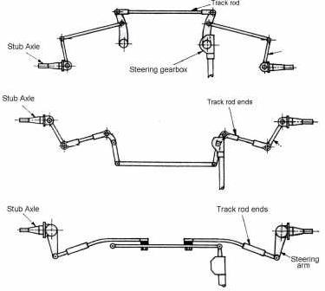
Differenttypesofsteeringlinkages
IndependentSuspensionSteeringSystem
  - In the rigid-beam suspension, the stub-axle is pivoted at each end of the axle-beam. Consequently the relative movement is permitted only in the horizontal plane due to which effective track-rod length is not affected by any vertical suspension deflection.
  - Independent-suspension steering, on the other hand, copes with up a down movement of each stub-axle independent of the other due to which the distance between track-rod-arm ball-joint centres varies continually.
  - Therefore,ifa singletrack-rodjoinsthetwostub-axlestogether,the slightest bump orreboundtendsto pull both stub-axle arms at onceand thusinterferes with the steering-track toe-in or toe-out.

  - To overcome the problem of the changing distance between track-rod-arm ball-joint centres, a three-piece track-rodisused.Thecentreportionofthetrackrod maybearelay-rodsuspendedbetweenthesteering-box drop-arm and an idler arm fixed to the body structure.
  - Also the centre portion may from the track shaft of a rack-and-pinion steering-box . In both the cases, this part moves only in the horizontal plane. Movement in the vertical plane is provided by the two outer connecting rods, known as tie-rods. The tie-rods swing about the ball-joints placed at the end of the middle track rod member. Inearlier designs, independent suspension steeringincorporated stub-axlesand king-pin pivots similar to those used with the axle-beam. But current systems use ball-swivel joints for the stub axle pivot and are also spaced further apart
  - Large cars normally use the system shown in Fig. When the steering-wheel is acted, the drop-arm conveys movement to the relay-rod, which in turn transmits this motion to both tie-rods and stub-axles. The drop- arm and idler-arm relay joints provide movement only in the horizontal plane. The tie-rod joints provide movement in both the horizontal and vertical planes.
  - Themostpopularsteeringsystemused forsmalland mediumcarsisshown inFig.Thistypeofsteering box has a rack-and-pinion housing bolted along the body cross-member. The angular movement of steering wheel is converted to a linear to-and-fro movement of the rack. Each end of the rack shaft is attached to a tie-rod by means of a ball-and-socket joint. The outer tie-rod ends also use ball-joints, which are bolted to the stub-axle track-rod arms. The rack shaft thus provides the transverse steering thrust and the tie-rod ball joints allow pivoting in two planes.
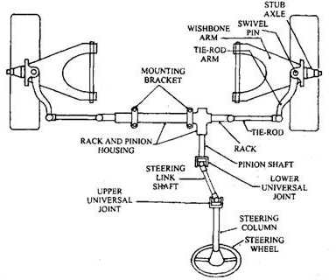

Splittrack-rodwithrelay-rodandidlersteeringlinkagelayout.

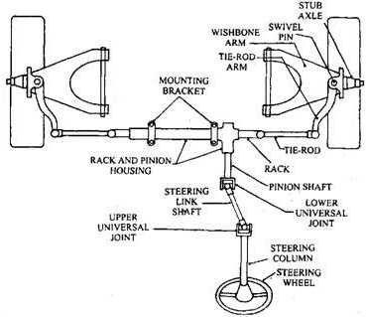
Rack-and-pinionsteeringlinkagelayout.
- WHATARETHE DIFFERENTTYPES OF STEERING GEARS?WHAT IS THE PURPOSEOF STEERING GEAR? EXPLAIN WITH SKETCH OF STEERING GEARS.

SteeringGear
  - Oneoftheimportanthumaninterfacesystemsintheautomobileisthesteeringgear.
  - Thesteeringgearisadeviceforconvertingtherotarymotionofthesteeringwheelinto straightlinemotion of the linkage.
  - Thesteeringgearsareenclosedinabox,calledthesteeringgearbox.
  - Thesteeringwheelisconnecteddirectlytothesteeringlinkageitwouldrequireagreatefforttomovethe front wheels. Therefore to assist the driver, a reduction system isused.

FunctionsofSteeringGears:
  - Ithelpstomultiplya smalleffortappliedonthesteeringwheelbydriverintoagreaterforceonthedragging link.
  - Itfunctionstotransformtherotarymotionofthesteeringwheelintotheto-and-frommotionofthedrag link.

TypesofSteeringGears:
- ThePit-man-armtypeand
- TheRack-and-Piniontype

TypesofsteeringgearsBox
- Wormandsectorsteeringgear.
- Wormandrollersteeringgear.
- Camanddoubleleversteeringgear.
- Wormandballbearingnutsteeringgear.
- Camandrollersteeringgear.

- Camandpegsteeringgear.
- Recirculatingballnutsteeringgear.
- Rackandpinionsteeringgear.
- Wormandnutsteeringgear

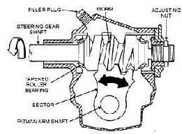
WormandSector
Wormandsectorsteeringgear
  - WormandsectorarebasedontheprincipleoftransmittingthemotionfromthesteeringtubetothePitman arm.
  - Thewormisattachedwiththeinnercolumnofthebearingblock.
  - Theboxisconnectedtotheleveloftheplugwithnormalgearoilforlubricationofthesteeringgear.
  - Thewormattheendofthesteeringshaftmesheswithasectormountedonasectorshaft.
  - Whenthesteeringwheelisrotates,thentheworm willrotates.
  - Thenthesectorwillalsoberotatingthesectionshaft.
  - So,themotionistransmittedtothewheelthroughthelinkage.

WormandRollersteeringgear
  - Wormandrollergearhavetwo-toothedrollerwhicharefastenedtothecrossshaftcalledasrollershaftor sector shaft.
  - Thethreadsofthewormgeararemeshedwithrollershaftattheendofthesteeringtube.
  - Whenthewormshaftisturnedbythesteeringtube,theroller willalsobemovedinanarcforrotatingthe roller shaft.
  - Thebearingsaredesignedtoresistbothradialandendthrust.
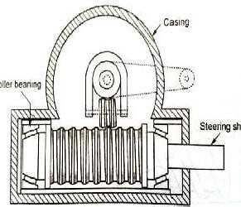
  - ThissystemisusedinFordcarsandAmericanpassengercars.
Wormandrollertypesteeringgear

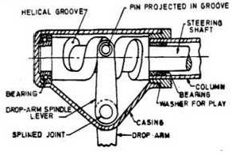
Camandleversteeringgear
Camandleversteeringgear
  - Thecamismountedatthelowerendofthesteeringshaft.Itconsistsofvariablepitchworm.
  - Atwinlevercarryingstudsmeshesinthegrooveofthecam.
  - Thisarrangementprovidesminimumoffrictionwhenthecontactismadebetweencamandasmallstud.
  - Whenthecamturns,thestuds willalsomoveinanarc.Thecamiscylindricalinshape.

Wormandballbearingnutsteeringgear
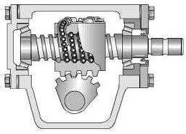
Warmandballbearingnutsteeringgear
  - In worm and ball bearing, the principle of transmitting the movement from the steering tube is worm andball nut.
  - Awormisconnectedatthelowerend ofthesteeringshaftwhereasaballnutisconnectedwithworm.
  - Steelballsarecirculatedforobtainingfrictionlessdrivebetweenthewormandnut.
  - Ifthesteeringshaftisturnedtoleft,theballnutismoveddownwardbyrollingaction.
  - Theteeth ofthe ball bearingnut movingup or downthe shaft will bemovedonthesector teethto forcethe cross shaft and rotate.
Camandrollertypesteeringgear
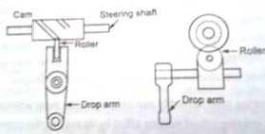
Camandroller

Construction
  - Thecamandrollersteeringboxesareveryefficient.
  - Thecamiscarriedbythesteeringshaftconnectedwithrollers.
  - Thedroparmspindlecarriestheveeshapedroller.
  - Thisspindleiscarriedbyballbearingsinthecasing.
  - Themeshingmembercontainsthespiralgrooves.Thecentrepositionofthepinsupportstheroller.

Working
  - Bymovingthesteeringwheelandsteeringshaft,thecamisrotated.
  - Duetothisrotation,therollerisconstrainedtofollowthehelixofthegroove.
  - Whenthecamrotates,therollerisfollowedthecamandmadetherockershafttorotate.
  - Thecontourofthecamisproperlydesignedtomatchwithouraim.
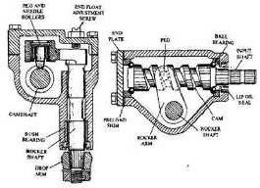
CAMandPEGtype
Camandpegtypegear
  - Thesteeringgearhas ataperedpegintherockerarmengagedwithaspecialcamprovidedontheinner column.
  - Thepegismovedalongthegrooveforrotatingtherockershaftbyrotatingthecam.
  - An adjusting screw on theside cover is connected forgoverning the backlash and end floatof the rocker shaft.
  - Therockerarmisrotatedwithhighefficiencycamandpeggearrotatesbyapeginthebearings.
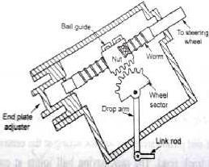
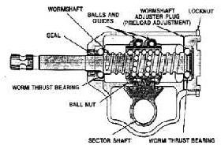
Recirculatingballsystemsteeringsystem:

Recirculatingballtypesteeringgear
Construction
  - ThistypeofgearwasthemostwidelyusedsteeringgearatonetimeinTata andStandard20vehicles.
  - Itconsistsofawormattheendofsteeringrod,halfnutandtransfertubecontainingtheballs.

  - Theballsarefedbacktothenutconnectedbyhalfnutwiththetransfertube.
  - Awormandnutareplacedattheend ofthesteeringshaft.Steelballsareloadedbetweenthe setsofgroove of worm and nut for recirculation.
  - Thenuthasteethonitscircumference.Theseteetharetobemeshedwithatoothedwheel.

Working
  - Whenthedriverturnsthesteeringwheel,thetwosteelballraceswillrollinthegroovesandmakethenutto travel along the length of the worm.
  - Themotionfromthenutistransmittedtothewheelsector.

Advantage
  - Theseballsreducethefrictionandincreasetheefficiencyofthemechanismto90%.
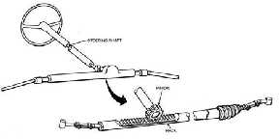
RackandPinion
Rackandpinion
Construction
  - Thistypeofsteeringgearismainlyusedincarshavingindependentfrontsuspension.
  - Thepinionismountedattheendofthesteeringshaft.
  - Auniversaljointisconnectedatthebottomendofthesteeringshafttomountthesteeringboxcentrally.
  - Arackisengagedwiththepinion.Therackreciprocatessidewaystogivelateralmovementtothefront wheels.
  - Springpadsconnectedwiththerackreducethebacklashbetweengearstoa minimum.

Working
  - Thedrivereffortistransmittedtothefrontwheelthroughthesteeringwheel,tosteeringshaftandfinallyto the steering knuckle.
  - Therack havingballjointsateachend forallowingtheriseandfallofthewheelisengagedwiththepinion mounted at the end of the steering shaft.
  - Arackisengagedwiththepinion.Therackreciprocatessidewaystogivelateralmovementtothefront wheels.
  - Thebacklashinrackisreducedtoaminimumduetospringpadsareplacedbelowtherack.
Advantages
  - Therackandpinionsteeringprovidessufficientlyalowgearreduction.
  - Itisalsomadesuitableforheaviermotorvehiclesbypowerassisting.

WormandNutGear Construction
  - Thesetypesofsteeringboxesarecommonlyused.
  - Screwandnutgearhasaphosphor-bronzeofsteelnutwhichisscrewedontoamulti-startAcmethread.
  - Asingleballraceprovidedatthetopendoftherockershaft carriestheaxialthrustofthecolumn.
  - Atthattime,thenutslidinginthehousingsupportsthelowerend.
  - Thescrewismadetorotatefreelyonbearings.

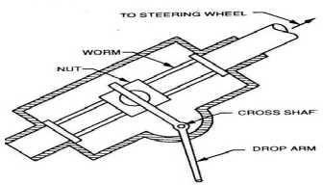

Wormandnutsteeringgear

Working
  - Ashaftconnectsthescrewwiththesteeringwheel.
  - Therefore,asthescrewisturnedbyrotatingthesteeringwheel.
  - Thespindleismountedonballbearings.Thedroparmistakenbythisspindleatitsouter end.
  - Thetwoarmsofthespindleareattachedtothenutbybronzepads.
  - Thesepadsareplacedandmadetorotateinthecylindricalrecessesprovidedinthesidesofthenut. Also these pads have parallel groovesto receive the arms of the spindle.
  - Thebronzepadscausethearmsofthetwoarmedspindlesmovingincircularpath.

EXPLAINTHEPOWERSTEERINGSYSTEMWITHNEATSKETCH
Introduction
  - Vehicle dynamic is an integral part of an automobile vehicle which is as important as the power train of a vehicle, as if we need a power train to run a vehicle we also need vehicle dynamics systems to keep the vehicle running with stability, as we know suspension system is the part of vehicle dynamics that provide surface contactalong withtheturning stability tothe vehicle butlet‘sjust think,turningthedirection by the vehicle.
  - A steering system ofan automobile is an integral part of vehicle dynamics ofa vehicle in which a series of mechanical components having certain important angles comes together to steer the front wheels of the vehicleaccordingtoinputprovidedbythepassengerthroughsteeringwheel.Andthepowersteeringsystem is the advanced steering system in which the effort required to steer the front wheels of the vehicle side to side is reduced by using intermediate electric or hydraulic devices that multiplies the force applied by the driver through steering wheel inorder toachieve smoothandquick directional changeof the vehicle.
  - Today all the 80% of the cars on road are equipped with the power steering system which has become the basic need of today‘s automobile.
  - After the introduction of the power steering in 1903, it is found that the number of accidents on the road is decreased to the appreciablelimit which inturn makesit thenecessity in a 4 wheel drive.
WhydoWeNeedPowerSteering?
  - Aswe havealready discussedabovea power steering decreasesthe steering effortswhichisthe need ofa 4 wheel automobile vehicle so we needa power steering dueto the followingreasons
  - Quickresponse- As the number of the vehicle on the road is increasing day by day and today almost 60% families of the world are having a 4 wheeler in their houses, with this increase in number of vehicles the danger of accidents onroadisalsoincreased, sotoavoidthis danger andto takequick turnsrequired bythe road conditionsa quick response steering system isrequiredina 4 wheel vehicle.
  - Steering efforts – Ifwe drive old cars likeMaruti Suzuki800 ,itis foundthatthe steering wheel ofthe car feels very hard to rotate when the vehicle is going below 40km/hr (above that the steering feels less hard)

which is found to cause fatigue to the driver while going on a long ride. So a vehicle should be equipped witha power steering system so that the steeringeffortrequiredto steerthe front wheels can bereduced.
  - Bump steer-As we know the bumps of the road is reduced by the suspension system but as the steering systemisdirectlyattachedtothewheel‘shub someamount ofbumpsforceisalsotransferredtothesteering system which in turn tries to steer the vehicle against the will ofthe driver due to which a vehicle can lose its stability, though the bump steer can be controlled mechanically by providing optimumscrub radius (angle between the centre line of the wheel and the king-pin inclination of the knuckle) but the power steering controls it in a more effective manner.
  - Return ability- after taking a turn it is found that the steering returns automatically to its original position which in turn automatically straightens the moving vehicle. A vehicle equipped with a powersteering system provides better return ability to the steering system.
TypesofPowerSteeringSystem
On the basis of the method used to multiply the steering force there are 3 types of power steering system that are-
- Hydraulicpowersteeringsystem
- Electro–hydraulicpowersteeringsystem
- Electronicpowersteeringsystem
Hydraulic PowerSteeringSystem
It is the type of power steering system in which hydraulic system having hydraulic pump driven by the engine and hydraulic cylinders, is used to multiply the steering wheel input force which in turn reduces the efforts required to steer the front wheels of the vehicle.
  - A highly compressed hydraulic fluid is used inside the hydraulic cylinder that applies pressure on the steering gear.
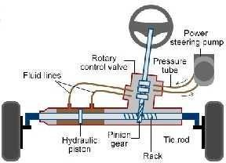
  - In this type of power steering system as we discussed above the hydraulic force is used to multiply the steering input force in order to smoothen the steering of the front wheels, this hydraulic force is generated by a series of components that includes hydraulic cylinder, rotator hydraulic pump, hydraulic lines, highly compressedhydraulicfluidandacouplingmechanismthatcancouplethishydraulicsystemwithrackofthe steering system.
  - When the driver provides input by rotating the steeringwheel, the hydraulic pump driven by the engine starts pumping the highly compressed hydraulic fluid through lines.
  - The hydraulic pressure produced by the pump enters the hydraulic cylinder which in turn applies pressure over the cylinder‘s piston.
  - The piston whichisunder high pressure startsmoving from oneendtothe another whichinturn pushesthe further fluid through lines, with this movement of piston the input force applied by the driver is multiplied several times.

  - This high pressure fluid sent by the hydraulic cylinder then applies the pressure to the attached pinion throughthe coupling mechanism which in turn applies high force to the rack gearand the steering action in the front wheels takes place.
ImportantComponents
Theimportantpartsofapowersteeringsystemare-
- Steering mechanism-Usually rack and pinion steering mechanism is used in power steering in which the rotational motion of the steering wheel is converted into the transverse motion of the wheels by a set of constantly meshed worm gears called rack that provide transverse motion and a pinion that providesrotational motion.
- Linkages– Theyarethemechanicalconstraintsthatproviderelativemotionbetween2 components,thetype oflinkages usedin power steeringis the tie-roadsthat connects the rack to theknuckle ofthe wheel in order to transfer the transverse motion of the rack to the wheels.
- Power device- Aswe havealready discussedabovea force multiplying device(either hydraulic or hybrid or electric) is used to multiply the steering wheel force in order to reduce steering efforts. This device is attached with the pinion of the rack and pinion mechanism.
- Steering wheel-A round steering wheel is used inside a cockpit (operated by the driver) that provides the rotational steering input tothe further steering devices in order to steer the vehicle.
WorkingofPowerSteeringSystem
The working of the power steering system differs with the difference in force multiplying devices used. so to understand the working ofthe power steeringallthe3 methods must bediscussed separately.
HybridorSemiHydraulicPowerSteeringSystem
  - Itisthemodifiedversionofthehydraulicsysteminwhichtherotaryhydraulicpumpwhichisdrivenbythe

engineinhydraulicpowersteering electric motor.
systemisreplacedwiththehydraulicpumpwhichisdrivenbythe

  - Itisalsocalledthehybridpowersteeringsystemduetotheuseofbothhydraulicandelectriccomponents.
  - In this type of power steering system the hydraulic pump driven by the engine from the hydraulic power steering system is replaced with electric pump which makes it more reliable, this is the only modification maderest the working ofthis system is sameas the hydraulic power steering system mentionedabove.
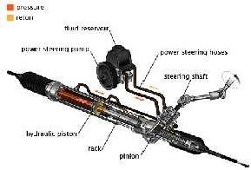
ElectricPowerSteeringSystem
  - Itisthelatesttypeofpowersteeringsysteminwhichthehydraulicsystemfromthehydraulicpower steering iscompletelyreplacedwithelectricmotors andelectricsensors,insteadofusinghydraulicforce
,the motordriven bythe vehicle‘s batteryisusedtoapply force on the steering gearandtorque providedby the motor is controlledbythe sensorsthat detectsthe position of the steeringcolumn.
  - The steering response of this system is quick and very effective that is why it is used in almost all the new cars today.

  - This system is latest of all the steering system mentioned above in this type of steering system as we have already discussed theforcemultiplication isthe function oftheelectricmotor insteadof hydraulicfluidand the working of this system is as follows-
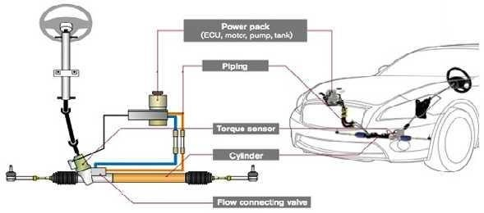
  - Whenthedrivergivesinputthroughthesteeringwheeltheelectronicsensorsattachedtothesteering columnreads the inputand sent them to the electric controlunit of the vehicle.
  - The ECU ofthe vehicle analyses these inputs and sent the voltage signal to the electric motor placedat the end ofthe steering column whose gear is in constant mesh withthe pinion gear.
  - Due to these voltage signals sent by the ECU the motor which is driven by the battery ofthe vehicle starts and provides the particular torqueaccording tothe valueof the voltage signals received
  - Afterthemotorstartsthegearwhichisinconstantmeshwiththepiniongearstartstransmittingthe multipliedtorquetothepiniongear whichinturnappliesthistorquetotherackthroughwhichitisattached.
  - Withthis torque applied by the pinion over rack, rack moves which in turn steer the front wheels (with the help of the tie rods attached) as per the requirement.

- STEERINGTROUBLESHOOTING
- ExcessiveBacklashinsteering
- Wander
- Pullingtooneside
- Wheelwobble(lowspeedshimmy)
- Highspeedshimmy
- Wheeltramp
- Excessivetyrewear
- Hardsteering
- Slippingsteering
- Poor returnability Excessive Backlash in steering
  - Steeringgearboxelooseinchassisframe.
  - Steeringdroparmmaybelooseonsplines.
  - Theballjoinsmaybelooseorworm.
  - Linkagenotbeproper,whichmaybedonecorrectly
  - Defectiveshockabsorberswhichhavetobereplaced.
  - Lowpowersteeringfluid.(hydraulic)

Wander
  - Tyresmaybebadlyworm.
  - Thebearingofsteeringknuckle.
  - Thefrontwheelbearingsmaybewormout.
  - Theamountofcastoronthewheelsmaybeless.
  - Thevehiclemaybesimplyoverloadedattherear.
  - Thetoe-inmaybeincorrect.
  - U-boltsorthesteeringearmountingsmaybeloose.
  - Lackoflubrication.

Pullingtooneside
  - Thetyrepressuremaybeuneven.
  - Theunevenwormouttyres.
  - Thebrakesmaybedragging.
  - Thecambermayhavechanged.
  - Thecastoronthefrontwheelsmaybeunevenorincorrect.
  - Alignmentoffrontwheelsmaybeincorrect.
  - Thefrontwheelbearingsmaybetight.
  - Thesuspensionspringmaybebroken.
  - Thestiffnessofthefront springsmayhavebecomeunevenwithuse.
  - Springtieboltsmayhavebroken.
  - Defectiveshockabsorbers.

Wheelwobble(lowspeedshimmy)
  - Tyresmayhavewornunevenly.
  - Incorrectbalanceweights.
  - Thetyrepressuremaybeuneven.
  - Theballjointsmayhavewormout.
  - Steeringgearorwheelbearingsmaybeloose.
  - Thestiffnessofthespringmaybeless.
  - Thecambermaybeincorrectoruneven.
  - Thecastermayhavebecomeexcessiveduetowearofbushesordamagetofrontsuspension.

Highspeedshimmy
  - Wheelrimmaybebuckled.
  - Fronttyresmaybehavingunevenpressure.
  - Thebearingsoffrontwheelsmayhavewormoutorotherwiseloose.
  - Hydraulicshockabsorbermaybefaulty.
  - Thetoe-infrontwheelsmaynotbecorrect.

Wheeltramp
  - Thetyrepressureinthewheelsinthewheelsmaybeunequal.
  - Thewheelassemblymaynotbebalanceddynamically.
  - Thefrontshockabsorbermaybedefective.
  - Incorrectcaster.

Excessivetyrewear
  - Tyrepressuremaynotbeincorrect.
  - Excessivetoe-inortoe-out.

  - Excessivecamber.
  - Thebrakesmaybedragging.

Hardsteering
  - Tyrepressuremaybetoolow.
  - Excessivecaster.
  - Excessivefrictioninthesteeringgearboxorlinkageorballjoints.
  - Steeringgearadjustedtootightlyorbindingconditioninsteeringcolumn.
  - Incorrectwheelalignment.
  - Defectivepowersteeringpump.
  - Loosepowersteeringpumpbelt.
  - Incorrectpowersteeringfluidlevel.

Slippingsteering
  - Incorrectpowersteeringfluidlevel.
  - Defectivepowersteeringpump.
  - Loosepowersteeringpumpbelt.
  - Leakingpowersteeringrack.
  - Damagedsteeringrackmounts.

Poorreturnablity
  - Tyrepressuremaybetoolow.
  - Steeringgeartocolumnmisalignment.
  - Tightorfrozensteeringshaftbearings.
  - Tightsteeringleakage.
  - Steeringgearmaybeadjustedtootight.
  - Frontwheelalignmentmaybeincorrect.

SUSPENSIONAND BRAKING SYSTEM

1.WHATARETHEOBJECTIVESAND COMPONENTSOFSUSPENSIONSYSTEM?(OR) EXPLAIN IN DETAIL ABOUT SUSPENSION SYSTEM WITH NEAT SKETCHES. (OR) EXPLAINTHEDIFFERENTTYPESOFSUSPENSIONSPRINGSWITHNEATSKETCHES.
1.SUSPENSIONINTRODUCTION
- Suspension system is the term given to the system of springs, shock absorbers and linkages that connects a vehicle to its wheels.It isbasically cushion for passengersprotectsthe luggage orany cargoandalso itself from damage and wear.
- SirWilliamBrushisthefatherofsuspensionsysteminautomobiles.
- Suspensionistheterm giventothesystemofsprings, dampers(shockabsorbers)andlinkagesthat connects a vehicle to its wheels.
- Suspensionsystemsserveadualpurpose–contributingtothe
- car'shandlingandbrakingforgoodactivesafetyandkeeping
- vehicleoccupants‗comfortable‘andreasonablywellisolatedfrom
- roadnoise,bumps,andvibrations
- These goals are generally at odds,so the tuning of the suspension involves finding the right compromise. The suspension also protects the vehicle itself from damage and wear.
- Thedesignoffrontandrearsuspensionofacarmaybedifferentfromoneanother.
- Soa suspensionlinkagesystemofsomesortisneededtoenablethewheeltomoveup&downvertically.

Objectsofsuspension:
- Topreventtheroadshocksfrombeingtransmittedtothevehiclecomponents
- Tosafeguardtheoccupantsfromroadshocks
- Topreservethestabilityofthevehicleinpitchingorrolling,whileinmotion.

Purpose
Thepurposeofthesuspensionistoprovidethevehiclewiththefollowing:
- Asmoothride
- Accuratesteering
- Responsivehandling
- Supporttheweightofa vehicle
- 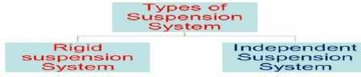Maintainacceptabletirewear

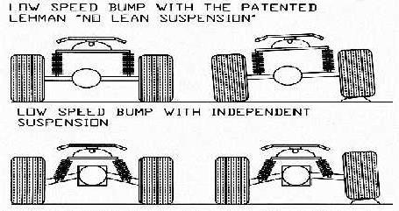

- Non-independent/Rigidsuspensionhasbothrightandleft wheelattachedtothe same solidaxle.Whenone wheel hitsa bumpin theroad,its upward movement causesa slight tilt of the other wheel.
- Independentsuspensionallowsonewheeltomoveupanddownwithminimal effecttotheother.
Coilspringisthemostcommontypeofspringfoundonmodernvehicles.
Leafspringsarenowlimitedtotherear ofsomecars.

Principle:
  - When a tire hits an obstruction, there is a reaction force. The size of this reaction force depends on the unsprung mass at each wheel assembly.
  - Ingeneral,thelarger theratio ofsprung weight tounsprung weight,theless thebodyand vehicleoccupants areaffectedbybumps,dips,andother surfaceimperfectionssuchassmallbridges.Alargesprungweightto unsprung weight ratio can also impact vehicle control. No road is perfectly flat i.e. without irregularities. Evenfreshlypavedhighwayshavesubtleimperfectionsthat canbeinteractwithvehicle‘swheels.Theseare the imperfections thatapply forces on wheels.
  - According to Newton ‘s law of motion all forces have both magnitude and direction. A bump in the road causesthewheelto moveupanddownperpendiculartotheroad surface.Themagnitudeofcourse ,depends on whether the wheel is striking a giant bump or a tiny speck. Thus, either the wheel experiencesa vertical acceleration asit passes over an imperfection. The suspension ofa car isactually part ofthe chassis, which comprisesall of the important systemslocated beneath the car'sbody. These systeminclude :
    - Frame
    - Suspensionsystem
    - Steeringsystem
    - TiresorWheels

BasicConsiderations:
VerticalLoading:duetobumporpitontheroad
Rolling:duetothecentreofgravityofthevehiclesisconsiderablyabovetheground,whichcausesthe centrifugal force acts outwards on the C.G. of vehicle while taking the turns.
BrakeDip:onbraking,thevehiclehasa tendencytobeloweredor todip,which basedontheC.G., wheelbase and other suspension characteristics.
SideThrust:Duetocornering,crosswinds,camberingoftheroadetc.
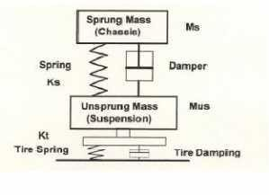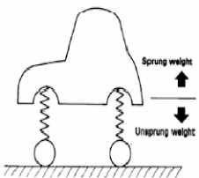Unsprung Weight: The weight of vehicle components between the suspension and the road surfaces, which includes rear axle assembly, steering knuckle, front axle, wheels, tyres and brakes. (Sprung weight means the weight supportedbythevehiclesuspension systemincludestheframe,body, engineandtheentiretransmission system.

Miscellaneous:Pitching,Yawing,etc.

FunctionsofSuspensionSprings:
  - Storingtheenergybydeflection
  - Expendingtheenergybyrebounding.

TypesofSuspensionsprings:
- SteelSprings:
  - Leafspring
  - TaperedLeafSpring
  - CoilSpring
  - Torsionbar
- RubberSprings:
  - Compressionspring
  - Compressionshearspring
  - Steelreinforcedspring
  - Progressivespring
  - FaceShearspring
  - Torsionshearspring
- PlasticSpring
- AirSpring
- HydraulicSpring

LEAFSPRINGS
  - Leafspringsareformedbybending.
  - Theyaremadeoflongstripsof steel.
  - EachstripisnamedasLeaf.
  - ThelongleafiscalledMasterLeaf,anditconsistsofeyesatitsbothends.
  - Oneendisfixedtothechassisframe,theotherendisfixedtotheshacklespring.
  - Thespringwillgetelongatedduringexpansionandshortenedduringcompression.
  - Thischangeinlengthofspringiscompensatedbytheshackle.
  - TheU-boltandclampsarelocatedattheintermediatepositionofthespring.
  - Thebronzeorrubberbushesareprovidedonbotheyesonthemasterleaf.
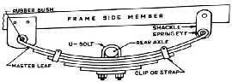
  - Originallycalledalaminatedorcarriagespring

Leafspring
TypesofLeafSprings
Therearesixtypesofleafsprings
  - Full–elliptictype
  - Semi–elliptictype
  - Quarter–elliptictype
  - ThreeQuarter–elliptictype
  - TransverseSpringtype
  - HelperSpringtype

Full–elliptictype
  - Theadvantageofthistypeistheeliminationofshackleandspring.
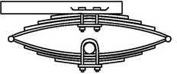
  - Thelubricationandwearfrequentlywhichareonofthemaindrawbackofthistypeofsprings.

Full-elliptic
Semi–elliptictype
Thistypeismorepopular forrearsuspensionisusedin75%ofcars.
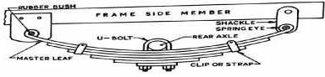

Quarter–elliptictype
  - Thistypeisrarelyusedinnow-a-days.
  - Itgivesverylessresistanceinroadshocks.

Semi-elliptic

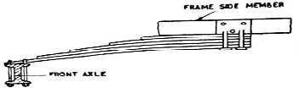

ThreeQuarters–elliptictype
  - Thistypeisrarelyusedinnow-a-days.

Quarter-elliptic

  - Itiscombinationofquarters-ellipticandsemielliptic.
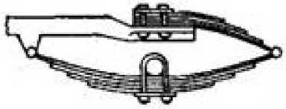
  - Itgivesresistance,butoccupiesmorespacethanothertypes.

ThreeQuarters–elliptic

TransverseSpringtype
  - Thistypeofspringisarrangedtransverselyacrossthecarinsteadoflongitudinaldirection.
  - Thetransversespringforfrontaxle,thisisboltedrigidlytotheframeatthe centerandattachedtotheaxle by means of shackle at both ends.

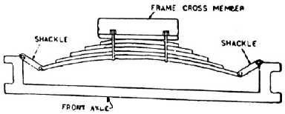

TransverseSpring
HelperSprings:
  - Thehelperspringsareusedinheavyvehiclesforrear suspension.
  - Whenvehiclefullyloadedthemainspringaswellashelper springtocomeinactionandabsorbtheroad shocks.
  - Whentheloadofthevehicleisless,thehelper springwillnotactandthemainspringonlyabsorbtheroad shocks

TaperedLeafSprings:
.
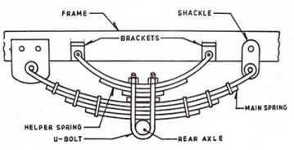
HelperSprings

    - AnothernameisTaperlitesprings
    - AdvantagesoverconventionalLeafsprings:
    - Lightweight(60%)
    - Nointerleaffrictionasinconventionalleafspring
    - Absenceofsqueaking
    - Stressesarelowerandmoreuniform
    - Occupylessspace
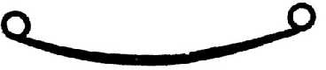
    - Nocollectionofmoisturebetweentheleavesandhencenofrettingfatigue.

TaperedLeafSpring
CoilSprings
    - Usedinindependentsuspension
    - Theenergystoredperunitvolumeisalmostdoubleinthecaseofcoilspringsthantheleafsprings
    - Nonoiseproblems,Nostaticfrictioncausingharshness
    - Takesshearaswellasbendingstresses.
    - Cannottaketorquereactionandsidethrust.

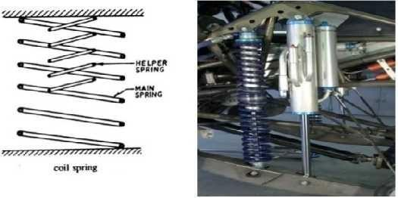
    - Ahelpercoilspringisalsosometimesusedtoprovidestiffnessagainstincreasingload.
Coilspring

EXPLAINTHEWORKINGOFTORSIONBARWITHNEATSKETCH.
Torsionbar(Heattreatedalloyspringsteel)
  - Arodactingintorsionandtakingshearstressesonly
  - Usedinindependentsuspension
  - Oneendisfixedwithframe,otherattheendofthewheelarmandsupportedinbearing.
  - Theotherendofthewheelarmisconnectedtothewheelhub
  - Whenthewheelstrikesabump,itstartsvibratingupanddown,thusexertingtorqueonthetorsionbar, which acts as a spring.
  - Occupieslessspace
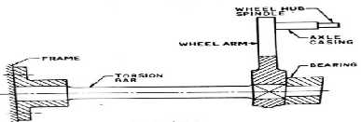
  - Sometimestorsiontubesareusedinsteadofthebars,theformerbeingstifferthanthelatterones
Torsionbar
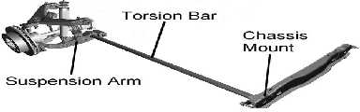
Componentsoftorsionbar

Advantages
- Themainadvantagesofatorsionbarsuspensionaresoftrideduetoelasticityofthebar,durability, easy adjustability ofrideheight, and small profile along the width of the vehicle.
- Ittakesuplessofthevehicle'sinteriorvolumethancoilsprings.

Disadvantages:

  - Doesnottakethebrakingordrivingthrust
  - Absenceoffrictionforce,andhenceofdampingwhichisnecessitytocontrolthevibrationsproduced due to road shocks.

RubberSprings:
Advantages:
  - StoreGreaterenergyperunitweight
  - Excellentvibrationdampingproperties
  - Absenceofsqueaking
  - Numberofbearingsisreducedconsiderably
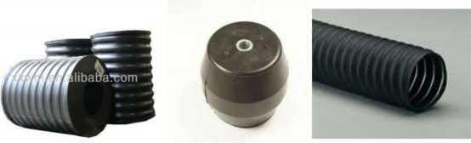
  - RubberismoreReliable.

Compressionspring Compressionshearspring Steelreinforcedspring
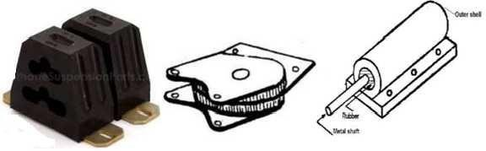
Progressive spring Face shear spring Torsional shear spring Types of Rubber Springs:
- Compression Spring: It is reliable, simple construction, resist occasional overload of large magnitude and large measure of inherent damping.
- Compression Shear Spring: The load is carried partly by shear and partly by compression components in therubber and large strains maybeallowed in the rubber body. Fatigue propertiesare excellent
- Steel Reinforced Spring: ‗Eligos‘ spring consists of a steel helical spring bonded in a rubberbody. Steel spring carries about 20% of the load, balance carried byrubber material.
- Progressivespring:Ithasinitiallyanexceedinglysmallratewhichrises rapidly as the central cavity closes.
- Face Shear Spring: consists of a thick disc of rubber having metal plates bonded to its flat surfaces, and axially precompressed. It operates by relative rotation of the plates about its axis thus loading the rubber partly in shear.

- Torsional Shear Spring: consists of an inner metal shaft, tubular or solid, and an outer trough-like shell between whichrubber bodyisbonded, thelater being putunder pressureby closingthetrough withariveted or spot welded bas plate.The springoperates bytherotation ofthe shaftabout its ownaxisrelativetothe shell.
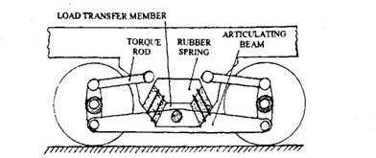

EXPLAINTHEWORKINGOFSHOCKABSORBERWITHNEATSKETCH.(OR)
EXPLAINTHEOPERATIONOFATELESCOPICTYPESHOCKABSORBERWITHASKETCH. SHOCK ABSORBERS:
  - The shock absorbersareused to control the excessive spring vibrations(Control theamplitudeand frequency of spring vibrations)
  - Absorbstheenergyofshockconvertedintoverticalmovementoftheaxlebyprovidingdampingand dissipating the same into heat.
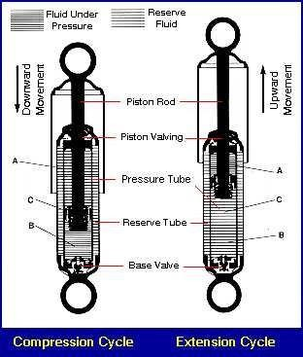
  - Theshockabsorbersarebasicallyoftwotypes:Thefrictiontypeandhydraulictype. Friction typealmost obsolete due to its non predictable damping characteristics.

Shockabsorber
A-OutercylinderB-innercylinderC-fluid
Principle of Hydraulic shock absorber: When a piston forces the fluid in a cylinder to pass through some hole, a high resistance to the movement of piston is developed which provides the damping effect. The dampeningactionofahydraulicshockabsorbercomesfromtransferringoil,underpressure,throughvalvesthat restrict the oilflow.Resistance tomotion is low whenthe pistonmovesslowly,and highwhen itsvelocityis

high.Inhydraulictypethedampingeffectisproportionaltothesquareofthespeed.Therefore,forsmall vibrations, the dampingis small and for larger vibrations, the damping becomesautomatically more.

TelescopicTypeShockabsorber:
ConstructionofShockabsorber:
  - Rod Gisattachedtothe2wayvalveA,whileanothersimilartwowayvalveBisattachedatthelower space between cylinder C andtubeD, which is connectedtothe space below the valveassemblyB
  - HistheglandintheheadJandanyfluidscrappedoffby rod Gisbroughtdownintothe annularspace through the inclined passage shown in the head.
  - TheeyeEisconnectedtheaxle,whiletheeyeFisattachedtothechasisframe.
  - ThefluidusedinSAisamixtureof60%transformeroiland40%turbineoil.
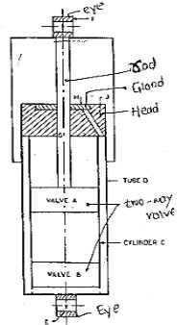
Telescopicabsorber

Operation:
  - Considerthecarhascomeacrossabump.
  - Eye E would move up and therebythe fluid will pass from the lower side ofvalveassembly A to its upper side.
  - SincethevolumeofthespaceaboveAislessbythevolumeoftherodG,the
  - fluidwillalsoexertitspressureonvalveassemblyBandgototheundersideof
  - valveB
  - Thispassingofthefluidthroughvalveopeningsprovidesthedamping.
  - Similarly for downward motion ofthe Eye E, the fluidwill pass from the upper side ofthe valve assembly Atothelower sideand also from the lower side of valve assemblyB toits upper side.
  - TheconstructionofvalveassemblyA&Bareshowninfigure.
  - Whenthepressure ontheupper side becomegreater,thevalveC opensagainstthe forceofthespringdand therebyallows the fluid to come down to the lower side.
  - However whenthepressure onthelower side becomes greater,the valve a is liftedagainstthe force of star shaped spring b and the fluid passes up through the various openings.

Leverarmtypeshockabsorber:
  - Largedeflectionsarepossibleinthistypeanditsfadecharacteristicsarebetter.
  - Thisconsistsoftwo pistonsoperatingin twoadjacent chambersfilled with oil and connected through holes which are covered or uncovered by means of a valve.
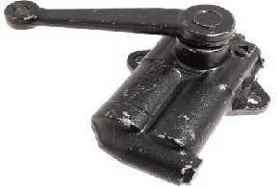
  - The up and down movement of the lever arm due to road shocks causes one piston to move up and other down, thus causing the oil to flow through the oil holes which absorbs the energy of vibrations and causes their damping.

EXPLAIN THE WORKING OF FRONT INDEPENDENT SUSPENSION SYSTEM WITH NEAT SKETCH.

IndependentSuspension:
  - When rigid axle suspension is used in vehicle, which causes, the whole vehicle to tilt on one side, causing rough ride (wheel wobble) and road adhesion is also decreased.
  - Toavoidthisthewheelsaresprungindependentofeachother,sothattiltingofonedoesnoteffectthe other.

AdvantagesofIndependentsuspension:
  - Lightersprings can be used (The elastic strain energy per unit spring weightstore in acoilortorsion bar spring is greater than the leaf spring)
  - Unsprungweightisreduced,whichreducesthetyrescrubandhenceincreasestyrelife.
  - Softerspringscanbeused
  - Steeringgeometryisnotalteredwithspringdeflectionasincaseofconventionalrigidaxlesuspension.
  - Engineandchasisframecanbeplacedrelativelylower.

TypesofFrontwheelIndependentsuspension:
  - Wishbonetypeorparallellinktype
  - MacPhersonStrutType
  - VerticalGuideType
  - TrailinglinkType
  - 5SwingingHalfaxletype.

Wishbonetypesuspension:
  - Consists ofupper and the lower wishbone arms(like chicken wishbone or letter V in shape) pivoted to the frame member.
  - Thespringisplacedinbetweenthelowerwishboneandtheundersideofthecrossmember.
  - Thevehicle weight istransmitted fromthebodyand cross membertothe coil spring through which it goes to the lower wishbone member.
  - Theshockabsorberisplacedinsidethecoilspringandisattachedtothecrossmemberandtolower wishbone member.

  - Dueto the V shape, the wishboneis usedto position the wheelsandtransmit the vehicleloadtothe springs and also resist acceleration, braking and cornering (side) forces.
  - Theupperarmsare shorter inlengththan thelowerones, whichhelpstokeep wheeltrack constant,thereby avoiding the tyre scrub thus minimizing tyre wear.
  - Howeverasmallchangeinthecamberangledoesoccur.
  - Mostpopularindependentsuspensionsystem.

ObjectsofSuspensions:Wishbonetypesuspension
  - Topreventtheroadshocksfrombeingtransmittedtothevehiclecomponents.
  - Tosafeguardtheoccupantsfromroadshocks.
  - Topreservethestabilityofthevehicleinpitchingorrollingwhileinmotion.
  - Toproviderequiredheighttobodystructureaswellasbearthetorqueandbreakingreaction.
  - Tokeepthebodyperfectlyinlevelwhiletravellingovertheunevenroad.
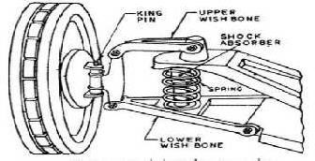

Wishbonetypesuspension
MacPhersonTypeofSuspension:
  - Onlylowerwishbonesareused.
  - Astrutcontainingshockabsorberandthespringcarriesalsothestubaxleonwhichthewheelismounted.
  - The wishboneishingedtothecross memberand positionsthe wheelaswellasresistsaccelerating, braking and side forces.
  - Simplerthandoublewishbonetype
  - Lighter,keepingtheunsprungweightlower.
  - Thecamberalsodoesnotchangewhenthewheelmovesupanddown.
  - Givesthemaximumroomintheenginecompartment.
  - Commonlyusedonfrontwheeldrivecars.
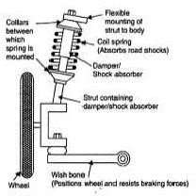
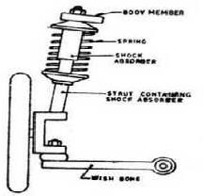
  - Whenthis systemadded withananti-roll bar, which will giveincreased road safety, improved ridecomfort and light and self stabilizing steering (car continues along its chosen line of travel when the brakes are applied even through the road surface may vary)

Advantages:
  - Simpledesign
  - Lowmanufacturingcost
  - Itislighterthandoublewishbonetypeandhenceunsprungweightislower.
  - ItgivesmaximumroomintheenginecompartmentandhencegenerallyusedinFWDvehicles.

Disadvantages:
  - Itrequiressubstantialverticalspaceandastrongtopmount.
  - Geometricanalysisshowsitcannotallowverticalmovementofthewheelwithoutsomedegreeofeither camber angle change, sideways movement, or both.
  - Itisnot generallyconsideredtogiveasgoodhandlingasadoublewishboneormulti-linksuspension, because it allows the engineers less freedomto choose camber change androll centre.
  - Ittendstotransmitnoiseandvibrationfromtheroaddirectlyintothebodyshell,givinghighernoiselevels and a "harsh" feeling to theride compared with double wishbones

VerticalGuideSuspension:
  - Thekingpinisattacheddirectlytothe crossmemberoftheframe.
  - Itcanslideupanddown, correspondingtotheupanddownmotionofthewheel, thus compressing or elongating the springs.
  - Thetrack,wheelbaseandwheelattituderemainunchanged.
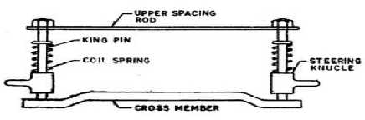
  - Maindisadvantage:decreasedstability.

TrailinglinkSuspension:
  - Acoilspringisattachedtothetrailinglinkwhichitselfisattachedtotheshaftcarryingthewheelhub.
  - Whenthewheelmovesupanddown,itwindsandunwindsthespring.
  - Atorsionbarhasalsobeenusedincertaindesignsinplaceofthecoilsprings.
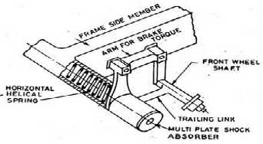
  - Thissystem maintains the camberand wheeltrack constant, but distance betweenthe frontand rear wheels does change.

SwingingHalfaxlesuspension:
  - Inthis wheels are mounted rigidly on the halfaxles, which are pivoted on their endsto the chassis member at the middle of the car.

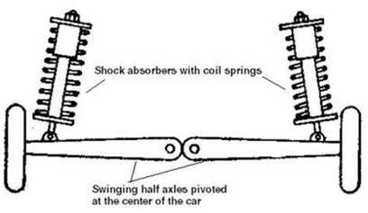
  - Themaindisadvantageisthatupanddownmovementofthewheelcausethecamberangeltovary.

RearWheel(LiveAxle)IndependentSuspension:
  - There is a considerable difficulty in the rear wheel springing if the power has to be transmitted to the rear wheels.
  - Figureshowsonemethodofrearwheelindependentsuspension.
  - Universal couplings A and B keep the wheel vertical, while the sliding coupling C is required to maintain the wheel track constant, therebyavoidingscrubbingof the tyres.Example: de Dion Axle

TrailingLinkIndependentRearSuspension:
  - Inthis typethetrailing links are pivotedat right anglesto the longitudinal axis of the car and carrytherear wheels at their ends.
  - AandBaretheuniversaljointstokeepthewheeltrackandthecamberconstantwiththeupanddown movement of the wheels.
  - Sarethecoilspringswithshockabsorbersmountedconcentricallywithinthem.
  - Thetrailinglinksholdthewheelsfirmlyandalsosustainacceleratingandbrakingforces.

Linkedtrailingarmrearsuspension:
  - Inthisthecombinedmetal-rubbermountingsrespondsoftlyonstraightroads,increasingridecomfort.
  - Whencornering,theyresistlateralforcewithareliablestabilizingeffect,even
  - whenthecarisfullyloaded

DisadvantagesofIndependentsuspensionsystem:
  - Theinitialcostishigh.
  - Greatermaintenancerequiredbecauseoflargernumberofbearings
  - Misalignmentofsteeringgeometrywiththewearofcomponents,thusrequiring
  - morefrequentattention.
  - Intheeventofbodyroll,thewheelscamber(tiltoutwardsincaseof wishbone
  - typeandinwardsincaseofMcPhersonStruttype),duetowhichcornering
  - powerisreduced.
  - Morerigidsub-frameorchassisframerequired.
  - Forcesduetounbalancedwheelsaremorepronouncedandtransmittedeasilyto
  - thesteeringwheel.

StabilizerorAntiRolldevice:
  - Whenoneroadwheel isdeflectedmorethantheother,e.g.,whenitcomesoverapumpontheroad,thereis a tendency for the vehicle to roll

  - Toavoidthistendency,a stabilizerisusedintheformofatorsionbar.
  - ThetorsionbarCisfixedtospringsAandBbymeansoftwoshortrodsD.
  - ThetorsionbarissupportedintwobearingsEwhicharefixedtotheframe.
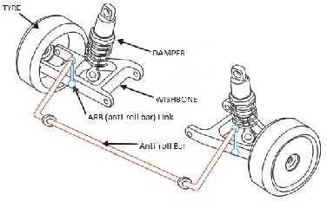

Working:
  - Whenthecarrollsoutsuchthatthenearersideinthefiguremovesup.
  - ThatdecreaseloadonspringAwhichcausedthenearerrodDtomovedown.
  - OntheotherhandtheloadonspringBisincreased,therebylettingthefartherrodDmoveup.
  - ThusthebarCwhichissupportedinbearingsundergoestwisting.
  - Itistheresistanceofthebartotwistingthatcountersthetendencyofthecar torollout,therebyproviding stability against lateral forces

InterconnectedSuspensionSystems:
  - AirSuspension
  - HydroelasticSuspension
  - HydragasUnits

InterconnectedSuspensionSystems:(Linkedsystems)
  - Thefrontandrear suspensionunitsorelsetheunitsonthetwosidesofthe
  - automobileareconnectedtogether.
  - Themajoradvantageisthattendencyofthevehicletobounce,pitchorrollis
  - reducedandaconstantdesirableattitudeofthevehiclecanbemaintained.
  - Thesimplestlinkedsystemistheair suspension.
  - TheothersystemsincurrentuseareHydrolasticsuspensionandHydragas
  - suspensionsystems.

EXPLAINTHEWORKINGAIRSUSPENSIONSYSTEMWITHNEATSKETCH.
  - Thesemaintainaconstantfrequencyofvibrationwhetherthevehicleis
  - ladenorunladen.
  - Thestiffnessofthissystemincreaseswiththeincreaseofdeflection
  - Thesemaintainaconstantfromheightfromtheroadsurface.

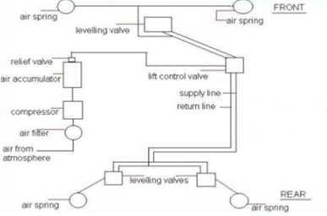
LayoutofAirsuspensionsystem
Typeofair springs:
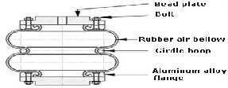
- Bellowtypespringand
- Pistontypespring.
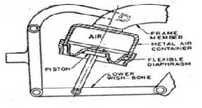
  - Both have been employed in a wishbone type independent suspension system. The four air springs, which may be eitherthebellows typeorthe pistontypeare mountedonthe same position where generallythe coil springs are mounted.
  - An air compressor takes the atmospheric air through a filter and compresses it to a pressure of about 240 MPa, at which pressure the air in the accumulator tank is maintained, which is also provided with a safety relief valve,
  - Thishighpressureairgoesthroughtheliftcontrolvalveandthelevelingvalves,totheairsprings.
  - Eachairbagofairspringisfilledwithcompressedairandsupportstheweightofthevehicle.
  - Theairspringisplacedbetweenthechasisfromandtheaxlebeam.
  - Astheloadisappliedtotheframe,theairbagsgetcompressed,actuatingthelevelingvalve.
  - Airfromthetankfillsthecompressedairbagsandhenceraisestheleveloftheframe.
  - Thesupplyofairisautomaticallycutassoonastheframereachesa predeterminedlevel.
  - Theair fromtheairbag getsreleasedas soonastheloadonthe chasis framedecreases,whichisagaindone by the leveling valve.

HydroelasticSuspension:
  - Rubberspringsactuatedbyhydraulicpressure.
  - Eachwheelhasitsownunit.
  - The energy released by rubber springs is less than the energy imparted during bumps. Rubber gives good damping characteristics.
  - Theunitisattachedbetweentheframeandtheaxle.
  - Thefrontandtherearunitsareconnectedbypipesthroughwhichthefluidflows.
  - When the road wheels encountera bump, the piston of the hydro elastic unitmoves upwards pushing the diaphragm.
  - The fluidbetweenthe separator plateand diaphragm gets compressedand passes to therear unitsthrougha two-way valve.
  - Theresistanceofthisvalveprovidesthedampingeffect.
  - Thefluidpressure,inturnpushesthediaphragmoftherearsuspensionunits,raisingtherearend.
  - Thustheleveloftheframefromtheroadsurfaceismaintained.
  - Afterthe carhas passed the bump, the fluidreturns from the rear units tothe front, restoring theoriginal position.
  - Similarly,whentherearwheelsmeetabump,thefrontportionofthecarisraisedup.
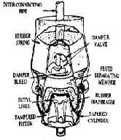

HydragasSuspensionUnits:
  - Commonlyknownashydro-pneumaticsuspensionunits
  - Theseprovidingbothdampingandselflevelingeffect.
  - Eachwheelhasa separateunit,thepistonoftheunitbeingattachedtothecentreofthesuspensionarm.
  - Thesuspensionarmlinkseachwheeltothechassisframe
  - Theunitconsistsofametallicsphericalcasingwhichisintwohalves.
  - Theupperhalfcontainsnitrogenunderpressureabovethediaphragm.
  - Belowthediaphragmisahydrauliccylinderfullofhydraulicfluid.
  - Apistonslidesinsidethehydrauliccylinderandisconnectedtoapushrod.
  - Theendofthepushrodispivotedtothesuspensionarmwhichlinkseachwheeltotheframe.
  - Adamperintheformofavalveislocatedatthetopofthehydrauliccylinder.
  - Thefluidiskeptinatanktheflowbeingcontrolledbyaslidevalve.
  - The displacer chamber is sealed at its lower end by a load absorbing nylon reinforced rubber diaphragm (piston diaphragm) which rolls between the conical piston and the tapered displacer chamber skirt as the suspension deflectsup anddown whenthe wheels pass over anyirregularities on theroad surface.
  - Within the spherical chamber is a butyl-rubber diaphragm (separator diaphragm) which separates the sphere into nitrogen charged (17.5 bars) upper region (the spring media) which is sealed for life, and the lower region which is filled with fluid.
  - Initiallyfluidispumpedintothedisplacerchamberuntilitreachesthenitrogenchargingpressure.

  - Then it will compress and lift the separator diaphragm off the bottom of the sphere. Since the gas and fluid pressuresare equal,the separator diaphragmis not subjected to heavy loads,in factitonly functions as as a flexible wall to keep the gas and fluid apart.
  - A water based fluid containing 50% industrial alcohol and a small percentage of anti-corrosion additive is pumped into the systemtoa pressureof 23 bars withthecar inanun-laden state, thisbeingthecondition in which the car's body to ground height is checked.
  - Oneadvantage in usingtherolling diaphragm type of displacer is that a water based fluid can beutilized as opposed to oil which would not have such stable viscosity characteristics.
  - The effective area of the piston compressing the fluid is that projected areaof the displacer diaphragm which is not supported bythe internal tapered skirt of the displacer chamber.
  - Therefore, as load on the displacer piston increases, and the piston is pushed further into the chamber, less ofthe displacer diaphragm willbe supported bythechamber'sskirtand more will form partoftheprojected effective piston area.
  - The consequence of the diaphragm piston pushing up within the displacer chamber is that the load bearing area ofthe pistonisincreased due to the diaphragmrollingaway from itssupportingtapered chamber skirt.
  - Asaresulttheresistanceofferedbythefluidagainsttheupwardmovementofthepistonrises.
  - In other words, due to the tapered chamber's skirt, the spring rate (stiffness) increases in proportion to the spring's deflection.
  - The progressive action of the rubber valve between the two chambers provides for a measure of damping which slows down bumpandrebound movements caused bytheimpact ofthe tyre on verybumpyroads.
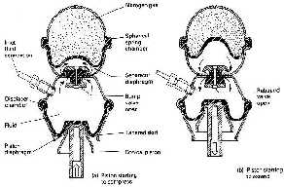

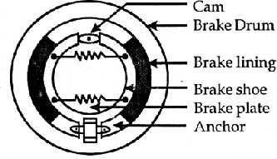
EXPLAINTHEMECHANICALBRAKESYSTEMWITHNEATSKETCH. DRUM BRAKES WORK

MechanicaldrumBrake

  - This internal expandingtype ofbrake contains two shoes thatare attachedtoa back-plate andare fixedtoa stubaxleoraxletube.Thesection ofeach shoeisof―T‖shape.

  - A frictionliningisrivetedor bondedtotheouter faceofthe shoe. A driveis fittedat one end ofthe shoe so that the shoe expands when the brake pedal is applied. In a simple brake a cam is used as a shoe expander, but modern systems for cars use hydraulicallyoperated pistons for shoe expansion.
  - The shoe anchor is rigidly attached to the back-plate and takes the form of a large pin that passes through theshoes, or housing. The shoesbutt against the anchor. Springspull the brake shoesonthe back-plateand alsoreturn the shoes tothe‗off positionafter the brake has been applied.
  - Insomelayoutsseparatespringsexecutetheretentionandreturnfunctions. The inner cylindrical surface of the cast iron drum is made smooth on to which the brake linings rub. The drum is generally fixed to the hub flange using counter-sunk screwsand secured bythe wheel nuts.
  - It is necessary to adjust excessive clearance due to wear of the friction facing, so that they are always positioned very close to the drum. This is carried out either manually adjusting the brakes periodically, or having an automatic adjuster that continually sets the shoes.

AdvantagesofDrumbrakesystem:
  - Simpledesign.
  - Fewerparts.
  - Easy&cheapertomanufacture.
  - Lowmaintenancecost.
  - Comparativelylongerlife.

DisadvantagesofDrumBrakesystem:
  - LowbrakingforcecomparedtoDiscs.
  - Brakes'fade'whenthedriverappliesthemforaprolongedtime.
  - Thebrakeshoeliningmadeofasbestosisharmfultohumans.
  - Whenwet,thebrakinggripreducesconsiderably.
  - Non-asbestosliningscatchmoisture;causingthebrakestograbsuddenly.

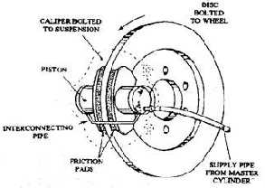
MECHANICALDISCBRAKE
MechanicalDiscbrake
  - One problem with drum brakes is fade and to minimize this problemthe disc brake was developed. It uses an exposed disc that is attached to the hub flange. The two friction pads are pressed on to this disc to provide braking action . The pads are actuated by hydraulic pistons placed in cylinders formed in a caliper, which is secured to a fixed part of the axle.
  - The hydraulic pressure forces the friction pads against the rotating cast iron disc. Consequently, the disc motion isretarded and heat generated fromthe energy of motion is conducted tothedisc.
  - Since a large part of the disc is exposed to the air, heat is easily dissipated, so that the brake can be used continuously for long periods before serious fade occurs. In this layout the friction pads move at a right angleto the disc, sothat anydrop in the friction value does notaffect the forceappliedtothepad.

  - For the application ofa disc brake,a greater pedal pressure is necessary to produce a givenretardationthan that required for a drum brake. Adjustment of pad wear is automatic on a disc brake.In this brake system thepads can also beinspected easilyandintheabsence of corrosion, the pads can berenewed easily.
Advantages
  - Itislighterthandrumbrakes.
  - Ithasbettercooling(becausethebrakingsurfaceisdirectlyexposedtotheair)
  - Itoffersbetterresistancetofade.
  - Itprovidesuniformpressuredistribution
  - Replacementofbrakepadsiseasy.
  - Bydesigntheyareself-adjustingbrakes.
Disadvantages
  - Itiscostlierthandrumbrakes.
  - Higherpedalpressureisrequiredforstoppingthevehicle.Thisbrakesystemisinstalledwithvacuum booster.
  - Noservoactionispresent.
  - Itisdifficulttoattachasuitableparkingattachment.
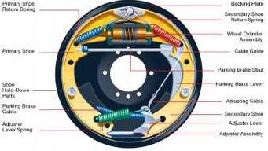
HYDRAULICDRUMBRAKE
Hydraulicdiscbrake
  - Thewholeassemblyofthedrumbrakeisfittedtotheback plateofthewheel.Thebackplateremains stationary and it does not rotate with the wheel.

BrakeDrum:
  - Itisaroundcastironhousing whichisusedto stopthevehiclewiththehelpofbrake shoe.Thedrumbrake is bolted to the hub ofthe wheel. It rotates with the hub.

BrakeShoe:
  - Itisthefrictionalpartofthedrumbrake, withoutittheworkingofthebrakeisnotpossible.Thebrakeshoe has brakeliningat its outer curve.It isthe brake lining which makes contact with brake drum during the stopping of the vehicle. It is of two types
- PrimaryBrakeShoe:Theshoehavinglargeliningmaterialiscalledasprimaryshoe.
- Secondarybrakeshoe:Theshoewithsmallliningmaterialiscalledsecondaryshoe.

WheelCylinder:
  - Itisusedtoforcethebrake shoeoutwardtoapplythebrake.Thewheelcylinderisconnectedtothemaster cylinder.Itcontainspistonwhichmovesoutward when brakeisappliedand forcesthebrakeshoetowards inner surface of the drum.

ReturnorRetractingSpring:
  - Itisusedtoretractthebrakeshoeafter brakeisapplied.Tworeturnsprings arethereindurmbrake,onefor the primary shoe and other one is for secondary shoe.

SelfAdjuster:
  - Itmaintainstheminimum gapbetweenthebrakeshoeanddrumsothattheydonotcontacteachotherwhen pedal is not pressed. In the case ifthe brake lining wear out,and gapincreasesin between the shoe and drum,It can beadjustedagainto maintainthegap between shoeand druminner surface. onceit isadjusted it maintains the same gab during the brake working byitself.
WorkingPrinciple
  - The brake shoeisallowed to expandin boththe direction. Asthe brakelining ofshoe touchesthe inner surfaceofthedrum, frictionisgeneratedinbetweenthebrakeshoeanddrumandstopsthevehiclefrom moving.
WorkingofDrumBrakes
  - Asthebrakepedalispressed,itcompressesthefluidinthemastercylinderandallowsthepistonofthe wheel cylinder to expand outward.
  - Theoutwardmotionofthepistonofwheelcylinderforcesthebrakeshoeoutwardagainstthebrakedrum.
  - Asthebrakeshoeliningtouchestheinner surfaceofthedrum,andduetothefrictiongeneratedinbetween thebrake shoeand drum, the motion ofthe wheel reduces and vehicle stops.
  - Astheforceisremoved fromthebrakepedal,theretractingspringsdrawsthebrakeshoeinwardandthe contact between the frictionliningand drum ended. Nowagain the brakeis readyto apply.
  - Aselfadjustingscrewispresent atthebottom, whichisusedtomaintaina minimumgapbetweenthedrum andbrakeshoe.Whentheliningofthebrakeshoeiswearoutthanthegapbetweenthedrumandbrakeshoe increases, at that time the adjuster is adjusted again to maintainthe minimum gap.

Advantages
  - Theyareselfenergizingbrakingsystem.Itmeanstheyaredesignedtooperatebyitself.
  - Itischeaperthanthediscbrakingsystem.

Disadvantages
  - Heating problem: Since the frictionarea is totally covered bylining, so heatis developed during the frictionisnotallowedtogooutintheatmosphere.Thismayreducesthebrakingefficiencyofthevehicle.
  - The drum brakes will not work properly ifit gets wet in water. Thisis because water takes longer time to comeoutfromthedrum.thewaterreducesthefrictioninbetweenthebrakelininganddrum.Inthisarticle we have learnt about how drum brakes works andits main parts, working principle with advantagesand disadvantages. If you like this article than don‘t forget to share.

HYDRAULICDISCBRAKE
  - Brakesareverycrucialforstoppingavehicle.Withoutbrakesitisimpossibletodriveacaroranyvehicle. Brakesare of different types andaccordingtotherequirement the types of brakes are chosen for the application. Here we will discuss aboutDisc brake – main components, working,advantagesand disadvantages with application.

MainComponentsofDisc brake
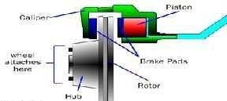
- WheelHub:Thediscrotor isattachedtothewheelhubanditrotateswithit.Thewheel ofthevehicleis bolted to the wheel hub.

CaliperAssembly:
Thecaliperassemblyconsistof
  - Brakepad:Itmakescontact withtherotordiscandduetothefrictionbetweenthebrakepadandrotordisc the vehicle speed reduces and it stops.

Caliperbracket
  - Caliperframe
  - Piston:Itappliesthebrakeforceonthebrakepadswhenbrakeleverispressed.
  - Sliderpin:Itistheslidingpinwhichslidesintheholewhenbrakeisapplied.
  - Dustboots:Itpreventstheentryofdustintothecaliperpinorsliderpinhole.
- DiscRotor:Itistherotatingpartofdiscbrake.Whenbrakesareapplied,alotofheatisgeneratedwhichcan decreasethe braking efficiency, so the rotor has drilled vent holes onit whichdissipatesthe heat.
WorkingPrinciple
TheworkingofadiscbrakeisbasedonPascallaw.
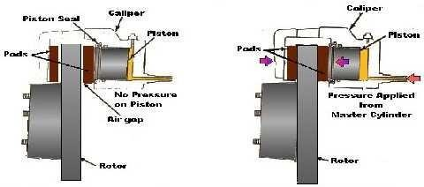
Working
- Whenbrakepedalispressed,thehighpressurefluidfromthemastercylinderpushesthepistonoutward.
- Thepistonpushesthebrakepadagainsttherotatingdisc.
- Astheinnerbrakepadtouchesrotor,thefluidpressureexertsfurtherforceandthecalipermovesinwardand pullsthe outward brake pad towards the rotating discand it touchesthe disc.
- Nowboththebrakepadsarepushestherotatingdisc,alargeamount offrictionisgeneratedinbetweenthe padsand rotating discand slows down the vehicle and finallylet it stop.
- Whenbrakepadisreleased,thepistonmovesinward,thebrakepadawayfromtherotatingdisc.Andthe vehicle again starts to move.
Advantages
  - Itislighterthandrumbrakes.
  - Ithasbettercooling(becausethebrakingsurfaceisdirectlyexposedtotheair)
  - Itoffersbetterresistancetofade.
  - Itprovidesuniformpressuredistribution
  - Replacementofbrakepadsiseasy.
  - Bydesigntheyareself-adjustingbrakes.
Disadvantages
  - Itiscostlierthandrumbrakes.
  - Higherpedalpressureisrequiredforstoppingthevehicle.Thisbrakesystemisinstalledwithvacuum booster.
  - Noservoactionispresent.
  - Itisdifficulttoattachasuitableparkingattachment.

Application
Discbrakesaremostlyusedinmotorcyclesandcars.

EXPLAINTHEWORKINGPRINCIPLESOFHYDRAULICBRAKESYSTEMWITHNEAT SKETCH

HydraulicBrakingSystem
Introduction
  - Hydraulicbrakingsystemisatypeofbrakingsysteminwhichunlikemechanicalbrakingsystem,hydraulic fluidisusedtotransmitthebrakepedal or breaklever forcefromthebrake pedal or brakelevertothefinal drum shoes or disc caliper in order to achieve braking.
  - Inthistypeofbrakingsystemthemechanicalforcetransmittedbythedriveronthebrakepedalisconverted intothe hydraulic pressure bya deviceknownas master cylinder andthenthishydraulic pressureis sent to the final drum or disccaliper in order to stop or de-accelerate the vehicle.
WhyWeNeedHydraulicBrakingSystem
  - Asthebrakingofanautomobilevehicleisaverycrucialsafetypart sotheresponsesfromthebrakepedalto the final braking must be very quick which wasa failure ofa mechanicaltype braking systemand isvery well achieved bythe hydraulic braking system which provides quick braking.
  - Thebrakeforcegeneratedbyhydraulicbrakingsystemisveryhighascomparedtothemechanicalbraking which isa veryimportant factor for today‘s super and hyper series ofvehicles.
  - Frictionalwearandtearincaseofmechanical brakingsystemwasveryhigh duetotheinvolvementof manymovingparts,whichisverywellreducedtotheoptimumlevel withtheintroductionofhydraulic braking system which has veryless movingparts as compared to the mechanical one.
  - Brake failurechancesin case ofhydraulicbraking systemareverylessascomparedto the mechanical systemduetodirectconnectionbetweentheactuator(brakepedalorlever)andthebrakediscordrum.
  - Design complexityincaseofmechanicalbrakingwasveryhighwhichisreducedwiththeintroductionof hydraulic braking system which has simple and easily assembled design.
  - The maintenancein case of mechanical braking system was high dueto the involvement of complexand morenumberofmemberwhichisnotaproblemwiththehydraulicbrakingsystemasithassimpledesign with less moving parts.
Types
Hydraulicbrakingsystemareclassifiedon2basis-
- Onthebasisoffrictionalcontactmechanism-Onthisbasis,hydraulicbrakesareof2types–
  - Drumbrakeorinternalexpandinghydraulicbrakes.
  - Discbrakesorexternalcontractinghydraulicbrakes.
- Onthe basisofbrakeforcedistribution-onthisbasis,hydraulicbrakesareof2types-

Singleactinghydraulicbrakes
  - Dualactinghydraulicbrakes
Wehavealreadyfamiliarwiththesetermsfromourlastarticleontypesofbrakingsolet‘sjuststudyabouttheir construction and working.

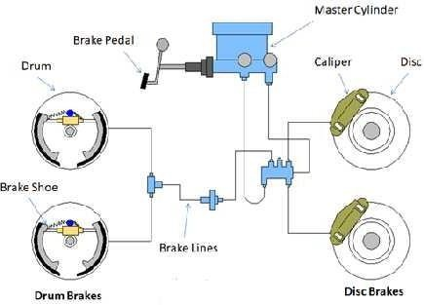
ConstructionalDetails

HydraulicBrakesystem

    - DrumHydraulicBrakeorInternalExpandingHydraulicBrakes-
Indrumhydraulicbrakingsystemthepartsinvolvedare-
      - Brake pedalor brakelever-Inhydraulicbrakingsystemsameasother brakingbrakepedal or brakelever isrequiredbythedrivertoapplybraking,thisbrakepedalorbrakeleverisattachedwiththemastercylinder through mechanical rod or connecting rod.
      - Mastercylinder–Itisthesimplecylinderandpistonarrangement(refertoarticleonmastercylinder)which convertsthe mechanical force fromthe brake pedal into the hydraulic pressure.
Thebrakepedalisconnectedwiththemastercylinder‘spistoninsuchafashionthatthemovementofpedal causes to and fro motion of the piston inside the master cylinder.
      - Brakefluidreservoir–itisthesimplereservoirtank containingbrakefluidwhichisconnectedtothe master cylinder with the help of brake hose.
      - Brakelines-Theyarethehollowhighpressuremetaltubethatconnectsthemastercylinderwiththedrum cylinder inside these brake lines high pressure brake fluid from the master cylinder flows whichis responsible for further brake actuation.
      - Drumcylinder-Itistheanothercylinderfittedinsidethedrumofthedrumbrakesandisconnectedwith thebrake shoes, thehigh pressure brake fluid fromthebrakelines comes to this cylinder.
      - Brakedrum(refertoarticleondrumbrake)–Itishousingofdrumcylinder,brakeshoesandspring, the outer part ofthe drum rotates with the wheel andinner part consisting the brake shoeand cylinder remains stationary.

DiscHydraulicBrakesorExternalContractingHydraulicBrakes-
Dischydraulicpartsanddrumhydraulicbrakepartsarealmostsamethatare
      - Brakepedalorbrakelever-Exactlysameasdrumbrakesmentionedabove.
      - Mastercylinder-Sameasdrumbrakes
      - Brakefluidreservoir-Sameasdrumbrake.
      - Brakelines–Sameasdrumbrakebutheretheyconnectthemastercylinder withthedisccallipercylinder.

      - Discrotor-Itisthemetallicdiscfittedwiththewheelhubinsucha fashionthatitrotateswiththewheelof avehicle moreover discrotoristhesurfacethatmake frictionalcontactwiththebrake shoeinordertostop or de accelerate the vehicle.
      - Disccaliper-Itisasmall stationarycomponentfittedovera discjustlikeaclamp,insidewhichthereisa housing of brake shoes and hydraulic cylinder, when the brakesareapplied the brake shoes inside the caliper contractsand make frictional contact withthe rotating discinorder toprovidebraking.
OntheBasisofBrakeForceDistribution
Allthecomponentsofsingleactinghydraulicbrakesanddoubleactinghydraulicbrakeswhetherit‘sadrum type singleactingbrake ordisctype singleacting brakeare sameasmentionedabove,theonlydifferenceis typeofmastercylinderusedwhichdecidesthebrakeforcedistribution i.e.Inbikes-singlewheelbrakingor double wheel braking,In cars-two wheel braking orall wheel braking. So let‘sjust see that in detail.

SingleActingHydraulicBrakes-
Insingleactingtypeofhydraulicbrakes,simplesinglecylindertypeofmastercylinderisusedwhichprovides limitedhydraulicpressurewhichcanonlybetransferredinsingledirectioni.e.Inbikes-onlysinglewheel,In cars– only single pair(front or rear) of wheels.

DoubleActingHydraulicBrakes-
Indoubleactingtypeofhydraulicbrakes,doubleor tandemmaster cylinder isusedwhichprovideshigher brakeforce whichcanbetransferredindoubledirectioni.e.bothwheelsinbikesandallthewheelsincars. Working of a Hydraulic Braking System

DrumHydraulicBrake
Whenthedriverapplybrakesinavehicleequippedwithdrumtypehydraulicbrakesfollowingprocesstake place-
  - Duetothemovementoractuationofbrakepedaltheconnectingrodattachedinbetweenpedalandpistonof a master cylinder moves whichinturn pushes the master cylinder‘s pistoninsidethe master cylinder just like a medical syringe.
  - Duetothismovementofthepistoninsidethemaster cylinderthecompressionofbrakefluidinsidethe master cylinder takesplacewhichinturnprovidestheconversion ofmechanicalenergyintohydraulic pressure.
  - Thishighlycompressedbrakefluidfromthemastercylindermovesinsidethebrakeandthetransferofthis hydraulic pressure from master cylinder to the brake drum takes place.
  - Whenthis high pressure brake fluid entersthe wheel cylinder or drum cylinder due o its high pressure, movementinthecylinderpistontakesplacewhichinturnexpandsthestationarybrakeshoesattachedtoit.
  - Duetotheexpansionofthebrakeshoesfrictionalcontactbetweenbrakeshoesanddrumlining(therotating drum part) is made which inturn converts thekinetic energy of the vehicleinto heat energy and finally braking occurs.
Single Acting Drum Type Braking –The working of the singleacting drum type hydraulic brake is exactly sameasmentionedabove,inthistypeofbrakingsingle wheelor a singlepairof wheelsgetsthebrakingforce. Double Acting Drum Type Braking-In doubleacting hydraulic brake the high pressure brake fluid from the master cylinderisdistributedin2directionsi.e.boththewheelsinbikesandallwheelsincarsduetotheuseof tandem master cylinder ( refer to thearticle on master cylinder)

DiscHydraulicBrakes
Whenthedriverappliesbrakeina vehicleequipped with disctypehydraulicbrakes theprocessinvolvedis sameasdrumhydraulicbakesupto whenthehighpressurebrakefluidentersthebrakelinesbutdifferabit after that
  - Thehighpressurebrakefluidfromthebrakelinesentersthedisccallipercylinderofadiscbrakesystem.
  - Thishighpressurebrakefluidcause‘smovementinthecallipercylinder‘spistonwhichinturncausesthe movement of the brake pad attached to the piston inside the calliper.

  - Duetothis movement of brake pad the clamping oftherotating discrotor takes placeand due to this frictionalcontactbetweenbrakepadsandtherotatingdiscrotor,conversionofvehicle‘skineticenergyinto heat energy takes place which in turn stops or de accelerate the vehicle.
SingleActingDiscTypeBraking-Theworkingofsingleactingdisctypehydraulicbrakingisexactlysameas mentionedabove,inthistype of braking single wheel or a single pair of wheels getsthe braking force.
Double Acting Disc Type Braking- In doubleacting disctype hydraulic brakethe high pressure brake fluid fromthemaster cylinderisdistributedin2directionsi.e.boththewheelsinbikesandallwheelsin carsdueto theuse of tandem master cylinder ( refer tothe article on master cylinder).
ApplicationofHydraulicBraking
  - DrumTypeHydraulicBrakes-TheyareusedinsomelowspeedfourwheelerslikeTataAce.
  - DiscTypeHydraulicBrakes-TheyarewidelyusedinalmostallthecarslikeMarutiSuzukiswift, Hyundai i20 etcand also in bikeslike Bajaj pulsar 180, KtmDuke 390 etc.
  - SingleActingHydraulicBrakes-Frontbrakesofpulsar180isofsingleactingtype.
  - DualActingHydraulicBrakes–Allthecarsmentionedabove.

- EXPLAINTHEPNEUMATICORAIRBRAKESWITHNEATSKETCH.

AirBrakeSystem
Introduction
  - Apneumaticbrakeorcompressedairbrakesystemisthetypeofbrakesysteminwhichthecompressed liquid fluid from the hydraulic system isreplaced withthe compressed air for applying pressure tothe master cylinder‘s piston whichinturn pressesthe brakepadsinorder to stop or deceleratethe vehicle.
  - Pneumaticairbrakesystemisusuallyusedinheavyvehicleslikebusesandtrucks.

WhydoweNeedAirBrakeSystem?
  - Aswehavealreadydiscussedbrakesystemistheneedofanautomobilevehiclebutasweallknow whenit comes to the application every vehicleis not sameas some vehicle are used for light utility purposes like carsand bikesand someareused for heavy purposes like busesand trucks, sothereisa need of different braking systems due to the following reasons-
  - Astheloadoverlightvehicleandheavyvehiclevariesthebrake forcerequiredtostoptheheavyvehicleis farmorethanthatoflight vehicle, sotheheavyvehiclesshouldbeequippedwithabrakingsystemthatcan providethe enough brake forcethat can stop or decelerate the vehicle.
  - Whenwetalkabout light weight vehicles,hydraulicbrakesprovidesmorethanenoughbrakeforcetostop ordeceleratethevehicle duetoitsshortdimensionbutwhenitcomestotheheavyvehicles whicharelarge in sizethe effectiveness of hydraulic brake systemis the great concern.
  - Asthefluidisusedtopressthepistoninhydraulicbrakingsystemthesafetyisthegreat concernasifthere is anyleak inthe components of the hydraulic system the efficiency of the braking isreadilyreduced or even lost completely, sinceair isalwaysavailable so thebrakefailuredueto leakageisthelessconcernin air braking system.
  - Thecomponents(mastercylinder,brakelinesetc.)sizeofthehydraulicbrakesystemincreaseswiththe increaseinthesizeofthevehiclewhichinturnmakesitverycomplextoinstall,whichisnota problem with air brake system.
  - Duetothesafetymeasureslikebrakefailureandefficiency,Governmenthasmadeitcompulsoryforheavy vehicles like buses and trucks to use air brake system.
  - SoduetotheseabovementionedreasononMarch1872GeorgeWestinghouseintroducedairbraking system for the braking system in railways due to its fail-safe feature.

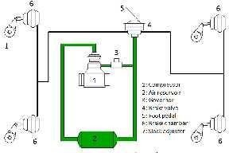
MainComponents
BasicAirBrakeSystem
- Aircompressor-Itisthecompressorthatpumpsairfromatmospheretotheairstoragetankandisdrivenby the engine through belt drive.
- Aircompressorgovernor-Itisthegoverningdeviceusedinairbrakesystemthatcontrolsthecompression pressure oftheair that is pumped tothe air storage tank through air compressor.
- Air dryer- Itis the deviceused to remove moisture content from the air coming fromtheatmosphereto preventthelinesandairstoragefromwatercondensationthatcancausebrakefailuresuchasduringwinters due to the freezing of that condensed water.
- Airstorage(reservoir)-Itisthetankthatisusedtostorethecompressedairsentbythecompressor,this storagealwayshasenoughamountofcompressedairsothatthebrakescan beappliedseveraltimeandalso preventsthe brake failure when the air compressor shows malfunctioning.
- Brake pedal- Itisthe mechanismthatisoperatedbythedriverandisusedtoactuatethebrakesinorder to stopordeceleratethevehicle.Brakeswhenpressedpushedthecompressedairwhichinturnappliesbrakesto the moving tyre.
- Dirtcollector-Itisthedevicethatisplacedinsidea brakepipelineatplacewhereabranchis separatedand taken offto thetriple valve which removes dirt fromtheair before sending it to thetriplevalve
- Brake cylinder or Brake chamber- It isthe device that consists of a cylinder and piston over which the compressedairpressureisappliedinordertopushbrakepadswhichinturnmakesfrictionalcontactwiththe disc or drum in order to stop or decelerate the vehicle.
- Brake valve or Triple valve- The actuation and release of brake requires continuous release and building ofpressure inside the brake linesandbrake cylinder according to the motion of the brake pedal this is done by thetriple valve used in air brake system.
- Brake drums – Brake drumis the componentthrough which the brake force due to frictional contact between brakepadsand drumlining istransferred tothewheel in order to stop or deceleratethevehicle,Outer surfaceofthebrakedrumconsistingofdrumliningrotateswiththewheelandtheinnerpartconsistingofbrake shoes stays in its state of rest when the brake pedal isnot pressed.
Note–Usuallybrakedrumsareusedinairbrakesystembut withsuitablearrangementdiscbrakecanalsobe used in air brake system.

WorkingofAirBrakeSystem
  - Whenthedriverofavehiclepressesthebrakepedalinordertostopordeceleratethevehiclethefollowing processes takes place-
  - Whenthe driver starts the engine the brake compressor starts asit is driven by the engine which inturn startscompressing the atmospheric airand through the compressor governor this compressedair with optimumpressureissenttothecompressedairreservoirwhichalwayshassomeamountofairstoredfrom the previous cycle.

  - Whenthedriverpressesthebrakepedaltheoutlet valveofthetriplevalve closesandinletvalveopensup whichinturngivespassagetothe compressedair fromthereservoir to pass throughthebrakelinesofthe system.
  - Thiscompressedair flowingthroughthebrakelinesisthentransferredtothebrakecylinderwhichhas piston inside it.

BasicAirBrakeSystem(whenbrakesarenotapplied)

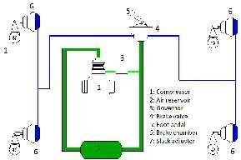
BasicAirBrakeSystem(whenbrakesareapplied)

  - Whenthecompressedairappliespressureoverthepistoninsidethebrakechamber,pistonmovesaway fromits original position which converts this pneumatic energyintothe mechanical energy.
  - Onthewheelendofthebrakecylinder,brakedrumsareplacedinsidewhichthereisa housingofthe mechanical actuator like springs or slacks having brake pads at itsouter end.
  - Duetothe movement of piston because ofthe pressureapplied by the compressed air, The mechanical actuatorinsidethebrakedrumexpandswhichinturnpushesthebrakepadsinoutwarddirectionin orderto make frictional contact with the rotating drum lines.
  - Withthisfrictionalcontactbetweenbrakepadsandrotatingdrumlinesbrakesareappliedtothewheelsin order to stop or decelerate the vehicle.
Application
Duetoits property of preventing brake failure air brakes systemsare widely used in various vehicles butin heavyvehiclesliketrucksandbusesduetothegovernmentvehicleregulationsairbrakesystemismandatory.
  - Itisusedinrailways
  - Allthetrucksandbussesontheroadtodayuseairbrakesystems,fewfromthemare.
- Volvo9400PXbuses.
- Bharat Benz 3123R truck. 3.

EXPLAINTHEVACUUMBRAKESYSTEMWITHNEATSKETCH. VACUUM BRAKE SYSTEM

Introduction
  - The vacuum brake was, for many years, used in place ofthe air brake as the standard, fail-safe, train brake on railways in the UK and countries whose railway systems were based on UK practice. Hereisa simplified description of the vacuum system.

Basics
  - Amovingtraincontainsenergy,knownaskineticenergy, whichneedstoberemovedfromthetraininorder to cause it to stop. The simplest way of doing this is to convert the energy into heat. The conversion is usually done by applying a contact material to the rotating wheels or to discs attached to the axles. The material createsfrictionandconvertsthekineticenergyinto heat. Thewheelsslowdownand eventuallythe train stops.The material used for brakingis normallyin the form of a block or pad.
  - The vast majority of the world's trains are equipped with braking systems which use compressed air as the force used to push blocks on to wheels or pads on to discs. These systems are known as"air brakes" or "pneumatic brakes".The compressed air is transmitted along the train through a "brake pipe".Changing the levelof airpressure in the pipe causes achange in thestate of the brake on eachvehicle.Itcan apply the brake, release it or hold it "on" after a partial application.The system is in widespread use throughout the world.
  - An alternative to the air brake, known as the vacuum brake, was introduced around the early 1870s, the same time as the air brake. Like the air brake, the vacuum brake system is controlled through a brake pipe connecting a brake valve in the driver's cab with braking equipment on every vehicle. The operation of the brake equipment on each vehicle depends on the condition of a vacuum created in the pipe by an ejector or exhauster. The ejector, using steam on a steam locomotive, or an exhauster, using electric power on other typesoftrain,removesatmospheric pressure fromthe brake pipe to create the vacuum. Witha full vacuum, the brakeis released. With no vacuum,i.e. normal atmospheric pressureinthe brake pipe,thebrakeisfully applied.
  - The pressureintheatmosphereis definedas1 baror about14.5 lbs. per squareinch. Reducingatmospheric pressureto0 lbs. persquareinch,createsa nearperfectvacuum which ismeasuredas30 inchesofmercury, written as 30 Hg. Each 2 inches of vacuum therefore represents about 1 lb. per square inch of atmospheric pressure.
  - In the UK, vacuum brakes operated with the brake pipe at 21 Hg, except on the Great Western Railway which operated at 25 Hg.
  - The vacuum in the brake pipe is created and maintained by a motor-drivenexhauster. The exhauster has two speeds, high speed and low speed. The high speed is switched in to create a vacuum and thus release the brakes. The slow speed is used to keep the vacuum at the required level to maintain brake release. It maintainsthe vacuumagainstsmallleaksinthe brake pipe. The vacuumin thebrakepipeisprevented from exceedingits nominatedlevel(normally21 Hg) bya reliefvalve, which opensatthe settingandletsair into the brake pipe to prevent further increase.
  - Principal Parts of the Vacuum Brake System. This diagram shows the principal parts of the vacuum brake system as applied to an electric or diesel train. The systems used on steam locomotives were somewhat different. Diagram: Author

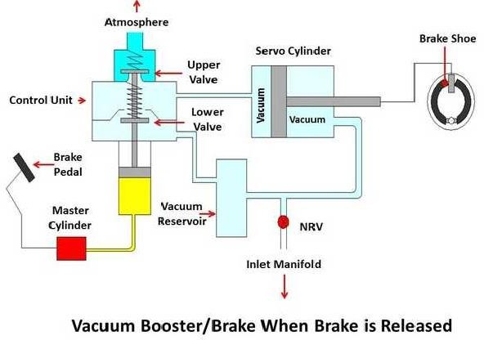

Vacuumairbrakesystem
.Driver'sBrakeValve
  - The means by whichthe driver controls the brake. The brake valve will have(at least) the following positions: "Release", "Running", "Lap" and "Brake On". There may also be a "Neutral" or "ShutDown" position,whichlocksthevalveoutofuse.The"Release"positionconnectstheexhaustertothebrakepipe andswitchestheexhauster tofull speed. Thisraisesthevacuuminthebrakepipeasquicklyaspossibleto get a release.
  - Inthe"Running"position,theexhausterkeepsrunningbutatitsslowspeed.Thisensuresthatthevacuum is maintained againstany small leaks or lossesin the brake pipe, connectionsand hoses.
  - "Lap"isusedtoshutofftheconnectionbetweentheexhausterandthebrakepipetocloseofftheconnection toatmosphereafter abrakeapplication hasbeen made.It can beusedto providea partialreleaseaswellas a partial application, something not possible with the original forms ofair brake.
  - "BrakeOn"closesofftheconnectiontotheexhausterandopensthebrakepipetoatmosphere.Thevacuum is reduced as air rushes in.
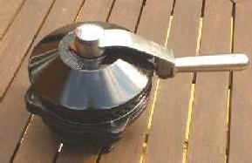
Adriver’sbrakevalveforaDMU.Photo:Tractionads.

  - Somebrakevalveswerefittedwithan"Emergency"position.Itsoperationwasthesameasthe"BrakeOn" position, except that theopeningtoatmosphere waslarger to givea quicker application.

Exhauster
  - A two-speed rotary machine fitted to a train to evacuate theatmospheric pressure fromthe brake pipe, reservoirsandbrakecylinderstoeffectabrakerelease.Itisusuallycontrolledfromthedriver'sbrakevalve, being switchedinat full speed to geta brake release or at slow speedto maintainthe vacuumatitsrelease level whilstthetrain isrunning. Exhaustersare normally driven offan electric motor but they can berun directly from a diesel engine. See also Ejector.

BrakePipe
  - The vacuum-carrying pipe running the length of the train, which transmits the variations in pressure requiredtocontrolthebrake.Itisconnectedbetweenvehiclesbyflexiblehoses,whichcanbeuncoupledto allow vehiclesto be separated. The use of the vacuum system makesthe brake"fail safe",i.e.theloss of vacuum in the brake pipe will cause the brake to apply.

DummyCoupling
  - Attheendsofeachvehicle,a dummycouplingpointisprovidedtoallowtheendsofthebrakepipehosesto be sealed whenthe vehicle isuncoupled. The sealed dummy couplingspreventthe vacuum being lost from the brake pipe.

CoupledHoses
  - Thebrakepipeiscarriedbetweenadjacentvehiclesthroughflexiblehoses. Thehosescanbesealedatthe outer ends ofthe train by connecting them to dummy couplings.

BrakeCylinder
  - Each vehicle hasat least one brake cylinder. Sometimestwo or more are provided. The movement ofthe pistoncontainedinsidethecylinderoperatesthebrakesthroughlinkscalled"rigging".Theriggingapplies the blocks to the wheels. I do notknow of a vacuum brake system which uses disc brakes. The piston insidethebrakecylindermovesinaccordance withthechangeinvacuumpressureinthebrakepipe. Loss ofvacuum applies the brakes, restoration ofthe vacuum releases the brakes.

VacuumReservoir
  - The operation of the vacuum brake relies on the difference in pressure between one side of the brake cylinder pistonandtheother. Inordertoensurethereisalwaysa sourceofvacuumavailabletooperatethe brake, a vacuum reservoir is provided on, or connected to the upper side ofthe piston. Inthe simplest versionofthebrake,shownabove,thebrakecylinderisintegralwiththevacuumreservoir. Someversions ofthebrakehavea separatereservoir anda piped connection to theupper side of the piston.

BrakeBlock
  - Thisisthefrictionmaterialwhichispressedagainstthesurfaceofthewheeltreadbytheupwardmovement ofthe brake cylinder piston.Often made of castiron or some composition material, brake blocks are the main source of wear in the brake systemand requireregular inspectionto seethat theyare changed when required.

BrakeRigging
  - Thisisthe system by which the movement ofthe brake cylinder piston transmitspressureto the brake blocks on each wheel. Rigging can often be complex, especially undera passenger car withtwo blocksto eachwheel,makingatotalofsixteen.Riggingrequirescarefuladjustmenttoensurealltheblocksoperated from one cylinder providean evenrate ofapplicationto each wheel. Ifyou change one block, you have to check and adjust all the blocks on that axle.

BallValve
  - The ball valveis neededto ensure that the vacuuminthe vacuumreservoir is maintained at therequired level,i.e.thesameasthebrakepipe,duringbrakereleasebutthattheconnectiontothebrakepipeisclosed duringa brakeapplication. Itis necessaryto closetheconnectionas soonas the brake pipe vacuum is

reducedsothatadifferenceinpressureiscreated betweentheupperandlowersidesofthebrakecylinder piston. See the next paragraph - Operation on Each Vehicle.

Operation on Each Vehicle Brake Release
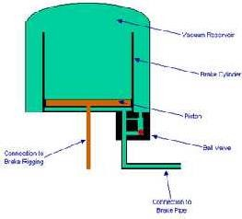

  - This diagram shows the condition of the brake cylinder, ball valve and vacuum reservoir in the release position.Thepistonisatthebottomofthebrakecylinder. Notehowthebrakecylinderisopenatthetop so that it is in direct connection with the vacuum reservoir. Diagram: Author.
  - Avacuumhasbeencreatedinthebrakepipe,thevacuumreservoirandunderneaththepistoninthebrake cylinder. Theremoval of atmospheric pressure from the system has causedthe ball valve to openthe connection betweenthe vacuum reservoir andthe brake pipe. The fall of the pistonto the bottom of the brake cylinder causes the brake blocks to bereleased from the wheels.

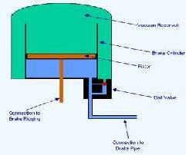
BrakeApplication
  - Thisdiagramshowstheconditionofthebrakecylinder,ballvalveandvacuumreservoirintheapplication position.Thevacuumhasbeenreducedbytheadmissionofatmosphericpressureintothebrakepipe. This has forced the piston upwards in the brake cylinder. By way of the connection to the brake rigging,the upwardmovementofthepistonhascausedthebrakeblockstobeappliedtothewheels.Diagram:Author.
  - The movement of the pistonin the brake cylinder relies on the fact thatthere isa pressure difference betweentheundersideofthepistonandtheupperside.Duringthebrakeapplication,thevacuuminthe brake pipe is reduced by admitting air from the atmosphere.
  - Astheair entersthe ball valve, it forces the ball (inredinthe diagramabove) upwardsto close the connectiontothevacuumreservoir.Thisensuresthatthevacuuminthereservoirwillnotbereduced.At the sametime, theair enteringtheundersideof the brake cylinder createsan imbalance inthepressure compared with the pressureabove the piston. This forcesthepiston upwards to apply thebrakes.

- EXLPINTHEANTI-LOCKBRAKINGSYSTEMWITHSUITABLESKETCH.

Anti-lockBrakingSystem(ABS)
WhatisAnti-lockBrakingSystem?
  - Anti-lock Braking System also known as anti-skid braking system (ABS) is an automobile safety system which prevents the locking of wheels during braking and avoid uncontrolled skidding. The modern abs systemallows steering during brakingwhich gives more control overthe vehicleincase ofsudden braking.
  - The main advantages ofusing ABS system in vehicle is that it provides better control over the vehicle and decreases stopping distance on dry and slippery surfaces. Since in ABS installed vehicle the chance of skiddingis verylessand henceit provides a better steering control during braking.
  - Without ABS system, even a professional driver can fail to prevent the skidding of the vehicle on dry and slippery surfaces during sudden braking. But with ABS system, a normal person can easily prevent the skidding of the vehicle and get better steering control during braking.
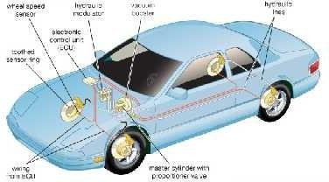
ABS
PrincipleofWorking
  - It works on theprinciple ofthreshold braking and cadence braking. Cadencebraking and threshold braking is a technique in which a driver applies the brakes and releases it before locking up the wheel and then applies the brakes and releases it again before locking.
  - This process of applying and releasing the brakes on the wheel is done in pulse form to prevent it from locking and stop skidding of the vehicle.
  - Thedriver practicesthistechniquetoachievebettercontrol over thevehicleduringinstant brakingandstop skidding of the vehicle.
  - The ABS system automatically does this cadence braking to prevent locking of wheel and skidding of vehicle when brakes are applied.
WhyAnti-lockBrakingSystem(ABS)isessentialinvehicles?
  - Tounderstandthis ina better way letsustakean incident.When you are drivingyourcar ona highwayand suddenly an obstacle comes in front ofyou and you apply brake with full power. This will locks wheels of your car andyour car will start skiddingontheroadandalsoduringskiddingyoulost your steeringcontrol andunabletomovethe carin desireddirectionin which you want.Finally you hitthatobstacleand meetan accident.
  - Let‘sustake another situation, now you are driving a car which isequipped with anti-lock braking system. When you encounter withanobstacle on the road and suddenly applythe brakes.
  - But this time the ABS system ofyour car prevent the locking ofthe wheel and avoid skidding. At this time you can control your steering and can stops your car hitting from the obstacle. This is how the abs system preventsthe skidding of the vehicleand provides greater control over it and preventsaccidents.

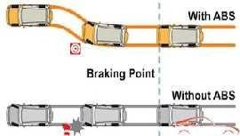

MainComponentsofABSSystem
Ithasfourmaincomponents
- speedsensors
- Valves
- Pump
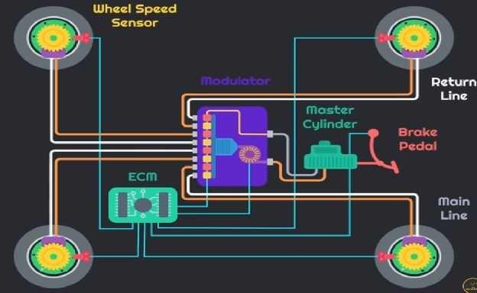
- Controller

SpeedSensors
  - It is used to calculate the acceleration and deceleration of the wheel. It consists of a toothed wheel and an electromagnetic coil or a magnet and a Hall Effect sensor togenerate signal.
  - When the wheel or differentials of the vehicle rotates, it induces magnetic field around the sensor. The fluctuation in thismagnetic fieldgeneratesvoltagein the sensor.Thisvoltage generated sendssignalstothe controller. With the helpofthe voltagethecontroller readstheacceleration and deceleration ofthe wheel.

Valves
Each brake line which is controlled by the ABS has a valve. In some of the systems, the valve works on three positions.

- In position one, the valve remains open; and pressure from the master cylinder passed through it to the brake.
- In position two, the valve blocks the line and separates the brake from the master cylinder. And this prevents the further rise of the pressure to the brakes. Valve operates in second position when the driver applies the brake harder.
- Inpositionthree,someofthepressurefromthebrakeisreleasedbythevalve.
The clogging ofthe valve isthe major problem in ABS. When the valve is clogged, it becomes difficult for the valve to open, close or change position. When the valve isin inoperable condition, it preventsthe system form modulating the valves and controlling pressure to the brakes.

Pump
  - Pump is used to restore the pressure to the hydraulic brakes after the valve releases the pressure. When the controller detects wheel slip, it sends signals to release the valve. After the valve releases the pressure supplied from the driver, it restore a desired amount of pressure to the braking system. The controller modulates(adjust)the statusofthepump soastoprovide desiredamountof pressureandreduce slipping of the wheel.

Controller
  - The controller used in the ABS system is of ECU type. Its main function is to receives information from each individual wheel speed sensors and ifa wheel loses its traction with the ground, a signal is sent to the controller, the controller than limit the brake force (EBD) and activate the ABS modulator. The activated ABS modulator actuatesthe braking valves on and offand variesthe pressuretothe brakes.

WorkingofAnti-lockBrakingSystem(ABS)
  - Thecontroller(ECU-ElectronicControlUnit)readsthesignalfromeachofthespeedsensorsofthewheel.
  - As the brakes are suddenly applied by the driver, this makes the wheel to decelerate at faster rate and may cause the wheel to Lock.
  - As the ECU reads the signal which indicates the rapid decrease in the speed ofthe wheel, it sends signal to the valve which makes the valve close and the pressure to the brake padreduces and prevents the wheel from locking.
  - The wheel again starts to accelerate, again the signal sends to the controller, this time it opens the valve, increasing the pressure to the brake pad and brakes are applied, this again reduces the speed of the wheel and tries to make it stop.
  - This process of applying brakes and releasing it happens 15 times in a second when a driversuddenly applies the brake harder. Due to this the locking of the wheel is prevented and the skidding of the vehicle eliminated.
  - DuringbrakingwithABSsystem,thedrivercansteerthevehicleandreducestherisk ofvehiclecollision.
  - When the ABS in operation, it can be felt by the driver through pulsation in the brake pedal; this happens because of the rapid opening and closing of the valves. The pulsing action of the pedal tells the driver that ABS systemisin operation. Any fault inthe ABS systemisindicated ontheinstrument panel ofthe vehicle and it will work when the fault is completely removed.

Advantages
    - Itpreventsthelockingofthewheelandthuseliminatesthechanceofskidding.
    - Theskiddingofthevehicleiscompletelyremoved,whichresultsinexcellentcontrolduringbraking?
    - AbettersteeringcontrolisobtainedwiththeABSsystem.
    - Itreducesthechanceofcollisionby30 %.

Disadvantages
AvehicleequippedwithABS(Anti-lockBrakingSystem)iscostlierascomparedwithavehiclewithoutABS.

WHATISEBD(ELECTRONICBRAKEFORCEDISTRIBUTION)ANDHOWDOESITWORK?
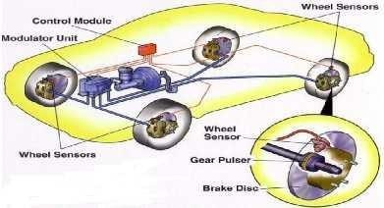
  - Most ofthe carstoday come fitted with ABS or Anti-lock Braking system. Coupled along with ABS, there isanother electronic marvel called the EBD or electronic brake force distribution. Simply put, EBD isa system wherein the amount of braking force on each wheel of the car can be varied taking factors such as load bearing on each wheel, condition oftheroad, speed ofthevehicleand soon.
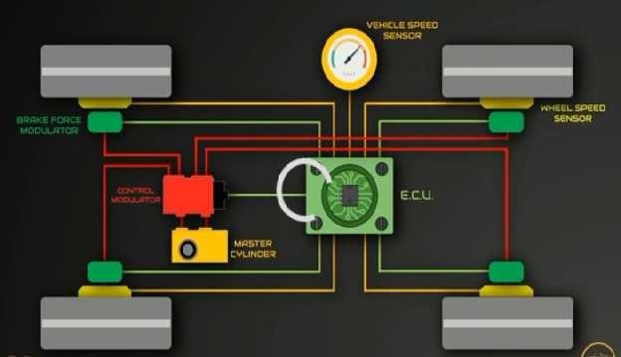

Howdoesitwork?
ThehardwareofEBDcomprisesthefollowingcomponentswhichare:
- WheelSpeedsensors
- Loadsensor
- Brakeforcemodulators/Valves
- ElectronicControlUnit(ECU)
  - Thesimpleidea behindanEBD systemisthatit neednotbenecessarytoapplythe sameamountofbraking forceoneachwheelsoastoreducethespeedofthecarorbringittoacompletestop.AnEBDsystem

makesuse of four components which makeit tick. The speed sensors, Loadsensor, brake force modulators and electronic control unit (ECU).
- Speed Sensor: The speed sensor not only calculates the speed of the car, but the speed of the engine also (RPM). One ofthe scenarios can be that the speed of the wheel might not be the same as the speed of the car. Suchasituationcanleadtothewheel(s) skidding.ThespeedsensorscalculatetheslipratioandrelayittoECU.
- Load sensor:This sensor is used to find out the weight in eachwheels and distribute the equal brake pressure to the system
- Electronic ControlUnit:It isa small chip which collectsthe data fromthe speed sensorsin each wheel and uses the data to calculate the slip ratio (difference between the speed of the car and the rotation of the tyre). Oncethe slipratiois determined, it makesuseofthe brake force modulators tokeepthe slipratio withinlimits.
- Brake Force Modulators: It is the job of these modulators to pump brake fluid into the brake lines and activatethe brake cylinders. The brake forceapplied on each wheel canbe modulated.
  - In this mechanism, each wheel has a separate sensor mounted on it for precise calculation of their speed. Additionally, there is a load sensor which measures the weight distribution between the front and the rear wheels of the vehicle.
  - In the event of braking, based on the feedback received from the load sensor and the wheel speed sensors, the ECU calculates the braking force for each wheel separately.
  - It then applies only thatmuch force for that particular wheel. In addition, it can even reduce the excess brake force applied to other wheels. The actual application of hydraulic pressure i.e. brake force is carried out by the Brake Force modulators or the valves.
  - There is a difference between the Anti-lock Braking System or ABS and the EBD. In fact, the Electronic BrakeforceDistribution can actually sensetheweight supported by each wheel at every moment. Hence, it can calculate the required braking force which is not the case with the ABS. Nowadays, many car manufacturerslikeToyota, Honda, and Mazda offer EBD as standard ontheir models.
- EXPLAINTHETRACTIONCONTROLWITHSUITABLESKETCH

TractionControl BasicDescription
  - A traction control system prevents wheel spin from occurring due to a loss of traction during acceleration. This usually happens on a slippery surface, such as snow or wet road, where the wheels are not able to generate enough traction to move the vehicle.
  - Antilock braking systems(ABS)also preventa vehicle's wheels from slipping dueto a loss oftraction. The major difference between an ABS and traction control systems is that ABS stops the wheel from losing traction while braking, while traction control stops the wheel from spinning when the vehicleis accelerating.
  - Traction control systemsare often referred to by other names(e.g. anti-slip regulation or stability control); however tractioncontrol is not the sameas electronic stabilitycontrolor active yaw control.
  - Traction control systems use wheel speed sensors to determine the rate at which the drive wheels are rotating. They detect if there is any slip occurring between the tire and the road. If slip is detected, the systemslowsthewheelbyapplyingthe brakeor reducingthetorquetothat wheeluntilitisabletogenerate the required amount of friction for the vehicle to move.
  - In vehicles with a standard differential, applying the brake to a slipping wheel, increases the amount of torque delivered to the opposite wheel, which may have better traction. Ifboth the driven wheels are losing traction,traction control systemsusuallyslow boththe slippingwheels equallyuntiltheyregaintraction.

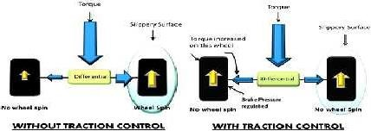
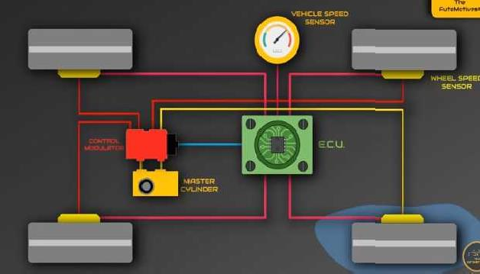
  - Someperformancevehiclesprovidetheoptiontoswitchoffthetractioncontrolsystem.
  - TractionControlSystemisa well-known car safety featurethathasbecomeintegralinensuringthe safety of the driver and passengers. Car brands are working tirelessly to improve the standard of car safety technologies offered in their new and upcoming cars.With the advancement in modern day technologies, car brands have been successful in developingadvanced technological featuresthat help to improve the safety ofthe occupants of a car and increase itsreliability in challenging driving conditions.
  - Driving on wet roads and slippery conditions can be really troublesome even for seasoned drivers because the handlingofthevehicle becomesa lot more difficultin such conditions. The vehicle can spin or slide off the road when the road is slippery, which can be dangerous for everyone sitting inside the car and other commuters on the road. A vehicle that slips or spins out of control can causeextremely dangerous situations, especially on roads with heavy traffic.
  - Traction Control System or simply Traction Control isa safety feature that ensures improved stability of the vehicle on wet roads and gives more control to the driver to stop the vehicle from slipping. Tyres without the Traction Control System become susceptible to slipping on wet roads and don‘tmaintain enough grip on the road, which endangersthe safety of passengers.
  - Here is everything one must know about this safety feature, how it can help a driver and when it is most effective.

WhatisTractionControlSystem?
  - Traction Control is anactive safety featurewhich ensures that the vehicle makes use of the maximum available traction on the road when driving on low-friction surfaces. Ifa vehicle with no traction system tries to accelerate on a slippery surface such as loose gravel, snowor ice, the tyres become vulnerable to sliding and slipping.
  - Without the Traction Control System, the tyres spin very quickly on a wet road because of reduced grip and stability.Thedriver can completelylose controlofthe vehicle in such circumstancesandthat canresult in a dangerous road accident. However, this can be avoided with the Traction Control System as this cutting-edge safety technology improves a vehicle‘s stability by adjusting the acceleration of the vehicle according to the road condition.
  - Traction Control System will activate automatically when it senses that thewheels might slip and helps the driver to make use of the maximum traction available on the road surface.This system only utilizes the available traction on a road to optimize acceleration of the vehicle and does not have the ability to create any traction of its own.
  - Traction Control is often a secondary function ofthe Electronic Stability Control, however, it isa complete safetytechnology that can perform its function independently as well.
WhenisTractionControlMostEffective?
  - This system is most effective when the vehicle is trying to accelerate on a slippery and uneven road. The effectiveness of the Traction Control System can increase even more if the driver remains attentive and drives slowly and carefully in slippery conditions. A proactive and safe driving approach coupled with Traction Control System canhelp in maneuvering a vehicle around sharp turns on a wet roadwith relative ease.
  - However, there are some limitations of the Traction Control System.This system does support the snow tyresand doesn’t improvethestabilityof thevehicle when driving in mud. Driversare, in fact,advised to turn offTraction ControlSystem ifthey are stuck in mud becausein such driving conditions,this system doesn‘t get any avaiable traction from the road.
UsefulnessofTractionControlSystem
  - TractionControlSystem canbeveryusefulinthe driving conditionssuchaspoorly maintainedroads,loose gravel, uneven roads and wet roads. This safety feature can beuseful when:
    - Uphilldrives–Tryingtoacceleratewhilegoinguphillonapaththatisroughanduneven.
    - Wetroadconditions–Drivingona wetroadthat cancausethevehicletoslowdownasthewheelswill not get enough traction to speed up.
    - Accelerating from standstill position– Trying to accelerate at a green traffic light on a wet and slippery road with traffic approaching from behind.
  - ManyadvancedTractionControlSystemsreducethe poweroftheengine tomanagetheaccelerationof thevehiclebetteron wetroads.It savesthe vehicle fromslippingandhence hasitsimportanceinavoidinga fatal crash. Drivers feel more comfortable when they have the Traction Control System in their vehicles because this system automatically adjusts theacceleration according to the condition oftheroad.

PRINCIPALOFENGINEEMISSIONSANDEMISSIONSTANDARDS.
SIEngines | CO,HCandNOx
CIEngines | CO,HC,NOxandPM
  - CO=Carbon monoxide,HC =Unburnedhydrocarbons,NOx =Nitrogen oxidesmainlymixtureofNOand NO2, PM = Particulate matter
  - Otherengineemissionsincludealdehydessuchasformaldehydeandacetaldehydeprimarilyfromthe alcoholfuelled engines, benzene and polyaromatic hydrocarbons (PAH).

SourcesofEngine/VehicleEmissions
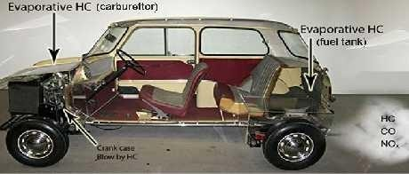
  - Figure shows the sources of emissions from a gasoline fuelled SI engine viz., exhaust, crankcase blow by and fuel evaporation from fuel tank and fuel system
Emissionsourcesinagasolinefuelledcar.
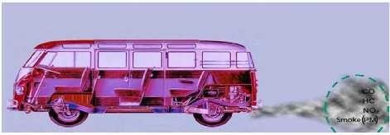
EmissionsourcesinaDieselpoweredbus.
EmissionsandPollutants
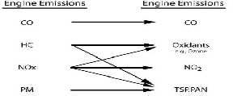
Engineemissionsundergochemicalreactionsinatmosphereknownlargelyas‗photochemical‘reactions and give rise to other chemical species which are hazardous to health and environment. Linkage of engine emissions and air pollutants is shown in Fig.
TSP=Totalsuspendedparticulatematterinair PAN = Peroxy- acetyl nitrate

Airpollutantsresultingfromengineemission

The effect of pollutants on human health depends on pollutant concentration in the ambient air and the durationto which the human beingsareexposed. Adverse healtheffectsofdifferentpollutantsonhuman health are given in Tablefor short term and long term exposures. Carbon monoxide on inhalation is known to combine with haemoglobin at a rate 200 to 240 times faster than oxygen thus reducing oxygen supply to body tissuesand results inCO intoxication.Nitrogenoxides get dissolvedin mucous forming nitrousand nitricacids causing irritation of nose throat and respiratory tract. Long term exposure causes nitrogen oxides to combine with haemoglobin and destruction of red blood cells. Long term exposure resulting in more than 10% of haemoglobinto combine with nitrogen oxides causes bluish colouration of skin,lips fingers etc
Pollutants | Shorttermhealth effects | Long-termhealtheffects
Carbon  monoxide | Headache,shortnessofbreath,  dizziness, impaired judgment, lack of motor coordination | Effectsonbrainandcentralnervoussystem,  nausea, vomiting, cardiac and pulmonary functionalchanges,lossofconsciousnessand death
Nitrogen  dioxide | Soreness,coughing,chest  discomfort,eyeirritation | Developmentofcyanosisespeciallyatlips,fingers  andtoes,adversechangesincellstructureof lungwall
Oxidants | Difficultyinbreathing,chest tightness, eye irritation | Impairedlungfunction,increasedsusceptibilityto respiratoryfunction
Ozone | SimilartothoseofNO2butat a lower concentration | Developmentofemphysema,pulmonaryedema
Sulfates | Increasedasthmaattacks | Reducedlungfunctionwhenoxidantsarepresent
TSP/Respirable  suspended particulate | Increasedsusceptibilityto  otherpollutants | Manyconstituentsespeciallypoly-organicmatteraretoxicand  carcinogenic,contributetosilicosis,brownlung

HistoricalOverview:EngineandVehicleEmissionControl
Beginning with the identification during early 1950s that mainly the unburned hydrocarbonsand nitrogenoxidesemittedbyvehiclesareresponsiblefor formationofphotochemicalsmoginLos-Angelesregion inthe US,the initiativesand milestones in pursuit ofvehicle/ engine emission controlare given inTable
Year | EventandMilestone
1952 | Prof A. J. Haagen- Smit of Univ. of California demonstrated that the photochemicalreactionsbetweenunburnedhydrocarbons(HC)andnitrogen  oxides(NOx)areresponsibleforsmog(brownhaze)observedinLos- Angeles basin
1965 | Thefirst vehicleexhaustemissionsstandardsweresetinCalifornia,USA
1968 | TheexhaustemissionstandardssetforthefirsttimethroughouttheUSA
1970 | VehicleemissionstandardssetinEuropeancountries
1974 | Exhaustcatalyticconvertersforoxidationofcarbon monoxide(CO)andHC were needed in the US for meeting emission targets. Phasing-out of tetra ethyl lead (TEL), the antiknock additive fromgasoline begins to ensure acceptable life of the catalytic converters
1981 | Three-waycatalyticconvertersandclosed-loopfeedbackair-fuelratiocontrol  forsimultaneousconversionofCO,HCandNOxintroducedonproduction cars
1992 | Euro1emissionstandardsneedingcatalyticemissioncontrolongasoline vehicles implemented in Europe
1994 | Catalyticemissioncontrolforenginesunderleanmixtureoperationintroduced
1994 | US Tier-1standardsneedingreductioninCObynearly96%,HC by97.5% and NOx by 90%
2000-2005 | Widespreaduseofdieselparticulatefiltersandleande-NOxcatalystsystems on heavy duty vehicles
2004 | USTier -2standardsneedingreductioninCObynearly98%, HCby99% and NOx by 95%

EMISSIONSTANDARDS
  - The vehicle emission standards were implemented for the first time in 1965 when control of crankcase hydrocarbon emissions fromgasolinepassenger cars wasrequired as per thelaw. Useofpositive crankcase ventilation (PCV) system on the gasoline passenger cars became necessary to prevent emission of hydrocarbon rich crankcase blow by gases into atmosphere.
  - At the same time, the exhaust gas emission standards for new cars were also established in the state of California and in 1968, US enacted legislation to implement nationwide vehicle emission regulations. In Europe , vehicle emission standards were implemented beginning fromthe year 1970.
  - Over the years, the emission standards have become more and more stringent and have driven the development ofadvanced enginedesignsand emission control technology. Now, nearlyall thecountriesall over the world have enforced vehicle emission regulations of varying severity following largely either the US or the European regulations. The emission limits that are in force in the US and Europe and the trends thereof over the years are discussed below.

LightDutyVehicles US Standards
  - The US emission standards for passenger cars are given in Table 4.1 since the limits were set for the first time under the Clean Air Act of 1968. The standards set for 1975 were rather stringent such that the oxidationcatalyticconverterswererequiredonmost cars. AmendmentstoCleanAir Actin1977resultedin the standards that required in 1980/1981 reduction of 90% in HC and CO, and 75% in NOx . The 1980-81 standards resulted in widespread use of 3-way catalyst technology.
  - During 1990s, the 1977 amendments were found inadequate as 9 US cities had higher ozone levels and 41 cities higher CO levels than the air quality standards. The 1990 Clean Air Act Amendments (CAAA) followedresultinginfurthertighteningoftheemissionstandardsbesidesothermeasureslikeintroductionof better quality fuels such as the reformulated gasoline. The new emission regulations known as Tier 1 were implemented from 1994 and Tier 2 standards from 2004 through to 2009. It is seen that the current production vehicles emit lessthan 1% of emissions of pre-control era vehicles.
  - Inthe meantimeCalifornia introduceda new setofemissionregulations(Table4.2)and calledthevehicles meeting these regulations by the name of different grades of low emission vehicles (LEV) such as TLEV ( Transitional), LEV, ULEV(Ultra), SULEV (Super Ultra) and PZEV ( Partial zero emission vehicles).

USFederalEmissionStandardsforPassengerCars,g/mile
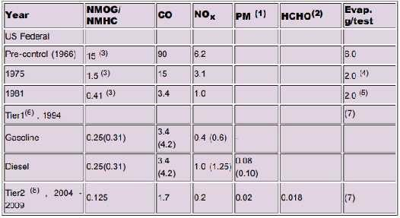

NMHC/NMOG=Non-methanehydrocarbonsororganicgases
(1)For diesel vehiclesonly(2) foralcohol fueledvehiclesonly(3)Total hydrocarbons(4) Carboncanister trap method (5) SHED (Sealed Housing EvaporativeDetermination) technique, the6.0 g/test limit representsabout 70 % less than 2.0 g/test by carbon trap method (6) values in parentheses for full useful life equal to 100,000 miles, (7) newlimits(8) To be phasedinbetween2004-2009,limits for all types of light dutyvehiclesGVW

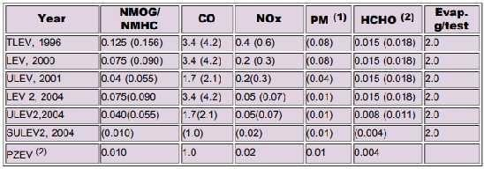
CaliforniaEmissionStandardsforPassengerCars,g/mile(1)
- Limitsinparenthesesattheendofdurabilityrunfor100,000milesandfromtheyear2004at120,000miles.
- Partialzeroemissionvehicles(PZEV)limitsarefor150,000milesdurability.
  - European Standards European emission standards for the light duty vehicles are given in the Table 4.3. Before1992 i.e. prior to Euro 1 standards, emission limits were based on ECE-15 cycle and varied with vehicle reference weight, the higher emissions were permitted for the heavier passenger cars. From 1992 however, the same limits for all the passenger cars irrespective of vehicle weight as in the US were introduced. EU standards up to Euro 3 stage require durability demonstration for 80,000 km or 5 years, whichever occurs first. In lieu of actual durability test, the manufacturers may use thefollowing deterioration factors:
  - Gasolinecars:1.2forCO,HCandNOx
  - Dieselcars:1.1forCO,NOxandHC+NOx,1.2forPM
  - Euro 5 stage requires durability of 160,000 km or 5 years, whichever occurs first. Theemission standards for the light duty trucks and medium duty vehicles also, have been laid down and can be found in the European regulations

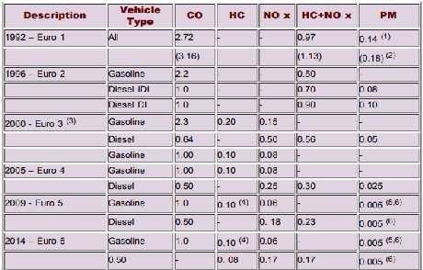
EuropeanEmissionStandardsforPassengerCars,g/km

- PMlimitsapplyonlytodieselcars.
- Valuesin parentheses are conformityofproduction (COP)limits. From Euro2 standardstype approvaland COP limits are the same
- 40sidlephaseprecedingtesteliminated
- 0.068g/kmNMHC(non-methanehydrocarbons)
- Applicableonlytoleanburngasolinedirectinjectionengines
- Likelytobereducedto0.003withnewmeasurementmethod.
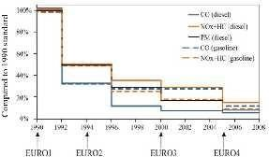
Since 1991/1992 when the European vehicles needed catalytic exhaust after treatment to meet the regulations drastic reductions in emission limits have been enforced. Relative emissions limits since 1990 (pre-Euro1) to Euro4 limitsare shown on Fig4.8.TheEuro4 limitswereonlyabout5 to 15 %ofthepre1990 limits.Beyond Euro 4 standards, drastic reductions in diesel NOx and PM emissions are required. The diesel passenger car NOx would be reduced to just 1/3 rd and PM to 1/5 th ofEuro 4 limits.

EvolutionofEUemissionstandards(lightduty)
HeavyDutyEngines
  - Most heavy-duty vehicles are powered by the diesel engines. Hence, the heavy duty engine emission regulations have been directed more towardsreduction in NOx and PM emissions.

USStandards
  - The US emission standardsfor the enginesofheavy-duty vehicles(GVW>3855kg)are given inTable4.4. The emission limits applicable from the model year 2007 specify a drastic reduction over the year 2004 standards.The PM standards will be fully effective fromthe year2007.TheNOxand NMHC standardsare to be phased-in for the diesel engines between 2007 and 2010.
  - Emission durability is to be demonstrated over the useful life of the vehicles that varies from 8 years or 176,000 km for light heavy-duty engine vehicles (>8,860 kg 15000 kg GVW).To make the year 2007 standards effective, diesel fuel sulphur is to be reduced to 15 ppm maximum down from the earlier limit of 500 ppm.

USFederalHeavyDutyEngineEmissionStandards,g/bhp-h,(USHD-Transientcycle)
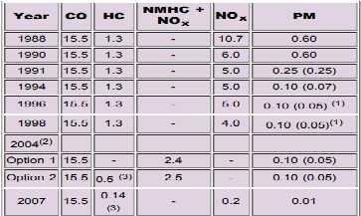

Note:valuesinparenthesesapplytourbanbuses
- PMstandardinuseis0.07g/hp.h
- Enginemanufacturersmayuseeitherofthetwooptions.
- NMHClimitsapply.

EuropeanStandards
  - The European regulations for new production heavy-duty diesel engines since Euro 1 stage are given in Tables.Thesestandardsapplytobothheavy-duty highwayvehiclesas well astourbanbuses.Thetestcycle was changed with the implementation of Euro 3 standards in the year 2000. To meet the Euro 4 standards andbeyond, diesel enginesneedsomeformofaftertreatment devicessuchasoxidationcatalysts,particulate filters, de-NOx catalysts etc.
  - From Euro 3 regulations, heavy-duty engines operating on gaseous fuels are tested also on ETC in addition to ESC cycle. However, for compliance with Euro 4 or later standards, all heavy-duty engines are to meet ESC, ELR and ETC test limits. Evolution of European emission regulations for heavy duty vehicles is shown on Fig.

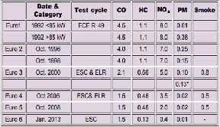
EuropeanHeavyDutyDiesel(CI)EngineEmissionStandards–g/kWh(smokeinm-1)
*Forenginesoflessthan0.75litre/cylindersweptvolumeandratedspeedofmorethan3000rpm.

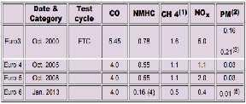
EmissionStandardsforCIandSIEngines,ETCTest,g/kWh

(1) for natural gas engines only; (2) not applicable for gas fuelled engines for approval to Euro 3 and Euro 4 standards; (3) for engines of less than 0.75 litre/cylinder swept volume and rated speed above 3000 rpm; .(4) THC (total hydrocarbons) limits apply for diesel; (5) particle number limit may apply to prevent ultra fine particles from flow through ( or partial flow) filters.
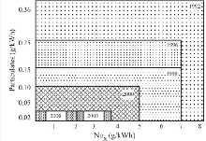

EvolutionofEuropeanHeavydutyEmissionStandards

EmissionStandardsinIndia
  - India has adopted the European emission limits on a slightly modified driving cycle for the light duty vehicles.The overall emission limits and test procedures for the heavy duty vehicles however are the same as those in Europe . In India , the emission limits are being enforced by a time lag of around 5 years as shown in Table 4.7.

IndianEmissionRegulations
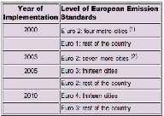
(lightdutyemissionstandardswithamodifiedEUDC-maximumspeedlimitedto90km/h)
- Delhi,Mumbai,Kolkatta,Chennai
- Banglore,Hyderabad, Ahmedabad, Pune, Surat , Kanpur , Agra ; added fromthe year 2005-Sholapur and Lucknow

MotorcycleEmissionStandards
Asian countries have a very large population of motorcycles and mopeds and these vehicles are estimated to contribute very heavily to urban air pollution. Taiwan and India have lead enforcement of stringent emission limits for two wheelers. Although the USA and Europe have implementd emission regulations for the two wheelers many decades back, but the number of these vehicles not being very large the standards were not tightened for a long time. However, now in these countries too very stringent limits are being enforced. Motorcycle emission standards in some countries are given in Table 4.8. Presently, most countries follow different test procedures. However, as discussed earlier, a world motorcycle test cycle has been developed and in future most countries are expected to use WMTC.

WorldwideMotorcycleEmissionStandards
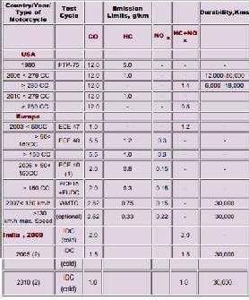
- Warm-upperiodbeforeemissionmeasurementofECE15cycleeliminated.
- Forcatalystequippedmotorcyclesanemissiondeteriorationfactorof1.2applies.

DIFFERENT TYPES OF EMISSION CONTROL DEVICESPOSITIVECRANKCASEVENTILATION(PCV)SYSTEM
  - There is many types of pollution control systems used on engines today. ThePositiveCrankcase Ventilation (PCV) systemis one that is very popular. What is the PCV system, how doesit work,and what type of pollution is being reduced?
  - The positive crankcase ventilation system, referred to as the PCV system, was one of the first pollution control devices to be used on engines. Years ago, all engines had a ―breather tube.‖ Its purpose was to remove crankcase vapors and gases from the engine. The breather tube allowed these vapors to go into the atmosphere as a known contributor to air pollution. Today, all engines use some variation of the positive crankcase ventilation system. The purpose of the PCV system is to stop crankcase vapors and gases, produced within the engine, from getting into the air.
  - Crankcase vapors and gases in the engine are a result of piston blow-by.During combustion,a small amount of combustion vapors and gases pass by the piston rings and into the crankcase area.Referring to the illustration above, the crankcase vapors and gases are drawn into the intake of the engine by the intake manifold vacuum, to be further burned by the combustion.
  - The PCV vacuum circuit works as follows. Air for the system enters the air cleaner area. The air then goes throughtheair filter,througha tube,andthroughthe closedoil filler cap. The intake manifold vacuumthen drawsthecrankcase vapors and gases backto the PCV valve. From the PCV valve, the vapors and gases are drawn into the intake ofthe engine to be burned by combustion.
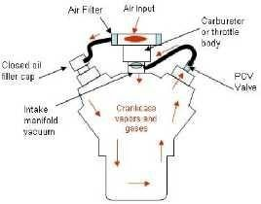

PositiveCrankcaseVentilation
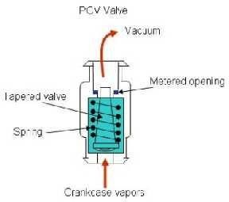

  - If too many vapors and gases get into the intake manifold, it may upset the air-fuel ratio. The PCV valve helps to control the amount of vapors and gases going back into the intake manifold.A typical PCV valveis shown in the illustration to the left. In operation, two forces are working against each other. Spring pressure inside the PCV valve works against the intake manifold vacuum. When the engine is stopped, no intake manifold vacuum exists. At this point,thePCV valveis moved down bythe springinside.
  - When the engine is decelerating or at an idle, intake manifold is very high.The intake manifold vacuum lifts the PCV tapered valve upward against the spring pressure. This reduces the size of the metered opening.Under this condition, verylittle crankcase vapors or gases enter theintake manifold.
  - During normal loads and speeds, the vacuum in the intake manifold drops. Thisallows the inside spring to push the plunger down which increases the metered opening on the top of the valve. Under this condition, theamount of crankcase ventilation vaporsand gases goingintotheintake manifold increases.
  - During acceleration or heavy loads, the intake manifold vacuum is very low. The inside spring now pushes the tapered metering valve further down, allowing more crankcase vapors and gases to enter the intake manifold.In summary, when the engine is at low speeds, only a smallamount of crankcase vapors and gasesare sentintotheintake manifold. Asthe engineincreasesin speedand load,moreand more crankcase vapors and gases are allowed to enter the intake manifold.
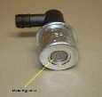
  - The photo to the left shows a typical PCV valve used on most engines.The arrow is pointing to the bottom ofthe meteringvalve. Asmentionedabove, whenthereisno intake manifoldvacuum, the spring pushesthe metering valve down. Even with thespring pressure, the valve doesn't go all the way down. Ifshaken back and forth, the PCV metering valve should rattle. If it doesn‘t, it is most likely plugged and needs to be replaced.

CATALYTICCONVERTER
  - There are millions of vehicles on roads today. Majority of them are run by internal combustion engines whichbecomeamajor contributortotheairpollution.Especiallyincities,wherehugetrafficisunavoidable canresult inpoor air qualitythat can affect not justthe environment, but even our health.
  - To solve this problem, the governments of different countries around the globe have taken necessary steps toimplement stricter emissionnormsfor vehicles.Catalyticconverterisoneofthedevicesthat couldlessen the intensity of harmful emissions coming out of a vehicle.

WhatisaCatalyticConverter?
  - Catalytic converter is a device that converts harmful toxic emission gases from a vehicle into less harmful emission gases. The process is achieved either through oxidation or reduction. Catalytic converters can be used to treat exhaust gases of both gasoline and diesel engines.

2wayCatalyticConverters
  - Unlikethethree way catalytic converter,2-way catalytic convertersareusedtoreduce CO and HC gases.2 way converters don‘t eliminate or eliminate very little amount of NO_{X}. They are made of only oxidation catalysts (platinum (Pt) and palladium (Pd)).
  - It is made of honeycomb ceramic structure with a coating of alumina. A secondary coat of precious materials, platinum and palladium is applied to the structure.

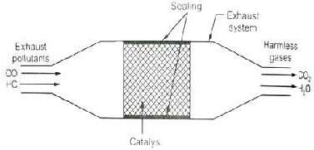

2waycatalyticconverter
  - The oxidation catalyst is honeycomb shaped structure made of platinum and palladium. Since, it is an oxidation reaction; the catalyst will try to attractthe oxygen atoms. The CO bond is strong enough to be split by the catalyst.
  - Thus CO molecule as a whole will be attracted towards the catalyst surface. The catalyst surface will also attract the oxygen molecules(O₂).Now, since O₂ molecules‘ bondsare weaker than the CO bond,theO₂ is split into individual oxygenatoms(O).The oxygen atoms will bond with the CO moleculesto form CO₂.

2CO+O₂→2CO₂
  - The hydrocarbon (HC) molecules also get treated by the oxidation catalyst. When HC molecules come in contact withthecatalystsurface,theyaresplitintohydrogen(H)andcarbon(C).Bothhydrogenandcarbon bond with oxygen to form water vapor (H₂O) and carbon dioxide(CO₂).

C₈H₁₈+17O₂→ 8CO₂₊18H₂O
Or

CH₄+2O₂→CO₂₊2H₂O

3-wayCatalyticConverters:
  - A 3-way catalytic converter is used to treat the 3 main harmful gases coming out of exhaust such as the nitrogen oxides (NO_{X}), hydrocarbons (HC) and carbon monoxide (CO) emissions.
  - There are 2 different catalysts at work: one is the reduction catalyst and the other is the oxidation catalyst. The reduction catalyst is made of platinum and rhodium. The oxidation catalyst is made of platinum and palladium.

AluminaCoating:
  - Thecatalystsareinthe formofthousands ofmicro ductsthatresemblethe formofa honeycomb.Thegases pass through these catalyst ducts. The honeycomb structure is applied with a coat of alumina (aluminum oxide).
  - Aluminaishighly porouswhich greatly increasesthesurfacearea ofthe structure.Thealumina coat carries the precious catalyst materials which help in oxidation and reduction.
  - Thisdesignmaximizesthesurfaceareaofthecatalyst,thusgivingitmoregasestoreact on.
  - Catalytic converter is installed between exhaust pipe and muffler. It works best when it is heated and can give efficiencyupto90%. Asa result, we get lessharmful toxic gases from thetail pipe.

Workingofacatalyticconverter:
  - The exhaust gases from the engine are first sent through the reduction catalyst. The reduction catalyst (platinum + rhodium) will try to eliminate NO_{X} as much as possible.

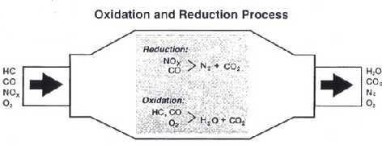

3 waycatalyticconverter
Reactionatreductioncatalyst:
  - When NO_{X} (NO or NO₂) molecules pass through the contact area, the catalyst breaks the bond between nitrogen and oxygen atoms. Since, it is a reduction reaction; the catalyst will try to get rid of oxygen atoms and would attract the nitrogen atoms.
  - The individual oxygen atoms (O) pair up with other oxygen atoms(O) to form oxygen molecule (O₂). The nitrogen atoms (N) stick to the catalyst surface unless they find other nitrogen atoms (N) to bond with to form nitrogen molecules (N₂).

2NO→N₂+O₂
(or)

2NO₂→N₂ + 2O₂
  - Thereductioncatalystwon‘teliminatetheCOandHCmolecules.

Reactionatoxidationcatalyst:
  - The oxidation catalyst isanother honeycomb shaped structure made of platinum and palladium. Since, it is an oxidation reaction; the catalyst will try to attract theoxygen atoms. The CO bond is strong enough to be split by the catalyst.
  - Thus CO molecule as a whole will be attracted towards the catalyst surface. The catalyst surface will also attract the oxygen molecules(O₂).Now, since O₂ molecules‘ bondsare weaker than the CO bond,theO₂ is split into individual oxygenatoms(O).The oxygen atoms will bond with the CO moleculesto formCO₂.

2CO+O₂→2CO₂
  - The hydrocarbon (HC) molecules also get treated by the oxidation catalyst. When HC molecules come in contact withthecatalystsurface, theyaresplitintohydrogen(H)andcarbon(C).Bothhydrogenandcarbon bond with oxygen to form water vapor (H₂O) and carbon dioxide(CO₂).

C₈H₁₈+17O₂→ 8CO₂₊18H₂O
(or)

CH₄+2O₂→CO₂₊2H₂O EXHAUST GAS RECIRCULATION (EGR)
  - ExhaustGasRecirculation(EGR)isanemissioncontrolsystemusedtoreduceNO_{X}emissionsinparticular.
Itredirectssomeamountofexhaustbacktothecombustion chamberofanenginetodilutetheoxygeninthe intake stroke and reduce the combustion temperature.
  - NO_{X} is produced at peak engine temperature and the emission is higher when the oxygen content in the intake is high (lean mixture). At high temperatures, nitrogen combines with oxygen to form various oxides ofnitrogen (collectively known asNO_{X}). NO_{X}is responsible for the formation of smog in cities.

DesignandOperationofEGR:
  - The exhaust from the engine is re-circulated only when a vacuum operated valve opens. The EGR valve is operatedbytheexhaust backpressure. Ata particular back pressurerange, EGR valveallows someamount of exhaust to be sent back to the combustion chamber.
  - The exhaust gas is an inert gas, hence it cannot be burned. It dilutes the fresh air in the inlet manifold, thus reducing the oxygen content. The inert gases also absorb the combustion chamber heat to reduce the peak temperature.
  - The exhaust gases pass through an EGR cooler to reduce its temperature. Reducing the temperature of exhaust helps in reducing the peak temperature ofthe cylinder.
  - In an S.I. engine, EGR re-circulates 5 % to 15 % of the exhaust. Excess amount of recirculation can compromise engine efficiency. EGR is not used at engine idling speed to avoid unstable combustion. It is alsonotusedathighloadsaswerequirehighpoweroutputto gain high speedsandEGR wouldjust prevent high oxygen intake at high loads.

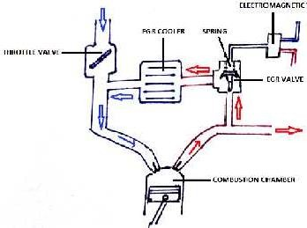
  - In a diesel engine, exhaust can be continuous flame front and knocking.
re-circulatedashighas50%asdieselengineisnotsubjectedto
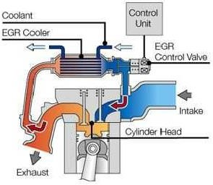

ExhaustGasRecirculation

  - In the mid-1990s, pneumatic EGR valves became more popular in EGR system. It consists of an electromagneticvalvewhichisoperatedbyvacuum. Vacuumisusuallygenerated bythepressuredifference between inlet manifold and exhaust manifold.

EVAPORATIVEEMISSIONCONTROLSYSTEM(OR)FUELVAPORCANISTER
  - Canister is a pollution control device used mainly in gasoline fuel tanks to prevent the vapors of the fuel escape from the tank. Gasoline gets easily vaporized, and evaporated gasoline can increase the emissions because it is a mixture of hydrocarbons (HC) which is harmful for both environment and humans. This systemisalsoknownasEvaporativeEmissionControlSystem(EVAP) orfuelvaporcanisterorcarbon canister.
  - Fuel vapor canisters were first used in the mid-1970s and it significantly reduced the HC emissions. Gases escaping from the tank or engine result in HC emissions.
  - Topreventtheevaporated fueltoescapeunburned, fuelvapor canisterisusedtotrapallthevaporsandthen store and use it later when the engine is switched ON. A fuel vapor canister only works when the engine is OFF.

DesignofCanister:
  - There is an inlet port and an outlet port. The canister is filled with charcoal. The charcoal traps the gas and then sends it out via the outlet port.
  - Whenthegasoline vaporizes,thevaporsfromthetank escapethrougha ventlineandthenreachthecanister through the inlet port. The outlet port is connected to a purge valve which prevents the fuel from entering the inlet manifold unless the engine is switched ON.
  - A carburetor vent line is provided for the fuel bowl in the carburetor. The fuel in the carburetor bowl will vaporize when the temperature rises. The vaporized fuel is supplied to the canister through the carburetor vent line.
  - The canister is provided with a purge air line at the bottom which allows theair from the atmosphere to enter the canister and form a fuel-air mixture.

WorkingofaFuelVaporCanister:
  - The evaporated gases reach the canister through the vent port and reach the carbon canister. The gases are trapped inside due to its properties to trap hydrocarbons. The gases are stored in the canister. When the engineisswitchedON, suctioniscreatedintheintake manifold whichpromptsthe purge valve to openand thisallows the air to be sucked insidethe canister through an air filter.
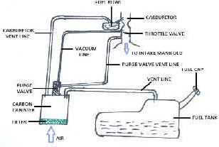
  - Theair from the purge air line pushesthe gasoline vapors from the canister to the intake manifold. The air- fuel mixtureis then supplied and burned insidethe combustion chamber. The canister stops working when the engineis switchedON. Fuel vapor canister canonlybeused ina vehicle havinga carburetor.

Evaporative Emission Control System MULTI POINT FUEL INJECTION SYSTEM FOR SI ENGINES.
  - Inthissysteman electricallydriven fuelpumpdrawsfuel fromfueltankandsuppliesittoacommonheader or tube. A pressure regulator fitted at the end maintains a constant pressure of fuel approx. 3 bars in the header.
  - The header is connected to different branchesof inlet manifold through fuel injectors. For each cylinder of enginethereisseparatefuelinjectorwhichinjectsfuelinthecorrespondingairpassageofthat cylinder.Due to this the system iscalled multi-point fuel injection (MPFI) system.
  - The fuel injectors are precision built solenoid valves having single or multiple orifices. Due to constant pressure of fuel maintained in the common header, the quantity of fuel injected depends only on the time period for whichthe solenoidvalve type fuel injectorsarekept in open position.
  - An on-board ECU(Electroniccontrolunit) i.e. microprocessor controlsthequantity of fuelinjected to each cylinder individually and also the ignition timing of each cylinder.
  - The data input to the ECU comes from a number of sensors located all over the engine. These sensors collect the following data continuously.

- Ambienttemperature
- InletmanifoldvacuumorAirVelocity
- Exhaustgasestemperature
- ExhaustO₂content
- Throttleposition
- Enginer.p.m.
- Crankshaft&position
- Enginecoolanttemperature

  - Basedonprogrammedinterpretationorprocessingofthisdata,ECUcalculatestheamountoffuelneededto maintain stoichiometry i.e. air/fuel ratio of14.7:1 and converts it into required pulse width i.e. time period for which it keeps the solenoid injector energized.
  - 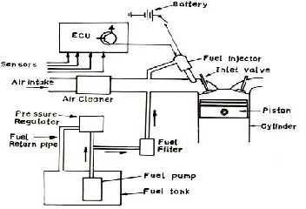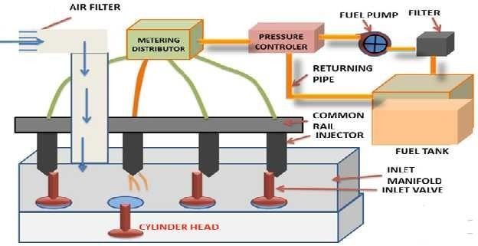ECU also gives command to spark ignition system. In this way ECU ensures overall satisfactory performance ofthe engine from startto shut down including emission control by sendingright quantityand quality of fuel air mixture to each cylinder of engine at right time based on requirement of engine and also ignites it at right time.

MPFI(Electronicfuelinjectionsystem)

EngineSensors
In order to providethe correct amount of fuel for every operating condition,the engine control unit (ECU)has to monitor a huge number of input sensors. Here arejust a few-
  - Massairflowsensor-TellstheECUthemassofair enteringtheengine.
  - Oxygen sensor(s)- Monitors the amount of oxygen in the exhaust so the ECU can determine how rich or lean the fuel mixture is and make adjustments accordingly
  - Throttle position sensor - Monitors the throttle valve position (which determines how much air goes into theengine) so theECU can respond quicklyto changes,increasing or decreasingthe fuelrateas necessary.
  - Coolant temperature sensor - Allows the ECU to determine when the engine has reached its proper operatingtemperature Voltage sensor - Monitorsthe system voltageinthe car sotheECU canraisetheidle speed if voltageis dropping (which would indicate a high electrical load).
  - Enginespeedsensor-Monitorsenginespeed,whichisoneofthefactorsusedtocalculatethepulsewidth

AdvantageofElectronicFuelinjectionovercarburetor:-
  - Betteratomizationoffuel
  - Loweremissionofpollutant
  - Betterflowduetoeliminationofventure
  - Rapidresponsetimewithrespecttothechanges
  - Improvedfuelefficiency
  - IguessthisexplainsMPFIsysteminsufficientdetail.

Advantagesofmultipointfuelinjectionsystem
  - The multi-point fuel injection technology improves fuel efficiency of the vehicles.MPFI uses individual fuel injector for each cylinder, thus there is no gas wastage over time. It reduces the fuel consumption and makes the vehicle more efficient and economical.
  - The vehicles with MPFI automobile technology have lower carbon emissions than a few decades old vehicles. It reduces the emission of the hazardous chemicals or smoke, released when fuel is burned. The more precise fuel delivery cleansthe exhaust and produceslesstoxic byproducts.Therefore,the engine and the air remain cleaner.
  - MPFI system improves the engine performance. It atomizes the air in small tube instead additional air intake, and enhancesthe cylinder-to-cylinder fuel distribution that aidtothe engine performance.
  - It encourages distribution of more uniform air-fuel mixture to each cylinder that reduces the power difference developed in individual cylinder.
  - The MPFI automobile technology improves the engine response during sudden acceleration and deceleration.
  - TheMPFIenginesvibratelessanddon‘trequiretobecrankedtwiceorthriceincoldweather.
  - Itimprovesfunctionalityanddurabilityoftheenginecomponents.
  - TheMPFIsystemencourageseffectivefuelutilizationanddistribution..

OtherbenefitsofMPFI
  - Smoothoperationsanddrivability
  - Reliability
  - Competenttoaccommodatealternativefuels
  - Easyenginetuning
  - Diagnosticcapability
  - Initialandmaintenancecost

COMMONRAILFUELINJECTIONSYSTEMFORSIENGINES.
  - In this system of diesel injection, a common rail diesel injection (CRDI) technology isused. It is more or lesssameasCommonRailSystemofMechanicalInjectionbutthedifferencecomesinthecontrolover

metering& timing of injectors which is done by an on-board computer system or electronic control unit. Thus it resembles with the operation of MPFI system of S.I engine.
  - The basic system is same; there is a high pressure fuel pump which maintains high pressure in a common rail (steel tube) through high pressure regulator. But here the pressure maintained is very high ofthe order of2000 barascomparedto3-5 barsinMPFI system.The fuelinjectorsare very specialeither solenoidtype or piezzoelectrictype whichcontrolthe fuelinjection from commonrail to each cylinder veryprecisely.
  - The opening time, pulse width etc of fuel injectors can be electrically controlled by the E.C.U. Here is the main advantage of system that the fuel can be injected in more than one pulse in a very controlled manner unlike onlyone pulse or one injection per cycle in the mechanical system.
  - Herea pilotinjectionis donebeforethe main injection for fast burningand lessignition delay ofthe fuel.It reducesthenoiselevel very muchandalsoensurescompleteburningof fuel, high efficiency, lowemission and good cold start.
  - This new technology has considerably removed the demerits of diesel engines like high noise level, high pollution,difficultyin starting etcandimproved fuel efficiencyalot. AschematicdiagramofCRDI system is given here in fig.
  - TheCRDitechnology worksintandemwiththe engineECUwhichgetsinputsfromvarioussensors.Itthen calculates the precise quantity of fuel and timing of injection. The fuel system features components which are more intelligent in nature and controls them electrically / electronically. Additionally, the conventional injectorsare replaced with more advanced, electrically operated, solenoid injectors. They are opened by an ECU signal, depending uponthe variables such as engine speed, load, enginetemperature etc.
  - A Common Rail system uses a ‗common-for-all-cylinders‘ fuel-rail or in simple words a'fuel distribution pipe'.It maintainsoptimumresidualfuelpressureandalsoactsasa sharedfuelreservoirforalltheinjectors. IntheCRDi system,the fuel-rail constantly storesand suppliesthe fueltothe solenoid valveinjectorsatthe required pressure. This is quite opposite to the fuel injection pump supplying diesel thru‘ independent fuel lines to injectors in case of earlier generation (DI) design.

ComponentsofCommonRailDirectInjectionSystem
- HighPressureFuelPump
- CommonFuelRail
- Injectors
- EngineControlUnit

TheworkingprincipleofCommonRailDirectInjection-
  - A high-pressure pump supplies pressurized fuel. The pump compresses the fuel at the pressures of about 1,000 bar or about 15,000 psi. It, then, supplies the pressurized fuel via a high-pressure pipe to the inlet of the fuel rail. From there, the fuel-rail distributes the fuel to individual injectors which then inject it into the combustion chamber.
  - Most modern CRDi engines use the Unit-Injector system with Turbocharger which increases power output and meets stringent emission norms. Additionally, it improves engine power, throttle response, fuel efficiency,andcontrolsemissions.Barringsomedesignchanges,thebasicprinciple&workingoftheCRDi technology remains primarily the same across the board. However, its performance depends mainly on the combustion chamber design, fuel pressures and the type of injectors used.
Advantages
The common rail diesel engine allows for better emission control and consumption of fuel and power. In other words, common rail diesel engines can deliver more power to the vehicle while consuming less fuel and producingfeweremissions. For thesereasons,it complieswithgovernment regulatorswhowanttoputacapon the volume of carbon emissions produced by a vehicle.

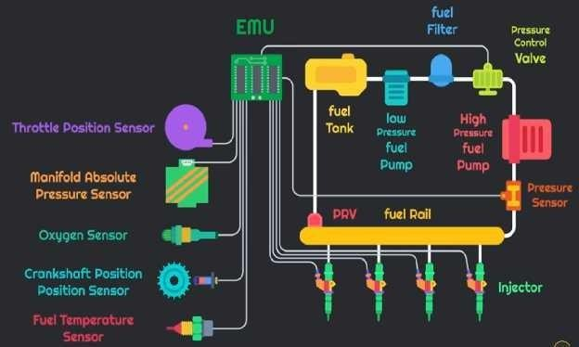
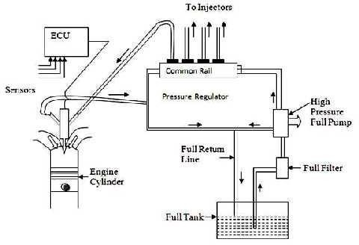

Commonraildieselinjectionsystem

Belowisalist ofthe5mainadvantages.
- Lower Emissions– One of the reasons that common rail diesel engines were invented by vehicle manufacturers was because the government created stricter regulations on carbon emissions. Remember when big diesel trucks used to release a lot of black smoke into the air? You hardly see thatanymore because the common rail diesel engine is designed to reduce those emissions. This is better for the environment and is one step closer to fighting global warming.

- MorePower – Studies have shown that vehicleswith a common rail diesel enginewill produce25% more power than a traditional diesel engine. This means the overall performance of the diesel engine will be improved.
- LessNoise –Direct fuelinjectionsystemswereknownforbeingnoisywhiledriving.Thecommonrail will reducealotofthenoisethatyoumightrememberhearing.Thismakesitamore pleasantdrivingexperience for you and those around you on the road.
- Fewer Vibrations – There used to be a lot of vibrations felt in traditional direct fuel diesel engines. Now those vibrations have beenreduced with the common rail direct injection system.
- BetterMileage – Sincethecommonrail diesel engineprovidesmorepower,that meansyou will get better mileageonyour fuel. Asaresult,your fuel economywill bebetteraswell. Thismeanslessmoneyspent on fuel when you‘re on the road.
Disadvantages
Withall theadvantages of the commonraildiesel engine,thereare some disadvantagesas well. Althoughthere are fewer disadvantages, they may affect your decision of whether to purchase a common rail diesel engine- powered vehicle or not.
Belowarethetop3 disadvantages.
- Expensive Vehicle – Vehicleswith a commonrail diesel engineare going to bemoreexpensivethan those withthetraditionaldieselengine.Ifyou‘reworkingforacompanythatsuppliesyouwiththevehicle,thenit is no sweat.But ifit isa personal vehicle, then you maynot want to spendthe extra money.
- Expensive Parts– Since the common rail vehicles are more expensive, you can expect that replacement parts are going to be expensive as well.
- More Maintenance– Common rail diesel engines will need more maintenance than a traditional diesel engine. Evenif you dothe maintenance yourself, it still takes moretime, effort, and possiblyexpense.
Thecommon rail dieselengineiscertainlyanadvancementindiesel technology that will eventuallyreplace thetraditional directinjectionsystemaltogether.Perhapswhenthisnewtechnologybecomesmorecommon in every diesel-powered vehicle, then it will become less expensive. Until then, you will be making an investment into an engine that gives you better performance, better mileage, better driving experience, and promotes an environmentally friendlier agenda.

Thebenefitsofcommonrail
  - Noise, vibration and harshness (NVH) are improved with CRDi as a result of the timing flexibility. Your engine sounds quieter and has a better quality of sound. It also runs smoother. You will seefuel consumption benefitsaswell becausegreater injection pressure producesa finer spray of fuel (atomisation) that burns more efficiently.
  - Better combustion efficiency is a key part of meeting emission standards. Less fuel is wasted as soot or particulatesin the exhaustand depositsinthe engine. A cleaner running engineis good forthe environment – and for the cost of ownership. Cleaner running improves the long-term durability and reliability of your engine.
  - We have designed our engines to deal with more stringent operating requirements. For example, improved fuel filtration ensures a higher level of purity in the fuel injected from the common rail. Clean servicing procedures are necessary to keep your engine running efficiently and within the limits of the applicable emission standards.

HYDROGEN:
  - Cleanburning fuelandhasthehighest energy content perunitmassofanychemical fuelswhich canreduce the dependency on hydrocarbon based fuels

Production:
  - Most common method of producing hydrogen involves splitting water (H2O) into its componentparts of hydrogen (H2) and oxygen (O). There are different methods to produce hydrogen-
    - Steamreformationor partial oxidationof hydrocarbonssuchasnatural gas, naphtha or crudeoil. It converts methaneintohydrogenand carbon monoxide byreaction with steam over a nickel catalyst.
    - Coalgasification- Hydrogen made from coal can probably be justifiedasa fuel for specialapplications where the unique characteristics of hydrogen can be put to advantage such as its weight or its non- polluting characteristics.
    - Electrolysis-it uses electrical current to split water into hydrogenat the cathode (+) and oxygen at anode (-).
    - Thermo chemical method-it utilizes heat to achieve the chemical splitting of water to its elements without the need for intermediate electricity generation and without the need to use the extremity high temperature of 2500 °C or more.
    - Photo-electrolysis-it usessunlight and catalyststo split water.In thismethod,acurrentisgenerated by exposing on or both electrodesto sunlight. Hydrogen and oxygen gasesare liberated at the2 electrodes bythedecomposition ofwater. A catalyst maybe included to facilitatethe electrode process.
    - Biologicalandphoto-biologicalwatersplittingusesunlightandbiologicalorganismstosplitwater.
    - Thermalwatersplittingusesaveryhightemperature(approximately1000°C)tosplitwater.
    - Biomass gasificationuses selected microbes to break down a variety of biomass feed stocks into hydrogen.

Utilizationofhydrogengas:
Hydrogencanbeutilizedforthefollowingpurpose:
    - Residential use-hydrogen can be used in domestic cooking (stoves), radiant space heaters, electricity forlightingand foroperating domesticappliances(e.g.refrigerator) which could begenerated by means of fuel cells, with hydrogen gas at one electrode andair at other.
    - Industrial use-hydrogen can be used as a fuel or a chemical reducing (i.e. oxygen removal) agent. It can also be used instead of coal or coal derived gases, to reduce oxide ores (iron ore) to the material (iron).
    - Aircraft application-Theearliestapplicationofliquidhydrogenfuelisexpectedtobeinajetaircraft. Coldliquid hydrogen can beuseddirectly orindirectly to cool the engineandtheair frame surfacesofa high speed air craft.
    - Electric power generation-It comprises the production of electricity by using hydrogen in fuel cell system. Hydrogen could also be used as a means for storing and distributing electrical energy. The objective of developing fuel cell power stations istocentralizedandlocal generation of electricity.
    - Asanalternativetransportfuel-Hydrogenistriedasanalternativefuelininternalcombustionengine. The stoichiometric hydrogen air mixture burns seven times as fast as the corresponding gasoline air mixture which isa great advantage in internal combustion engines, leading to higher engine speedsand greater thermal efficiency . Hydrogen fuel used in IC engines is in automobiles, buses, trucks and farm machinery.

AdvantagesofusingHydrogenfuelledengine
  - Itprovideshighefficiencybecauseitutilizesahigherproportionoftheenergyinthefuel.
  - The amount of carbon monoxide and hydrocarbons in the exhaust is very small since they are originating only from the cylinder lubricating oil.
  - Itcanbeeasilyavailablebecauseitisproducedbyelectrolysisofwater.
  - Fuelleakagetoenvironmentisnotpollutant.

DisadvantagesofusingHydrogenfuelledengine

  - Duetohigh heatreleasethe combustiontemperature may be highand also a levelofnitrogenoxideis high. It can be reduced by reducing the combustion temperature by injecting water vapor into the cylinder from the exhaust.
  - Itrequiresheavy,bulkyfuelstoragebothinvehicleandattheservicestation.
  - Difficultyinrefuelingandpossibilityofdetonation.
  - Poor engine volumetric efficiency- gaseous fuel will displace some of inlet air and poor volumetric efficiency will result.
  - Fuelcostwouldbehighatpresentdaytechnology

BIOMASS

Whatisbiomass?Whatisbioenergy?
  - Biomassisfuelthatisdeveloped from organic materials,a renewableand sustainable source ofenergyused to create electricity or other forms of power. Bioenergy – or biopower – is carbon neutral electricity generatedfromrenewableorganicwastethat wouldotherwisebedumpedinlandfills, openlyburned,or left as fodder for forest fires.
  - Biomass can be made from agricultural and forestry residues and some industrial wastes and crops grown solely for energy purposes.Biomassisanattractive fossil-fuelalternative becauseit isa renewableresource thatismoreevenlydistributedovertheEarth‘ssurfacethanfinitefossil-fuelenergy sourcessuchascoal,oil and natural gas, and may be developed using more environmentally friendly technologies.

biomassused
  - People have used biomass for heating and cooking for thousands of years – if you have a fireplace in your house, or have ever cooked over a campfire, you have used biomass. With today‘s technology, plant materials can be used to generate electricity, heat, or liquid fuels for motor vehiclesthat have substantially lower environmental impacts than traditional fossil fuels.

electricitycreatedwithbiomass
  - Direct combustion is the simplest and most common method of capturing the energy contained within biomass.Inbiomasspower plants, woodwasteor other wasteisburnedtoproducesteamthatrunsaturbine to provides electricity and heat to industries and homes.
  - Fortunately, new technologies — including pollution controls and combustion engineering —have advancedtothe pointthatany emissions from burningbiomassare generallylessthanthose produced when using fossil fuels(coal, natural gas, oil).ReEnergyhas includedthesetechnologiesinits facilities.
  - Direct combustion technology is very similar to that used for coal, but biomassdoesnot have the elements like sulfur and mercury that are found in coal, and its emissionsare therefore safer.

bioenergyrenewable
  - Yes.AtReEnergy,wearecreatingrenewableenergyevery day.Becausewewillalwayshavewoodwaste
—eitherfromforestresidueorfromother sources—wewillalwaysbeableto makebiomassfueltopower our renewable electricity generation facilities. Biomass that is created from other waste isrenewable because we will always have waste.

Biomasscontributetoanincreaseingreenhousegases
  - No. As a renewable and reliable energy source, biomass can be used to generate energy on demand with virtually no net contributions to global greenhouse gas.
  - Burning biomass to create clean electricity releases no new carbons back into the atmosphere. Instead, it releases what would bereleased naturallyas the organic matter decomposed.
  - It forms a closed cycle, too, because the carbon that is released when biomass is burned is re-absorbed by other plants in their growing cycle. When fossil fuels are burned, they release carbon that has been trapped for centuries, adding carbon into theatmosphere that had been unavailableunderground.

  - So, by burning biomass fuels we release no more carbon dioxide than would have been produced in any caseby naturalprocessessuchascropandplant decay. And,providedourconsumption ofbiomassdoesnot exceed our ability to continually supply the biomass feedstock weuse, we havea renewable energy source whoseusedoes not substantially disturb the natural biochemical cycleona humantime scale.

over-harvestingtreesandplantstomakebiomassfuel
  - Biomass power does not pose a threat to forests, farmland or crops. It is not economically viable for a biomass power plant to clear forests or chop down trees solely for the purpose of converting the trees into biomass to make electricity. Biomass is most cost effectively made from crops specifically planted for that purposeorfromresidualsofpapermills, woodcollectedfromtheforestfloor,treetrimmingsandremainder wood from current, sustainable logging practices.
  - In comparison to fossil fuels, which take millions ofyears to be produced, plants that make up biomass are easytogrow, collect, utilize andreplace quickly without depleting natural resources.

Thebenefitsofusingbiomassforenergygeneration
  - Aswithmanyotherrenewableenergysources,biomassis capableofsimultaneouslyaddressingthenation‘s energy, environmental, and economic needs. Increased use of biomass for energy would lead to reduced greenhouse gas emissions, reduced dependence on foreign oil, an improved U.S. balance of trade, an improved rural economy, and the creation of a major new American industry with the potential to employ tens of thousands.
Theenvironmentalbenefitsofbiomass
  - The use of biomass energy provides a multitude of environmental benefits. It can help mitigate climate change; reduce acid rain; prevent soil erosion and water pollution; minimize pressure on landfills; provide wildlifehabitat; and help maintain forest health through better management.
  - The use of biomass will reduce the nation‘s greenhouse gas emissions. Fossil fuels emit vast quantities of carbon dioxide into the atmosphere upon combustion, carbon that would otherwise remain trapped underground. Biomass also releases carbon dioxide as it burns, but the carbon dioxide released during combustion was absorbed during the plant‘s life, and would eventually be released as the organic matter decays,to be absorbed by otherplants that are in the growth stages – thuscreatinga closed-carbon cycle.
Thebenefitsforagriculturalandforestland
  - The nation has many vast tracts of unused agricultural land — the byproduct of increasingly efficient agricultural techniques — that could be reclaimed to growplants for biomass, rather than have that land be converted to residential or industrial use. These lands that grow biomass crops will restore soil carbon, reduce erosion and chemical runoff, and enhance wildlife habitat.
Impactcouldbiomasshaveonourdomesticenergysupply
  - Biomass currently provides about 4 percent of the electricity produced in the United States, and, according to biomass power associations, it could easily supply 20 percent. As a result of the available land and agricultural infrastructure this country already has, biomass could conceivably replace all ofthe power that nuclear plants generate and do so in a sustainable fashion.
Theplantbiomassenergyistransformedbythreeprocesses,whichcanbegroupedintothreemajorgroups:
  - thermo-chemical
  - biological
  - physical

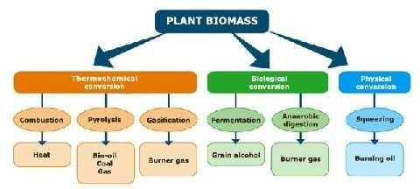
Different processes such ascombustion, pyrolysisandgasificationcan generate the thermochemical conversion of the plant biomass energy. The biological conversion can be obtained by thealcoholic fermentation and digestion, while the physical conversion by squeezing.

COMBUSTION
  - Combustion is the more traditional process for the conversion of biomass. To be efficient, it requires a reduction of the water content of the biomass, obtained by drying the products to the sun. In Italy there are about 40 large systems generating biomasses electricitybycombustion- generallyturningresiduesfrom wood processing - for a total electrical power of about 330 MW. They are, indeed, co-generation plants: final energy is given by heat and electrical energy. Part of the heat produced is in fact usedto produce steam, employed to power the turbines connected to electric generators. The part of the remaining heat can be used for industrial or residential users. The efficiency of these systems is of 20-25%, so it‘srather modest.

PYROLYSIS
  - Pyrolysis is a process for thermochemical decomposition of organic material, also called dry distillation, whichisbasedonthetransformationofbiomassthroughheat,in strongoxygendeficiency.Pyrolysiscanbe applied to any organic material with low water content (<15%). The material is brought to temperatures between 200 and 700° C, and sometimes appropriate amount of oxygen can facilitate the inception of a partial combustion, which leads to a rising of temperature.

GASIFICATION
  - Thebiomass gasification processis a physical chemical process that occurs when a solid fuel (wood, biomass) istransformedina gaseous fuel.Theprocess consistsinanincompleteoxidationofcarbonaceous compounds brought to high temperature (about 1000 ° C), in an oxygen-deficient environment. The gas obtained, called syngas, can be used directly to power internal combustion engines, mainly employed for theproductionofelectricity.Thesyngasisamixtureofnitrogen, methane, hydrogen, carbonmonoxideand other gases. The conversion of plant biomass energy through biochemical processes can be split into two processes:
    - Alcoholicfermentation;
    - Anaerobicdigestion.

FERMENTATION
  - Alcoholic Fermentation is a biochemical transformation process in which sugars are converted into ethyl alcohol.Theproductionofethanol frombiomasswith highsugar content hasbeenfullytested:inBrazilthe fermentation ofsugarcaneallowstoobtainethanolata pricethatmight be comparedtothe gasoline one.In Italy some sugar beet experiences have been made, but with poor results: processing costs were not convenient.

ANAEROBICD
  - Anaerobic digestion isa processof conversion done by bacteria operating in a rich cellulose biomass; this process allows to obtaining a biogas containing about 65% methane. This gas is used to fuel an internal combustion engine connected to an electric generator. The electricity produced is directly fed into the distribution network and sold at remunerative price (Green Certificate), as obtained from arenewable energy source. The digested residual component can be used as fertilizer. These kind of biomass power plants are very common in Northern Europe.
  - To better optimize the plants‘ performance, it may be convenient to get special device to use the produced heat, as for each kWh you get about 1 kWh ofthermal energy.

SQUEEZING
  - Thephysical conversionis essentially a process of mechanical pressing of crops with high oil content (sunflower rapeseed, soybean). Theendresultsare someedible squeezingoil and protein panels containing a higher percentage of oil (10% max), used bytheanimal feed industry.
  - The vegetable oil thus obtained, which is a mixture of methyl esters of fatty acids, can be used directly as fuelfordieselenginesslightlymodified,orbechemicallytreatedtomakeitsimilartodiesel fuel (biodiesel).

(C)ALCOHOLS
  - Theseincludemethanol (methyl alcohol), ethanol (ethyl alcohol), propanol (propyl alcohol), butanol (butyl alcohol) as compounds
  - The OH group which replaces one ofthe H atoms in an alkane, gives these compounds their characteristic properties
  - Specificheatingvalueislowerthangasoline(42–43MJ/kg)
  - methanol(19.7MJ/kg)andethanol(26.8MJ/kg)
  - Forair-fuelmixtureSHViscomperablewithgasoline(MJ/kg-mixtureatstoichiometricmixtures)
  - OtheralcoholgroupssuchasdihydricandtrihydricalcoholsarenotusedasafuelinIC engines

(i)Methanol
    - Canbeobtainedfromnaturalgas–hasnearandlong-termpotential
    - Hashighoctanequality(130RON,95MON)
    - Canbeusedinlow-concentration(5-15%)ingasolinetoincreaseoctanenumberofthemixture Problems
    - Poorsolubilityingasoline,toxicity,lowenergycontent(abouthalfofgasoline),highlatentheatof vaporization and oxygen content
    - Contributetopoordriveability,incompatibilitywithsomemetals

(ii)Ethanol
    - Producedfrombiomass
    - Itismadefromthesugarsfoundingrains,suchas:Corn,Sorghum,andBarley
    - Other sources of sugars to produce ethanol include: Potato skins, Rice, Sugar cane, Sugar beets, Yard clippings, Bark, Switch grass etc.
    - Hashighoctanenumber–canbeusedinlow–concentrationsingasoline
    - MostoftheethanolusedintheUnitedStatestodayisdistilledfromcorn
    - Scientistsare workingon cheaper waysto make ethanolbyusingall partsofplantsandtreesratherthan just the grain.
    - About 99% ofthe ethanol produced in the United States is used to make "E10" or "gasohol," a mixture of 10% ethanol and 90% gasoline.
    - Any gasoline powered engine canuseE10, but onlyspeciallymade vehicles can run on E85,a fuelthat is 85% ethanol and 15%

LPG(LIQUEFIEDPETROLEUMGAS)
  - -LPG is available in the market in two forms- one is propane and the other is butane. Propane is popular alternative fuel because of its infrastructure of pipe lines, processing facilities and storage for its efficient distribution and also it produces fewer emissions. Propane is produced as a byproduct of natural gas processing and crude oil refining
  - -Natural gascontainsLPG, water vaporandotherimpuritiesandabout55%oftheLPGiscompressedfrom natural gas purification. LPG is a simple mixture of hydrocarbon mainly propane/propylene (C3S) and butane/ butylenes (C4S)
  - -Propaneisanodorless,nonpoisonousgaswhichhaslowestflammabilityrange.

UTILIZATIONOFLPG
  - LPG isused asa fuel in heatingappliances and vehicles.It isincreasinglyused asanaerosolpropellantand a refrigerant, replacing chlorofluorocarbons in an effort toreduce damage to the ozone layer
  - -In Europe, LPG is used as an alternative to electricity and heating oil (kerosene).It can also be used as power source for combined heat and power technologies (CHP). CHP is the process of generating both electrical power and useful heat froma single fuel source. Thistechnology hasallowed LPG to beused not justas fuel for heatingand cooking, butalso for de-centralized generation of electricity
  - -LPGhashigherpotentialasanalternatefuelforICengine.

AdvantagesofLPG
  - EmissionismuchreducedbytheuseofLPG.
  - LPGmixeswithairatalltemperatures.
  - Uniformmixturecanbesuppliedtoallcylindersofmulti-cylinderengine.
  - Enginewithhighcompressionratio(10:1)canusepropane.
  - Thereiscostsavingofabout50%andlongerlifewithLPGrunningengine.

DisadvantagesofLPG
  - AgoodcoolingsystemisnecessarybecauseLPGvaporizerusesenginecoolanttoprovidetheheatto convert the liquid LPG to gas .
  - TheweightofvehicleisincreasedduetotheuseofheavypressurecylinderforstoringLPG.
  - AspecialfuelfeedsystemisrequiredforLPG.
  - Requirementofsafetydevice to preventaccidentdue toexplosionofgascylindersorleakage inthe gas pipes.

CNG(CompressedNaturalGas)
  - Naturalgasconsists ofelements ofcompressor, some sortofcompressed gas storageand dispensingunit of CNG into vehicles
  - TwotypesofCNGrefuelingsystem-slowfillandfastfill.
  - In slow fill system, several vehicles are connected to the output of the compressor at one time. These vehicles are then refilled over several hours of compressor operation.
  - In fast fill systems, enough CNG is stored so that several vehicles can be refueled one after the other, just like refueling from a single gasoline dispenser
  - The storage system of CNG is arranged as several tanks in cascade form. The CNG pressure in cascade is higher thanthe maximum storagepressure ofthe cylinder onthevehicle.The cascadeattemptsto deliver as much of its CNG to vehicles as possible before the pressure difference decreases to where the flow rate slows dramatically.
  - A dryer should include in most CNG refueling systems to remove water vapor, impurities and hydrogen sulphidefromnaturalgasbeforeitiscompressed.Ifwatervaporispresentthenitcancondenseinthe

vehiclefuel system, causingcorrosionespeciallyifhydrogensulphideispresent.CNG drivenvehicleswith catalytic converter havelessCO and HC emission but NOx emission is high

Advantages
Someclearadvantagestonaturalgasareasfollows:
  - Naturalgasisenvironmentallyfriendlybecauseitburnscleanerthanotherfossilfuels.
  - It'ssaferandeasiertostorewhencomparedtootherfossilfuels.
  - Naturalgasisextremelyreliable,unlikeelectricpowerthatcanbeknockedoutduringa storm.

Disadvantages
TherearemanyadvantagesaswellasdisadvantagesofCNGbifuelsystem....
  - EnvironmentFriendly:
  - CNGiscleanfuel.NaturalgasproducesverylesshydrocarbonemissionsthanLPGandpetrol.
  - CNGisEconomic:CNGischeaperthanpetrolandLPG.

CHARGINGSYSTEM
  - The modern charging system hasn't changed much in over 40 years. It consists of the alternator, regulator (which isusually mounted inside the alternator) and the interconnecting wiring.
  - The purpose of the charging systemis to maintain the charge in the vehicle's battery, and to provide the main source of electrical energy while the engine is running.
  - Ifthe charging system stopped working, thebattery'schargewould soon bedepleted,leaving the car with a "dead battery." If the battery is weak and the alternator is not working, the engine may not have enough electrical current to fire the spark plugs, sothe engine will stoprunning.
  - Ifthe battery is "dead", it does not necessarily mean that there is anything wrong with it.It is just depleted ofits charge. It can be brought back to life byrecharging it witha battery charger, or byrunning the engine so that the alternator can charge it.
  - Thesecomponentsmake upthechargingsystem:
    - Alternator
    - Voltageregulator
    - Battery
    - ChargingIndicator
  - .The main component in the charging system is theALTERNATOR. The alternator is a generator that produces Alternating Current (AC), similar to the electrical current in your home. This current is immediately converted toDirect Current (DC) insidethealternator. Thisisbecauseall modern automobiles have a 12 volt, DC electrical system.
  - AVOLTAGE REGULATORregulates the charging voltage that the alternator produces, keeping it between 13.5 and 14.5 voltsto protect the electrical components throughout the vehicle.
  - Thereisalsoa systemto warn the driver if something isnot right withthe charging system. This couldbea dash mounted voltmeter, an ammeter, or more commonly, a warning lamp. This lamp is variously labeled "Gen" Bat" and "Alt.". If this warning lamp lights up while the engine is running, it means that there is a probleminthecharging system,usuallyanalternator that hasstopped working.Themost common causeis a broken alternator drive belt.
  - The alternator is driven by a belt that is powered by the rotation of the engine.This belt goes around a pulley connected to the front of the engine's crankshaft and is usually responsible for driving a number of other components including the water pump, power steering pump and air conditioning compressor. On some engines, there is more than one belt andthe task of driving thesecomponents is divided between them.These beltsareusuallyreferred to as:FanBelt, Alternator Belt, DriveBelt, Power SteeringBelt, A/C Belt, etc. More common on late model engines, one belt, called a Serpentine Beltwillsnake around the front ofthe engine and drive all the components by itself.

  - On engines with separate belts for each component, the belts will require periodic adjustments to maintain the proper belt tension. On engines that use a serpentine belt, there is usually a spring loaded belt tensioner that maintains the tension ofthe belt, so no periodic adjustments are required. A serpentine belt is designed tolastaround30,000 miles. Check your owner's manual to see howoften yours should be replaced.
  - Alternatoroutput ismeasured inbothvoltage andamperage.Tounderstandvoltageand amperage,you must alsoknowabout resistance,whichismeasuredinohms. Aneasywaytopicturethisistocomparethe movementofelectricitytothatofrunningwater.Waterflowsthroughapipewithacertainamountof pressure. The size (diameter) of the pipe dictates how much resistance there will be to the flowing water. Thesmallerthepipe,the moreresistance.You canincreasethe pressureto get more waterto flowthrough, oryoucan increase thesizeof thepipe to allow morewater toflow usingless pressure.Since toomuch pressurecanburstthepipe,weshouldprobablyrestricttheamountofpressurebeingused.Yougetthe idea, but how is this related to the flow of electricity?
  - Well, voltage is the same as water pressure. Amperage is like the amount or volume of water flowing through, while resistance is the size of the wire transmitting the current.Since too much voltage will damage the electrical components such as light bulbs and computer circuits, we must limit the amount of voltage. This is the job of the voltage regulator. Too much water pressure and things could start breaking. Too much voltage and things could start burning out.
  - Now, let's go a little deeper and see how these charging system components actually work to produce the electrical power that a modern automobile requires.

Alternator
  - The alternator uses the principle of electromagnetism to produce current. The way this works is simple. If you take a strong magnet and pass it across a wire, that wire will generate a small voltage. Take that same wireandloopit manytimes,thanifyou passthe same magnetacrossthebundle ofloops,you createa more sizable voltage in that wire.
  - There are two main components that make up an alternator. They are the rotor and the stator. The rotor is connected directly to the alternator pulley.Thedrive belt spins the pulley,which in turn spins the rotor. The stator is mounted to the body of thealternator andremains stationary. Thereis just enoughroom inthe center of the stator for therotor to fitand beableto spin without makingany contact.
  - The stator contains 3 sets of wires that have many loops each and are evenly distributed to form a three phase system. On some systems, the wires are connected to each other at one end and are connected to a rectifier assembly on the other end.On other systems,the wiresare connected to each other endto end,and at each of the three connection points, there is also a connection to the rectifier. More on what a rectifier is later.
  - The rotor contains the powerful magnet that passes close to the many wire loops that make up the stator. The magnetsintherotorareactually electro magnets, nota permanent magnets. Thisisdone sothat wecan control how much voltage the alternator produces by regulating the amount of current that creates the magnetic field in the rotor. In this way, we can control the output of the alternator to suit our needs, and protect the circuits in the automobile from excessive voltage.
  - Now we know that every magnet has a north and a South Pole and electro magnets are no exception. Our rotor has two interlocking sections of electro magnets that are arranged so that there are fingersof alternating northand south poles. that are evenly distributed onthe outside oftherotor.
  - When we spin the rotor inside the stator and apply current to the rotor through a pair of brushes that make constant contact with two slip rings on the rotor shaft. This causes the rotor to become magnetized. The alternating north and south pole magnets spin past the three sets of wire loops in the stator and produce a constantly reversing voltage in the three wires. In other words, we are producing alternating current in the stator.
  - Now, wehavetoconvert thisalternating currentto directcurrent current. Thisisdonebyusinga seriesof6 diodes thatare mountedin a rectifier assembly.A diode allows currenttoflow only in onedirection.If

voltage tries to flow in the other direction, it is blocked. The six diodes are arranged so that all the voltage coming fromthe alternator isalignedin one directiontherebyconverting AC current intoDC current.
  - Thereare2 diodes for eachof the three sets of windingsinthe stator. Thetwo diodesare facingin opposite directions, one with itsnorthpole facingthe windingsand the other withitssouth pole facing the windings. Thisarrangement causesthe AC currentcomingout ofthe windingsto beconvertedtoDC current beforeit leaves the alternator through the B terminal. Connected to the B terminal of the alternator is a fairly heavy wire that runs straight to the battery.
  - Current to generate the magnetic field in the rotor comes from the ignition switch and passes through the voltageregulator.Sincetherotorisspinning,weneeda waytoconnectthiscurrent fromtheregulatortothe spinning rotor. This is accomplished by wires connected to two spring loaded brushes that rub against two slip rings on the rotor's shaft. The voltage regulator monitors the voltage coming out of the alternator and, when it reaches a threshold of about 14.5 volts, the regulator reduces the current in the rotor to weaken the magnetic field.Whenthe voltagedrops below thisthreshold, the current tothe rotor isincreased.
  - There is another circuit in the alternator to control the charging system warning lamp that is on the dash. Part ofthat circuitisanother set ofdiodesmountedinsidethealternator calledthediodetrio. Thediodetrio takescurrent coming fromthethree stator windingsand passesasmallamountthrough three diodes so that onlythepositivevoltage comesthrough. Afterthediodes,thewiresarejoinedintoone wireand sent out of thealternator at the L connection. It then goes to one side ofthedash warning lamp that isused to tell you whenthereisa problem withthechargingsystem. Theother sideofthelampisconnectedtotherunsideof the ignition switch. If both sides of the warning lamp have equal positive voltage, the lamp will not light. Remove voltage from one sideandthe lamp comesontolet you know there is a problem.
  - This system is not very efficient. There are many types of malfunctions of the charging system that itcannot detect, so just because the lamp is not lit does not mean everything is ok.A volt meter is probably thebest method of determining whether the charging system is working properly.

TheVoltageRegulator
  - The voltage regulator can be mounted inside or outside of the alternator housing.If the regulator is mounted outside (common on some Ford products) there will be a wiring harness connecting it to the alternator.
  - The voltage regulator controls the field current applied to the spinning rotor inside the alternator.When thereisno currentapplied tothe field,thereis no voltage produced fromthealternator.When voltage drops below13.5 volts,theregulatorwillapplycurrenttothefieldandthealternator will start charging.Whenthe voltage exceeds14.5 volts, theregulator will stop supplying voltageto the field and thealternator will stop charging. This is how voltage output from the alternator is regulated.
  - Amperage or current is regulated by the state of charge of the battery. When the battery is weak, the electromotive force (voltage) is not strong enough to hold back the current from the alternator trying to recharge the battery. As the battery reaches a state of full charge, the electromotive force becomes strong enough to oppose the current flow from the alternator, the amperage output from the alternator will drop to close to zero, while the voltage will remain at 13.5 to 14.5.
  - When more electrical power is used, the electromotive force will reduce and alternator amperage will increase. It is extremely important that when alternator efficiency is checked, both voltage and amperage outputs are checked. Each alternator has a rated amperage output depending onthe electrical requirements of the vehicle.

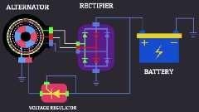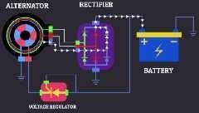
Statorcoilworking continuouslybatterycharging
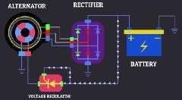
Currentgoesthoughalltheelectricalsystem
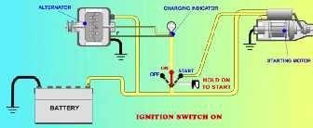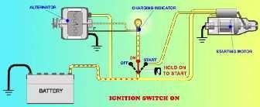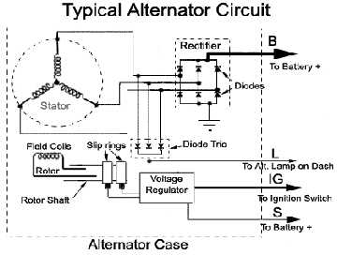

Battery
  - The batteries area reservoir of chemical electrical power. Their primary purpose is to crank the engine. They also supply power to vehicleaccessories whenthe electrical load istoo great for thealternator alone. Thebatteryalsoactsasa voltagestabilizer.Thebatterymustalwaysremainattachedtotheelectricalsystem while the engine is running.

ChargingIndicator

  - ThechargingindicatorisusuallyanON/OFFwarninglamp.Whenthesystemisrunning,thelightshould be off.Thelamp lights when the charging system is not providing sufficient charge.

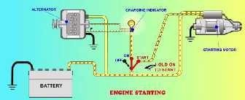
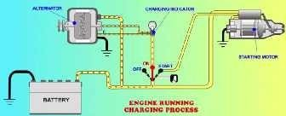
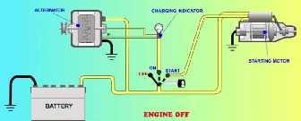

BothStartingsystemandchargingsystem
STARTINGSYSTEM
  - The"starting system", the heart of the electrical system in your car, begins with theBattery. The key is insertedintotheIgnitionSwitchandthenturnedtothe startposition. Asmallamountofcurrentthenpasses through the Neutral Safety Switchto aStarter RelayorStarter Selenoidwhich allows high current to flow through the Battery Cables to the Starter Motor.
  - Thestarter motorthencrankstheenginesothat thepiston, movingdownward, can createa suctionthat will draw aFuel/Airmixture into the cylinder, where a spark created by theIgnition Systemwill ignite this mixture.If the Compression inthe engineis high enoughandallthis happens attheright Time, the engine will start.

Battery
  - The automotive battery, also known as a lead-acid storage battery, is an electrochemical devicethat produces voltage and delivers current. In an automotive battery we can reverse the electrochemical action, thereby recharging the battery, which will then give usmany yearsof service. The purpose ofthe battery is to supply current to the starter motor, provide current to the ignition system while cranking, to supply additional current when the demand is higher than the alternator can supply and to act as an electrical reservoir.
  - The automotive battery requires special handling. The electrolyte (water) inside the battery is a mixture of sulfuricacidandwater.Sulfuricacidisvery corrosive;ifit getsonyourskinitshould beflushed with water immediately; if it gets in your eyes it should be flushed with a mild solution of baking soda and water immediatelyand you should seea doctoras soonaspossible. Sulfuricacid will eatthroughclothing, soitis advisableto wearoldclothingwhenhandling batteries.Itisalsoadvisabletoweargogglesandgloveswhile servicingthebattery.Whencharging,thebatterywill emit hydrogengas;it isthereforeextremelyimportant to keep flames and sparks away from the battery.

  - Because batteries emit hydrogen gas while charging, the battery case cannot be completely sealed. Years ago there was a vent cap for each cell and we had to replenish the cells when the electrolyte evaporated. Today'sbatteries(maintenance free)have smallventsonthe sideofthebattery;thegasesemittedhavetogo through baffles to escape. During this process the liquid condenses and drops back to the bottom of the battery. There's need to replenish or add water to the battery.
  - Today'sbatteriesareratedincoldcrankingamps.Thisrepresentsthecurrentthatthebatterycanproducefor 30 secondsat0 degreesbeforethebattery voltagedropsbelow7.2 volts. An averagebatterytoday willhave a CCA (Cold Cranking Amps) of 500. With the many different makes and models of cars available today, batteries will come in many different sizes, but all sizes come in many CCAs. Make sure you get a battery strong enoughtooperate properlyin your car.The lengthof the warrantyis notindicative ofthe strength of the battery.
  - Battery cables arelarge diameter; multi stranded wire which carry the high current (250+ amps) necessary to operatethe starter motor. Some battery cableswill havea smaller wire, solderedtotheterminal, whichis used to either operate a smaller device or to provide an additional ground. When the smaller cable burnsit indicates a high resistance in the heavy cable.
  - Even maintenance free batteries need periodic inspection and cleaning to insure they stay in good working order. Inspect the battery to see that it is clean and that it is held securely in its carrier. Some corrosion naturally collects around the battery. Electrolyte condensation contains corrosive sulfuric acid, which eats away the metal of battery terminals, cable ends and battery hold down parts. To clean away the corrosion, usea mixtureofbaking soda and water,and washallthe metalpartsaround thebattery, being carefulnot to allow any of the mixture to get into the battery (batteries with top cell caps and vents). Rinse with water. Remove the battery cables fromthe battery(negative cable first), wire brushtheinside ofthe cable endand thebatterypost.Reinstall thecables(negativeendlast).Coatallexposedmetal parts(paint or greasecanbe used) so that the sulfuric acid cannot get on the metal.

Ignitionswitch
Theignition switch allowsthedriver to distributeelectrical current to whereit isneeded. Thereare generally 5 key switch positions that are used:
- Lock-All circuits are open ( no current supplied) and the steering wheel is in the lock position. In some cars, the transmission lever cannot be moved in this position. If the steering wheel is applying pressure to the locking mechanism, the key might be hard to turn. If you do experience this type of condition, try moving the steering wheel to remove the pressure as you turn the key.
- Off-Allcircuitsareopen,butthesteeringwheelcanbeturnedandthekeycannotbeextracted.
- Run- All circuits, except the starter circuit, are closed (current is allowed to pass through). Current is supplied to all but the starter circuit.
- Start-Power is supplied to the ignition circuit and the starter motor only. That is why the radio stops playing in the start position. This position of the ignition switch is spring loaded so that the starter is not engaged whilethe engineis running. This position isused momentarily, just toactivatethe starter.
- Accessory-Power is supplied to all but the ignition and starter circuit. This allows you to play the radio, work the power windows, etc. while the engine is not running.

Mostignitionswitchesaremountedonthesteeringcolumn.Someswitchesareactuallytwoseparateparts;
  - The lock into which you insert the key. This component also contains the mechanism to lock the steering wheel and shifter.
  - Theswitch which containstheactual electrical circuits. Itisusuallymountedon top ofthe steering column just behind the dashandis connected to the lock bya linkage or rod.

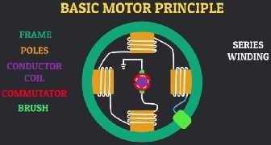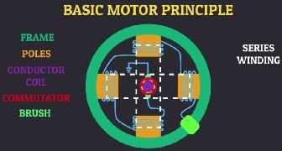
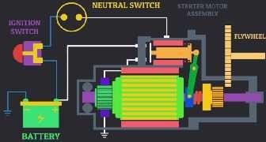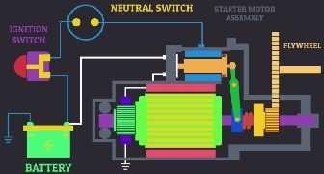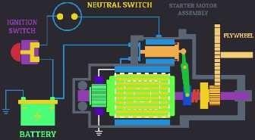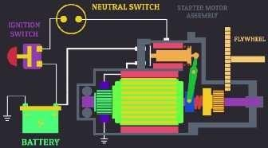

Neutralsafetyswitch
  - This switch opens (denies current to) the starter circuit when the transmission is in any gear but Neutral or Park on automatic transmissions. This switch is normally connected to the transmission linkage or directly on the transmission. Most cars utilize this same switch to apply current to the back up lights when the transmission is putinreverse. Standardtransmissioncars will connectthis switchtothe clutch pedal sothat thestarter will not engageunlesstheclutch pedalisdepressed.Ifyou find that you haveto move theshifter away from park or neutral to get the car to start, it usually means that this switch needs adjustment. If your carhas anautomaticparkingbrakerelease, the neutral safety switch will control that functionalso.

StarterRelay
  - A relay is a device that allows a small amount of electrical current to control a large amount ofcurrent. An automobile starter uses a large amount of current (250+ amps) to start an engine. If we were to allow that muchcurrenttogothroughtheignitionswitch,wewouldnotonlyneedaverylargeswitch,butallthewires would have to be the size ofbattery cables (not very practical). A starter relay is installed in series between the battery andthestarter.Somecars use astartersolenoid to accomplishthe same purpose of allowing a

small amount of current from the ignition switch to control a high current flow from the battery to the starter.The starter solenoidin some casesalso mechanically engages the starter gear withthe engine.

BatteryCables
  - Batterycablesarelargediameter, multistrandedwirewhichcarrythehighcurrent(250+amps)necessaryto operatethestartermotor.Somehavea smaller wiresolderedtotheterminalwhichisusedtoeitheroperatea smaller device or to provide an additional ground. When the smaller cable burns, this indicates a high resistance in the heavy cable. Care must be taken to keep the battery cable ends (terminals) clean and tight. Battery cables can bereplaced with onesthatare slightlylarger but never smaller.

Startermotor
  - The starter motor is a powerful electric motor, with a small gear (pinion) attached to the end. When activated, the gear is meshed with a larger gear (ring), which is attached to the engine. The starter motor then spinsthe engineover sothatthepistoncandrawina fuel/airmixture, which is thenignitedto startthe engine. When the engine starts to spin faster than the starter, a device called an overrunning clutch (bendix drive) automatically disengagesthe starter gear from the engine gear.

STANDARDBENDIXDRIVE
  - PINION DRIVE ASSEMBLY.- The pinion driveassembly includes the pinion gear, the pinion drive mechanism,and solenoid. There are two ways thata starting motor can engage the pinionassembly-( 1) withamoveablepoleshoethatengagesthepiniongearand(2)withasolenoidandshiftforkthatengages the pinion gear.
  - Thepiniongearisasmallgearonthearmatureshaftthatengagesthering gearontheflywheel.Most starter piniongearsaremadeaspartofa piniondrive mechanism.Thepiniondrivemechanismslidesoverone end of the starter armature shaft.
  - Thepiniondrivemechanismsfoundonstartingmotorsthatyouwillencounterareofthreedesigns-Bendix drive, overrunning clutch, and Dyer drive.

Bendixdrive
  - Thebendix drivereliesonthe principle ofinertia to causethepinion gearto mesh withthe ring gear.When thestartingmotorisnotoperating,thepiniongearisoutofmeshandentirelyawayfromtheringgear.

Whentheignitionswitchisengaged,thetotalbatteryvoltageisappliedtothe armature immediately starts to rotate at high speed.
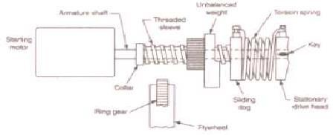

StandardBendixdrive
startingmotor,andthe

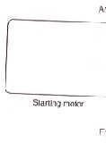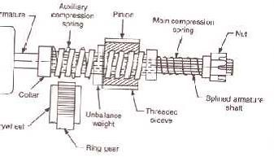
BendixDrivewithCompressionSpring
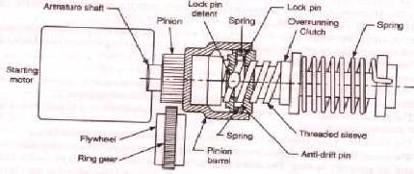
Folo-thruStartingDrive
  - Thepinion, beingweightedononesideandhavinginternal screwthreads, doesnotrotateimmediatelywith the shaft but because ofinertia, runs forward on the revolving threaded sleeve until it engageswiththering gear.
  - If the teeth of the pinion and ring gear do not engage, the drive spring allows the pinion to revolve and forces the pinion to mesh with the ring gear.
  - Whenthe pinion gearisengaged fully withtheringgear, the pinionisthen driven by the starterthroughthe compressed drive spring and cranksthe engine.The drive spring actsasa cushion while the engineisbeing crankedagainst compression.Italsobreakstheseverityoftheshock onthe teethwhenthegearsengageand when the engine kicks back due to ignition.
  - When the engine starts and runs on its own power, the ring gear drives the pinion at a higher speed than does the starter. This action causes the pinion to turn in the opposite direction on the threaded sleeve and automatically disengages from thering gear.This prevents the engine from drivingthe starter.

OVERRUNNINGCLUTCH
  - The overrunning clutch provides positive meshing and demeshing of the starter motor pinion gear and the ring gear. The starting motor armature shaft drives the shell and sleeve assembly of the clutch. The rotor assemblyisconnectedtothepiniongearwhichmesheswiththeenginering gear.Spring-loadedsteelrollers are located in tapered notches between the shell and the rotor.
  - The springs and plungers hold the rollers in position in the tapered notches. When the armature shaft turns, the rollers are jammed between the notched surfaces, forcing the inner and outer members of the assembly to rotate as a unit and crank the engine.

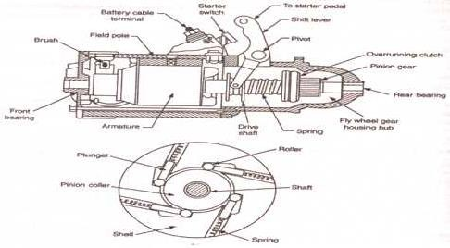
Typicaloverrunningclutch.
  - After the engine is started, the ring gear rotates faster than the pinion gear, thus tending to work the rollers back against theplungers, and thereby causing an overrunning action. This action prevents excessivespeed of the starting motor. When the starting motor is released, the collar and spring assembly pulls the pinion out of mesh with the ring gear.

DYERDRIVE
  - The dyer drive provides completeand positive meshing ofthe drive pinion and ring gear before the starting motor is energized. It combines principles of both the Bendix and overrunning clutch drives and is commonly used on heavy-duty engines.
  - A starter solenoid isused to maketheelectrical connection between thebattery and the starting motor. The starter solenoid is an electromagnetic switch; it is similar to other relays but is capable of handling higher currentlevels. Astartersolenoid,dependingonthedesignofthestartingmotor,hasthefollowingfunctions:
  - Closesbattery-to-startercircuit.Rushesthestarterpiniongearintomeshwiththeringgear.
  - Bypassresistancewireintheignitioncircuit.
  - The starter solenoid may be located away from or on the starting motor. When mounted away from the starter,thesolenoidonlymakesandbreakselectrical connection.Whenmountedonthestarter,italsoslides the pinion gear into the flywheel.
  - In operation, the solenoid is actuated when the ignition switch is turned or when the starter button is depressed. The action causes current to flow through the solenoid (causing a magnetic attraction of the plunger) to ground. The movement of the plunger causes the shift lever to engage the pinion with the ring gear. After the pinion is engaged, further travelof the plunger causes the contacts inside the solenoid to close and directly connects the battery to the starter.
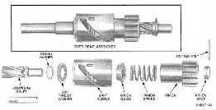
Dyerdrive.

  - The starter solenoid may be located away from or on the starting motor. When mounted away from the starter,thesolenoidonlymakesandbreakselectricalconnection.Whenmountedonthestarter,italsoslides the pinion gear into the flywheel.
  - In operation, the solenoid is actuated when the ignition switch is turned or when the starter button is depressed. The action causes current to flow through the solenoid (causing a magnetic attraction of the plunger) to ground. The movement of the plunger causes the shift lever to engage the pinion with the ring gear. After the pinion is engaged, further travelof the plunger causes the contacts inside the solenoid to close and directly connects the battery to the starter.
  - If cranking continues after the control circuit is broken, it is most likely to be caused by either shorted solenoid windings or by binding of the plunger in the solenoid. Lowvoltagefrom the battery is often the cause of the starter making a clicking sound. When this occurs, check all starting circuit connections for cleanliness and tightness.

MECHANISMOFSOLENOIDSWITCH
  - Solenoid switchesare used to switch high power circuits on and offusing a much smaller electrical control signal to actuate the switching. This allows extensive logic and decision making circuitry to be performed on inexpensive microchips and small electronic parts, with the actual switching of the high power signals being limited to the very last step.
  - The result is cooler running of less sophisticated equipment. It also enables the high power switching equipment to be limited to a remote location. Solenoid switches are typically used on automotive engine starting systems.

SolenoidSwitchOperation
  - Solenoids are wound wire magnetic coils with an open core to receive a sliding cylindrical plunger. When thecoilisenergized withan electrical current,amagneticfieldiscreatedin thehollowopening which pulls theplunger into it or pushesit out,basedontheorientation ofthe solenoidand the polesof the plunger.
  - Theplungerismechanicallyconnectedtoa setofswitchcontacts,whichperformthehighpower switching. Thethere area minimum of four connector terminals on a solenoid switch.
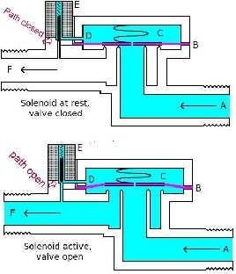
  - The coil requires two and is most often isolated from all the other terminals, which keeps the coil wires completely independent of the current being switched. The switched current terminals are usually substantially heavier than the coil terminals.

Solenoidswitchworkingprinciple.

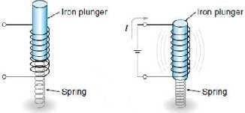
Unenergized Energized

SwitchTypes
  - Mostsolenoidswitcheshaveonlyoneswitchedpoledue totheamountofcurrentbeingpassedthrough them. Someareonlymomentarilyoperated, such asis the case with starter solenoids on automobiles.
  - Oncetheautomotiveengineisstarted,thestartermotorandsolenoidarecompletelyisolatedfromthe operation of the rest of the electrical system.
  - Some non-inertial automotive starting systems also use the moving plunger to slide the starter pinionalong the starter shaft to engagethe flywheel, inadditiontoactually poweringthe starter motor.

SolenoidSwitchesversusRelays
  - Whereas solenoids impart substantial motion to their plungers, either for switches or valves, the coils of electrical relays are wound around a ferrous magnetic post which becomes magnetized and attracts a steel plateacross a small gap to closea set of electrical contacts.
  - These contacts may switch more than one pole and are commonly used to switch AC line currents at 120, 240 or 480 volts, although relays are available for both AC and DC switching and any voltage range. Solenoid switches perform both electrical switchingand coordinated mechanical motion.

SolenoidSwitchApplications
  - Besideswidescaleenginestartingapplications, solenoidswitchesareusedtoswitch on many othertypesof motors while mechanically engaging or disengaging their shafts. This allows latching and opening mechanisms for windows, doors and hatches to derive two functions from the same piece of coordinated equipment.

EngageThenTurnOn
  - Since solenoid switches typically placethe switch contacts at the very end ofthe plunger stroke,they actas self contained logic interlocks, not allowing a motor to start or a valve to open until the plunger has moved its entire distance first.

LimitationofSolenoidvalve
  - Themainlimitationofthesolenoidisitsshortstroke,whichisusuallyunderaninch.
  - Still,therearemanyapplicationsforshort-strokelinearmotion;examplesareactivatingelectriccar-door locks, opening and closing valves, and triggering mechanical latches.
  - Mostapplicationsusethesolenoidasa onoroffdevice—thatis,thecoilis either completelyenergizedor switched off. However, variable-position control is possible byvaryingthe input voltage.

LIGHTINGSYSTEM
  - The lighting system of a motor vehicle consists of lighting and signalling devices mounted or integrated to thefront,rear, sides,andinsomecasesthetopofa motorvehicle.Thislightstheroadwayforthe driverand increases the visibility of the vehicle, allowing other drivers and pedestrians to see a vehicle's presence, position, size, direction of travel, and the driver's intentions regarding direction and speed of travel. Emergency vehicles usually carry distinctive lighting equipment to warn drivers and indicate priority of movement in traffic.

  - Statutoryregulationsspecifythenumber,positionandspecificationofmanyoftheexternal lightsfittedtoa vehicle.Inadditiontotheobligatorylights,manufacturersandownersofthevehicleofteninstallother

supplementary lights tomeetother include the following
requirements.Variouslampsaregroupedinseparatecircuits,which

    - Sideandrearlampsincludinglampsforthenumberplate,glovecompartmentandinstrumentpanel illumination.
    - Main driving lamps (headlamps)incorporating adippedfacility to prevent approaching driversbeing dazzled.
    - Rearfoglamp(s)toguardtherearofthevehicleinconditionsofpoorvisibility.
    - Auxiliarydrivinglampsincludingspotlampsfordistanceilluminationandfoglampstoreducethe reflected glare from fog.
    - Reversinglampstoilluminatetheroadwhenthevehicleismovingbackwardsandwarnother drivers of the movement.
    - Brakelightstowarna followingdriverthatthevehicleisslowingdown.
    - Interiorlightandcourtesylightsondoors.
    - Instrument panel lights to signal the correct operation ofa unit or the presence ofa fault in a particular system.
    - Directionalindicatorsandhazardwarninglights. Circuit Layout
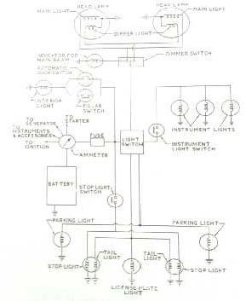

Lightingcircuit
  - Toobtain maximumillumination thelampsareconnected in parallel. With thearrangement anopen circuit inany branchcausesfailureonlyinthatonebranch,theotherlampsstillfunctionnormally.Thevehicle

lighting systems normally use an insulatedreturnortwowiresystem.
earthreturncircuit,becausethisrequireslesscablelengththanan

  - When the vehicle body is used as an earth, a good clean connection must be provided at suitable earthing points on the main body. This earthing lead is specifically essential if the lamp is fitted in a plastics body panel.
  - Lightingcircuitdiagramsarepresentedineitheralocational orcompacttheoretical from.Intheformertype each component is located relative to its position on the vehicle. This is useful in indicating the location of the various connectors and components, but the diagram becomes more difficult to trace out a particular circuit path.
  - To avoid this problem, some manufactures make use of extra diagrams to indicate separate parts of the circuit. Figure illustrates a simple circuit drawn on above concepts.
HORN
  - Horns are simple electromagnetic devices that produce loud, audible sounds to get the attention of nearby vehicle occupants or pedestrians. A typical horn is composed of a magnetic coil, an armature with a metal diaphragm, a pair of electrical contacts, and a switch.
  - When the driver activates the switch, the closed electric contact allows a current to flow through the coil generatinga magnetic forcethatattractsthearmature,aswellasthemetaldiaphragm.Thisactionbreaksthe electric contact, cutting off the current and releasing the armature and diaphragm.
  - When they move back to their initial positions, the electrical contact is re-made and the cycle repeats. The rapidrepetition ofthis process generatesanoscillation ofthe diaphragm and createsthe horn‘s sound.
  - In general; there are two types of horn shapes: plate and spiral. The plate type is smaller and lighter. It is also more easily installed on a car. The spiral type employs a spiral duct to obtain a richer sound. Most horns assemblies have two horns (low and high notes) and achieve sound levels of approximately 107-109 decibels.
  - The frequency ofthe horn is usually related to the size ofthe vehicle. Bigger vehicles generally have lower frequency horns, while smaller vehicles have higher frequency horns. The sound for luxury cars is often "smooth" compared to economy cars with less refined tones. Many countries mandate a car's specific horn frequency.
  - Horns installed on trucks are usually driven by compressed air instead of current. Air horns can generate very loud sounds, typically at levels of 117-118 decibels.
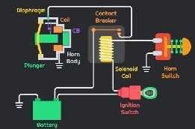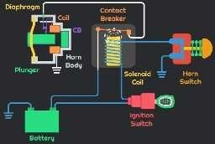
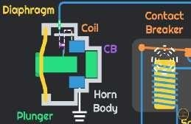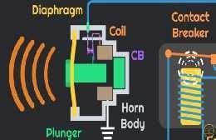

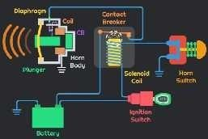
Hornworkingsystem

WIPER
  - Awindscreen wiper or windshield wiper(American English) isa deviceused toremoverain, snow,iceand debris from a vehicle's front window. Almost all motor vehicles, including cars, trucks, buses, train locomotives, and watercraft with a cabin and some aircraft are equipped with one or more such wipers, which are usually a legal requirement.
  - Awiper generally consistsofa metalarm; one end pivots,the other end hasa longrubber bladeattached to it.Thearmis powered bya motor, oftenan electric motor,although pneumatic power isalsoused for some vehicles.
  - The blade is swung back and forth over the glass, pushing water, other precipitation, or any other impediments to visibility, from its surface. On vehicles made after 1969, the speed is normally adjustable, with several continuous speeds, and often one or moreintermittent settings.
  - Mostpersonalautomobilesusetwosynchronizedradial-typearms,whilemanycommercialvehiclesuseone or more pantograph arms.
  - On somevehicles, a windscreen/windshield washer systemisalso used to improveand expand the function ofthe wiper(s) to dry or icy conditions. This system sprays water, or an antifreeze window washer fluid, at the windscreen using several well-positioned nozzles. This system helps remove dirt or dust from the windscreen when it is used in concert with the wiper blades. When antifreeze washer fluid is used, it can help the wipers remove snow or ice.
  - 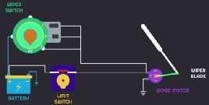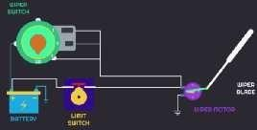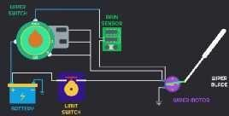For these types of winter conditions, some vehicles have additional heaters aimed at the windows, or embedded heating wire(s) in the glass; these defroster systems help to keep snow and ice from building up on thewindscreen. Less frequently, miniaturewipersareinstalled on headlightsto ensurethatthey function optimally.

Wiperworkingsystem
HowWindshieldWipersWork
  - The windshield wiperis movedbya motoratthe base ofthe window to clearthe window ofrain.Thereare multiple ways for the windshield wipers to be configured. Most cars have two wipers which move in sync with each other, but some models such as Fiat, Citroen, Subaru, and Mercedes have a single wiper that covers a wider swatch of window.
  - There are also some models of vehicle that come with a wiper on the back window, such as SUVs, hatchbacks,andminivans. Alsoimportanttonotearethefewolder vehiclemodelsthat havewipersontheir headlights like Saab and Chevrolet.

ThePartsofaWindshieldWiper
  - Like most systems in a vehicle, the windshield wiper is made up of many parts. The main parts of the windshield wiper are:
    - WiperBlades-Thewiperbladesarewhatremovesthemoisturefromthewindshield
    - Wiper Arm -The wiperarm connectsthe wiper blade tothe wiper transmission, toallowfor unhindered movement over a large patch of the windshield
    - WiperTransmission-Thewindshieldwipertransmissioncontrolsthemovementofthewiperarm
    - WiperMotor-Thewindshieldwipermotorprovidespowertothewipertransmissionandfluidpump
    - Windshield wiper fluid pump, tanks and tubes- The windshield wiper fluid pump, tanks, and tubes are the system responsible for spraying out windshield wiper fluid, allowing the driver to clean a dirty windshield
    - Windshield Wiper Interior Controls- The windshield wiper internal controls are located either on a control arm protruding fromthe steering wheel, on the steering wheel, or onthe main dashboard panel, to the left of the main dash display

FUELGAUGE
  - A fuel gauge is a measuring instrument that determines and reports the amount of fuel that is left in a vehicle‘s tank or tanks. Each gauge consists of two separate components: an indicator and a sensing or sendingunit.
  - Theindicatoristhepartofthegaugethatislocatedonthedash,typicallyin theinstrumentcluster, whilethe sensingunitislocatedinthe fueltank.Therearea few differenttypes of gas gauges, eachof which worksa little differently, but in general terms the sensing unit measures the fuel level, and the indicator reports that level.

FuelGaugeComponents
Everyfuelgaugeconsistsoftwobasiccomponentparts:
    - anindicator
    - asensororsendingunit Fuel gauges can also include:
    - afloat
    - apotentiometer

Fuel GaugeOperation
  - The most common type of fuel gauge uses a sending unit that is installed in the fuel tank. The sending unit hasa floatthat ismountedonanarmthatallowsit tomoveupanddownwiththelevel offuelthat ispresent in the tank. The arm, in turn, is attached to the potentiometer. As the arm moves up (with a full tank) and down (as the tank empties out), the resistance of the potentiometer changes.

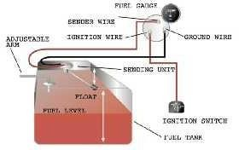
  - When theignition isturned on, an electrical current passesthrough the sending unit. Sincetheresistance of the potentiometer is tied directlyto the level ofthe float,and current flow depends on the overallresistance ofa circuit, thelevel of current flowingthroughthecircuit isalsotieddirectlytothelevel of gasoline in the tank.
  - In this type of system, the gas level indicator measures the amount of current that is flowing through the sendingunitatany giventime.In most cases,a high level ofcurrent correspondstoa full tank, whilea low level of current correspondsto an empty tank. Thisis so that if the sending unit malfunctions, the indicator will always read as empty.

FuelGaugeFailure
  - When a fuel gauge fails, it is typically the sending unit that goes bad. The gauge, wiring, and other components can also result in a malfunctioning fuel gauge, but sending units tend to fail more often. Since sendingunitsarelocatedinside fueltanks,itcanbetimeconsumingtotestorreplacethem.Unlessa vehicle has an access port, the fuel tank typically must be removed.
  - If a fuel gaugealwaysreads empty, whether the tank is empty or full, then the problem isusuallyrelatedto the sendingunit. Either the potentiometer is bad,the float is stuck down,the internal wiring is bad, or there isan issue elsewhere in the circuit. Depending on howthe specific fuel gauge system worksin a vehicle, it may be necessary to remove the sending unit and check itsresistance while manually operating the float arm.
  - When a fuel gauge always reads full, the problem may be in the sending unit, the dash indicator, or the wiring. A float that is stuck in the up position will cause a fuel gauge to always read full, as will certain wiring and indicator issues.

OILPRESSUREGAUGE

FunctionalPrinciple
  - Standard oil pressuresensors work by displaying a warning signal when theoil pressure fallsoutsideofthe set range. Two important components to the oil pressure sensor include the spring-loaded switch and a diaphragm. The spring-loaded switchis connectedtothediaphragm that is exposed to the oil pressure.
  - The pressure switch is mountedontothe side ofan engine block and wired toanoil gallery. As the force of theoilpressurestartstobuildonthediaphragm,thisforceovercomestheswitchspringpressure, whichthen pullsaparttheelectricalcontactstoturnon the warninglight.Iftheoilpressurefallsbelowthe setlimit,the diaphragm releases pressure off the springs to close the switch contacts that would normally result in the display of a warning sign to the driver.
  - The low oil pressure indicator light is displayed on the dashboard of a vehicle. Any driver will know that when thislight flashes continuously, it is indicating a momentary drop in the oil pressure. However, ifthis light remains switched on, the driver isalerted to a completeloss of oil pressure.
  - So, when the engine to a vehicle is switched on, an electrical current travels from a fuse and straight to the oilpressureswitch,makingsurethattheindicatorlightis‗off‘.Whenoilpressurestartstoriseabove4.3psi (per squareinch),the diaphragm movesapartthe contacts, thus switching on the oil pressurelight.

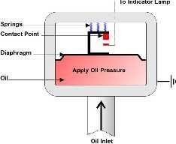

Workingmechanismtoanoilpressuresensorsystem.
PressureGaugeSensor
  - A low oil pressure warning light is one method used to alert the driver to fluctuations in the oil pressure levels. An alternative system for this purpose is known as a mechanical type pressure gauge component. There is a Bourdon tube inside a pressure gauge that tends to straighten out upon receiving pressure via a copper tubular component.
  - The Bourdon tube is attached to a needle on the gauge, which moves as the tube begins to take a different shape. Movement of the needle across a scale on the gauge is used as a reference point to indicate changes in oil pressure inside the engine to a vehicle.

ENGINETEMPERATUREINDICATOR

EngineTemperatureSensor
TheEngineTemperatureSensoraccuratelymeasuresthe enginecoolanttemperature.Thereby,itgivesan indication of the temperature of the engine.

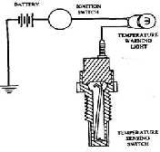
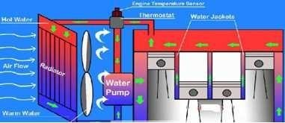
EngineTemperatureSensorworking
Enginetemperatureindicator
  - Theenginetemperaturesensorisatypeofsensor that changesitsresistancewithtemperature. Manycritical engine functions such as selection ofair-fuel ratio, fuel injection timing, ignition timing etc. depend on the engine‘s temperature. This is because a cold engine requires a rich air-fuel mixture; whereas the engine runningat optimum operating temperature requires a lean mixture.
  - The engine temperature sensor informs the engine‘s ECU about the current& ongoing variations in the engine temperature. ECU, in turn, adjusts and regulates the fuel quantity & ignition timing. The data from the engine temperature sensor provides readings for engine temperature gauge on the dashboard. Based on this data,the ECUalso controlstheadditional functions suchas switching on/ offtheengine cooling fan.

CoolantTemperaturesensorlocation
  - Engine Coolant Temperature sensor is primarily located in the coolant passage ofthe liquid cooled engine; typically near the thermostat valve.

  - The engine temperature sensor connects either to the temperature gauge or to the temperature indicator in the dashboard. In modern cars, you will notice that there is no separate engine temperature gauge. Instead, thereisa tiny‗light‘ symbolizing the enginetemperature; whichis integrated withrpm-meter.
  - Upon turning the ignition 'ON', the letter ‗C‘ also lightsalong with the temperature symbol; indicating that the engine iscold. It should automatically disappear; once the engine warmsup to its optimum temperature (usually within 2/3 Kilometers of the drive).

Thecommoncausesoffailure
  - Inmost cases,the enginetemperature sensor failsduetocorrosion.Thisisbecauseofitsexposureto engine coolant. It may also fail if the coolant leaksthrough its wiring connector.

Whattodoiftheenginetemperaturesensorfails?
  - Ifyouseethattheenginetemperaturesymbol‗C‘islit continuouslyanddoesnotdisappearafter sometime; it indicates that there is some problem in the engine‘s cooling system. Also, if the engine temperature goes abovetheprescribedlevels(usually above100ºC),anothersymbol–aHigh-Temperatureindicatorlight
‗H‘lightsupinredcolor;indicatingthattheengineisover-heating.
  - Furthermore, it is not safe to drive a car with the indicator light ‗H‘ on. As it may cause further damage and/or seize the engine. Stop the car and look for any coolant (usually green colored) leakage. Ifthere is a noticeable leakage, do not drive the car in that condition. Instead, tow it to the nearest service station for repair.

ENGINE MANAGEMENT SYSTEM ENGINEMANAGEMENTSYSTEM
  - Engine management systemis, now-a-days, used in many of the modern cars such asBenz, Mitsuibisi, and Toyota etc.This system uses much electronic control system involving micro controllers.The generalized block diagram of this system is shown in fig.
  - Theobjectiveofthesystembeingtoensurethattheengineisoperatedatitsoptimumsettings.
  - Thesystemconsistsof manysensorsfor observingvehicle speed, enginetemperature, oiland fuel pressure, airflow etc. These sensors are supplying input signals to the micro controller after suitable signal conditioning and providing output signals via driverstoactuate corresponding actuators.
  - A single cylinder engine consists of some of these elements in relation to an engine is shown in fig.The engine sensor is an inductive type s It consists of a coil and sensor wheel.Theinductanceof the coil changesastheteethofthesensorwheelpassitandso results in an oscillating voltage.
  - The engine temperature sensor is generally thermocouple which is made of bimetallic strip or a thermistor.Theresistanceof thethermistor changeswith changein enginetemperaturethisresult in voltage variation. Hot wire anemometer is used as a sensor for measuring mass airflow rate. The basic principle is thattheheated wirewillbecooledasairpassesoverit.Theamountofcoolingisdependingonthemassrate of flow.
  - Theoilandpressuresensorsarediaphragmtypesensors. Accordingtothepressure variation,thediaphragm may contract or expandandactivates strain gauge which produces voltage variationinthe circuit.
  - TheoxygensensorisusuallyacloseendtubewhichismadeofZirconiumoxidewith porousplatinum electrodeontheinner andouterSurfaces.Thesensorbecomespermeabletooxygenionsat about 300°C.This results in generation of voltage between the electrodes. The various drivers such as fuel injector drivers, ignition coil drivers. Solenoid drivers are used to actuate actuation according to the signal by various sensors.
  - Analog signals given by sensors are converted into digital signal by using analog to digitalconverters (ADC) and sent it to micro controllers.The various output digital signals are converted intoanalog signals byDAC(i.e., Digital to AnalogConverter) and shownin variousrecorders or meters.

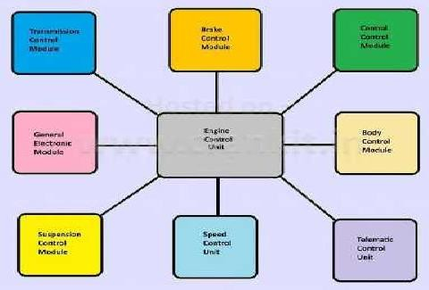
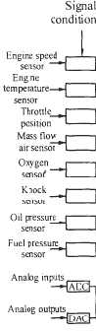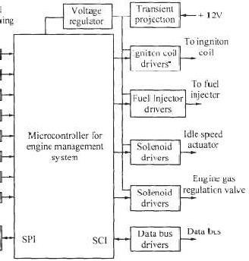
Blackdiagramofenginemanagementsystem
  - EMS stands for Engine Management System which consists of a wide range of electronic and electrical componentssuchassensors,relays,actuatorsandanEngine Control Unit. Furthermore,they work together to provide the Engine Management System with vital data parameters that are essential for governing various engine functions effectivel . The Engine Management system isincorporated in the modern day enginetechnologies, suchasMPFi &GDi systemsin Petrol enginesand CRDi systemin diesel enginesfor improved performance.
y
e

  - ECUstandsforEngineControl UnitandECMforEngineControlModule, bothar also a generic term for any Electronic Control Unit/Module respectively.
thesame.ECU/ECMis

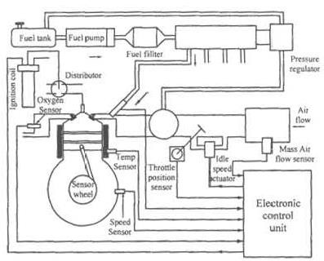

Enginemanagementsystemwithsensorsandactuators

EngineControlUnit

  - TheEngineControl Unitisa centralpartoftheEngineManagement System whichisvirtuallythe 'Brain' of an engine. It plays an important role in collecting, analyzing, processing and executing the data it receives from various sub-systems. Furthermore, an ECU comprises a computer which uses a microchip to process the inputs from various engine sensors in real-time.

  - The Electronic Control Unit contai consists ofamicro-controllerchip
n
s hardware and software. The printed circuit board (PCB) of the ECU ortheCPU(CentralProcessingUnit).Thesoftwareisstoredonthe

micro-controller or chips on the PCB. It is possible to re-program the ECU by updating the software or by replacing chips. All the engine sen ors send data inputs by the way of electrical signals to the ECU. The ECU, in turn, controls various actuators, ignition timing, variable valve timing etc.
s

WorkingofECU
  - Based on this data input, the ECprecisely calculates and delivers the idealair-fuel mixture. It also regulates the idle speed of the engine and limits the top speed of a vehicle. This system is also widely referred to as an ‗Electronic Engine Management System‘ or the EMS. Furthermore, it is possible to customize the modern day ECUsto suit different vehicular applications and varying customer demands. In addition,somecarshaveanindividal‗Control Module‘forall majorsystems. Aoderncar hasfollowing individual Control Modules which control the respective systems.
U
u m

SL.NameoftheSensor Purpose
- Air–fuel Ratio Meter Monitorsthecorrectair-fuelratioforthe engine
- EngineSpeedSensor Monitorsenginespeed
- ThrottlePositionSensor Monitorsthepositionofthethrottleinan
engine
- Crank Position Sensor Monitorspiston‘sTDCpositioninthe engine
- CamPositionSensor Monitorspositionofvalvesintheengine
- Knock Sensor Detectsengineknockingbecauseoftiming advance
- Engine Coolant Temperature Sensor Measures the engine temperature Manifold Absolute Pressure or MAP
08
Sensor Usedtoregulatefuelmetering
09 MassAirFloworMAFSensor Notifiesthemassofairenteringtheengine
toECU
- Oxygen/O2/LambdaSensor Monitorstheamountofoxygeninthe
exhaust
- FuelPressureSensor Measurespressureinthefuelsystem
- VehicleSpeedSensor(VSS) Measuresthespeedofavehicle

