ENTREPRENEURSHIPANDMANAGEMENT & SMART TECHNOLOGY
5thSEMESTER

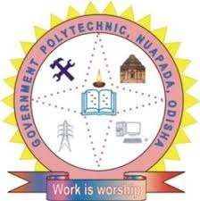

PREPARED BY

MICHEAL SUVEER(GF)

DEPARTMENT OF MECHANICAL ENGINEERING


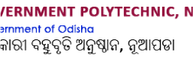

ENTREPRENEURSHIP and MANAGEMENT & SMART TECHNOLOGY

Entrepreneurship
Entrepreneurshipistheabilityandreadinesstodevelop,organizeandrunabusiness enterprise, along with any of its uncertainties in order to make a profit. The most prominent example of entrepreneurship is the starting of new businesses.

MeaningofEntrepreneur
The entrepreneur is defined as someone who has the ability and desire to establish, administer andsucceed inastartupventurealong withriskentitled toit,to makeprofits.Thebest example of entrepreneurship is the starting of a new business venture. The entrepreneurs are often known as a source of new ideas or innovators, and bring new ideas in the market by replacing old with a new invention.
It can be classified into small or home business to multinational companies. In economics, the profitsthatan entrepreneurmakesarewithacombinationofland,naturalresources,labour and capital.
Itisclassifiedintothefollowingtypes:
- SmallBusinessEntrepreneurship-
These businesses are a hairdresser, grocery store, travel agent, consultant, carpenter, plumber, electrician, etc. These people run or own their own business and hire family members or local employee. For them, the profit would be able to feed their family and not making 100 million businessortakingoveranindustry.Theyfundtheirbusinessbytakingsmallbusinessloans or loans from friends and family.
- ScalableStartupEntrepreneurship-
This start-up entrepreneur starts a business knowing that their vision can change the world.Theyattractinvestorswhothinkandencouragepeoplewhothinkoutofthebox.The researchfocusesonascalablebusinessandexperimentalmodels,so,theyhirethebestand the brightest employees. They require more venture capital to fuel and back their project or business.
- LargeCompanyEntrepreneurship-
These huge companies have defined life-cycle. Most of these companies grow and sustain by offering new and innovative products that revolve around their main products. The change in technology,customerpreferences,newcompetition,etc.,buildpressureforlargecompanies

to create an innovative product and sell it to the new set of customers in the new market. To cope with the rapid technological changes, the existing organisations either buy innovation enterprises or attempt to construct the product internally.
- SocialEntrepreneurship-
This type of entrepreneurship focuses on producing product and services that resolve social needsandproblems.Theironlymottoandgoalistoworkforsocietyandnotmakeany profits.

NeedofEntrepreneurship
Theneedforentrepreneurshipisdetaileddowninthefollowingsection:
- Passion,Perseverance&Persistence
Passion is a strong and uncontrollable emotion that is based on something higher to achievethan what the person is carrying within himself. Perseverance is a mature emotion that comes throughexperiencesgatheredandanalysed.Whilepersistenceisthesailthatwillrowthe boat of anentrepreneurthrough the toughest of climates.
- BigDreamer
Dreaming big further strengthens an entrepreneur with his ability to dream and see the wide picture. This is the very first step that sets the path to self-discovery.
- Learning
Learningisnevertostopirrespectiveofageandthusarmingoneselfwitheducationdoes play a vital role in forming leadership qualities when needed.

- GoodListener
Theabilitytocontributewillonlycomeoncewehaveabundanceinourselves,andthis comes by absorbing the words of others. The ability to truly listen to the customers and employees is actuallywhat makes adifference.Thisvery skill leads to asuccessful venture.
- FinancingPartner
Choosingafinancingpartnerwhounderstandsthebusinessneedsisverymuchessential. This is as critical as choosing the business which the entrepreneur wants to pursue. Also, a business loan from the right lender will for sure play a pivotal role in realizing the dreams of becoming a successful entrepreneur.

CharacteristicsofEntrepreneurship:
Notallentrepreneursaresuccessful;therearedefinitecharacteristicsthatmakeentrepreneurship successful. A few of them are mentioned below:

  - Ability to take a risk- Starting any new venture involves a considerable amount of failurerisk.Therefore,anentrepreneurneedstobecourageousandabletoevaluate and take risks, which is an essential part of being an entrepreneur.
  - Innovation- It shouldbehighlyinnovativetogeneratenewideas,startacompany and earn profits out of it. Change can be the launching of a new product that is new to themarketoraprocessthatdoesthesamethingbutinamoreefficientand economical way.
  - Visionary and Leadership quality- To be successful, the entrepreneur should have a clearvisionofhisnewventure.However,toturntheideaintoreality,alotof resources and employees are required. Here, leadership quality is paramount because leaders impart and guide their employees towards the right path of success.
  - Open-Minded- In a business, every circumstance can be an opportunity and used forthebenefitofacompany.Forexample,Paytmrecognisedthegravityof demonetizationand acknowledgedtheneedforonlinetransactionswould bemore,so it utilised the situation and expanded massively during this time.
  - Flexible- An entrepreneur should be flexible and open to change according to the situation.Tobeon thetop,abusinesspersonshouldbe equipped to embrace change in a product and service, as and when needed.
  - KnowyourProduct-Acompanyownershouldknowtheproductofferingsandalso beawareofthelatesttrendinthemarket.Itisessentialtoknowiftheavailable product or service meets the demands of the current market, or whether it is time to tweak it a little. Being able to be accountable and then alter as needed is a vital part of entrepreneurship.

ImportanceofEntrepreneurship:

    - Creation of Employment- Entrepreneurship generates employment. It provides an entry-level job, required for gaining experience and training for unskilled workers.
    - Innovation- It is the hub of innovation that provides new product ventures, market, technology andquality of goods, etc., and increase the standard of living of people.

    - Impact on Society and Community Development- A society becomes greater if the employment base is large and diversified. It brings about changes in society and promotesfacilitieslikehigherexpenditureoneducation,bettersanitation,fewer slums, a higher level of homeownership. Therefore, entrepreneurship assists the organisation towards a more stable and high quality of community life.
    - IncreaseStandardofLiving- Entrepreneurshiphelpstoimprovethestandardof living of a person by increasing the income. The standard of living means, increase in the consumption of various goods and services by a household for a particular period.
    - Supports research and development- New products and services need to beresearched and tested before launching in the market. Therefore, an entrepreneur also dispenses finance for research and development with research institutions and universities. This promotes research, general construction, and development in the economy.

QualityofanEntrepreneur

- Creativity–
One of the most basic qualities that successful entrepreneurs share is creativity. Typically, entrepreneurs love creating things. This might mean being able to invent an innovativeproductthathasneverexistedbefore.Itmightalsomeanbeingableto comeupwithanefficientandbettermeansofdoingsomething.Itdoesnotmatter what they create; entrepreneurs simply have the inbuilt ability to use their imagination and come up with solutions to make things easier and more enjoyable.
- Self-Motivation
Entrepreneurs are typically achievers and go-getters that won’t sit around and wait for someonetourgethemtogetthingsdone.Theyknowthatitdoesn’tjuststopat coming up with ideas; they know that if their ideas are to become reality, they need to put in the effort.Their motivation comes from within; from theinnate desire tosee what they had in mind being brought to life.
So,evenifnooneischeeringthemontheystayfocusedandmotivated.Andthisis thebesttypeofmotivationthereistohave.Youwon’talwayshavepeople encouraging or commending you for what you are doing.

- Passionate–
Entrepreneurs are usually very passionate about what they do. They have this burning passion for their work and would be content spending several hours every day surrounded by their work. To someone looking at them from the outside, they would merelyseesomeoneofferingasimpleproductorservice,buttheentrepreneurseesit asaveryvitalpartoftheirlife.Anentrepreneurwakesupeverymorningwith thoughts about the work they need to get done that day. They also go to sleep thinkingof how they can get better and improve their work the next day.
- GreatCommunicationSkills
If you are to succeed in a competitive commercial marketplace, then you need great communication skills. What some business owners do not know is that some communication skills far outweigh others.
- StrongWorkEthics
Entrepreneurs often have admirable work ethics. If there’s an unfinished project, an entrepreneur won’t mind showing up at work even on holidays and weekends to finish up the work.
- EntrepreneursKnowWhentoDelegate–
Another quality that successful entrepreneurs share is knowing when to delegate. Successfulentrepreneursknowthattheycannotdoeverythingallbythemselves.
Theyknowhowtospotanemployee’shiddentalentandthendelegateprojects relating to that talent to them if it ever comes up
- Empathy–
People typically do not start their business with the sole purpose of helping people or making the world better. The major reason people start businesses is so they can make profits. If profit isn’t made, then the business will go bankrupt and would have to beshut down.
So, it is only normal that helping people only comes after profit-making for several business owners. However, successful people know that they shouldn’t be tooconsumed with their need to make profits to the point that they stop being empathetic. Successfulentrepreneursareusuallyempatheticandknowhowtoconnect emotionally with those they work with. Being genuinely empathetic is great forbusiness.

- EntrepreneursareEverReadytoLearn
Entrepreneurs know that they can’t possibly know everything.And because ofthemany responsibilities that come with running a business (especially a new one) an entrepreneurneedstobeanall-rounder.Forinstance,whenabusinessisinits buddingstage,theworkforcemaynotbesoversatile.Thebusinessownermayhave to play several roles in his new business; they may need to handle their marketing, accounting, and so on.
So,theyarealwaysreadytolearnnewthingsorabetterwaytodothingsregardless of who is teaching them.
- Willpower
An entrepreneur typically has very strong willpower to achieve their goals and vision. This is what drives their actions. Despite the challenges they may encounter, their willto get to their goals never wavers. And it keeps them working toward their vision even though they fail several times.
- EntrepreneursareSmart–
Itisveryrare(ifnotimpossible)tofind asuccessfulentrepreneurthatisn’t smart. Theydonotonlyhavecommonsense,buttheyalsoknowhowtomakewiseand sensible decisions.
Their thoughts are collected and calculated so that they can make the best choice at all times. Asidefrommaking decisions,the smart nature of entrepreneurs makesit possible for them to make plans and then come up with working strategies to executethe plans. This quality is also one of the reasons they are great at dealing with people.
- EntrepreneursKnowHowtoMakePlans–
Oneofthekeythingseveryentrepreneurneedstoknowhowtodoismakeplans. Even though entrepreneurs have an easygoing attitude, they never do things without having a plan and several other backup plans.
Anentrepreneur’sstrengthliesintheirabilitytomakespecific,measurable, achievable, relevant, and time-bound (SMART) plans. They know that if they do not make plans, then the chances of succeeding at what they seek to achieve will significantly reduce.
- Risk-Taking
Entrepreneurs are often risk-takers. They have this innate ability to see and sees an opportunity even though it comes with risks.

BarriersinEntrepreneurship
Entrepreneurship is often seen as a pathway to innovation, economic growth, and personal success. However, it's not without its challenges and barriers. Here are some common barriers that entrepreneurs may face:

- FinancialBarriers:
  - LackofCapital:Oneofthemostsignificantbarriersisthedifficultyinaccessing sufficient capital to start or grow a business.
  - HighStartupCosts:Manyindustriesandbusinessesrequiresubstantialinitialinvestments in equipment, technology, or infrastructure.
- RegulatoryandLegalBarriers:
  - ComplexRegulations:Navigatingawebofregulations,licenses,permits,and compliance requirements can be daunting.
  - IntellectualPropertyChallenges:Protectingintellectualpropertyanddealingwithpatent, copyright, and trademark issues can be a significant hurdle.
- MarketBarriers:
  - Competition:Enteringmarketswithestablishedcompetitorscanbechallenging, especially for new startups.
  - Market Saturation: In some industries, markets may be saturated, making it difficult to find a niche.
- ResourceBarriers:
  - LimitedAccesstoResources:Scarcityofessentialresourceslikeskilledlabor,raw materials, and suppliers can be a significant impediment.
  - Lack ofNetworking: Building a network of contacts,mentors, and advisors is crucialfor success. A lack of such connections can be a barrier.
- EconomicBarriers:
  - EconomicDownturns:Economicrecessionsordownturnscancreateuncertainty, reduce consumer spending, and affect business viability.
  - EconomicInequality:Socioeconomicdisparitiescanlimitaccesstoentrepreneurial opportunities and resources.
- RiskAversion:
  - Fear of Failure: The fear of failure can deter potential entrepreneurs from taking risksand pursuing their business ideas.

  - RiskyBusinessEnvironment:Uncertainmarketconditionsandthepotentialfor significant financial loss can discourage risk-taking.
- EducationandSkillsGaps:
  - LackofEntrepreneurialEducation:Limitedaccesstoentrepreneurialeducationand training can hinder individuals from starting and managing a business.
  - SkillGaps:Insufficientknowledgeandskillsinareaslikemarketing,finance,and management can impede success.
- CulturalandSocialBarriers:
  - Stigma:Insomecultures,entrepreneurshipisstigmatized,anditmaybechallenging to gain support or acceptance.
  - GenderandDiversityBarriers:Disparitiesinopportunitiesandsupportcanaffectunderrepresented groups in entrepreneurship.
- TechnologicalBarriers:
  - Rapid Technological Changes: Keeping up with evolving technology and adapting todigital transformation can be difficult for many entrepreneurs.
- MentalandEmotionalBarriers:
  - StressandBurnout:Thehighlevelsofstressandthepotentialforburnoutcanbe overwhelming for entrepreneurs.
  - LackofSelf-Confidence:Alackofself-confidencecanpreventindividualsfrompursuing entrepreneurial opportunities.

DiffereriencatebetweenEntrepreneurshipvsManager

Entrepreneurs:

- RoleandFocus:
  - Entrepreneurs are typically the founders of a business or individuals who initiate new businessventures.Theyareprimarilyfocusedoncreatinganddevelopingnew business opportunities.
- InnovationandRisk:
  - Entrepreneurs are often associated with innovation and risk-taking. They identify gapsinthemarket,createnew productsor services,andare willingto take calculatedrisks to achieve their goals.

- Ownership:
  - Entrepreneurs often have a significant ownership stake in the business and are highly motivated to see it succeed because their personal wealth is closely tied to thecompany's performance.
- VisionandCreativity:
  - Entrepreneurs have a vision for their business and are often the creative driving force behind the company, shaping its mission, values, and culture.
- Adaptability:
  - Entrepreneurs need to be adaptable and willing to pivot and change course as the business environment evolves.
- ResourceAcquisition:
  - Entrepreneurs are responsible for securing initial funding and resources to start the business, often through sources like personal savings, loans, or investors.

Managers:

- RoleandFocus:
  - Managersareresponsiblefortheday-to-dayoperationofanestablishedbusiness. They focus on planning, organizing, coordinating, and controlling the business'sexisting activities.
- ExecutionandEfficiency:
  - Managers are primarily concerned with executing existing strategies and processes efficiently to achieve established goals and objectives.
- Responsibility:
  - Managersmaynothaveasignificantownershipstakeinthebusinessandare generallyresponsibleforoverseeingtheworkofemployeesandensuringthattasks are completed on time and within budget.
- Implementation:
  - Managers are tasked with implementing the strategies and decisions made by entrepreneurs or higher-level executives.
- StabilityandConsistency:
  - Managersoftenworktomaintainstabilityandconsistencyinthebusiness's operations, ensuring that it operates smoothly and reliably.

- ResourceUtilization:
  - Managers focus on resource allocation, human resource management, and optimizingexisting processes.

FormsofBusinessOwnership

- SoleProprietorship:

  - Owner:Asoleproprietorshipisownedandoperatedbyasingleindividual.
  - Liability: The owner has unlimited personal liability for the business's debts and legal obligations.
  - Control:Theownerhasfullcontroloverthebusinessanddecision-making.
  - Taxation:Businessincomeandexpensesaretypicallyreportedontheowner's personal tax return.
  - EaseofFormation:Easyandinexpensivetoestablish.
  - Example:Smallretailstores,freelancebusinesses.

- Partnership:

  - Owners:Apartnershipinvolvestwoormoreindividualswhoshareownershipand management responsibilities
  - Liability:Partnersmayhaveunlimitedpersonalliabilityforthepartnership'sdebts and actions, depending on the type of partnership.
  - Control:Managementresponsibilitiesandcontrolaretypicallysharedamongthe partners according to the terms of a partnership agreement.
  - Taxation:Partnershipsare"pass-through"entities,meaningprofitsandlossesflow through to the individual partners' tax returns.
  - EaseofFormation:Relativelyeasytoform,usuallywithapartnershipagreement outlining the terms.
  - Example:Lawfirms,medicalpractices,smallconsultingfirms.

- LimitedPartnership(LP):

  - Owners:AnLPhasatleastonegeneralpartnerwithunlimitedliabilityandoneor more limited partners with limited liability.

  - Liability:Generalpartnershaveunlimitedpersonalliability,whilelimitedpartners have liability limited to their investment.
  - Control:Generalpartnerstypicallymanagethebusiness,whilelimitedpartnershave a more passive role.
  - Taxation:LPsarepass-throughentitiesfortaxation.
  - EaseofFormation:RequiresthefilingofaCertificateofLimitedPartnershipand may have more complex requirements.
  - Example:Realestateinvestments,venturecapitalfirms.

- LimitedLiabilityPartnership(LLP):

  - Owners:Partnersin anLLPhavelimitedpersonalliability for thepartnership'sdebts and actions.
  - Liability:Partnersaregenerallyprotectedfromthedebtsandliabilitiesofother partners.
  - Control:Managementresponsibilitiesareoftensharedamongthepartners.
  - Taxation:LLPsarepass-throughentitiesfortaxation.
  - EaseofFormation:Typicallyformedbyfilingregistrationdocumentswiththe appropriate state authorities.
  - Example:Accountingfirms,lawfirms.

- Corporation:

  - Owners:Shareholdersownacorporationthroughownershipofsharesofstock.
  - Liability:Shareholders havelimitedliability;theirpersonal assets areprotected from the corporation's debts.
  - Control:Shareholderselectaboardofdirectorstooverseethecompany,andtheboard appoints officers to manage day-to-day operations.
  - Taxation: Corporations are taxed separately from their shareholders. This is known as"double taxation."
  - EaseofFormation:Morecomplexandexpensivetoform,withvariouslegaland regulatory requirements.
  - Example:Largepubliclytradedcompanies,suchasAppleorMicrosoft.

- LimitedLiabilityCompany(LLC):

  - Owners: LLCs have members who own the company. LLCs can have single membersor multiple members.
  - Liability:Membershavelimitedpersonalliability,protectingtheirassets.
  - Control:Membersoftenhavemoreflexibilityinmanagementanddecision-making compared to corporations.
  - Taxation:LLCscanchoosehowtheywanttobetaxed:asapartnership,corporation, or sole proprietorship.
  - EaseofFormation:Relativelyeasytoform,oftenwithfewerformalrequirements compared to corporations.
  - Example:Smallbusinesses,realestateinvestments.

TypesofIndustries:

Industries are categorized based on the nature of their products or services, and they can be groupedinvariousways.Herearesomecommontypesofindustriesbasedondifferent criteria:

- PrimaryIndustries:

  - Theseindustriesinvolvetheextractionandproductionofrawmaterialsfromnatural resources.
  - Examplesincludeagriculture,mining,forestry,andfishing.

- SecondaryIndustries:

  - Secondaryindustriesareinvolvedinprocessingandmanufacturingrawmaterialsinto finished products.
  - Examplesincludemanufacturing,construction,andutilities.

- TertiaryIndustries:

  - Tertiaryindustriesprovideservicestoindividualsandotherbusinesses.
  - Examplesincludehealthcare,education,hospitality,andfinance.

- QuaternaryIndustries:

  - Quaternaryindustriesfocusonknowledge-basedactivities,includingresearch,technology development, and information services.
  - ExamplesincludeIT,researchanddevelopment,andconsultancy.

- QuinaryIndustries:

  - Quinaryindustriesarethehighestlevelofdecision-makinginaneconomyandoften include top executives, government officials, and leaders in various fields.
  - Examplesincludegovernment,healthcareadministration,andhigh-levelfinance.

- HeavyIndustries:

  - Heavyindustriesarethosethatinvolvelarge-scaleproductionofgoods,oftenwithsubstantial capital investment and heavy machinery.
  - Examplesincludesteelmanufacturing,automotiveproduction,andaerospace.

- LightIndustries:

  - Light industries typically involve the production of small and consumer-oriented goodswith less capital-intensive processes.
  - Examplesincludetextiles,electronicsassembly,andfoodprocessing.

- ServiceIndustries:

  - Serviceindustriesfocusonprovidingintangibleservicestoconsumers.
  - Examplesincluderetail,healthcare,education,andprofessionalservices

- SunriseIndustries:

  - Sunriseindustriesareemergingsectorsthatareexperiencingrapidgrowthand innovation.
  - Examplesincluderenewableenergy,biotechnology,andartificialintelligence.

- SunsetIndustries:

  - Sunsetindustriesaresectorsindecline,oftenduetochangingconsumerpreferences, technological advancements, or market saturation.
  - Examples includetraditional print media, someheavy manufacturing sectors,and non- renewable energy.

ConceptofStart-ups:

Astartupisarelativelynewbusinessventurethatistypicallycharacterizedbyinnovation, growth potential, and adegree of uncertainty.Hereare key concepts associated with startups:

- Innovation:Startupsareoftenfoundedtointroducenewandinnovativeproducts,services, or business models to the market.
- Growth Orientation: Startups are focused on rapid growth and scaling, aiming to capture a significant market share.
- High Risk and Uncertainty: Startups face a higher level of risk and uncertainty compared to established businesses. They may have unproven concepts, business models, or revenuestreams.
- Entrepreneurship: Startups are typically founded by entrepreneurs who are willing to take risks and invest their time, energy,and often personal resources in pursuit of their vision.
- Funding: Startups often seek external funding from venture capitalists, angel investors, or crowdfunding to support their growth and development.
- LeanApproach:Manystartupsfollowtheleanstartupmethodology,whichinvolves building a minimum viable product (MVP) anditerating based on customer feedback.
- Disruption: Startups may disrupt existing industries by introducing new technologies or business models that challenge traditional players.
- Ecosystem: Startupecosystems,often found in tech hubs like Silicon Valley,provide resources such as mentorship,networking, and access to investors to supportstartupgrowth.
- Exit Strategy: Founders and investors in startups often have an exit strategy in mind, such as acquisition by a larger company or an initial public offering (IPO).
- Failure Rate: Startups face a high failure rate, but successful ones have the potential for significant financial rewards and societal impact.

Entrepreneurialsupportagencies

  - Entrepreneurs'Organization

Entrepreneurs'Organization,orEO,wasestablishedin1987.Benefitsofmembershipinclude a forum for sharing and discussing your challenges, help from a personal mentor, access to large-scale networkingevents,healthcareoptions, resourcestohelpyoubuildyour leadership and more.
  - FoundersCard

More than 20,000 entrepreneurs, innovators and business professionals are part of Founders Card, an organization that offers exclusive discounts on hotel, travel, business and lifestyle products and services, as well as access to invitation-only networking events.

  - YoungEntrepreneurCouncil

Young Entrepreneur Council, or YEC, is an invitation-only organization for entrepreneurs 40 and under. It offers 24/7 support through forums, discounts on products and services, offline events, an editorial team that can help with content development and distribution to create brand-building and media opportunities, and a complimentary Founders Card membership.

Members are also given the opportunity to give back through organizations that help young entrepreneurs, including Junior Achievement, and many others

  - YoungPresident'sOrganization

Young President's Organization, also known as YPO, was founded in 1950. It offers global educational and networking opportunities for those 45 and under that are designed to help owners build their businesses. Members also have access to a variety of events, and the opportunity to seek advice from its large network. The organization also offers guidance for family members and couples.

  - Vistage

Vistage is committed to CEO and executive coaching, leadership development and business mentoring.ThosewhoareinterestedingivingbackcanalsobecomeaCEOcoachwith

Vistage. The organization is made up of more than 20,000 business leaders worldwide with a members-only online network.

  - Dynamitecircle

The Dynamite Circle, or the DC, is a private community for entrepreneurs with established, successful and legitimate businesses that are not location dependent. It was founded by Dan AndrewsandIanSchoenofTropicalMBA.TheDCbeganasasmallmastermindin2011, and still holds this as one of its primary tenants and value propositions.

DistrictIndustriesCenters(DICS)

This programme was started by 1978 with a view to provide integrated administrative framework at the district level for promotion of small-scale industries in rural areas. Its main functions are
    - Toprepareanactionplantoeffectivelyimplementtheschemesidentified.
    - Toappraisetheworthinessofthevariousproposalsreceivedfromentrepreneurs.
    - Toundertakeproductdevelopmentworkappropriatetosmallindustries.
    - Toassisttheentrepreneursinmarketingtheirproductsandassessthepossibilities of ancillarisation and export promotion of their products

SmallIndustriesDevelopmentOrganization(SIDO)

SmallIndustriesDevelopmentOrganization(SIDO)isasubordinateofficeofthe DepartmentofSSI&ARI.DevelopmentCommissioneristheheadoftheSIDO.Heis assisted by various directors and advisers in evolving and implementing various programmersoftrainingandmanagementconsultancy,industrialinvestigation,possibilitiesfor developmentofdifferenttypesofsmall-scaleindustries,developmentofindustrialestates, etc. The main functions of SIDO are
    - FunctionsrelatingtoCo-ordination
    - FunctionsrelatingtoIndustrialDevelopment
    - FunctionsrelatingtoextensionNational

SmallIndustriesCorporationLtd(NSIC)

ThenationalSmall Industries Corporation Ltd (NSIC) anenterpriseundertheunion ministry ofIndustries,wassetupin1955topromote,aidandfosterthegrowthofsmall-scale industries in the country. It main functions are
    - Toprovidemachineryonhire-purchaseschemetosmallscaleindustries•To provide equipment leasing facility
    - Tohelpinexportmarketingoftheproductsofsmall-scaleindustries
    - To help in development and upgradation of technology and implementation of modernization programmes of small-scale industries.

SmallScaleIndustriesBoard(SSIB)

The government if India constituted a Board, namely, Small Scale Industries Board (SSIB) in 1954 to advise on development of small-scale industries in the country. The SSIB is alsoknown as Central Small Industries Board. Hence to facilitate Co-ordination and inter- institutional linkages, the Small Scale Industries Board has been constituted. It is an apex advisory body constituted to render advice to the Government on all issues pertaining to the development of small scale industries Small Industries Service Institutes (SISIs) Small Industries Service Institutes (SISIs) are set up to provide consultancy and training to small entrepreneurs-both existing and prospective. It main functions are
    - ToserveasinterfacebetweenCentralandStateGovernments
    - Torendertechnicalsupportservices
    - ToconductEntrepreneurshipDevelopmentProgrammes.
    - Toinitiatepromotionalprogrammers

MarketSurveyandOpportunityIdentification(BusinessPlanning)

WhatIsBusinessPlanning?

Business planning can play out in many different ways. Anytime upper management comes together to plan for the success of a business, it is a form of business planning. Business planningcommonlyinvolvescollectingideasinaformalbusinessplanthatoutlinesa summary of the business's current state, as well as the state of the broader market, along with detailed steps the business will take to improve performance in the coming period.

Businessplansaren'tjustaboutmoney.Thebusinessplanoutlinesthegeneralplanning neededtostartandrunasuccessfulbusiness,andthatincludesprofits,butitalsogoes beyond that. A plan should account for everything from scoping out the competition and figuringouthowyournewbusinesswillfitintotheindustrytoassessingemployeemorale and planning for how to retain talent.

HowDoesBusinessPlanningWork?

Every new business needs a business plan—a blueprint of how you will develop your new business, backed by research, that demonstrates how the business idea is viable. If your new businessidearequiresinvestmentcapital,youwillhaveabetterchanceof obtaining debtor equityfinancingfrom financialinstitutions, angelinvestors,or venturecapitalistsif you have a solid business plan to back up your ideas.

SSI-SmallScaleIndustry

Small Scale Industries (SSIs) are entities that are involved in the manufacturing, production,and services of products on a micro or small scale. The maximum investment in machinery, plants, and industries by Small Scale Industries cannot exceed Rs. 1 crore. Small Scale enterprises must come under the guidelines of the Government of India. SSIs, help in the enhancement of employment opportunities, as most of the SSIs are labor-based.

SmallScaleIndustriesRegistrationProcedureinIndia

Step 1: Fill in the registration form by providing all the required information and follow theinstructions, as mentioned on the home page to complete the application form

Step2: Afterfillingtheform,clickon‘ValidateandPay’tosubmittheapplicationandto pay the registration fee

Step3:Postpaymentandformsubmission,anexecutivewillprocessyourapplication

Step4: Oncetheapplicationisapproved,youshallreceivetheSSIregistrationcertificate online via email

Note:ThevalidityoftheSSIRegistrationCertificateisforthelifetime.

Benefitsof SSI Registration

- Loansatloworconcessionalinterestrates
- SSIscanavailvarioustaxrebates,afterSSIregistration
- SSI units are granted carry forward of credit for Minimum Alternate Tax (MAT) for up to15 years
- OnlySSIsareallowedtohaveaccesstocertaingovernmenttenders
- Acquiringgovernmentlicensesandcertificationsbecomeseasieronceaunitreceivesa permanent registration
- As many concessions and rebates are available, therefore the cost of setting up of industryreduces.

FeaturesofSSI

- Ownership: Usuallysmallscalemanufacturingindustrieshaveasoleproprietorship or if required, a partnership with a few individuals
- Control: Thecontroloftheindustry iswith theowner himself/herself,leading tothe active participation of the owner in routine business activities
- LaborIntensive: Technology inSSIisonanominalscale.Thereisextensiveuseof labor for production activities
- ShortReach: Theoperationsinthesmall-scalemanufacturingindustryarenoton large scale. Hence, they are only able to cater to regional demand
- Flexibility: Astheunitsarecomparativelysmallinsize,changingaccordingtothe dynamic environment is more feasible for them

- Resources: Small Scale Industries are located in places where resources are easilymade available. This reduces transportation costs for the manufacturer and the use of resources is also efficient

ListofSSIsinIndia

Here,wetakealookatthelistofsomesmallscaleIndustries youcanworkonwithlow investment:

- BasicMetalIndustries
- Beverages,Tobacco&TobaccoProducts
- Chemical&ChemicalProducts
- CottonTextiles
- ElectricalMachinery&Parts
- FoodProducts
- Hosiery&Garments–WoodProducts
- Jute,Hemp,andMestaTextiles
- Leather&LeatherProducts
- Machinery&PartsexceptforElectricalgoods
- MetalProducts
- MiscellaneousManufacturingIndustries
- Non-metallicMineralProducts

Q.WhatistheprimaryuseofSSIregistration?

- SSIregistrationcanbeusedingettingconcessionsandrebatesfromthegovernment.

Q.WhatisthemaximuminvestmentthatcanbedonebySSI?

- ThemaximuminvestmentallowedforSSIisuptoRs.1crore.

Q.CanIregisterSSIonline?

- Yes, you can register SSI online by visiting their official website and filling and submission of the application form.

Q.IsSSIregistrationcompulsory?

- AbusinessunitfallingintothebracketoftheMSMEprovisionsisnotmandatedto register under SSI. Registration is voluntary.

Q.Howisthevaluationofequipmentforservicesenterprises,andplantand machinery for manufacturing enterprises done?
- ForcomputingthevalueofthePlantandMachinery,andEquipment,itsoriginal value is taken into account. There are some component costs that are to be excluded.

Q.Howmuchtimeitwilltaketoregisterafterformsubmission?

- Theregistrationcertificatewillbeissuedinstantlyviaemail,assoonasyousubmit the application form.

Q.WhatalldocumentsdoIneedtosubmittoregisterforSmallScaleIndustriesin villages?

- No documents are required to register as SSI, information submitted in the application form is sufficient to get your business registered under Small Scale Industries.

Q.Willagetahardcopyofthecertificatealongwithanemail?

- No,aspertheGovernment’sguidelinesnopapershallbeusedforthebenefitofthe environment.

Q.WhatisthedifferencebetweenSSIregistrationandMSMEregistration?

- ThereisnodifferencebetweenSSIandMSMEregistration.Earlier MSMEregistrationwas termed as SSI registration.

Q.IsitcompulsorytogetregisteredasCollateandSmallScaleIndustries?

- Itisrecommendedtogetregistered,asGovernmentinitiatedschemes,subsidiesand incentives can only be availed after getting registered as Small Scale Industry.

Q.WhataretheexamplesoftheSmallScaleIndustry?

- Ans. Some examples are Basic Metal Industries, Beverages, Tobacco & Tobacco Products, Chemical & Chemical Products, Cotton Textiles, Electrical Machinery & Parts, Food Products, Hosiery & Garments, Wood Products, Metal Products, Leatherand Leather Products.

AncillaryUnit

Anancillary smallindustrialunitistheonewhosuppliesnotlessthan50%ofitsproduction toanotherindustryreferredtoastheparentunitandhavingtheinvestmentinplant/ machinery, which is not more than Rs 5 crore.

TinyUnit

A tiny industry is an industrial or business enterprise whose investment in fixed assets i.e.,plant/machinery, that does not exceed Rs 25 lakh.

ServicesectorUnits

Theservicesectoristhesectoroftheeconomythatproducesandoffersservices.

- Theservicesectoristhepartoftheeconomythatprovidesvariousservices,as opposed to providing tangible goods such as cars and televisions.
- Theservicesectoristhelargestsectoroftheeconomyindevelopednations.
- The rapid growth of service-related industries has been fueled by increases inknowledge and data, and rapid technological advances – especially, improvements in communication.
- PrimarySector

The primary sector is composed of industries engaged in the business of gathering raw materials.Itincludesminingcompanies,lumbercompanies,andoildrillingcompanies– along with the agricultural and fishing industries.

- SecondarySector

Thesecondarysectorincludesallbusinessesinvolvedinproducingandsellinggoods–such as auto manufacturers, furniture stores, and clothing retailers.

- TertiarySector

Thetertiarysectoristheservicesector.Itincludesindustriessuchasthefinancialservices industry, internet technology (IT), and the healthcare and entertainment industries.

TimeschedulePlan

Schedulingistheartofplanningyouractivitiessothatyoucanachieveyourgoalsandpriorities in the time you have available. When it's done effectively, it helps you:
  - Understandwhatyoucanrealisticallyachievewithyourtime.
  - Makesureyouhaveenoughtimeforessentialtasks.
  - Addcontingencytimefor"theunexpected."
  - Avoidtakingonmorethanyoucanhandle.
  - Worksteadilytowardyourpersonalandcareergoals.
  - Haveenoughtimeforfamilyandfriends,exerciseandhobbies.
  - Achieveagoodwork-lifebalance.

Onceyouhavedecidedwhichtoolyouwanttouse,prepareyourscheduleinthefollowing way:

Step1:IdentifyAvailableTime

  - Startbyestablishingthetimeyouwanttomakeavailableforyourwork.

  - How much time you spend at work should reflect the design of your job and your personal goals in life.

Step2:ScheduleEssentialActions

  - The actions you absolutely must take to do a good job. These will often be the things you are assessed against.

  - For example, if you manage people, make sure that you have enough time available to dealwithteammembers'personalissues,coaching,andsupervisionneeds.Also, allow time to communicate with your boss and key people around you.

Step3:ScheduleHigh-PriorityActivities

  - Review your to-do list, and schedule in high-priority and urgent activities, as well as essential maintenance tasks that cannot be delegated or avoided
  - Try to arrange these for the times of day when you are most productive – for example,somepeopleareattheirmostenergizedandefficientinthemorning,whileothersfocus more effectively in the afternoon or evening.

Step4:ScheduleContingencyTime

    - Schedule some extra time to cope with contingencies and emergencies. Experiencewilltellyouhowmuchtoallow–ingeneral,themore unpredictable your job, the more contingency time you'll need. (If you don't schedule this time in, emergencies will still happen and you'll end up working late.)

AssessmentofDemandandsupplyandPotentialareasofGrowth

    - Sales forecasting is the process of estimating future sales. Accurate salesforecasts enable companies to make informed business decisions and predict short-term and long-term performance.

    - Companies cab base their forecasts on past sales data, industry-widecomparisons, and economic trends

Some steps are there to evaluate the attractiveness of a new market opportunity and start prioritizing your business growth initiatives.
      - Researchyourcustomersandcompetition.

      - Getahighlevelviewofmarket.

      - Exploreadjacentopportunities.

      - Understandthebusinessenvironmentfactors.

IdentifyingBusinessOpportunity

ThereareSixSimpleStepstoIdentifyaBusinessOpportunity

- Findaprobleminyourcommunity,andprovideasolutionforit
- Findopportunityinyourpersonalexperience
- Lookforideaswithinexistingbusinessesandpresentnewsolutionstotheexisting problems.
- Experiencethroughphilanthropicworkandvolunteering
- Keepupwithcurrenteventsandavailnewopportunities
- ReadandReadanduseGoogletofindoutways

FinalProductselection

CONCEPTOFPRODUCTSELECTION

  - Productselectionisadecisionprocess,inwhichthedesignteamselectsoneorfew product concept for further development.
  - Anentrepreneurestablishesabusinessunitwith modestinvestmentsina smallscale level.

MainStagesofNewProductSelectionandDevelopmentProcess

- Exploration:
  - Newideasaresoughtfromthesalesforce,sincethatisthedepartmentwhichisin constant direct contact with customers.

  - The analysis of customer needs also takes into account competitors’ products and services.Newideasarealsogeneratedfromtheconsultants,shareholders, management employees, report on foreign markets and products, trade journals, R&D laboratories, other research, etc. However, technical feasibilities and market potential have to be kept in mind while examining new ideas.

- Screening

  - While choosing the most effective ideas, guesswork or hunches are not reliable. To ensureamorescientificandlessriskyselectionprocess,itisnecessarytokeepin

mind all possible quantitative, as well as, qualitative information. Keeping in mind the organizational objectives and available facilities, the following must points be considered while selecting an idea—

    - Marketpotentiality
    - Technicalfeasibilityoftheidea
    - Does the idea fall under any intellectual property rights or patentregulations?
    - Rawmaterialsupplyposition—atpresentandinthefuture
    - Doexisting production facilities and resource availability remain suitablefor commercialization of the new idea?
    - Thelevelofinvestmentrequired
- BusinessAnalysis:
Atthisstage,technicaland economicfactors,likemanhours,cash flow,inventory holding, etc., are analysed to evaluate commercial feasibility. This will ultimately facilitate thebudgeting process.

- Development:
A working model is developed at this stage to evaluate the practicability of the new idea, by studyingtheacceptabilityofcustomerstotheworkingmodel.Mostcompaniesuseproduct life cycle model at this stage.

- Testing:
Redesigning of the working model into a production prototype and testing the market before bulk production.

- Commercialization:
At thefinal stageofanewproduct planning,decisions haveto bemadewhetherto makeor buy components; production methodshave to be developed; distribution networks activatedand the new product has to integrate with the organization’s normal activity, and satisfactory sales volume and profitability have to be achieved.

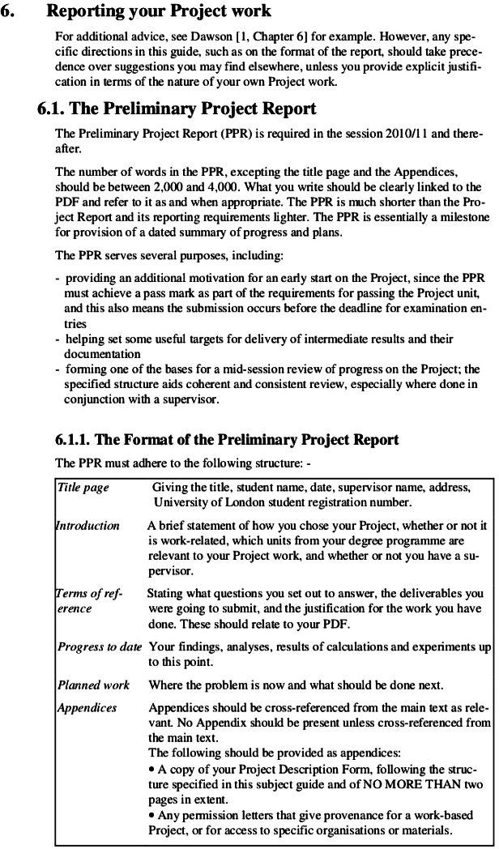

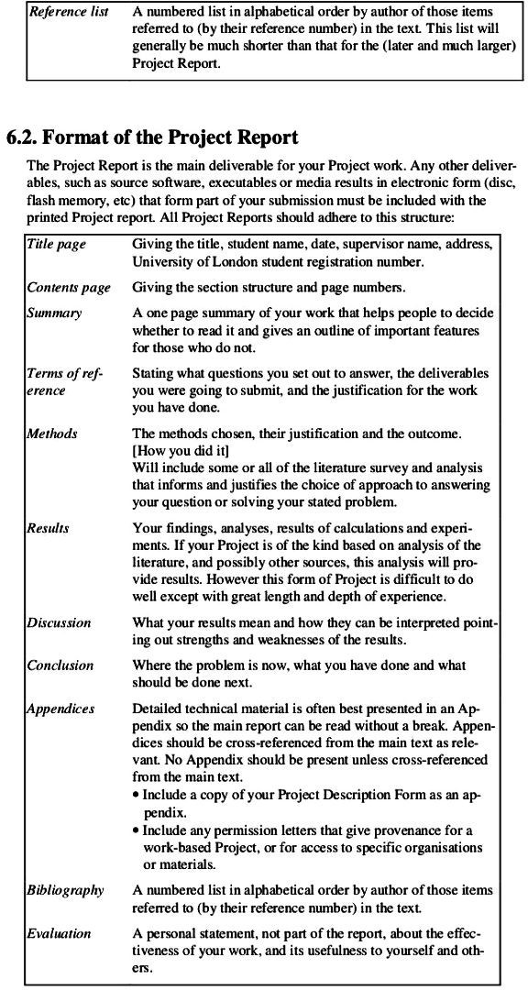

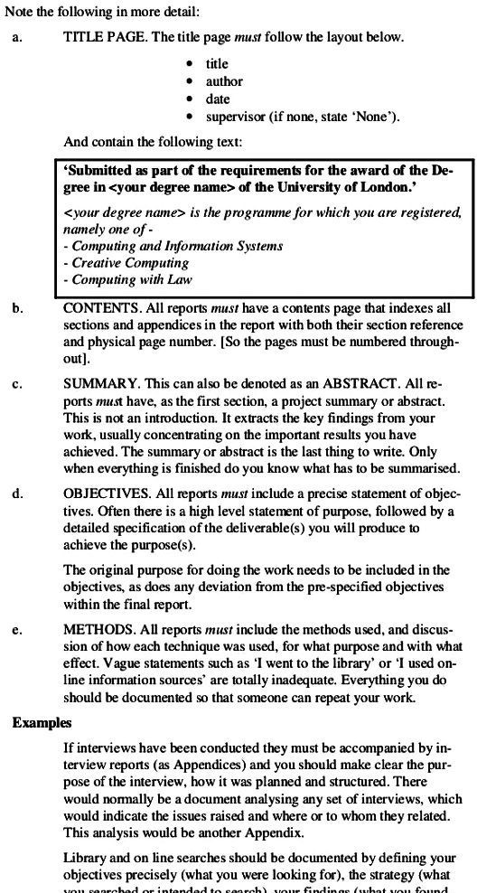

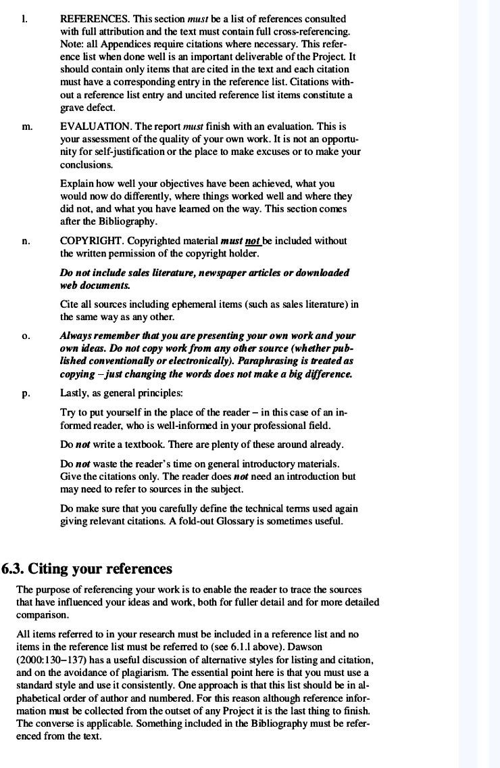

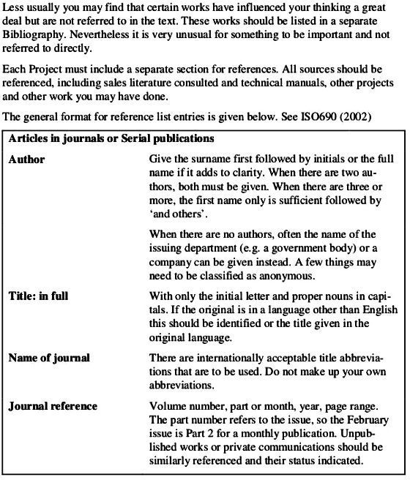

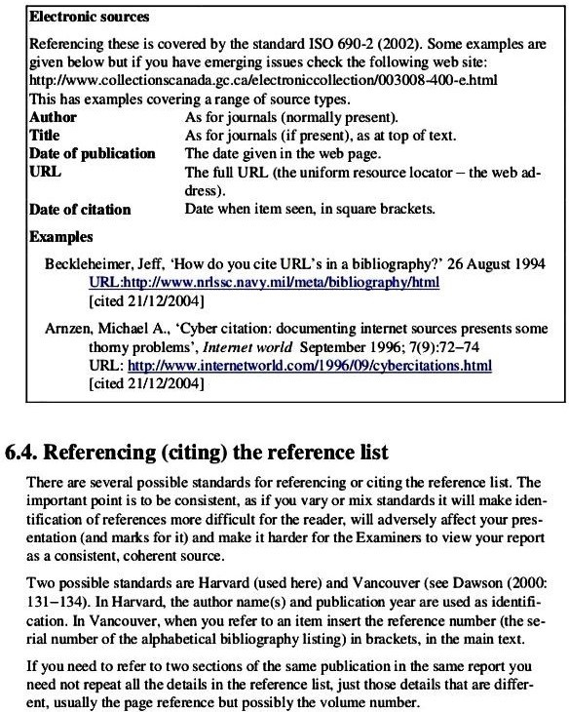

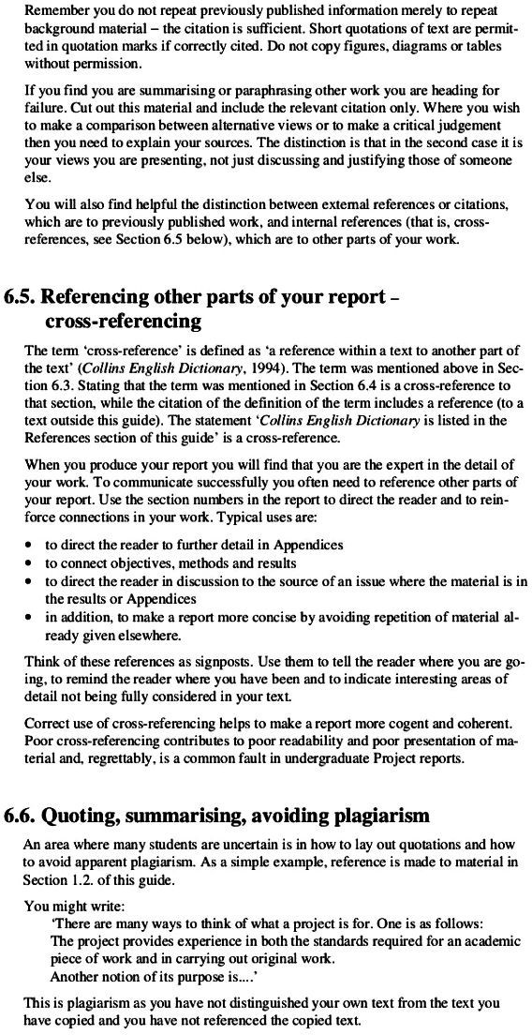

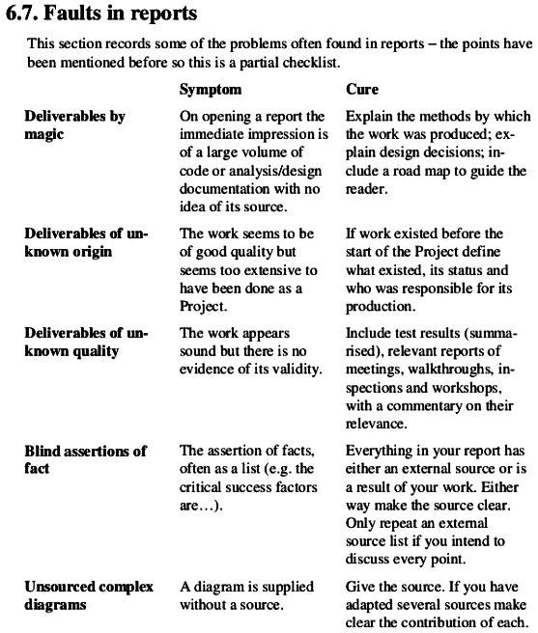

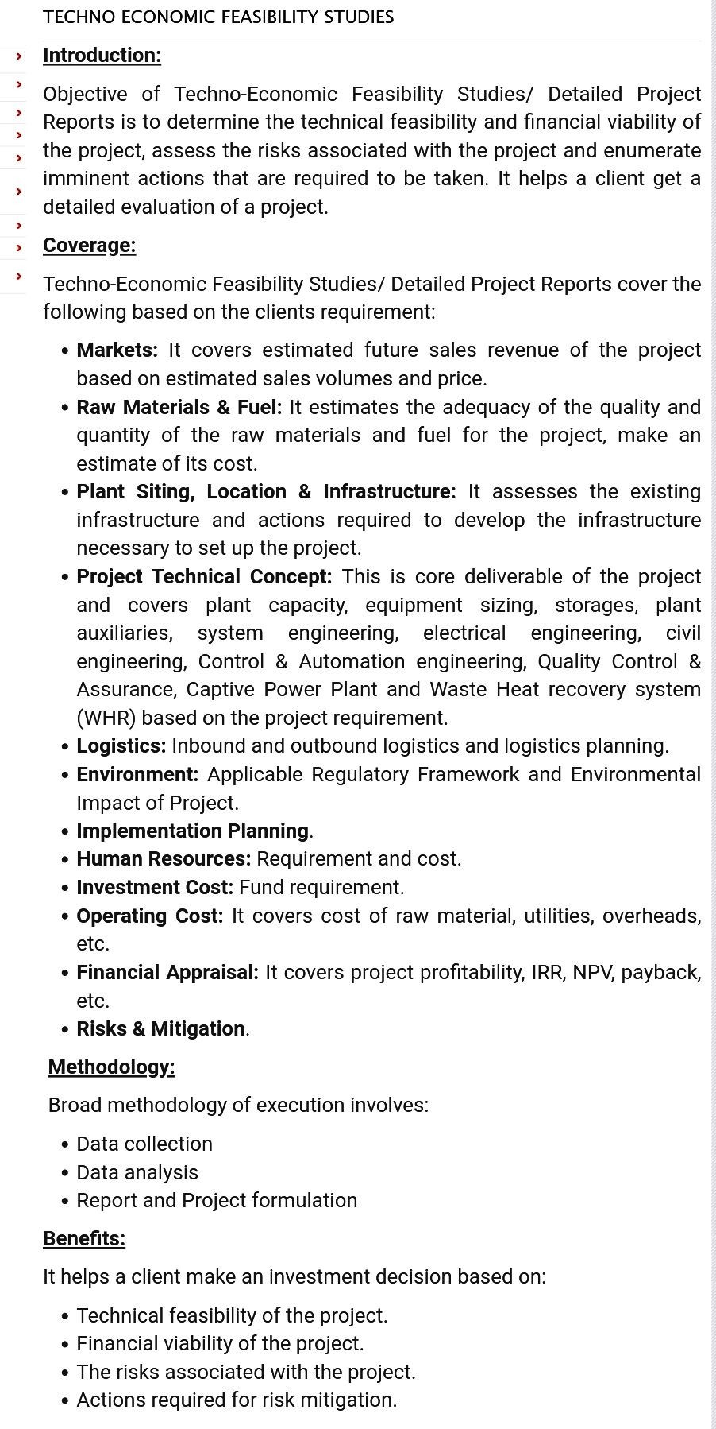

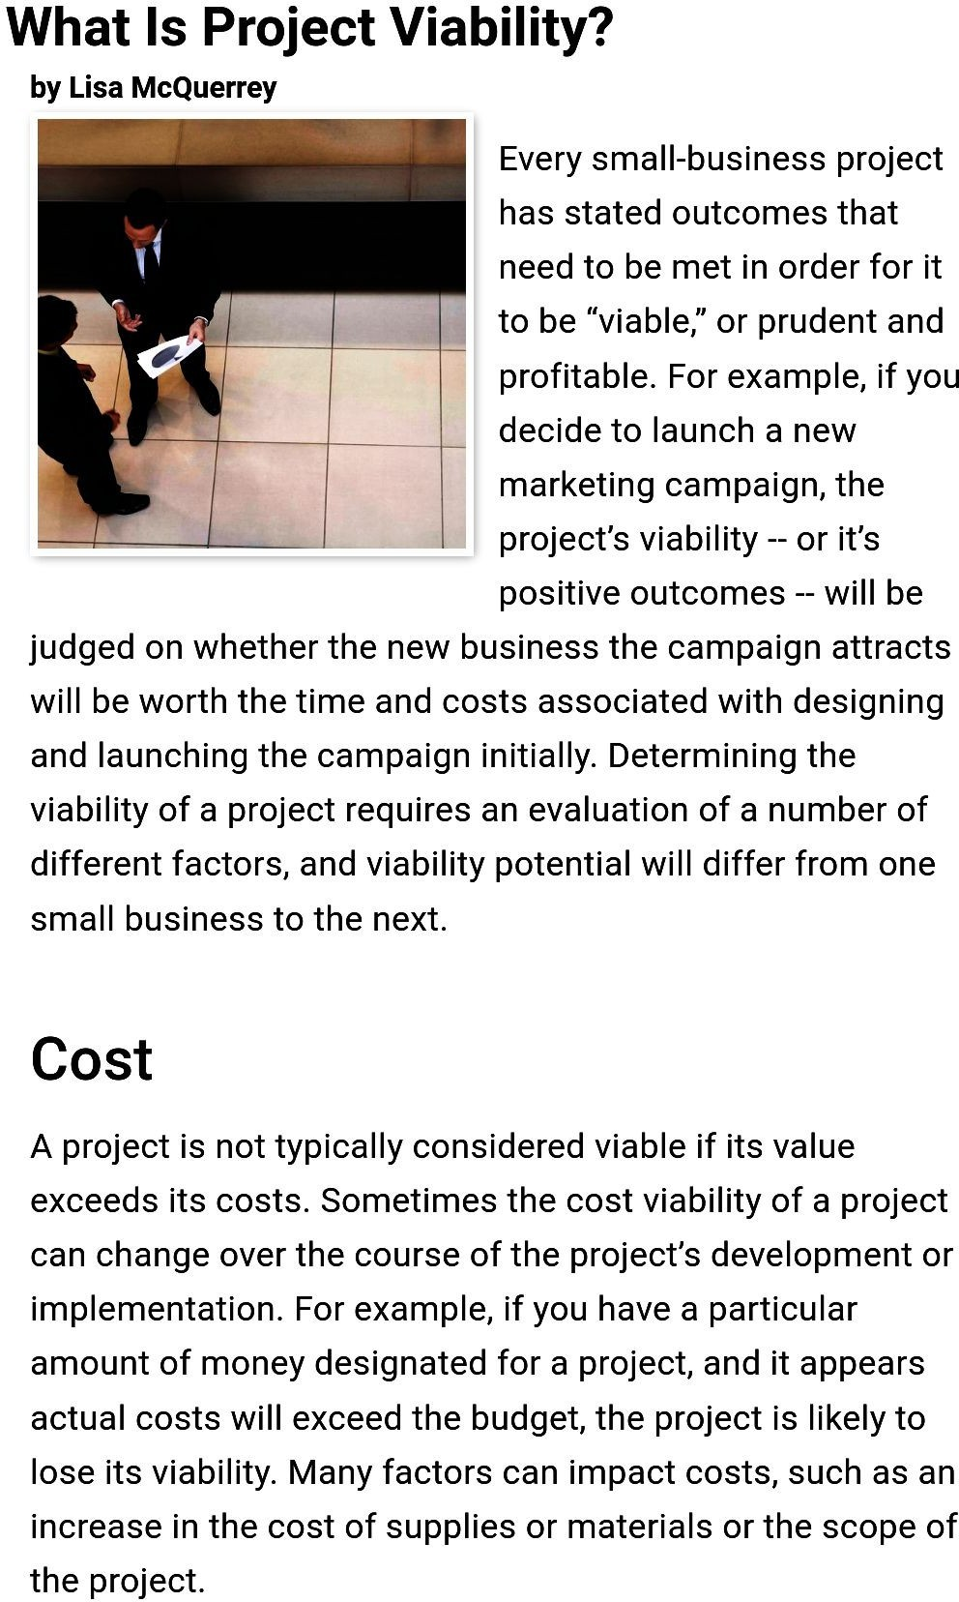

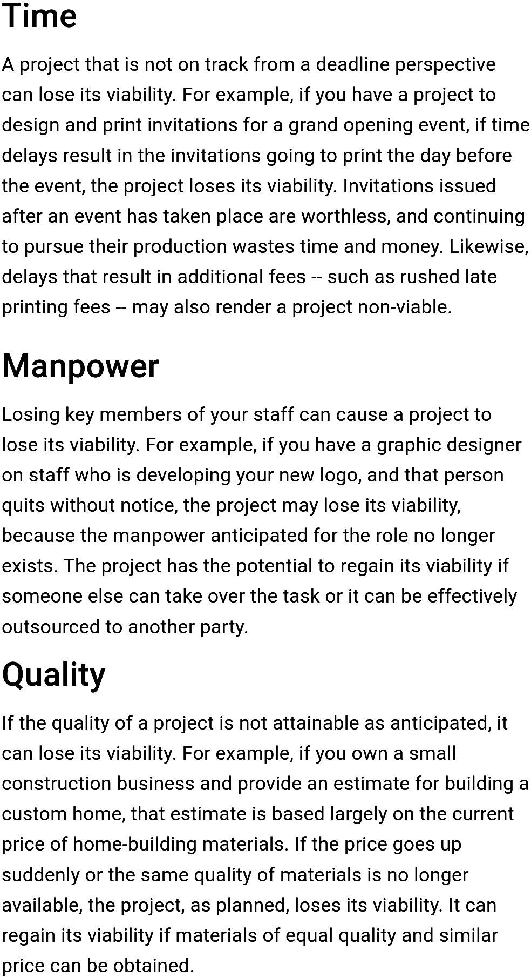

ManagementPrinciples

DefinitionofManagement

- Management is the coordination and administration of tasks to achieve a goal. Such administration activities include setting the organization’s strategy and coordinating the efforts of staff to accomplish these objectives through the application of available resources. Management can also refer to the seniority structure of staff members withinan organization.
- To be an effective manager, you’ll need to develop a set of skill, including planning, communication, organization and leadership. You will also need extensive knowledge of the company’s goals and how to direct employees, sales and other operations to accomplish them.

Principlesof management

HenryFayol, also knownasthe ‘father of modernmanagementtheory’ gave a new perception of the concept of management. He introduced a general theory that can be applied to all levels of management and every department. The Fayol theory is practised by the managers to organize and regulate the internal activities of an organization.
- DivisionofWork-
Henri believed that segregating work in the workforce amongst the worker will enhance the quality of the product. Similarly, he also concluded that the division of work improves the productivity,efficiency,accuracyandspeedoftheworkers.Thisprincipleisappropriateforboth the managerial as well as a technical work level.
- AuthorityandResponsibility-
These are the two key aspects of management. Authority facilitates the management to work efficiently, and responsibility makes them responsible for the work done under their guidance or leadership.

- Discipline-
Without discipline, nothing can be accomplished. It is the core value for any project or any management. Good performance and sensible interrelation make the management job easy and comprehensive. Employees good behaviour also helps them smoothly build and progress in their professional careers.
- UnityofCommand-
Thismeansanemployeeshouldhaveonlyonebossandfollowhiscommand. Ifanemployeehas to follow more than one boss, there begins a conflict of interest and can create confusion.
- UnityofDirection-
Whoever is engaged in the same activity should have a unified goal. This means all the person working in a company should have one goal and motive which will make the work easier and achieve the set goal easily.
- SubordinationofIndividualInterest-
This indicates a company should work unitedly towards the interest of a company rather than personal interest. Be subordinate to the purposes of an organization. This refers to the whole chain of command in a company.
- Remuneration-
This plays an important role in motivating the workers of a company. Remuneration can be monetary or non-monetary. However, it should be according to an individual’s efforts they have made.
- Centralization-
In any company, the management or any authority responsible for the decision-making process should be neutral. However, this depends on the size of an organization. Henri Fayol stressed on the point that there should be a balance between the hierarchy and division of power.
- ScalarChain-

Fayol on this principle highlights that the hierarchy steps should be from the top to the lowest. This is necessary so that every employee knows their immediate senior also they should be able to contact any, if needed.
- Order-
A company should maintain a well-defined work order to have a favourable work culture. The positive atmosphere in the workplace will boost more positive productivity.
- Equity-
Allemployeesshouldbetreatedequallyandrespectfully. It’stheresponsibilityofamanagerthat no employees face discrimination.
- Stability-
An employee delivers the best if they feel secure in their job. It is the duty of the management to offer job security to their employees.
- Initiative-
The management should support and encourage the employees to take initiatives in an organization. It will help them to increase their interest and make then worth.
- EspritdeCorps-
It is the responsibility of the management to motivate their employees and be supportive of each other regularly. Developing trust and mutual understanding will lead to a positive outcome and work environment.

Functions of management (planning, organizing, staffing, directing and controlling etc.
Management has been described as a social process involving responsibility for economical and effective planning& regulation of operation of anenterprise in thefulfillment of given purposes. It is a dynamic process consisting of various elements and activities. These activities aredifferent from operative functions like marketing, finance, purchase etc. Rather these activities are common to each and every manger irrespective of his level or status.

- Planning

  - It is the basic function of management. It deals with chalking out a future course of action & deciding in advance the most appropriate course of actions for achievement of pre-determined goals. According to KOONTZ, “Planning is deciding in advance - what to do, when to do & how to do. It bridges the gap from where we are & where we wantto be”. A plan is a future course of actions. It is an exercise in problem solving & decisionmaking. Planningis determinationof courses ofactiontoachievedesiredgoals.
  - Thus, planningis a systematic thinkingabout ways & means for accomplishment of pre- determined goals. Planning is necessary to ensure proper utilization of human & non- human resources. It is all pervasive, it is an intellectual activity and it also helps in avoiding confusion, uncertainties, risks, wastages etc.
- Organizing

It is the process of bringing together physical, financial and human resources and developing productive relationship amongst them for achievement of organizational goals. AccordingtoHenryFayol, “Toorganizeabusinessis toprovideit with everything useful or its functioning i.e. raw material, tools, capital and personnel’s”. To organize a business involves determining & providing human and non-human resources to the organizational structure. Organizing as a process involves:

  - Identificationofactivities.
  - Classificationofgroupingofactivities.
  - Assignmentofduties.
  - Delegationofauthorityandcreationofresponsibility.
  - Coordinatingauthorityandresponsibilityrelationships.
- Staffing

It is the function of manning the organization structure and keeping it manned. Staffing has assumed greater importance in the recent years due to advancement of technology, increase in size of business, complexity of human behavior etc. The main purpose o staffingis toputright manon rightjob i.e.squarepegsinsquareholesand roundpegs in

round holes. According to Kootz & O’Donell, “Managerial function of staffing involves manning the organization structure through proper and effective selection, appraisal & development of personnel to fill the roles designed un the structure”. Staffing involves:

  - ManpowerPlanning(estimatingmanpowerintermsofsearching,choosethe person and giving the right place).
  - Recruitment,Selection&Placement.
  - Training&Development.
  - Remuneration.
  - PerformanceAppraisal.
  - Promotions&Transfer.
- Directing

It is that part of managerial function which actuates the organizational methods to work efficiently for achievement of organizational purposes. It is considered life-spark of the enterprise which sets it in motion the action of people because planning, organizing and staffing are the mere preparations for doing the work. Direction is that inert-personnel aspect of management which deals directly with influencing, guiding, supervising, motivating sub-ordinate for the achievement of organizational goals. Direction has following elements:

  - Supervision
  - Motivation
  - Leadership
  - Communication

Supervision-implies overseeing the work of subordinates by their superiors. It is the act of watching & directing work & workers.
Motivation-means inspiring, stimulating or encouraging the sub-ordinates with zeal to work. Positive, negative, monetary, non-monetary incentives may be used for this purpose.

Leadership- may bedefined as aprocess by which manager guides andinfluences thework of subordinates in desired direction.
Communications- istheprocessofpassinginformation,experience,opinionetcfrom one person to another. It is a bridge of understanding.
- Controlling

It implies measurement of accomplishment against the standards and correction of deviation if any to ensure achievement of organizational goals. The purpose ofcontrolling is to ensure that everything occurs in conformities with the standards. An efficient system of control helps to predict deviations before they actually occur. According to Theo Haimann, “Controlling is the process of checking whether or not properprogressisbeingmadetowardstheobjectivesandgoalsandactingif necessary, to correct any deviation”. According to Koontz & O’Donell “Controlling is themeasurement & correction of performance activities of subordinates in order to makesure that the enterprise objectives and plans desired to obtain them as being accomplished”. Therefore controlling has following steps:

- Establishmentofstandardperformance.
- Measurementofactualperformance.
- Comparison of actual performance with the standards and finding out deviation if any.
- Correctiveaction.

LevelsofManagement

LevelsofManagementarebroadlyclassifiedintothree:

- ManagerialortheTopLevelManagement:

Thislevelconsists oftheboardofdirectorsandmanagingdirector. Itisthesupreme source of power since it manages the policies and procedures of an entity. Their main responsibility lies in planning and coordinating. The roles and responsibilities of this ‘creamy’ level can be summed up as follows:

  - Itisatthislevelthatalltheobjectivesandmajorpoliciesarelaiddown.

  - Instructionsaregivenforpreparingthenecessarybudgetsforvariousdepartments,schedules and policies.
  - Preparationofpremeditatedplansandpoliciesaredoneatthislevel.

  - Appointmentofexecutivesatcentrallevelordepartmentalheads.

  - Since it consists of Board of Director the top administration is accountable towards theshareholders for performance of the organization.
  - Harmonizationandcontrolarethetwomajorrolesplayedbythetopmanagement.

  - Itguidestheorganizationintherightdirectiontowardsachievingthegoalsand objectives.
- ExecutiveorMiddleLevelManagement:

The line and departmental managers form this level of management. These peopleare directly accountable to the top management for functioning of their respective departments. Their main role comes under the directional and managerial functionsof an organization. The roles of managers at this level are as follows:

  - The main role lies in the implementation of policies and plans as per the directives of the top management.
  - Preparingplansforthesubunitsoftheirrespectivedepartments.

  - Activelycontributeinguidanceandemploymentofsupervisorylevelofmanagement.

  - Their duty is to understand and elucidate the policies of the top management to the lower management.

  - Bringingtogethertheactivitieswithinthedepartmentisanotherroleatthislevelof management.
  - Assessmentofperformanceofjuniormanagers.

  - Timelyandimportantreportsordatatobesenttothetopmanagement.

  - Motivationofsupervisorymanagersisavitalroleofthislevelofmanagement.

- SupervisoryorOperativeLevelManagement:

This level constitutes mostly of supervisors, foremen and first line managers. The mainrole of these people are:

- Handingoverjobsorresponsibilitiestoavarietyofworkers.

- Guidancetowardsdaytodayactivitiesoftheorganization.

- Thesemanagersaredirectlyresponsibleforqualityandamountofproduction.

- They act as mediators in communicating the problems of workersand also undertake recommending solutions to higher level of organization.
- Theytakestockofthemachinesandmaterialrequiredfortheworktobedone.

.(f). They are the role models for the workers as they are directly and constantly in touch them.
a.Itistheirdutytoupholddisciplineanddecorumintheorganization

FunctionalAreasofManagement

ProductionManagement:
Theproductionmanagementisneededbythemanufacturingorganizations.These organizations change the form of the raw material and make it more useful.

- Therearesomefunctionalareaofmanagementincludesthefollowingactivities:

  - Toanticipatetheproductionactivities,
  - Todeterminethekindandquantityofthegoodstobeproduced,
  - Tomakeprovisionfortherawmaterialwellintime,
  - Toplanandcontrolproduction,
  - To determine the need of the employees of the production department andarrange for the recruitment and selection process,
  - Toconductthetimeandmotionstudy,
  - Todeterminethemethodofproduction,
  - Tocontrolthequalityofthegoodsproduced,etc.

WhatIsProductivity?

- The productivity of a production process can be defined as the efficiency with which goods and services are produced. Productivity is typically measured by comparing an aggregate output with a single input or comparing an aggregate input with an aggregate output, over time.
- Productivity is a measure of how efficiently a person completes a task. We can define it as the rate at which a company or country produces goods and services (output), usually judged based on the amounts of inputs (labor, capital, energy, or other resources) used to deliver those goods and services.

Quality Control
- Quality control (QC) is a process through which a business seeks to ensure that product quality is maintained or improved. Quality control requires the company to create an environment where management and employees strive for perfection. Thisis done by training personnel, creating benchmarksfor product quality, and testing products to check for statistically significantvariations.
- A significant aspect of quality control is the establishment of well-defined controls. These controls help standardize both production and reactions to quality issues. Limitingroomforerrorbyspecifyingwhichproductionactivitiesaretobe

completed by which personnel reduces the chance that employees will be involved in tasks for which they do not have adequate training.

WhyIsQCNeeded?
- Creating a product is costly, time-consuming, and can be unsafe without controls inplace. Additionally, if a company sends defective products out for purchase, it could be held liable for injuries or issues that arise from using its products. Quality control inspectors ensure that defective or unsafe products are identified, and the causes are corrected.

HowIsItDone?
- Quality testing is generally completed in each step of a manufacturing or business process. Employees often begin by testing raw materials, pulling samples from the manufacturing line, and testing the finished product. Testing at the various stages of manufacturing helps identify where a production problem is occurring and the remedial steps it requires to prevent it in the future.
- In a non-manufacturing business, quality testing can involve customer service evaluations, questionnaires, surveys, inspections, or audits. A business can use any process or method to verify that its end product or service meets the customer's needsand is safe and legal.

QCIsDifferent byIndustry
- Thequality control usedinabusinessis highly dependenton theproduct or industry. For example, in food and drug manufacturing, quality control includes ensuring the product does not make a consumer sick, so the company performs chemical and microbiological testing of samples from the production line.
- In automobile manufacturing, quality control focuses on parts meeting specifications and tolerances. QC ensures engines, drive trains, and other mechanical parts operate smoothly, efficiently, safely, and as designed.
- In electronics, quality testing might involve using meters that measure the flow of electricity and stress testing.

Productionplanning andcontrol

- Production planning and control address a fundamental problem of low productivity, inventory management and resource utilization.
- Productionplanningisrequiredforscheduling,dispatch,inspection,qualitymanagement, inventory management, supply management and equipment management. Production control ensures that production team can achieve required production target, optimum utilization of resources, quality management and cost savings.

Thebenefitsofproductionplanningandcontrolareasfollows:

- Itensuresthatoptimumutilizationofproductioncapacityisachieved,byproper scheduling of the machine items which reduces the idle time as well as over use.
- It ensures that inventory levels are maintained at optimum levels at all time, i.e. there is no over-stocking or under-stocking.
- It also ensures that production time is kept at optimum level and thereby increasing the turnover time.
- Sinceitoverlooksallaspectsofproduction,qualityoffinalproductisalways maintained.

ProductionPlanning
- Production planning is one part of production planning and control dealing with basic concepts of what to produce, when to produce, how much to produce, etc. It involves taking a long-term view at overall production planning. Therefore, objectives of production planning are as follows:

- To ensure right quantity and quality of raw material, equipment, etc. are availableduring times of production.
- Toensurecapacityutilizationisintunewithforecastdemandatallthetime.

Awellthoughtproductionplanningensuresthatoverallproductionprocessisstreamlinedproviding following benefits:
  - Organizationcandeliveraproductinatimelyandregularmanner.

  - Suppliersareinformedwillinadvancefortherequirementofrawmaterials.
  - Itreducesinvestmentininventory.
  - Itreducesoverallproductioncostbydrivinginefficiency.

- Production planning takes care of two basic strategies’ product planning and process planning.Productionplanningisdoneatthreedifferenttimedependentlevelsi.e.long-range planning dealing with facility planning, capital investment, location planning, etc.; medium- range planning deals with demand forecast and capacity planning and lastly short term planning dealing with day to day operations.

ProductionControl
Production control looks to utilize different type of control techniques to achieve optimum performance out of the production system as to achieve overall production planning targets. Therefore, objectives of production control are as follows:

- Regulateinventorymanagement
- Organizetheproductionschedules
- Optimumutilizationofresourcesandproductionprocess The advantages of robust production control are as follows:
- Ensureasmoothflowofallproductionprocesses
- Ensureproductioncostsavingstherebyimprovingthebottomline
- Controlwastageofresources
- Itmaintainsstandardofqualitythroughtheproductionlifecycle.

Production control cannot be same across all the organization. Production control is dependent upon the following factors:
- Natureofproduction(joboriented,serviceoriented,etc.)

- Natureofoperation
- Sizeofoperation

Productionplanningandcontrolareessentialforcustomerdelightandoverallsuccessofan organization

Inventorymanagement

Inventory management refers to the process of overseeing and controlling a company's stock of raw materials, work-in-progress items, and finished products. It involves the planning, procurement, storage, tracking, and distribution of inventory to meet customer demand while minimizing costs and ensuring optimal operational efficiency. Effective inventory managementis essential for businesses of all sizes and industries to balance the need for product availability with the desire to minimize holding and carrying costs.

Keycomponentsofinventorymanagementinclude:

- Demand Forecasting: Accurately predicting customer demand for products is crucial for maintaining the right inventory levels. This often involves the use of historical sales data and market analysis.
- Reorder Point: Determining when to reorder items to replenish stock and prevent stockouts. This is often based on factors like lead times, safety stock, and the rate of demand.
- Safety Stock: Maintaining a buffer stock to account for uncertainties in demand, lead times, and other factors. Safety stock helps prevent stockouts during unexpected fluctuations in demand or delays from suppliers.
- Order Quantity: Deciding how much to order when restocking inventory. This involves trade- offs between order size, carrying costs, and reordering frequency.
- Inventory Valuation: Assigning a value to the inventory on hand, which is crucial for financial reporting, tax calculations, and assessing the overall health of the business.
- Inventory Classification: Categorizing inventory items based on factors like demand, value,and turnover rate. This can help prioritize management efforts and strategies for different items.
- Supplier Management: Building and maintaining strong relationships with suppliers to ensure timely deliveries, quality products, and favorable terms.

- Inventory Tracking: Using inventory management systems and technology to keep real-time records of inventory levels, sales, and other relevant data.
- Inventory Turnover: Measuring how quickly inventoryis sold or used within a specific period. A high turnover rate indicates efficient inventory management.
- WasteReduction:Minimizingwasteandlossesassociatedwithobsoleteorexpiredinventory.

WhydoweneedInventorymanagement?

Inventory management is crucial for businesses for several reasons, as it plays a central role in balancingthetrade-offsbetweenmeetingcustomerdemandandminimizingcosts. Herearesome key reasons why inventory management is essential:

- CustomerSatisfaction: Maintainingoptimalinventorylevelsensuresthatproductsareavailable whencustomersneedthem. Thisreducesthe likelihoodof stockoutsandhelpsimprove customer satisfaction and loyalty.
- CostControl:Effectiveinventorymanagementhelpsminimizecostsassociatedwithstoringand holdinginventory, includingwarehousing, insurance,anddepreciation. Italsoreducesthe riskof overstocking, which can result in carrying costs and potential losses.
- Cash Flow Optimization: By reducing the amount of capital tied up in excess inventory, businesses can free up working capital for other investments or to pay down debt. This leads to better cash flow management.
- Efficient Operations: Proper inventory management streamlines processes and ensures that items are readily available for order fulfillment. This results in faster order processing, reduced lead times, and more efficient workflows.
- Supplier Relations: Maintaining optimal inventory levels helps in negotiating better terms with suppliers. Suppliersaremore likelytoofferdiscountsandfavorable conditionstobusinessesthat consistently order in a predictable and manageable manner.

- Inventory management systems provide valuable data on sales trends, demand patterns, and supplier performance. This data can inform strategic decisions, allowing businesses to adapt to market changes effectively.
Data-DrivenDecisionMaking:
- ReductionofRisk:Effective inventorymanagementhelpsminimizetheriskofholdingobsolete or expired goods, which can lead to financial losses. It also ensures that essential items are available in case of unexpected demand spikes or supply chain disruptions.
- Resource Optimization: Businesses can optimize their use of storage space and labor resources by maintaining efficient inventory levels, reducing the need for additional storage facilities and personnel.
- Competitive Advantage: Businesses with well-managed inventories can respond more effectively to market changes, customer demands, and supply chain disruptions, giving them a competitive edge in their industries.
- Sustainability: Inventory management practices can contribute to sustainability efforts by reducing waste through better control over production and stocking levels.
- Regulatory Compliance: In industrieswith specific qualitycontrol or traceability requirements, inventory management is essential to ensure compliance with regulations.
- Strategic Planning: Inventory management aligns with a company's strategic goals and objectives. It helps ensure that resources are allocated efficiently and in line with the company's overall strategy.

BenefitsofInventoryManagement

Inventorymanagementis a criticalaspect of business operations, and it offers various benefits to organizations of all sizes and across different industries. Effective inventory management can help a company streamline its processes, reduce costs, improve customer satisfaction, and increase overall profitability. Here are some key benefits of inventory management:

- CostControl:

  - Reduced carrying costs: Efficient inventory management helps minimize the costs associated with storing and holding excess inventory, such as warehousing, insurance, and depreciation.
  - Lower holding costs: By reducing the amount of inventory on hand, a company can minimize the expenses related to storing and securing goods.
- ImprovedCashFlow:

  - Reduced working capital requirements: By maintaining optimal inventory levels, businesses can free up capital that would otherwise be tied up in excess stock, allowing them to invest in other areas of the business or reduce debt.
- MinimizedStockoutsandOverstock:
  - Enhanced customer satisfaction: Proper inventory management ensures that products are available when customers need them, reducing stockouts. This leads to improved customer satisfaction and loyalty.
  - Lower holding costs: Preventing overstock helps avoid costs associated with storing and managing excess inventory.
- EfficientOrderFulfillment:
  - Faster order processing: Having accurate inventory data and organized storage systems enables quicker order picking and shipping, which leads to faster order fulfillment and improved customer service.
- BetterSupplierNegotiation:
  - Stronger bargaining position: Maintaining effective inventory management can provide businesses with better negotiating leverage when dealing with suppliers, potentially leading to discounts and more favorable terms.
- Data-DrivenDecisionMaking:

  - Informed decisions: Inventory management systems provide data and insights on sales trends, product demand, and supplier performance. This data can inform better decision- making and strategy development.

- ReducedRiskofObsolescence:
  - Minimized obsolescence: Timely monitoring of inventory levels and product lifecycles can help reduce the risk of holding obsolete or expired goods, which can result in financial losses.
- IncreasedProductivity:

  - Streamlined processes: Efficient inventory management can lead to more streamlined workflowsandreducedtimespentonmanualtasks,allowingemployeestofocusonmore value-added activities.
- BetterSpaceUtilization:

  - Optimal storage: Proper inventory management helps maximize the utilization of storage space, reducing the need for additional storage facilities and associated costs.
- RegulatoryCompliance:

  - Compliance with regulations: Effective inventory management can help ensure compliancewithindustry-specificregulations,particularlyinindustrieswithstrictquality control or traceability requirements.
- SustainablePractices:

  - Reduced waste: By avoiding overproduction and minimizing waste through better inventory control, businesses can contribute to sustainability efforts and reduce their environmental impact.

FinancialManagement

Financial management is the process of planning, organizing, controlling, and monitoring an organization'sfinancialresourcestoachieveitsgoalsandobjectiveseffectively. Itplaysacrucial role in ensuring the financial health and sustainability of a business or organization. Here are the key aspects and components of financial management:

- FinancialPlanning:

- Budgeting:Creatingadetailedfinancialplan,includingrevenueandexpenseprojections,to guide the organization's financial activities.
- Forecasting: Estimating future financial performance and needs, often based on historical data and market trends.
- Cash Flow Management: Managing the inflow and outflow of cash to ensure the organization can meet its financial obligations.

- CapitalInvestmentDecisions:

- Evaluatinganddecidingonlong-terminvestments,suchaspurchasingassetsorexpanding operations.
- Assessingthereturnoninvestment(ROI)andriskassociatedwiththeseinvestments.

- FinancingDecisions:

- Determiningthemixofdebtandequityfinancingfortheorganization.
- Evaluatingvarioussourcesofcapital,suchasloans,equityinvestments,andbonds.
- Managingtheorganization'scapitalstructuretooptimizefinancialleverage.

- RiskManagement:

- Identifying,assessing,andmitigatingfinancialrisks,suchasmarketrisk,creditrisk,and operational risk.
- Implementingstrategiestoprotecttheorganizationfromunexpectedfinanciallosses.

- FinancialAnalysis:

- Analyzingfinancialstatements,includingthebalancesheet,incomestatement,andcashflow statement, to assess the organization's financial health and performance.
- Usingfinancialratiosandmetricstogaugeprofitability,liquidity,solvency,andefficiency.

- WorkingCapitalManagement:

- Managing short-term assets and liabilities to ensure the organization's day-to-day operations run smoothly.
- Optimizingthelevelsofcash,accountsreceivable,andinventory.

- FinancialReportingandCompliance:

- Preparing and presenting financial reports to stakeholders, such as shareholders, investors, andregulatory authorities.
- Ensuringcompliancewithaccountingstandardsandlegalrequirements.

- TaxPlanning:

- Developingstrategiestominimizetheorganization'staxliabilitieswhileadheringtotaxlawsand regulations.

- DividendPolicy:

- Decidingonthedistributionofprofitstoshareholdersintheformofdividends.
- Balancingthedesiretorewardshareholderswiththeneedtoreinvestintheorganization.

- FinancialControl:

- Monitoringfinancialperformanceagainstestablishedgoalsandbudgets.
- Implementinginternalcontrolstopreventfraudandmismanagementoffunds.

- FinancialDecision-Making:

- Making informed decisions about investments, financing, and day-to-day financial operations to achieve the organization's objectives.

- FinancialSoftwareandTools:

- Utilizing financial software and tools, such as accounting software, financial modeling software, and financial analysis tools, to streamline financial management processes.

ManagementofWorkingcapital

Working capital management is a crucial aspect of financial management that focuses on effectively managing a company's short-term assets and liabilities to ensure it has the necessary liquidity to meet its operational needs. Proper working capital management is essential for sustaining day-to-day operations and supporting business growth. Here are key strategies and principles for the management of working capital:

- MaintainanAdequateCashReserve:
  - Ensure the company has sufficient cash on hand to cover its immediate needs, such as paying suppliers and meeting payroll. This may involve maintaining a cash reserve or establishing a line of credit for emergencies.
- AccountsReceivableManagement:
  - Efficiently manage accounts receivable by monitoring customer credit policies and payment terms. Accelerate the collection of receivables to improve cash flow, possibly through incentives or more stringent credit policies for slow-paying customers.
- InventoryManagement:
  - Keep a close eye on inventory levels to avoid overstocking or understocking. Implement just-in-time (JIT) inventory systems, reorder points, and economic order quantity (EOQ) models to optimize inventory management.
- AccountsPayableManagement:
  - Extend payment terms with suppliers when possible, without damaging relationships. Negotiate favorable terms and discounts for early payment to improve cash flow.
- Short-TermFinancing:
  - Use short-term financing options, such as lines of credit or working capital loans, tocover temporaryshortfalls or take advantage of growth opportunities. Ensure that interest costs are manageable and justified.

- MonitorandForecastCashFlow:
  - Regularlyreviewandupdatecashflowforecaststoanticipateperiodsofsurplusor deficit. This helps in proactive decision-making and planning.
- TightenCreditPolicies:
  - Implementstrictcreditpoliciesandcreditworthinesschecksfornewcustomers.Set appropriate credit limits and terms to minimize the risk of bad debts.
- ReduceOperatingExpenses:
  - Identify and eliminate unnecessary costs and inefficiencies in your operations to free up cash for working capital needs.
- SellNon-CoreAssets:
  - Considersellingassetsthatare notcriticalto thecorebusiness toreleasecash. Thiscould include selling surplus equipment or real estate.
- StrategicSourcingandSupplierNegotiation:
  - Workcloselywithsupplierstonegotiatefavorableterms,discounts,andpayment schedules. Explore cost-effective sourcing options to reduce the cost of goods sold.
- ReinvestmentofSurplusCash:
  - Ifthere'sasurplusofcash,investitwiselyinshort-termoreasilyliquidatedfinancial instruments to earn a return while maintaining liquidity.
- ContinuousImprovement:
  - Continuouslyevaluateandimproveworkingcapitalmanagementpracticesbasedon changing business conditions and performance metrics.
- TechnologyandAutomation:
  - Implementfinancialmanagementsoftwareandautomationtoolstotrackandmanage working capital more efficiently.
- ComprehensiveReportingandMonitoring:
  - Usekeyperformanceindicators(KPIs)andregularfinancialreportingtomonitorand assess the effectiveness of working capital management strategies.

Costing

Costing is a process used in accounting and financial management to determine and allocate theexpensesassociatedwithproducinggoodsorprovidingservices.Itisafundamentalaspectof

business operationsanddecision-making. Costinghelps organizations determine the cost of theirproducts or services, assess profitability, set prices, and make informed choices about resourceallocation.

Break-EvenAnalysis:ABriefOverview

Break-even analysis isafinancialtool usedtodeterminethelevel of salesorproductionatwhich a company's total revenue equals its total costs, resulting in neither profit nor loss. In otherwords, it identifies the point at which a business breaks even and starts generating profit. This concept is particularly useful for business owners and managers to make informed decisions about pricing, production, and profitability.
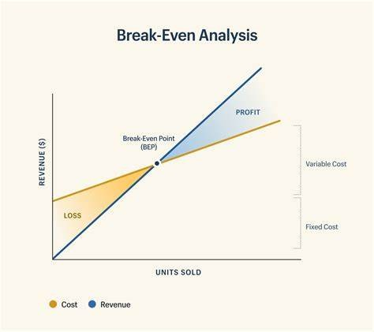

ComponentsofBreak-EvenAnalysis:

- Fixed Costs(FC): These are costs that remainconstant irrespective of the level of production or sales. Examples include rent, insurance, salaries, and depreciation.
- VariableCosts(VC):Variablecostsfluctuatewithchangesinproductionorsales.Common examples include raw materials, direct labor, and sales commissions.

- Total Costs (TC): The sum of fixed costs and variable costs for a given level of production orsales: TC = FC + VC.
- Total Revenue (TR): Total revenue is the income generated from sales and is a function of the selling price and quantity sold: TR = Price x Quantity.

TheBreak-EvenPoint(BEP):

The break-even point is the level of sales at which total revenue equals total costs. At this point, there is no profit or loss, and the business is said to be "breaking even."

Break-EvenPointFormula:

BEP(inunits)=FixedCosts/(SellingPriceperUnit-VariableCostperUnit)

Break-EvenAnalysisDiagram:

  - Thehorizontalaxisrepresentsthequantityofgoodsorservicessold.
  - Theverticalaxisrepresentsrevenueandcostsincurrencyunits.
  - Thefixedcostsarerepresentedbyahorizontalline,indicatingthattheydonotchangewith production or sales levels.
  - Thevariablecostsincreaselinearlywiththelevelofproductionorsales.
  - Thetotalcostcurveisthesumoffixedandvariablecosts.
  - Thetotalrevenuecurve isusuallyastraightline,startingfromtheorigin.
  - The break-even point is the intersection of the total cost curve and the total revenue curve. It isthe point where total revenue equals total cost.

KeyInsightsfromBreak-EvenAnalysis:

- Profitability:Ifsalesarebelowthebreak-evenpoint,thebusinessincurslosses.Profitsare generated when sales exceed the break-even point.
- PricingStrategies:Break-evenanalysishelpsindeterminingtheminimumpriceatwhicha product should be sold to avoid losses.

- Production Planning: Businesses can plan theirproduction levels to align with their break-even point, helping to avoid overproduction or underproduction.
- Risk Assessment: By knowing the break-even point, businesses can assess their risk toleranceand make informed decisions about expansion, cost control, and pricing strategies.

Break-even analysis is a valuable tool for financial planning and decision-making, assisting businesses in setting realistic financial goals, understanding cost structures, and optimizing profitability. It provides a clear picture of when a company will start making a profit and can guide strategic choices in the business world.

Bookkeeping: Bookkeeping is the systematic process of recording and organizing an organization's financial transactions. It involves recording financial data in a structured manner, trackingincome,expenses,assets,andliabilities,andensuringfinancialrecords are accurate and up-to-date. Bookkeepers use double-entry accounting principles to maintain a complete and balanced record of financial activities.

Journal Entry: A journal entry is a fundamental record-keeping technique used in double- entryaccounting. It documents individual financial transactions, suchas the purchaseof supplies or the receipt of income. Each journal entry consists of at least two parts: a debit and a credit. Debits and credits must balance, ensuring that the accounting equation (Assets = Liabilities + Equity) remains in equilibrium. Journal entries are later posted to the general ledger.

Petty Cash Book: A petty cash book is a subsidiary ledger used to track small, routine expenditures that are not suitable for individual journal entries. It simplifies the accounting process for minor expenses like office supplies or coffee. The petty cash book typically has a fixed amount of cash on hand, and when it's depleted, it's replenished with an equal amount, recording the expenses in the main accounting system.

Profit and Loss (P&L) Accounts: The Profit and Loss (P&L) account, also known as the income statement, reports a company's revenues and expenses over a specific period, typically a fiscal quarter or year. It summarizes the organization's profitability during that time frame. Revenues are shown on the credit side, and expenses are shown on the debit side. The difference between total revenues and total expenses represents the net profit or loss for the period.

Balance Sheets: A balance sheet is a financial statement that provides an organization's financial position at a specific point in time. It outlines the company's assets, liabilities, and equity. The balance sheetadheres to the fundamentalaccountingequation: Assets = Liabilities + Equity. It categorizes assets into current (e.g., cash, accounts receivable) and non-current (e.g., property, plant, equipment), and liabilities into current (e.g., accounts payable) and non-current (e.g., long-term loans). The difference betweenassets and liabilities is the owner's equity.

MarketingManagement:

Marketing management refers to the process of planning, implementing, and controlling an organization's marketing activities. It involves the strategic planning and execution of marketing efforts to meet the organization's goals, which may include increasing sales, building brand awareness, and satisfying customer needs. Marketing management encompasses a range of activities, from market research and product development to advertising and sales promotion.

ConceptofMarketingandMarketingManagement:

- Marketing: Marketing is the process of identifying, creating, communicating, delivering, and exchanging value with customers to achieve organizational goals. It involves understanding customer needs, developing products or services to meet those needs, and effectively promoting and distributing them.
- Marketing Management: Marketing management is the art and science of choosing target markets,understandingcustomerneeds,andcreatingvaluethroughproductdevelopment,

pricing, promotion, and distribution. It encompasses strategic decision-making to achieve marketing objectives and maximize customer satisfaction.

MarketingTechniques(Concepts):

- Segmentation and Targeting: Dividing the market into distinct segments and selecting specific target segments to focus marketing efforts on.
- MarketResearch:Gathering,analyzing,andinterpretingdataaboutconsumerbehavior, preferences, and market trends to make informed decisions.
- ProductDifferentiation:Creatinguniquefeaturesorbenefitsforproductsorservicesto distinguish them from competitors.
- BrandManagement:Developingandmaintainingastrongbrandidentitytocreatebrandloyalty and recognition.
- AdvertisingandPromotion:Usingvariouschannelsandstrategiestocommunicatewithcustomers and promote products or services.
- Public Relations: Managing relationships with the public and media to build a positive imageand reputation for the organization.
- ContentMarketing:Creatingandsharingvaluablecontenttoattractandengagetarget audiences.
- Digital Marketing: Utilizing online platforms and technologies for marketing, including social media, email marketing, SEO, and pay-per-click advertising.
- SocialMediaMarketing: Leveragingsocialmedia platformstoreachandengage with potential customers.
- Influencer Marketing: Collaborating with influencers or industry experts to promote products or services.

Conceptof4Ps(Price,Place,Product,Promotion):

The 4Ps, also known as the Marketing Mix, are the core elements that make up a marketing strategy. They are essential for achieving marketing objectives and satisfying customer needs. Here's a brief overview of each of the 4Ps:

- Product: This refers to the actual goods or services a company offers. It includes decisions related to product features, design, quality, branding, and packaging.
- Price: Price is the amount customers are willing to pay for a product or service. Pricingstrategies can vary, including premium pricing, discount pricing, or value-based pricing.
- Place: Place, also known as distribution, involves making the product or service available to the target market. It includes decisions about where and how the product is sold, such as through retail stores, e-commerce platforms, or direct sales.
- Promotion: Promotion includes all the activities a company uses to make the product or service known to its target market. This may include advertising, sales promotions, public relations, and digital marketing.

These 4Ps work together to create a comprehensive marketing strategy that aims to meet customer needs, generate demand, and drive business success. The effective management of the 4Ps is crucial for achieving marketing objectives and delivering value to customers.

HumanResourceManagement(HRM):

Human Resource Management is the strategic and comprehensive management of people within an organization to achieve organizational goals and objectives. HRM involves recruiting, training, managing, and developing employees, as well as ensuring their well-being and compliance with labor laws and regulations.

FunctionsofPersonnelManagement:

- Recruitment and Selection: Identifying job openings, attracting candidates,and selecting themost qualified individuals for positions.
- Training and Development: Providing employees with the necessary skills and knowledge toperform their roles effectively, and developing their potential for future roles.
- CompensationandBenefits:Developingandmanagingfairandcompetitivecompensation packages, including salaries, bonuses, and benefits like health insurance and retirement plans.
- Performance Management: Setting performance standards, evaluating employee performance, providing feedback, and addressing performance issues.

- EmployeeRelations:Managingrelationshipsbetweenemployeesandtheorganization,addressing conflicts, and maintaining a positive work environment.
- LaborandEmploymentLawCompliance:Ensuringadherencetoemploymentlawsandregulations, including workplace safety, labor relations, and equal employment opportunities.
- HealthandSafety: Promotingasafeandhealthyworkenvironment, includinginjuryprevention and wellness programs.
- Workforce Planning and Analysis: Assessing current and future staffing needs, and aligningthe workforce with organizational goals.
- Employee Engagement: Creating initiatives to enhance employee motivation, satisfaction, and commitment.

ManpowerPlanning:

Manpower planning, also known as workforce planning, involves analyzing and forecasting an organization's staffing needs. It ensures that the right number of employees with the required skills is available when needed. The process includes:

  - DemandForecasting:Estimatingthenumberandtypesofemployeesneededinthefuturebased on business goals and objectives.
  - SupplyForecasting:Assessingtheavailabilityofpotentialcandidates,bothinternallyand externally.
  - Gap Analysis: Identifying discrepancies between the demand and supply forecasts to determine recruitment and training needs.

Recruitment:

Recruitment is the process of attracting qualified candidates to fill job openings. It involves various activities, such as job posting, resume screening, interviewing, and candidate selection.

SourcesofManpower:

- InternalSources:Promotingcurrentemployeesortransferringthemtonewpositions.

- ExternalSources:Recruitingcandidatesfrom outsidetheorganizationthroughmethodslikejob advertisements, job portals, employment agencies, and campus placements.

SelectionProcess:

The selection process includes screening candidates to choose the most suitable ones for a job. It involves application screening, interviews, testing, and reference checks.

MethodsofTesting:

Varioustestingmethodsareusedintheselectionprocess,including:

  - PsychometricTesting:Assessingpersonality,aptitude,andcognitiveabilities.
  - SkillsTesting:Evaluatingspecificjob-relatedskills.
  - Interviews:Conductingstructuredorunstructuredinterviewstogaugeacandidate'ssuitability.

MethodsofTraining&Development:

- On-the-JobTraining:Learningbyperformingtasksintheworkplace.
- Off-the-Job Training: Trainingconductedoutside the workplace, such asworkshops, seminars, or online courses.
- MentoringandCoaching:Senioremployeesguideandsupportlessexperiencedones.
- E-Learning:Onlineplatformsandcoursesforself-pacedlearning.

PaymentofWages:

Payment of wages includes the process of compensating employees for their work. It involves determining wage structures, calculating salaries, and administering payroll. Methods of wage payment can include direct deposits, checks, or electronic transfers.

HumanResourceManagementplaysapivotalroleinthesuccessofanorganizationbymanaging its most valuable asset – its people. Effective HRM ensures that the right individuals are in the right roles, equipped with the skills and knowledge they need to contribute to the organization's growth and success.

LEADERSHIPANDMOTIVATION

Leadership is the potential to influence behaviour of others. It is also defined as the capacityto influence a group towards the realization of a goal. Leaders are required to develop future visions, and to motivate the organizational members to want to achieve the visions.

George R. Terry, “Leadership is a relationship in which one person influences others to work together willingly on related tasks to attain what the leader desires.” Koontz and O'Donnell, “Leadership is the process of influencing people so that they will strive willingly towards the achievement of group goals.”

According to Keith Davis, “Leadership is the ability to persuade others to seek defined objectives enthusiastically. It is the human factor which binds a group together and motivates it towards goals.”

CharacteristicsofLeadership

Natureofleadership

- Leadership derives from the power and is similar to, yet distinct from, management. In fact, “leadership” and “management” are different. There can be leaders of completely unorganized groups, but there can be managers only of organized groups. Thus it can be said that a manageris necessarily a leader but a leader may not be a manager.
- Leadershipisessentialformanaging.Itisainter-personalprocessinwhicha manager is into influencing and guiding workers towardsattainment of goals.
- It denotes a few qualities to be present in a person which includes intelligence,maturityandpersonality.
- Itisagroupprocess.Itinvolvestwoormorepeopleinteractingwitheachother.
- Aleaderisinvolvedinshapingandmouldingthebehaviourofthegrouptowards

accomplishmentoforganizationalgoals.
- Leadershipissituationbound.Thereisnobeststyleofleadership.Italldepends upon tackling withthe situations.
  - The ability to lead effectively is one of the keys to being an effective manager because she/he has to combine resources and lead a group to achieve objectives.
  - Leadership and motivation are closely interconnected. By understanding motivation, one can appreciate better what people want and why they act as they do. A leader can encourage or dampen workers’ motivation by creating a favourable or unfavourable working environment in the organization.
  - The essence of leadership is followership. In other words, it is the willingness of people to follow a person that makes that person a leader. Moreover, people tend to follow those whom they see as providing a means of achieving their desires, needs and wants.
  - Leadership involves an unequal distribution of power between leaders and group members. Group members are not powerless; they can shape group activities in some ways. Still, the leader will usually have more power than the group members.
  - Leaders can influence the followers’ behaviour in some ways. Leaders can influence workers either to do ill or well for the company. The leader must be able to empower and motivate the followers to the cause.
  - The leader mustco-existwith thesubordinatesorfollowersandmusthaveaclear idea about their demands and ambitions. This creates loyalty and trust in subordinates for their leader.
  - Leadership is to be concerned about values. Followers learn ethics and values fromtheir leaders.Leaders are the real teachers of ethics, and they can reinforce ideas. Leaders need to make positive statements of ethics if they are not hypocritical.
  - Leadingis a very demandingjob both physicallyand psychologically. Theleader must have the strength, power, and ability to meet the bodily requirements; zeal, energy, and patience to meet the mental requirements for leading.

Thefollowingpointsjustifytheimportanceofleadershipinaconcern.

- Initiates action- Leader is a person who starts the work by communicating the policies and plans to the subordinates from where the work actually starts.
- Motivation- A leader proves to be playing an incentive role in the concern’s working. He motivates the employees with economic and non-economic rewards and thereby gets the work from the subordinates.
- Providingguidance- Aleaderhasto notonlysupervise butalso playa guidingrole forthesubordinates. Guidanceheremeansinstructingthesubordinatesthewaythey have to perform their work effectively and efficiently.
- Creating confidence- Confidence is an important factor which can be achieved through expressingthe work efforts to the subordinates, explaining them clearly their role and giving them guidelines to achieve the goals effectively. It is also important to hear the employees with regards to their complaints and problems.
- Building morale- Morale denotes willing co-operation of the employees towards their work and gettingthem into confidence and winningtheirtrust. Aleader can be a morale booster by achievingfull co-operation so that they perform with best of their abilities as they work to achieve goals.
- Builds work environment- Management is getting things done from people. An efficient work environment helps in sound and stable growth. Therefore, human relations should be kept into mind by a leader. He should have personal contacts with employees and should listen to their problems and solve them. He should treat employees on humanitarian terms.
- Co-ordination- Co-ordination can be achieved through reconciling personal interests with organizational goals. This synchronization can be achieved through proper and effective co- ordination which should be primary motive of a leader.

Leadervs.Manager
“Leadership and managership are two synonymous terms” is an incorrect statement. Leadershipdoesn’trequireanymanagerialpositiontoactasaleader.Ontheother

hand,amanagercanbeatruemanageronlyifhehasgotthetraitsofleaderinhim.

Byvirtueofhis/herposition,managerhastoprovideleadershiptohisgroup.

A managerhas to perform all five functions to achieve goals, i.e., Planning,Organizing,Staffing,Directing,andControlling.Leadershipisapartof these functions.

Leadershipasageneraltermisnotrelatedtomanagership.Apersoncanbea leader byvirtueof qualitiesinhim.Forexample:leaderofa club,class, welfareassociation, social organization, etc. Therefore, it is true to say that, “All managers are leaders,but all leaders are not managers.”

A leader is one who influences the behaviour and work of others in group effortstowards achievementof specified goals in a given situation. On the other hand, manager can be a true manager only if he has got traits of leader in him. Manager at all levels are expected to be the leaders of work groups so that subordinates willingly carry instructions and accept their guidance. A person can be a leader by virtueof allqualities in him.
71

LeadersandManagerscanbecomparedonthefollowingbasis:

Basis | Manager | Leader
Origin | Apersonbecomesamanager byvirtueofhisposition. | Apersonbecomesaleaderonbasisof his personal qualities.
FormalRights | Manager has got  formal rights in an organization because of his status. | Rightsarenotavailabletoaleader.

Followers | Thesubordinatesare  thefollowersofmanagers. | Thegroupof employeeswhomthe leaders leadsare his followers.
Functions | Amanagerperformsall  fivefunctionsofmanagement. | Leader influences people to work willingly for groupobjectives.
Necessity | Amanagerisveryessential to a concern. | A leader is required to create cordial relation between person working in and fororganization.
Stability | Itismorestable. | Leadershipistemporary.
Mutual Relationship | Allmanagersareleaders. | Allleadersarenotmanagers.
Accountability | Manager is accountable for self  andsubordinatesbehaviourand  performance. | Leaders have no well defined accountability.
Concern | Amanager’sconcern  isorganizationalgoals. | Aleader’sconcernisgroupgoalsand member’ssatisfaction.
Followers | People follow manager  Byvirtueofjobdescription. | People follow them on voluntary basis.
Role continuation | A manager can continue in officetillheperformshis duties  satisfactorilyincongruence | Aleadercanmaintainhisposition  onlythrough

 | with
 | organizationalgoals. | daywishesoffollowers.
Sanctions | Managerhas command  over allocation and distributionofsanctions. | A leader has command over different sanctionsandrelated task records. These sanctions are essentially of informal nature.

QualitiesofaLeader

- Physical appearance- A leader must have a pleasing appearance. Physique and health are very important for a good leader.
- Vision and foresight- A leader cannot maintain influence unless he exhibits that he is forward looking. He has to visualize situations and thereby has to frame logical programmes.
- Intelligence- A leader should be intelligent enough to examine problems and difficult situations.He should be analytical who weighs pros and cons and then summarizes the situation. Therefore, a positive bent of mind and mature outlook is very important.
- Communicative skills- A leader must be able to communicate the policies and procedures clearly, precisely and effectively. This can be helpful in persuasion and stimulation.
- Objective- A leader has to be having a fair outlook which is free from bias and which does not reflects his willingness towards a particular individual. He should develop his own opinion and should base his judgement on facts and logic.
- Knowledge ofwork- Aleadershouldbe verypreciselyknowingthe nature of work of his subordinates because it is then he can win the trust and confidence of his subordinates.
- Senseofresponsibility-Responsibilityandaccountabilitytowardsanindividual’s

work is very important to bring a sense of influence. A leader must have a sense of responsibility towards organizational goals because only then he can get maximum of capabilitiesexploited in areal sense. For this, he has to motivate himself and arouse and urge to give best of his abilities.Only then he can motivate the subordinates to the best.
- Self-confidence and will-power- Confidence in himself is important to earn the confidence of the subordinates. He should be trustworthy and should handle the situations with full will power.

RoleofaLeader
- Required at all levels- Leadership is a function which is important at all levels ofmanagement. In the top level, it is important for getting co-operation in formulation of plans and policies. In the middle and lower level, it is required for interpretation and execution of plans and programmes framed bythe top management. Leadership canbeexercisedthrough guidanceandcounsellingof thesubordinatesatthetimeof execution of plans.
- Representative of the organization- A leader, i.e., a manager is said to be the representative of the enterprise. He has to represent the concern at seminars, conferences, general meetings, etc. His role is to communicate the rationale of the enterprise to outside public. He is also representative of the own department which he leads.
- Integrates and reconciles the personal goals with organizational goals- A leader through leadership traits helps in reconciling/ integrating the personal goals of the employees with the organizational goals. He is trying to co-ordinate the efforts of people towards a common purpose and thereby achieves objectives. This can be done only if he can influence and get willing co- operation and urge to accomplish the objectives.
- He solicits support- A leader is a manager and besides that he is a person who entertains and invites support and co-operation of subordinates. This he can do by his personality, intelligence, maturity and experience which can provide him positiveresult.Inthisregard,aleaderhastoinvitesuggestionsandifpossible

implement them into plans and programmes of enterprise. This way, he can solicit full support of employees which results in willingness to work and thereby effectiveness in running of a concern.
- As a friend, philosopher and guide- A leader must possess the three dimensional traits in him. Hecan be a friend by sharing the feelings, opinions and desires with the employees. He can be a philosopher by utilizing his intelligence and experience and therebyguidingthe employees asand whentime requires. He can be a guide by supervising and communicating the employees the plans and policies of top management and secure their co-operation to achieve the goals of a concern. At times he can also playthe role ofa counsellorby counsellingand a problem-solving approach. He can listen to the problems of the employees and try to solve them.

LeadershipandMotivation
  - Motivation is a goal-oriented characteristic that helps a person achieve his objectives. It pushes an individual to work hard at achieving his or her goals. An executive must have the right leadership traits to influence motivation. However, there is no specific blueprint for motivation.
  - As a leader, one should keep an open perspective on human nature. Knowing different needs of subordinates will certainly make the decision-making process easier.
  - Bothanemployeeaswellasmanagermustpossessleadershipandmotivationaltraits.
  - An effective leader must have a thorough knowledge of motivational factors for others. He must understand the basic needs of employees, peers and his superiors. Leadership is used as a means of motivating others.
  - Givenbelowareimportantguidelinesthatoutlinethebasicviewofmotivation:

TypesofLeadershipStyles

German-American psychologist Kurt Lewin is credited with branding the basic leadership stylesin 1939. Lewin and his researchers tasked schoolchildren with an arts andcraftsprojectwhiletheteamobservedbehaviorsandresponsestodifferentstylesof

leadership.Theideawastodeterminewhichstylewasmosteffective touseinbusiness.

Lewin identified three styles of leadership: Autocratic, Democratic, and Laissez-faire. Over time, more leadership styles have emerged, and one that is commonly grouped in with Lewin’s three is Transformational Leadership. Today, there are a variety of leadership styles in business, but the four primary leadership styles you’ll be exposed to include:
- Autocratic

- Democratic

- Laissez-faire

- Transformational
- AutocraticLeadership

  - Also known as Authoritarian Leadership, an Autocratic Leadershipstyle can easily be summed up by the command, “Do as you’re told.”
  - In Autocratic Leadership, direction comes from the top, a singular figure who leads a company or team. An autocratic leader determines strategy, policies, procedures, and the direction of the organization, dictating everything to subordinates. Authoritarian leaders are not focusedon collaboration with those in their circle, they are rarely interested in feedback, and they prefer to hold all of the power and be in charge.

InLewin’sresearch,hewitnessedfourbehaviorsandresultsoftheAuthoritarian Leadership style:
- Alldeterminationofpolicyisbytheleader.
- Techniquesandactivitystepsaredictatedbytheauthority,oneatatime,sothatfuturestepsortechniques are uncertain.
- Theleaderusuallydictatestheparticularworktaskandworkcompanionsofeach member.

- The dominator is “personal” in his praise and criticism of the work of each team member, but is aloof from active group participation, except when demonstrating. He is friendly or impersonal rather than openly hostile.
- Examples of autocratic leaders include Martha Stewart, and, New England Patriots Head Coach Bill Belichick.
Qualities: Autocratic leaders often possess qualities subordinates look up to, such as decisiveness, self- confidence, and a steadfast, focused commitment to the goal.
When It Works: While Autocratic Leadership and the “Don’t question my commands” approach doesn’tsound like fun, there are occasions when this leadership style can be appropriate and effective, such as in urgent or chaotic situations that require someone to reign in the team and make a prompt and effective decision.
When It Doesn’t Work: Employees working under an autocratic leader may feel micromanaged, and because all directives come from one person at the top, they may become dependent on that person for direction and incapable of making business decisions on their own.

- DemocraticLeadership

Also known as Participative Leadership, the Democratic Leadership approach involves gathering input from your subordinates and team members so everyone has a chance to contribute to the decision- making process. Democratic leaders are still the decision- makers, but their approach allows others to feel engaged and have a stake in the final outcome. Democratic leaders excel at sparking creativity among subordinates, and projects are enhanced when positive contributions come from all sides.
Lewin’s research into the Democratic Leadership style uncovered these four behaviors and results:
- All policies were a matter of group discussion and decision, encouraged and assisted by the leader.
- Activity perspective was gained during the first discussion period. General steps to group goal were sketched, and where technical advice was needed, the leadersuggested two or three alternative procedures from which a choicecould be made.

- The members were free to work with anyone, and division of tasks was left to the group leader.
- The leader was “objective” or “fact-minded” in his praise and criticism and tried to be a regular group member in spirit without doing too much of the work.
- Microsoft Corporation co-founder Bill Gates, Nelson Mandela, and Walt Disney, President of TheWalt DisneyCompany, are oftencitedasexamples of democratic leaders.

Qualities: Democratic leaders possess a curiosity that drives their desire for input from all sides. Their desire for a participative environment also makes them great communicators, and subordinates often find them easily approachable.
When It Works: A democratic approach to leadership yields positive results when the group feels part of the solution. This leads to more creative input and often heightens employee morale.
When It Doesn’t Work: Not every leader achieves success with the democratic approach. Inevitably, there will be employees who feel left out because their ideas or solutionswerenotchosen. Further, placingconfidenceinthegrouptopositsolutionscan be problematic if the group is not skilled or trained to answer the call.

- Laissez-faireLeadership

Don’t let the name deceive you. Laissez-faire Leadership is not a “Who cares?” approach. Rather, it involvesempoweringyouremployees,beinghands-off,and trusting them to accomplish the task at hand without constant questions or micromanagement. Laissez-faire leaders leave decisions to their employees, while staying available to provide feedback when necessary.

AccordingtoLewin,Laissez-faireleadersexhibitfourcommonbehaviorsandresults:
  - Completefreedomforgrouporindividualdecision,withoutanyleaderparticipation
  - Variousmaterialssuppliedbyleader,whomadeitclearthathewouldsupply

informationwhen asked,buttooknootherpartinworkdiscussions
  - Completenonparticipationbyleader
  - Veryinfrequentcommentsonmemberactivitiesunlessquestioned,andno attempttoparticipateorinterfere with the course of events
  - Former U.S. presidents James Buchanan, Herbert Hoover, and Ronald Reagan, aswellasindustrialistAndrewMellon,andbusinessmanWarrenBuffetareoftencitedas examples of Laissez-faire leaders.

Qualities: Laissez-faire leaders are excellent at delegating, and they instill confidence in employees when assigning them tasks without oversight. They are capable of providing constructivecriticism when needed, and are often seen as trusting, as they willingly place responsibilities in the hands of employees.
When It Works: The Laissez-faire approach often leads to faster decision-making, as employees don’t need to ask a higher up for approval. It is also especially effective in scenarios where the employees or groups are already trained and skilled for the task at hand. These workersare fully competent and don’trequire supervision, and when they’re empowered by a Laissez-faire leader, they may feel more accomplished when they complete their task without a guiding hand or directive.
When It Doesn’t Work: Hands-off can be problematic when your team doesn’t fully understand themission. Further, Laissez-faire leaders may find that without direction or oversight, employees don’taccomplish as much, or anything at all. Unless you have complete confidence in your employees andtheir collective ability to complete a task without close supervision, you may reconsider this approach.

- TransformationalLeadership

Transformational Leadership involves developing a grand vision and rallying your employees around it. Under this style, the team is eager to transform and evolve – personally and professionally – in order to achieve the overall goal. With theorganization and employees aligned, teams working under a transformational leader are unitedforthesingularcause,andwillingtocommittheireffort,time,andenergytothe

organization.
TransformationalLeadershipQualities:

  - Understandingwhatneedstochange
  - Abilitytostimulatetheintellect
  - Knackforencouragingparticipation
  - Talentforgenuinecommunication
  - Loyalty
  - Senseofthebiggerpicture
  - Personalintegrity
  - Aninspiringbearing/presence
When It Works: Transformational Leadership allows employees to see clearly the vision and goals for the organization, and employees remain loyal and productive while working to accomplish their mission. Transformational Leadership creates workplace harmony as everyoneis working together, and the lines of communication are always open between employees and leadership.
When It Doesn’t Work: While a fully engaged and committed group is what every leader wants,Transformational Leadership has been known to contribute to burnout as employeeswork continuously to achieve goals. This approach also requires constant communication and feedback between leadership and the employees, and if those lines are severed in any way, the latter can feel left out of the big picture.

Motivation

WhatisMotivation?

Motivation is a psychological process through which a person acts or behaves towards a particular task or activity from start to completion. Motivation drives or pushes a person to behave in a particular way at that point in time. When the motivation is positive, a personishappy, energetic, enthusiastic &self- driventoperformthe workandwhenitis negative motivation, person is demoralized, sad, lethargic & pessimistic leading to drop in productivity and

Definition

  - Motivationisregardedas“theinnerstatethatenergizesactivitiesanddirectsor channelsbehaviortowards the goal”.
  - Motivation is the process that arouses action, sustains the activity in progress andthatregulatesthepattern of activity

Entrepreneurialmotivation

The entrepreneurial motivation is the process that activates and motivates the entrepreneur to exert higher level of efforts for the achievement of his/herentrepreneurial goals. In other words, the entrepreneurial motivation refers to the forces ordrivewithin an entrepreneur that affect the direction,intensity, and persistence of his / her voluntary behaviour as entrepreneur. So to say, a motivational entrepreneur will be willing to exert a particular level of effort (intensity), for a certain period of time (persistence) toward a particular goal (direction).

NatureofMotivation

Thenatureofmotivationemergingoutofabovedefinitionscanbeexpressedasfollows:

- Motivationisinternaltoman

Motivation cannot be seen because it is internal to man. It is externalized via behavior. Itactivates theman to move toward his / her goal.
- ASinglemotivecancausedifferentbehaviors
A person with a single desire or motive to earn prestige in thesociety may movetowards to join politics, attain additional education and training, join identical groups, and change his outward appearance.
- Differentmotivesmayresultinsinglebehaviour

It is also possible that the same orsingle behaviour maybe caused bymanymotives. For example,ifapersonbuysacar,hissuchbehaviourmaybecausedbydifferentmotives

such as to look attractive, be respectable, gain acceptance from similar group of persons, differentiate the status, and so on.
- Motivescomeandgo

Like tides, motives can emerge and then disappear. Motives emerged at a point of time may not remain with the same intensity at other point of time. For instance, an entrepreneuroverlyconcernedaboutmaximizationofprofitearningduringhisinitialage as entrepreneur may turn his concern towards other higher things like contributing towards philanthropic activities in social healthand education once he starts earning sufficient profits.
- Motivesinteractwiththeenvironment

The environment in which we live at a point of time may either trigger or suppress our motives. You probably have experienced environment or situation when the intensity of your hunger picked up just you smelled the odour of palatable food.
You may desire an excellent performance bagging the first position in your examination but at the same time may also be quite sensitive to being shunned and disliked by your class mates if you really performtoo well and get too much of praise and appreciation from your teachers. Thus, what all this indicates is that human behaviour is the result of several forces differing in both direction and intent.
PublishedbyMBASkoolTeam,LastUpdated:August29,2021

WhatisMotivation?

Motivation isa psychological processthrough whicha personacts or behaves towardsa particular taskor activity from start to completion. Motivation drives or pushes a person to behave in a particular wayat that point in time. When the motivation is positive, a person is happy, energetic, enthusiastic & self- driven to perform the work and when it is negative motivation, person is demoralized, sad, lethargic & pessimistic leading to drop in productivity and performance.

ImportanceofMotivation
It is an importantpsychologicalfactorfor anyindividual as it defines the work, ambition and drive of that person to do any work. A person with high levels of motivation is motivated to do good quality work, help others, spread their energy and focus on achieving goals. On the contrary, a person with low levels of motivation, demotivates others, works shabbily and creates a negative atmosphere.
It is an important human factor in an individual’s personal as well as professional life. Positive motivation for people is required in every field like business, sports, politics, entrepreneurshipetc. It isthe desire of an individual to work towards a motive, which isa certain task. In business, good motivation helps employees learn important managerial skills like leadership, team management, time management, decision making, communication etc.

TypesofMotivation
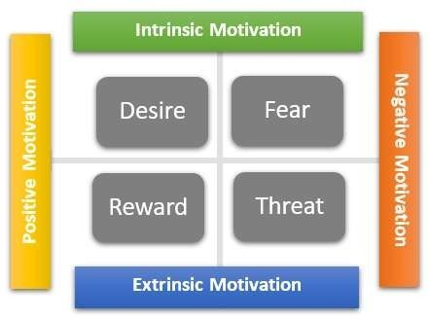

Itisdriven byseveralfactorswhichinfluencesthebehaviorandattitudeofanindividual. Based on the different factors and the kind of impact it has on a person, there are different types of motivation. The different types of motivation in people are:
- IntrinsicMotivation
This type comes from within a person to do a task or achieve a particular goal. It is a feeling of being self-driven and achieving objectives for oneself. Intrinsic motivation is drivenbymotiveslikesocialacceptance, eatingfood, desirestoachievegoals, biological needs etc.

- ExtrinsicMotivation
Thistype drivesanindividualdue toexternalforcesorparameters. Some otherpersonor organization motivates the individual to work hard to achieve certain goals or tasks. Extrinsic motivation is driven bymotives like financial bonus, rewards, appreciation, promotion, punishment, demotion etc.
- PositiveMotivation
This type drives an individual by offering positive accolades and rewards for performing a task. In this type of motivation, the individual is rewarded by monetary benefits, promotions etc. which drives an individual to work hard.
- NegativeMotivation
This is where fear and threat are used as a parameter to get the work done. In this type of motivation, individuals are threatened with things like demotion, reducing benefits, withdrawing merits etc.
For every individual, all the types are interlinked based on which he or she takes an action. Theresultant behavior of any person is basis the motivation types he or she has been influenced by.

TopFactorsInfluencingMotivation
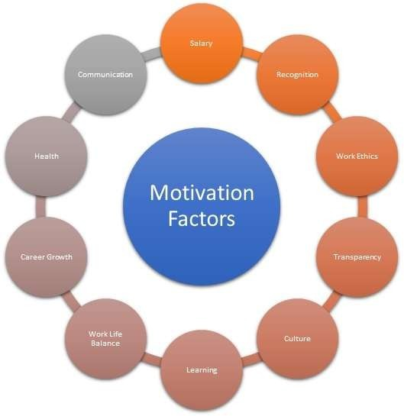

Keeping employees motivated is the biggest challenge for companies for ensuring that they give a high productive output at work and help in achieving company goals. A positive motivation amongst employees helps drive the business positively & enhances creativity. On the other hand, a demotivated employee will not contribute efficiently and slowdown progress at workplace. The key elements & top factors which influence employees in business or people in general are as follows:
- Salary
Monetarycompensation&benefitslikegrosssalary,perks,performancebonusesetc.are the biggest motivation factors. The better the salary and monetary benefits, the higher is the motivation level & passion of a person towards a job.
- Recognition
Rewards, recognition etc. are important for ensuring high enthusiasm levels for an employee.If the hard work of an individual is appreciated, it keeps them motivated to perform better.
- WorkEthics
Ethicalworkingenvironment, honestyetc. areimportant factorsforanyindividual. Good work ethics ina company helps keep employees motivated at work place.
Ontheotherhand,iftheworkenvironmentisnotethical,thentheworkforcemightbe demotivated.
- TransparencywithLeadership
The leadership in an organization helps in employee motivation if there are transparent discussion and flatter hierarchies. The senior management has to ensure that all subordinates are happy, focused & motivated.
- CultureatWork
Agood, vibrant,positivecultureat workplaceisalwaysanimportantfactor. Peoplefrom different backgrounds, religions, countries etc. working together helps create a social bond at workplace.

- LearningandDevelopment
Another factor influencing is the training and development opportunities that a person gets. L&D helps individuals develop more skills and have better opportunities in their professional career.
- WorkLifeBalance
Having a good quality of work life (QWL) helps in the motivation of people. A good work life balance ensures that a person can give quality time to both office work as well as family.
- CareerGrowthOpportunities
Career development opportunities have a positive influence on the motivation of any person. If a personknows their future & career path is secure, they tend to work with more passion.
- HealthBenefits
Health benefits, insurance & other incentives act as a source of motivation for people. If the medical bills, hospitalization charges etc. are taken care of by the company, it helps build a strong trust.
- Communication
A positive & transparent communication between managers and subordinates gives a senseofbelongingandaddstothe employee’smotivation.Discussionrelatedtoworkas well as personal life help make a friendly bond at workplace.
There are not finite factors influencing positive attitude of an employee. These keep on changing depending upon the type of environment, job responsibility, experience in life etc. Hygiene Factors of motivation are also given by the Hygiene Theory.

AdvantagesofMotivation

There are several advantages of an employee being motivated at work. Some of the mainbenefits ofmotivation for employees and companies are as follows:

- Feelingofbelongingnessandself-respect.
- Amotivatedemployeeisexcitedtolearnandcontributemore.
- Higherproductiveoutputduetopositivemotivation.
- Reducedabsenteeismandlowerattrition.
- Employeeshighonmotivationhelpreducecosts&improveprofits.
- Reducestress&anxietyatworkplace.

DisadvantagesofMotivation

Despiteseveraladvantages,therearesomeprobabledrawbacksaswell.Someofthemare:
- It is a relative feeling and hence there is no way of ensuring that everyone would feel the same way.
- Motivating employees inacompany requiresadditional efforts,money and timeon employee relatedactivities.
- Itamongpeopleismostlyashort-termfeeling.Afterwardsapersonbecome demotivatedorevenuninterested about a particular task.

ExamplesofMotivation

Motivation is relevant in every field of life for any individual. There can be many examples based on type, situation, field of work etc. Some examples are as follows.
- Considera person who hasjoineda university. Aftera lotofhard work, he or she gets admission in their preferred course. Hence the intrinsic motivation for the individual would be perform well in academics, get a good score, learn new skills and get a job opportunity with a good company. Since this is an internal feeling, the driving motives are achieving a personal goal.
- An example of extrinsic motivation can be seen from a footballer, cricketer or any other sportsperson.Anysportsperson wantsto excel in their sport notonlyforthemselves but to also become a crowd favorite and get their attention. Hence, he or she gets highly

motivatedbythisexternalfactorwhichdrivesthemtoperformbetterintheirsport.

Maslow'sHierarchyofNeedsTheory

One of the most popular needs theories is Abraham Maslow's hierarchy of needs theory. Maslow proposed that motivation is the result of a person's attempt at fulfilling five basic needs: physiological, safety, social, esteem and self-actualization. Accordingto Maslow, these needs can create internal pressures that can influence a person's behavior.
Physiological needs are those needs required for human survival such as air, food,water, shelter, clothing and sleep. As a manager, you can account for the physiological needs of your employeesby providing comfortable working conditions, reasonable work hours and the necessary breaks to use the bathroom and eat and/or drink.
Safetyneedsinclude those needsthatprovide a personwitha senseofsecurityandwell- being. Personal security, financial security, good health and protection from accidents, harm and their adverse effects are all included in safety needs. As a manager, you can account for the safety needs of your employees by providing safe working conditions, secure compensation (such as a salary) and job security, which is especially important in a bad economy.
Social needs, also called love and belonging, refer to the need to feel a sense of belonging and acceptance. Social needs are important to humans so that they do not feel alone, isolated and depressed.Friendships, family and intimacy all work to fulfill social needs. As a manager, you can account for the social needs of your employees by making sure each of your employees know one another, encouraging cooperative teamwork, being an accessible and kind supervisor and promoting a goodwork-life balance.
Esteem needs refer to the need for self-esteem and respect, with self-respect being slightlymoreimportant than gaining respect and admiration from others. As a manager, you can account for the esteem needs of your employees by offering praise and recognitionwhentheemployeedoeswell,andofferingpromotionsandadditional

responsibilitytoreflectyourbeliefthattheyareavaluedemployee.

Self-actualization needs describe a person's need to reach his or her full potential. The needto become what one is capable of is something that is highly personal. While I might have the need to be a good parent, you might have the need to hold an executive- level position within your organization. Because this need is individualized, as a manager, you can account for this need by providing challenging work, inviting employeesto participate in decision-makingandgivingthemflexibilityand autonomyin their jobs.
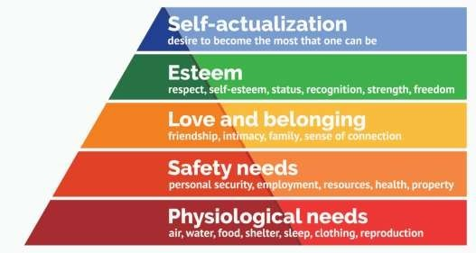

MethodsofImprovingMotivation

- Leadwithvision
Everyone wants to know that their efforts are driving towards something. What’s thenext step? What does successlook likefor thecompany? A destination helps to motivate the journey, so make sure the vision for the company is clear.
- Makesureeveryoneunderstandsthe‘why’
Your employees will know what needs to be done, but you need to explain further; you needtocommunicatethe‘why’ofeachtask.Thewhyisthecompany’soverallmission.

If everyone knowshowtheirindividualactionscanpersonallyaddtothe overallgoalof thecompany,itbringsmuch-neededintrinsic motivationtoeventhe mostsimpletask.
- Setfrequentcleartargets
You obviously have big targets that you want to hit as a company, but smaller goals are thekeytomotivation.Allgoalsshouldaddtotheoveralltarget,butbreakingthis intomoreattainablechunks feelslessoverwhelming.Ifemployeesarefrequently hitting targets, the feeling of satisfaction grows and will act as a great motivator to continue on to the next set of goals.
- Recogniseandrewardgreatwork
Employees need to know that their managers appreciate their hard work. Giving well- deserved recognition not only increases self-esteem but also enthusiasm and teammorale.
Arecognitionplatformisaneffective tool tocelebrate starperformerswho embodyyour company values. It's important to support employees all year round with team-building exercises, wellbeing schemes, secondment opportunities and EAP programs. However, for more special occasions, such as a 10-year work anniversary or employee of the month, we recommend going a step furtherand rewarding your teams.
The reward doesn't necessarilyhave to be monetary, it could be a gesture,such as giving them a day off. Rewards are particularly good promoters of motivation and job satisfaction. So if you wantto encourage your employees to go the extra mile, maketheir effort worth it with a gift or thoughtful act.
- Giveyourteamautonomy
Time is precious. So when we don’t feel in control of our time and energy, motivation levelscanreallydrop.Allowingforsomeelementsoffreedomintheworkplace,whether that’s flexible working hours orunlimited time off, demonstrates trust from leaders to employees. This adds motivation, as the satisfaction of a job well done comes with the feeling that they were in control and did it on their terms.

- Createawelcomingworkplaceenvironment
No one wants to sit in a gloomy office and desperately wait for home time every day. If workplaces create a friendly culture, with areas for rest and play, employees will look forward to coming into work. The saying ‘work hard, play hard’ is important here. As motivation and mood go hand in hand, a poor mood can affect the ability to concentrate and will lower the feeling of energy in the workplace.
- Offerimpressivebenefits
Make everyone feel that they are working in the best place they can be. Offering employee benefits and perks, such as the wide range available through our perks platform,and fringebenefits that aimtomake your people's lives better both in and outside of work, helpstoboostthemoodandsense of loyaltyto thecompany. Makesure your benefits suit your employees' unique needs; for instance, if they live in London,they may require a London weighted allowance.
- Encourageteamwork
Collaboration between teams in the company allows ideas to be developed further. Working with those with different skill sets will, in turn, create more innovative results. In teams, there’s powerin numbers andanyone experiencinga lackof motivation should be boosted by those around them.
- Createacareerpath
No one wants to be static for long. We all want to know that we are going somewhere and focus on that next step. Ask employees whatthey want from theircareer,and layout what they need to do to get there. Have growth conversations with team members to design a career path; this will help to create the drive to reach the next stage and feelthat they have a long and productive journey ahead within the company.
- Supportstaffmotivationbysupportingemployeewellbeing
Whenorganisationsareimplementingmotivationstrategiesoremployeeincentiveschemes, they oftenoverlook wellbeing.
There's no dispute that using rewards as an incentive isa great motivator. However,if anemployeeisfeelingtiredoroverwhelmedtheywon'tproducetheirbestwork–nomatter

howhardtheytry.
Taking a well-rounded approach to wellbeing, so addressing your teams' mental, emotional, andphysical health is a great way of keeping them healthy, happy, and at the top of their game.

Whyiscommunicationimportantinbusiness?

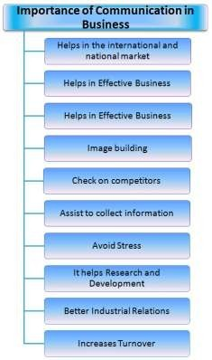
Communicationin businessisimportanttoconveyclear, strongmessagesaboutstrategy, customerserviceandbranding. Abusinessbuildinga brandreflectsaconsistentmessage tailored to its audience. Internal communication builds rapport among employees and managers and encourages teamwork andcollaboration.

Good communicators are vital to a business's profit margin and reputation. Employees whocommunicate well and understand the company's vision help make the company successful. Using effective communication skills can benefit a business and its employees in a variety of ways, including:

- Buildingbetterteams

Effective communication builds a positive atmosphere where teams can flourish. When communication is positive and encouraging, team members become stronger and work better together. Those who practice good communication skills make working beside them easier and less stressful. Job tensions or friction are promptly addressed since effective communicators work toward finding solutions.

- Preventingmisunderstandingsandconflicts

Listening is a part of communicating used to understand a situation fully. Good communicators listen well and react appropriately, and they're more likely to find solutions without becoming defensive. When conflicts arise, good communicators address the problem right away and listen to the other side.

- Improvingcustomerservice
Businesses need to know what their customers want and need from them to serve them. Forming business relationships is how companies build trust in their brand and bring customers back. Reliable and positive communication with customers is paramount to maintaining a valued customer service reputation.

Effective communication with customers by answering questions and providingsolutions helps toimprove the business's reputation. Communicating well over the phone or through socialmedia or email improves customer confidence and loyalty. Written communication that is consistent with the brand's voice can help promote community between customers and organizations.
- Meetinggoalsandearningsuccess

For a business to be successful, short- and long-term goals must be clear and concise. When employees know what the goals and visions of their company are, they are better able to focus their efforts on achieving them.

Communicate goals clearly, and regularly remind employees of the team or individual goals to keep them motivatedandencouraged. It can also helpemployees understandthe importanceof their roles inmaking the company successful, which can improve loyalty within the company and reduce hiring turnover
.
- Promotingcreativityandinnovation

Peoplewhoaregoodcommunicatorsareusuallyopentosharingideaswithoutjudgment. When trust is built based on effective communication, team members are more apt to share with each other to inspirecreativity.

Effective communicators are more inclined to collaborate to find creative solutions, as well. When employees are keen to share ideas, companies can transform theirapproaches and find unique ways to serve customers and clients.

- Advancingindividualcareerprospects
Goodcommunicationskills,suchasopenandhonestcommunication,eliminatesurprises and reinforce your commitment to solve problems and support the business. This can help you earn promotions and secure leadership positions in yourcurrent organization or pursue new advanced career opportunities elsewhere.

BarriersToEffectiveCommunication
The process of communication has multiple barriers. The intended communique will oftenbedisturbedanddistortedleadingtoaconditionofmisunderstandingandfailure of communication. The Barriers to effective communication could be of many types like linguistic, psychological, emotional, physical, and cultural etc. We will see all of these types in detail below.
- LinguisticBarriers

  - Thelanguagebarrierisoneofthemainbarriersthatlimiteffectivecommunication. Language is the most commonly employed tool of

communication.Thefactthateachmajorregionhasitsownlanguageisoneofthe Barriers to effective communication. Sometimes even a thick dialect may render the communication ineffective.
  - As per some estimates, the dialects of every two regions changes within a few kilometers. Even in the sameworkplace, different employees will have different linguistic skills. As a result, the communication channels that span across the organization would be affected by this.
  - Thus keeping this barrier in mind, different considerations have to be made for different employees. Someof them are very proficient in a certain language and others will be ok with these languages.
- PsychologicalBarriers

  - Therearevariousmentalandpsychologicalissuesthatmaybebarrierstoeffective communication.Somepeoplehavestagefear,speechdisorders,phobia,depression etc.All of these conditions are very difficult tomanage sometimes and will most certainly limit the ease of communication.
87
- EmotionalBarriers

  - The emotional IQ of a person determines the ease and comfort with which they can communicate. A person who is emotionally mature will be able to communicateeffectively. On the other hand, people wholet their emotions take over will face certain difficulties.
  - A perfect mixture of emotions and facts is necessary for effective communication. Emotions like anger, frustration,humour,canblurthedecision- making capacities of a person and thus limit the effectiveness of their communication.

- PhysicalBarrierstoCommunication

They are the most obvious barriers to effective communication. These barriers aremostly easily removable in principle at least. They include barriers like noise, closed doors, faulty equipment used forcommunication, closed cabins, etc. Sometimes, in a largeoffice,thephysicalseparationbetweenvariousemployeescombinedwithfaulty

equipmentmayresultinseverebarrierstoeffectivecommunication.
- CulturalBarriersofCommunication

  - As the world is getting more and more globalized, any large office may have people from several parts of the world. Different cultures have a different meaning for several basic values of society. Dressing, Religions or lack of them, food, drinks, pets, and the general behaviour will change drastically from one culture to another.
  - Hence it is a must that we must take these different cultures into account while communication. This is what we call being culturally appropriate. In many multinationalcompanies, special courses are offered atthe orientation stages that let people know about other cultures and how to be courteous and tolerant of others.
- OrganisationalStructureBarriers

  - As we saw there are many methods of communication at an organizational level. Each of these methods has its own problems and constraints that may become barriers to effective communication. Most of these barriers arise because of misinformationorlackofappropriatetransparencyavailabletotheemployees.
- AttitudeBarriers

  - Certain people like to beleftalone. They are the introverts or just people who are not very social. Otherslike to be social or sometimes extra clingy! Both these cases could become a barrier to communication. Some people have attitude issues, like huge ego and inconsiderate behaviours.
88
  - Theseemployeescancauseseverestrainsinthecommunicationchannelsthatthey arepresentin.Certainpersonality traits like shyness, anger, social anxiety may be removable through courses and proper training. However, problems like egocentric behaviour andselfishness may not be correctable.

- PerceptionBarriers

  - Different people perceive the same things differently. This is a fact which we mustconsiderduringthe communication process. Knowledge of the perception levels of the audience is crucial to effective communication. All the messages or communiquemustbeeasyandclear.Thereshouldn’tbeanyroomforadiversified interpretationalset.
- PhysiologicalBarriers

  - Certain disorders or diseases or other limitations could also prevent effective communicationbetweenthevarious channels of an organization. The shrillness of voice, dyslexia, etc are some examples of physiological barriers to effective communication. However, these are not crucial because they can easily be compensated and removed.
- TechnologicalBarriers&Socio-religiousBarriers

  - Other barriers include the technological barriers. The technology is developing fast and as a result, it becomesdifficulttokeepupwith thenewestdevelopments. Hence sometimes the technological advance maybecomeabarrier. In addition to this, the cost of technology is sometimes very high.
  - Mostoftheorganizationswillnotbeabletoaffordadecenttechforthepurposeof communication. Hence, this becomes a very crucial barrier. Other barriers are socio-religious barriers. In a patriarchal society, a woman or a transgender may face many difficulties and barriers while communicating.
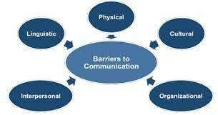

WorkCulture,TQM&Safety

HumanrelationshipandPerformanceinOrganization
Human relations is critical for developing and maintaining a positive work environment, retainingemployees andencouragingproductivity. Bymakinghuman relations the focus of your management approach, you can effectively create a workplace culture in which your employees can thrive. Developing your human relations skills can help you modify your management style so it's human relations-centric.

Whatishumanrelations?

Human relations refers tothe abilityto interactina healthymanner with others and build strong relationships. From the perspective of managers in a company, it involves the process of creating systems and communication channels to enable group employee relationships as well as strong one-on-one relationships. Additionally, it includes the process of training people for specific roles, addressing their needs, resolving conflicts between employees or between management and employees and creating a positive workplace culture.

Whyarehumanrelationsimportant?

Humanrelationsiscriticalinbusinessforavarietyofreasons,including:

- Employee productivity: When relationships between a company's managers and its employeesaresupportiveandpositive, productivityis shownto increase.Additionally, whenemployees aredependent upon each other with their work, it directly influences productivity. When employees feel that they're treated with respect and recognized for contributing to a company's success, they are more likely to produce quality work.
- Motivation: When employees recognize that performing job-related tasks will allow them to feelappreciated and valued, they are more motivated to do them.
- Positive perception: An employee's interpersonal and communication skills impact theperception that other employees have about their ability to positively contribute to

the workplace. A positive perception of an employee's work and attitude could create opportunities for future advancement.
- Employee retention: Employees who feel they're treated respectfully by their employer are morelikelytocontinueworkingforthemforalongerperiodoftime. By using human relationsto establish a feeling of mutual trust and value, a company creates an environment where employees feel that they matter and are less likely to pursue other opportunities.
- Creativity: In the workplace, creativity is often dependent on the employee's ability to communicate and share ideas with their colleagues. By creating a positive workplace culture andnurturing workplace relationships and teamwork, a business can encourage creativity and more quickly develop products and services to meets the consumer's changing needs managing

EmployeeCollaborationandWorkplaceCulture

Human relations in the workplace are a major part of what makes a business work. Emplo yees must frequently work together on projects, communicate ideas and provide motivation to get things done. Without a stable and inviting workplace culture, difficult challenges can arise both in the logistics of employees and inthe bottomline. Businesses with engagingworkplaces and a well-trained workforce are more likely to retain and attract qualified employees, foster loyalty with customers and more quickly adapt to meet the needs of a changing marketplace.

ImprovingEmployeeRetention

The quality of workplace relations is critical to employee retention. Employee retention may seem trivial – especially in a workplace that is used to a high turnover – but managers must remember that turnover is financially very costly. Every new employee requires a substantial investment of time and energy in their recruitment and training.

Inaddition, severingties witholdemployeescansometimesbe challenging, especiallyif the circumstances are not particularly amicable. Making sure quality employees remain interested and engaged in the business requires patience, compassion and flexibility, but can actually make the business more financially sound.

MotivationandProductivity

Workplace relationships provide a source of employee motivation, which is important to maintaining productivity. Employees who are interested in their work and in the well- beingofother employeestend to be more productive than those who are not.This productivitypaysobviousfinancial dividends to the company, as it can get more done in lesstimewithfewercosts.Building relationships, by both recognizing an employee's value to the company and a concern for their needs, often goes a long way.

FosteringEmployeeCreativity

The modern business environment often rewards businesses that are able to quickly develop products that meet changing consumer needs. In some industries – such as technology, for example – employees' ability to come up with effective new ideas isoften the difference between the entire company's success and failure. Employees' creativity is often dependent on theirabilityto communicate with other employees and share ideas.Withoutqualityworkplace relationships,employeesarelesslikelyto be able to develop and share the solutions thatabusinessneedsto survive.

TQMconcepts:QualityPolicy,QualityManagement,Qualitysystem

Total Quality Management (TQM) is a management frameworkbased on the belief that anorganizationcan buildlong-term success byhavingallitsmembers,fromlow-level workers to its highest ranking executives, focus on improving quality and, thus, delivering customer satisfaction.
A core definition of total quality management (TQM) describes a management approach to long-term success through customer satisfaction. In a TQM effort, all members of an organization participate in improving processes, products, services, and the culture in which they work.

PRIMARYELEMENTSOFTQM

TQM can be summarized as a management system for a customer-focused organization that involvesallemployeesin continualimprovement. Itusesstrategy, data,andeffective communicationstointegrate the quality discipline into the culture and activities of the organization. Many of these concepts are present in modern quality management systems,thesuccessortoTQM.Herearethe8principlesoftotalqualitymanagement:
91

- Customer-focused: The customer ultimately determines the level of quality. Nomatter what anorganization does to foster quality improvement—training employees, integrating quality into the design process, or upgrading computers or software—the customer determines whether the efforts were worthwhile.
- Total employee involvement: All employees participate in working toward common goals. Total employeecommitment can only be obtained after fear has been driven fromtheworkplace, when empowerment has occurred, and when management has provided the proper environment. High-performance work systems integrate continuous improvement efforts with normal business operations. Self-managed work teams are one form of empowerment.
- Process-centered: A fundamental part of TQM is a focus on process thinking. A process is a series of steps that take inputs from suppliers (internal or external) and transforms them into outputs that are delivered to customers (internal or external). The steps required to carry out the process are defined, and performance measures are continuously monitored in order to detect unexpected variation.
- Integrated system: Although an organization may consist of many differentfunctional specialties often organized into vertically structured departments, it is the horizontal processes interconnecting these functions that are the focus of TQM.
Micro-processes add up to larger processes, and all processes aggregate into the business processes required for defining and implementing strategy. Everyone must understand the vision, mission, and guiding principles as well as the quality policies, objectives, and critical processes of the organization. Business performance must be monitored and communicated continuously.

An integrated business system may be modeled after the Baldrige Award criteria and/or incorporate the ISO 9000 standards. Every organization has a unique work culture, and it is virtually impossible to achieve excellence in its products and services unless a good quality culture has been fostered. Thus, an integrated system connects business improvement elements in an attempt to continuallyimprove and exceed the expectations of customers, employees, and other stakeholders.
- Strategic and systematic approach: A critical part of the management of quality is the strategicand systematic approach to achieving an organization’s vision, mission, and goals. This process, called strategic planning or strategic management, includesthe formulation of a strategic plan that integrates quality as a core component.
- Continual improvement: A large aspect of TQM is continual process improvement. Continual improvement drives an organization to be both analytical and creative in findingwaysto become more competitive and more effective at meeting stakeholder expectations.
- Fact-based decision making: In order to know how well an organization is performing, data on performance measures are necessary. TQM requires that an organization continually collect and analyze data in order to improve decision making accuracy, achieve consensus, and allow prediction based on past history.
- Communications: During times of organizational change, as well as part ofday-to- day operation, effective communications plays a large part in maintaining morale and in motivating employeesat all levels. Communications involve strategies, method, and timeliness.

TQM requires organizations to focus on continuous improvement, or kaizen. It focuses on process improvements over the long term, rather than simply emphasizing short-term financial gains.

PrinciplesofTQM
  - TQM prescribes a series of ways for organizations to accomplish this, with the pathway to successful continuous improvement centered on the use of strategy, dataandeffectivecommunicationtoinstilladisciplineofqualityintothe

organization'scultureandprocesses.
  - Morespecifically,TQMputsaspotlightontheprocessesthat organizationsusetoproduce their products, and it calls for organizations to define those processes,continuouslymonitorandmeasure theirperformance,and use that performance data to drive improvements. Furthermore,it calls for all employees, as well as all organizational departments, to be part of this process.
  - TQM's objectives are to eliminate waste and increase efficiencies by ensuringthat the productionprocess of the organization's product (or service) is done right the first time.
  - This management framework was initially applied to companies in the manufacturing sector, but, over the decades, organizations in other sectors have adopted it, as well.

QualityPolicy

- The quality policy is where the company has stated its promise. The promise to strive for consistent quality and constant improvement. The quality policy is a short document created by the executive management team.
- It displays exactly what quality means to their company specifically. The purpose of their product or service and the strategic direction they are planning to take to achieve these goals.
- You must show this document to all employees so all are aware and the company is aligned with their objective. The document is also made public to be accessed by customers and investors for reference and reassurance.
- In short, a quality policy describes your business, what it offers and your commitment to delivering the highest quality product. Customer requirements are accounted for in the quality policy. Quality objectives are the goals linked to meeting customer requirements. These objectives are within the quality policy statements.

ThreeKeyElements

Thequalitypolicyshouldreallyhavethreekeyelements.

- Itshouldbedevelopedbymembersofseniormanagement.
- Itshouldshowcommitmenttoqualityandcustomersatisfaction.
- Itshouldberelativelyeasytogeneratekeyqualityobjectivesfromit.

A QualityPolicy isa requirement of anyformalized quality management system (QMS), and its purpose is to set the framework for the commitment of the scope of the QMS for internal and external stakeholders.
- A Quality Policy is typically a brief statement that aligns with an organization’s purpose, mission, and strategic direction. It provides a framework for qualityobjectives and includes a commitment to meet applicable requirements (ISO 9001, customer, statutory, or regulatory) as well as to continually improve.
- But a Quality Policy can be so much more. It can become a way to drive passion for cultural change within an organization by incorporating pieces of it into routine meetings and embedding it into employee objectives and performance measurement.
- For example, some companies will incorporate a quality objective directly into an employee’s annual goals. Examples could include being involved in a continual improvement project or simply maintainingcompliance.
- Most companies will post their Quality Policy on their websites and within company buildings as a visual reminder to employees, customers, and suppliers about their commitment to quality.
Here is our Quality Policy that we believe reflects the everyday way of life and commitment to quality practiced at Thermo Fisher Scientific.

QualityPolicy

We fulfill our Mission to enable our customers to make the world healthier, cleaner, and saferbycontinuouslyimprovingthe qualityofourproductsandservicesandbyensuring global regulatory compliance.

  - Quality for our customers means they can rely on our products and services to consistently meettheir specifications and requirements.
  - Qualityforourcolleaguesmeanswetakepersonalownershiptoensureour work meetscustomer requirements and is error free from design through use.
  - Quality for regulatory authorities means that we operate at the highest ethical standardsandmeet or exceed all applicable regulatory requirements.
  - Qualityforourcompanymeanswedriveacontinuousimprovementculture that is enabled bypracticalprocessimprovement(PPI)andourcompany’squality system.

WhatIsQualityManagement?
- Quality management is the act of overseeing all activities and tasks that must be accomplished to maintain a desired level of excellence. This includes thedetermination of a quality policy, creating and implementing quality planning and assurance, and quality control and quality improvement. It is also referred to as total quality management (TQM).

- A Quality Management System, or QMS, is essential for improving your business’s operations and enabling it to meet the requirements of customers. Many types of quality management systems are builtaround ISO 9000, a framework requiring all business processes to be documented and for people to follow these closely. Whether you manage all your processesin-house oroutsource to, forexample, a,a QMS allows your organization to remain compliant with the latest standards and regulations.
- Once yourcompanyis ISOcertified, implementingTotalQualityManagement(TQM) enables you to evaluate all processes to improve efficiency and reduce waste. TQM can be implemented in all facets of your business, from the front office to the production floor.
- In general, quality management focuses on long-term goals through the implementation of short-term initiatives.

  - Quality management is the act of overseeing all activities and tasks needed to maintainadesired level of excellence.
  - Qualitymanagementincludesthedeterminationofaqualitypolicy,creating and implementing quality planning and assurance, and quality control and quality improvement.
  - TQM requires that all stakeholders in a business work together to improve processes, products,services and the culture of the company itself.

UnderstandingQualityManagement
- At its core, TQM is a business philosophy that champions the idea that the long- term success of a company comes from customer satisfaction and loyalty. TQM requires that all stakeholders ina business work together to improve processes, products, services and the culture of the company itself.

- While TQM seems like an intuitive process, it came about as a revolutionaryidea. The 1920s saw the rise in reliance on statistics and statistical theory in business, and the first-ever known controlchartwas made in 1924. People began to build ontheories of statisticsand ended upcollectively creating the methodof statistical process control (SPC). However, it wasn't successfully implemented in a business setting until the 1950s.1

- It was during this time that Japan was faced with a harsh industrial economic environment. Its citizens were thought to be largely illiterate, andits products were known to be of low quality. Key businesses in Japan saw these deficiencies and looked to make a change. Relying on pioneers in statistical thinking, companies such as Toyota integrated the idea of quality management and quality control into their production processes.
- By the end of the 1960s, Japan completely flipped its narrative and became known as one of the most efficient export countries, with some of the most admired products. Effective quality management resulted in better products that could be produced at a cheaper price.

Real-WorldExampleofQualityManagement

- The most famous example of TQM is Toyota's implementation of the Kanban system. A kanban is a physical signal that creates a chain reaction, resulting in a specific action. Toyota used this idea to implement its just-in-time (JIT)inventory process. To make its assembly line more efficient, the companydecided to keep just enough inventory on hand to fill customer orders asthey were generated.

- Therefore, all parts of Toyota's assembly line are assigned a physical card thathasan associatedinventorynumber.Rightbeforeapartisinstalledinacar, the card is removed and moved up thesupply chain, effectively requesting another of the same part. This allows the company to keep its inventory lean and not overstock unnecessary assets.
- Aqualitysystemisastructureformanagingthequalityoftheoutputofa manufacturer.
- We have a verystringent quality system for inspectingitems anddelivering the best products.
- Agoodqualitysystempreventserrorsfromoccurringratherthancorrecting themaftertheyhavehappened.
- Aqualitysystemisastructureformanagingthequalityoftheoutputofa manufacturer.

Accidentsintheworkplace
- Your employer has a duty to protect you and tell you about health and safety issuesthat affect you. Theymust also report certain accidents and incidents, pay you sick pay and give you time off because of an accident at work should you need it.

Reportinganaccidentatwork
Youremployermustreportseriouswork-relatedaccidents,diseasesanddangerous

incidentstothe HealthandSafetyExecutive forNorthernIreland(HSENI)orthe Health and Safety department at your local authority. They must report:
- death
- majorinjuries,abrokenarmorribsforexample
- dangerousincidentslikethecollapseofscaffolding,peopleovercomebygas
- any other injurythat stops an employee from doing their normal work formore than three days
- disease

- The reporting must be done by your employer, but if you're involved it's a good idea to make sure it has been reported.
- Healthandsafetyatwork
- Your employer has to carry out a risk assessment and do what's needed to take care of the health and safety of employees and visitors. This includes deciding how many first aiders areneeded and what kind of first aid equipment and facilities should be provided.
First aiders have no statutory right to extra pay, but some employers do offer this. Employees must also take reasonable care over their own health and safety.
- Employees'healthandsafetyresponsibilities
- Employers'healthandsafetyresponsibilities

Recordingaccidents
- Any injury at work - including minor injuries - should be recorded in your employer's 'accident book'.
- All employers (exceptfor verysmallcompanies)must keepanaccidentbook. It's mainly for the benefit of employees, as it provides a useful record of what happened in case you need time off workor need to claimcompensation later on. But recording accidents also helps your employer to see what's going wrong and take action to stop accidents in future.

Sickpay

- In most cases, if you need time off because of an accident at work, you'll only have the right to Statutory Sick Pay. Your employer may have a scheme for paying more for time off caused by accidents, or may decide to pay extra depending on what has happened.

Makinganinjuryclaim

- If you've been injured in an accident at work and you think your employer is at fault, you may want to make a claim for compensation. Any claim must be made withinthreeyearsofthedate oftheaccidentandyou'llnormallyneedalawyer.If you belong to a trade union, you may be able to use their legal services. Or, you should speak to a specialist personal injury lawyer.
- By law, your employer must be insured to cover a successful claim and should place a certificate withthenameoftheiremployer'sinsurancecompanywhere itcanbeseenatwork.Ifnot,theymustgiveyou the details if you need them.
- If you're considering suing your employer, remember that the aim of legal damages is to put you in the position you would be in had the accident not happened - it's not about getting hold of some 'free' money. There are also court costs and legal fees to think about.

Ifyouhaveanaccidentintheworkplace,youshould:

- makesureyourecordanyinjuryinthe'accidentbook'
- ifneedbe,makesureyouremployerhasreportedittotheHSENI
- check your contract or written statement of employment for information about sick or accidentpay
- ifthere'sadispute,trytosortitoutwithyouremployer

PERSONALPROTECTIVEEQUIPMENT (PPE)FORINFECTION CONTROL

- Personal Protective Equipment (PPE) is specialized clothing or equipment worn by an employee for protection against infectious materials.

- PPE prevents contact with an infectious agent or body fluid that may contain an infectious agent, by creating a barrier between the potential i Importance
- According to the hierarchy of controls by the National Institute for Occupational Safety and Health (NIOSH), PPE (sometimes also reffered to as PPE equipment)—is recommended to be the last level of defense to prevent occupational injuries, illnesses, and fatalities, but some businesses combined it with other control measures to ensure a safe and healthy environment for their workers. Here are some benefits of using PPEs:
- preventunnecessaryinjuryintheworkplace;
- protectemployeesfromexcessivechemicalexposure;
- preventthespreadofgermsandinfectiousdiseasesincludingCOVID-19;
- help businesses comply with regulatory requirements(e.g., The Personal ProtectiveEquipment at WorkRegulations 1992 that’s recently been extended to limb workers); and
- Improveemployeeproductivityandefficiency.

The4BasicTypes

However, even the strictestcontrols will not necessarily eliminateallthe risks associated with most job tasks and this is where the need for PPE must be evaluated. A hazard assessmentcan help identify which specialized PPE will be required. There are numerous types of workplace safety equipment available depending on the hazard exposure and work conditions. The following are basic PPE that can help protect employees:

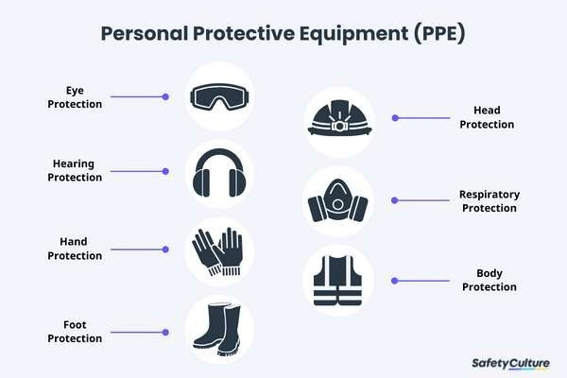

FaceandEyeProtection

PPE includes safety goggles and face shields and should be used for tasks that can cause eye damage or loss of vision, sprays of toxic liquids, splashes, and burns.

SafetyTips:
- CheckifsafetyglassescomplywiththeANSIZ87.1eyeprotectionstandard.
- Ensurethattherearenocracksordeformitiesonthelenses.
- Ensure the strap is in good working condition and is firmly sealed to the cheek and forehead.
- Cleananddisinfectafteruse.
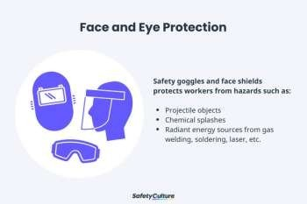

RespiratoryProtection

PPE includes full-face respirators, self-contained breathing apparatus, gas masks, N95 respirators, and surgical masks are used for a task that can cause inhalation of harmful materialstoenterthe body. This includesharmfulgas,chemicals, large-particle droplets, sprays, splashes, or splatter that may contain viruses and bacteria such as COVID-19, viral infections, and more.

SafetyTips:
- Ensurethat the equipmentisfit-tested and theemployeehasundergoneproper training beforewearing one.
- Carefullyreadtheinstructionstodetermineifitisdesignedtohelpprotectagainst the hazards you mayface.
- Changefiltersonhalf-maskorfull-maskrespiratorsfrequently.
- Replacedisposablerespiratorswitheveryuse.
- Surgicalmasksarenottobesharedwithanyone.
- Avoidtouchingthesurgicalmaskafterwearingit.
- Changesurgicalmasktimelyandshouldbedisposedofafteruse.
- Replacethemaskimmediatelyifitisdamagedorsoiled.

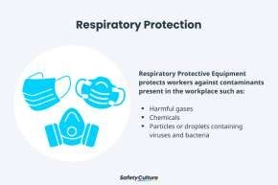

SkinandBodyProtection

PPEincludesthefollowingcategoriestoprotectemployeesfromphysicalhazards:

SafetyTips:
- Ensure handprotectionfits perfectly with no spaces and is free from cuts, burns and chemical residue.
- Alwaysreplacethemifanysignofcontaminationwasobserved.
- Use rubber gloves when working with heat and electricity to reduce the risk of burn or electrical shock.

HeadProtection

- PPEincludeshardhatsandheadgearsandshouldberequiredfortasksthatcan causeanyforceorobject falling to the head.

SafetyTips:
  - Ensurethattherearenodentsordeformitiesontheshellandconnectionsare tightened inside.
  - Donotstoreindirectsunlightasextremeheatcancausedamage.
  - Choose appropriate cleaning agents as it can weaken the shells of hard hats andmay eliminate electricalresistance.
  - Always replace a hard hat if it was usedfor any kind of impact, even if the damage is unnoticeable.Body Protection
  - PPE includes safety vests and suits that can be used for tasks that can cause body injuries from extreme temperatures, flames and sparks, toxic chemicals, insect bites and radiation.

FootProtection

PPE includes knee pads and safety boots and should be used for tasks that can cause serious foot andleg injuries from falling or rolling objects, hot substances, electrical hazards, and slippery surfaces.

SafetyTips:
  - Ensure boots have slip-resistant soles that can protect against compression and impact.
  - Ensure the sole plate is in good condition to prevent punctures. Fall Protection
PPE includes safety harnesses and lanyards and should be strictly used for tasks that can cause falling
fromheightsandseriousinjuryordeath.

SafetyTips:
  - Ensurethatthestrapsarefreefromtears,deformitiesandburnmarks.
  - Checkthebucklesifconnectedsecurelyandtightly.Disposeoftheequipmentifused after a falling incident.
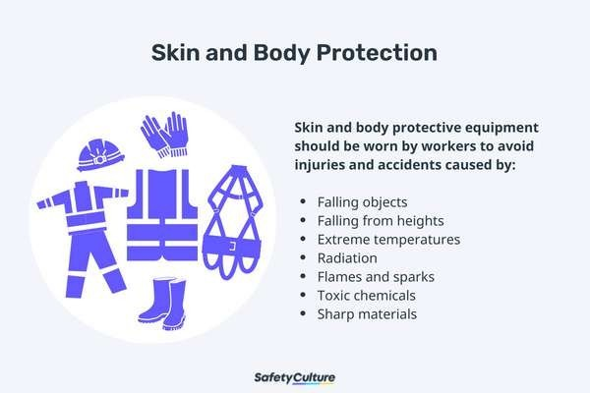

HearingProtection

PPEincludesearmuffsandplugsandshouldbeusedfortasksthatcancausehearing problems and lossof hearing.

SafetyTips:
  - Ensuretheequipmentfittheearcanalperfectly.

  - Itisrecommendedtouseformableearplugstofitondifferentsizesofearcanals.
  - Use protectors that reduce noise exposure to an acceptable level to have a room for communication.
  - Ensureearplugsarecleanandingoodcondition.
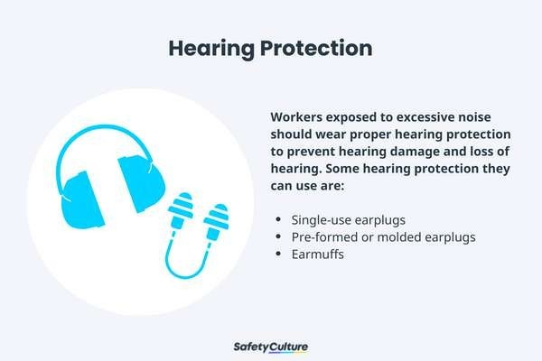

PPESafetyRequirements
TopromotePPEsafetyintheirworkplace,safetyofficerswillneedtodothefollowing:
  - CheckworksitesregularlyfortheneedofPPE.
  - IfPPEisneeded,provideemployeeswithproperly-fittedPPE.
  - TrainemployeesonOSHAPPEstandards.
  - Provide protective goggles or face shields when there is a danger of flying particles or corrosivematerials.
  - Require that safetyglasses are worn at all times in worksites that pose risk of eye punctures, abrasions,contusions, or burns.
  - Provide and require protective gloves in situations where employees could be cut or be possibly exposed to corrosive liquids, chemicals, blood, and other potentially infectious materials.
  - Require the use of foot protection when there is risk of foot injury from hot, corrosive,orpoisonoussubstances, and falling objects.
  - Inspecthardhatsperiodicallyfordamagetotheshellandsuspensionsystem.
  - MaintainPPEinsanitaryandready-to-useconditions.

  - Ensure that eyewash facilities and quick drench showers are easily accessible for employees when theyare accidentally exposed to corrosive materials.
  - Establish safe work procedures for disposing of or decontaminating PPE after hazardousexposuresSafetyCulture Marketplace: Your One-Stop Work Gear & Equipment Shop
ImprovesafetyinyourworkplacewithSafetyCultureMarketplaceasyour one-stopshop for all work gear and equipment needs. Get on-demand access to top quality and specialized work gear from trusted equipment brands in the industry—all in one centralized location. Raise the bar of safety and efficiency by empowering employees to request what they need with just a few taps, anytime and anywhere!

EnsureproperusageofPPEwithPPEcourses
Providing personal protective equipment (PPE) for your workers alone is not enough to protect them from hazards, injuries, and accidents, especially in industries such as construction, manufacturing, and healthcare. To ensure that their PPE fully serves its function, it’s crucial that your workers understand its proper use, maintenance, and disposal to protect themselves (as well as the people they serve, in the case of healthcare workers). Thankfully, training is made easy and convenient for you with the available PPE courses online that your workers can take at their own convenience.
Here,you’llfindourhighlyrecommendedPPEcoursesthatwillcoverthedifferenttypes of PPE and demonstrate when and how to use them properly. Reinforcing PPE training will not only keep your workers safe from hazards but also boost productivity without any threat of unwanted incidents. such
as:
    - PersonalProtectiveEquipment(PPE)forManufacturing
    - PersonalProtectiveEquipment(PPE)forConstruction

PPESafetySoftware
SafetyCulture (formerly iAuditor) provides a digital space for safety officers and employees to work towards PPE safety. SafetyCulture helps teams perform hazard assessmentstodetermineif enforcingPPEuseisthebestcontrolmeasureforthetask.It

alsoallowsemployeestomaintainPPEwithease.
Using the SafetyCulture app, employees can take pictures of PPE defects and even annotate photos to show where the damage is. Tracking the number of usable PPE is easier for safety officers as well and they are better equipped to provide what their employees need to get the job done.

PPEInspectionswithSafetyCulture
ByusingSafetyCultureforPPEinspections, safetyofficersareabletoprotectemployees from the hazards of the job by ensuring that their PPEs are always in good condition.
With SafetyCulture , conducting regular PPE inspections is easy with convenient access to inspection data automatically stored in the cloud. Safety officers can also generatePPE inspection reports instantlywith just one tap, anytime, and anywhere.
Beyond PPE inspections, SafetyCulture can also be used to develop an organization’shealth and safety
programbyenablingsafetyofficerstodothefollowing:
  - Enforcestandardizedsafetyprotocolsacrossteamsanddifferentsites
  - Mitigateriskswithawidevarietyoffreeriskassessmenttemplates
  - Plancorrectiveactionsimmediatelytopreventincidentsfromoccurring

EnsuringSafetyandProtectingEmployees
PPE Safety is the practice of ensuring a safe, working environment for employees and visitors through the use of Personal Protective Equipment (PPE). Safety is paramount to allbusinessesacrossindustries. UsingPPEs,pairedwithinspectionssuchas workplace and restaurantinspections,assessments like health and safety risk assessments, and analysis such as gap analysis—is essential to protect employees from risks and hazards.

SWOTANALYSIS

One way to explore these questions is through the useofanother devicepartially borrowed from TQM: SWOT analysis. SWOT stands for Strengths, Weaknesses, Opportunities, and Threats. Each of the questions above can be examined in the light of SWOT analysis. What are the strengths and weaknesses of your organization in regard to each question? What opportunities exist for the organization in each area of its functioning? And what threats or challenges will the organization have to overcome if it is to continue to be successful, and to maintain quality performance?
Strengths and weaknesses: Strengths and weaknesses may be trends, rather than specifics. A level of service that is currently appropriate, for example, is not a strength if it is more or less than will be needed in a year. A new program that's not ready to implement yet is not aweakness if it's unready because the developers are taking the time necessary to make it effective.
By the same token, strengths and weaknesses don't necessarily lie only in the success of programs or the skills of staff members, but in such areas as relationships, contacts, and reputation. An organization running a great program may still be have serious weaknesses because it lacks some of these other features, no matter how well it carries out its day-to-day activities.

Opportunities:

Opportunitiescantakemanyforms. Taking advantage of any opportunity can have both positive and negative consequences for your organization, so it's important to analyze the situation carefully before committing yourself.

Threats(Challenges):
Some of the challenges that go along with any opportunity can be truly dauntingif they're not thought through carefully. Many of the opportunities above require some sort of organizational restructuringor growth, processes that are always difficult, and require a lot of planning.Some even represent rethinking the purpose of the organization, which may become a different organizationintheprocess.Inbecominglargerormoreaccepted,forinstance,anorganization

mayforgetitsrootsoritsguidingprinciples,andlosemuchofitseffectiveness.
Other threats may come unaccompanied by opportunity. Your organization may experience difficulty finding -- and keeping -- ongoing funding and other resources, including competent staff; sustaining continued effort in all areas of functioning (advertising, recruitment, public relations, programming, evaluation, etc.); dealing with controversy; and addressing antagonism from individuals, other groups, or the community.
Applying SWOT analysis to all the areas yourorganizationhasto deal with makes it easierboth to anticipate and prepare for the negative, and to remember to identify andbuild on the positive.

LEGISLATION

INTELLECTUALPROPERTYRIGHTS(IPRIGHTS)

Intellectual Property Rights (IP Rights) are like any other property rights which are intangibleinnature. The IP Rights usually give the creator an exclusive right over the use of his/her creation for a certain period of time. With the rapid increase in the globalization and opening up of the new vistas in India, the "Intellectual Capital" has become one of the key wealth drivers in the present era. There are different country specific legislations, as well international laws and treaties that govern IP rights.

Every startup has IP Rights, which it needs to understand and protect for excelling in its business. Everystartupusestradename,brand, logo, advertisements, inventions, designs, products, or a website, in which it possesses valuable IP Rights. While starting any venture, thestartupalsoneedstoconfirmthatit isnot in violationof the IPRights ofany other person to save itself from unwarranted litigation or legal action which can thwartits business activities. Further, startup ventures should be proactive in developing and protecting their intellectual property for many reasons like improving the valuation of its business, to generate better goodwill, to protect its competitive advantage, to use intellectual property as a marketing edge and to use the IP Rights as a potential revenue stream through licensing.

IP Rights protect several aspects of a business and each type of IP Right carries its own advantages. The scope of IP Rights is very wide, but the prime areas of intellectual property which are of utmostimportance for any startup venture are as follows:

- Trademarks
- Patents
- CopyrightsandRelatedRights
- IndustrialDesigns

- Anorganizationmaybeabletomeetotherneedswithitscurrentstructure.Forinstance,an

organization that publicizes and provides prenatal care to pregnant teens could be inan excellent position to also publicize and provide vaccinations, nutrition information,and helpwith parenting skills after the babies are born.
- It maybepossible toexpand into otherareas of service, or intoa larger arena (anothertown, another county, national instead of just one state).
- Increasedfundingmaybeavailablefromnewsources, orbecause ofchangedcircumstances. A new census, for example, can result in an increase in federal funds to a region, or an economic downturn may bring a demand -- and increased funding -- for adult education or retraining.
- Collaborationwithothergroups,leadingtoincreasedresources,maybecomeaprospect.
- Invitations or awards offered to your organization or staff members or good press may lead to your organization being viewed as more "legitimate."

The Trade Marks Act 1999 ("TM Act") provides, inter alia, for registration of marks, filing of multiclass applications, the renewable term of registration of a trademark as ten years as well as recognition of theconcept of well-known marks, etc. It is pertinent to note that the letter "R" in a circle i.e. ® with a trademark can only be used after the registration of the trademark under the TM Act.

Trademarks meansanywords, symbols, logos, slogans, product packagingordesign that identify the goods or services from a particular source. As per the definition provided under Section 2(zb) of the TM Act, "trade mark" means a mark capable of being represented graphically and which is capable of distinguishing the goods or services of one person from those of others and may include shape of goods,their packaging and combination of colors.

The definition of the trademark provided under the TM Act is wide enough to include non-conventional marks like color marks, sound marks, etc. As per the definition provided under Section 2 (m) of the TM Act, "mark" includes a device, brand, heading, label, ticket, name, signature, word, letter, numeral, shape of goods, packaging or combination of colors or any combination thereof.

Accordingly, any mark used by the startup in the trade or business in any form, for distinguishing itself from other, can qualify as trademark. It is quite significant to note that the Indian judiciary has been proactive in the protection of trademarks, and it has extended the protection under the trademarks law to Domain Names as demonstrated in landmarkcasesof Tata Sons Ltd vManu Kosuri & Ors[90 (2001) DLT659] andYahoo Inc. v Akash Arora [1999 PTC 201].

PointstoConsiderWhileAdoptingaTrademark

Any startup needs to becautious in selectingits trade name, brands, logos, packagingfor products, domain names and any other mark which it proposes to use. You must do a proper due diligence before adopting a trademark. The trademarks, can be broadly classified into following five categories:

  - Generic
  - Descriptive
  - Suggestive
  - Arbitrary
  - Invented/Coined

Genericmarksmeansusingthenameoftheproductfortheproduct,like"Salt"forsalt.

Descriptive marks means the mark describing the characteristic of the products, like using the mark "Fair" for the fairness creams.

Suggestive marks means the mark suggesting the characteristic of the products, like "Habitat" for home furnishings products.

Arbitrary marks means mark which exist in popular vocabulary, but have no logical relationshiptothegoodsorservicesforwhichtheyareused,like"Blackberry"for

phones.

The invented/ coined marks means coining a new word which has no dictionarymeaning, like "Adidas".The strongest marks, and thus the easiest to protect, are invented or arbitrary marks. Theweaker marks are descriptive or suggestive marks which arevery hard to protect. The weakest marks are generic marks which can never function as trademarks.

India follows the NICE Classification of Goods and Services for the purpose of registrationof trademarks. The NICE Classification groups products into 45 classes (classes1-34includegoodsandclasses35-45includeservices).TheNICEClassification is recognized in majority of the countries and makes applying for trademarks internationally a streamlined process. Every startup, seeking to trademark a good or service, has to choose from the appropriate classes, out of the 45 classes.

While adopting any mark, the startup should also keep in mind and ensure that the mark is not being used by any other person in India or abroad, especially if the mark is well- known. It is important to notethat India recognizes the concept of the "Well-known Trademark" and the principle of "Trans-border Reputation".

Example of well-known trademarks are Google, Tata, Yahoo, Pepsi, Reliance, etc. Further, under the principle of "Trans-border Reputation", India has afforded protection to trademarks like Apple, Gillette, Whirlpool, Volvo, which despite having no physical presence in India, are protected on the basis of theirtrans-border reputation in India.

EnforcementofTrademark Rights

Trademarks can be protected under the statutory law, i.e., under the TM Act and the commonlaw, i.e., undertheremedyofpassingoff.Ifapersonisusingasimilarmarkfor similar or related goods or services or is using a well-known mark, the other person can fileasuitagainst thatpersonfor violationoftheIPrightsirrespectiveofthefact thatthe

trademarkisregisteredornot.
Registration of a trademark is not a pre-requisite in order to sustain a civil or criminal action against violation of trademarks in India. The prior adoption and use of the trademark is of utmost importance under trademark laws.

The relief which a court may usually grant in a suit for infringement or passing off includespermanentandinteriminjunction, damagesoraccount ofprofits,deliveryofthe infringing goods for destruction and cost of the legal proceedings. It is pertinent to note that infringement of a trademark is also a cognizable offence and criminal proceedings can also be initiated against the infringers.

PATENTS

Patent, in general parlance means, a monopoly given to the inventor on his invention to commercial use and exploit that invention in the market, to the exclusion of other, for a certain period. As per Section 2(1) (j) of the Patents Act, 1970, "invention" includes any new and useful;

- art,process,methodormannerofmanufacture;
- machine,apparatusorotherarticle;
- substanceproducedbymanufacture,andincludesanynewanduseful improvementofany of them, and an alleged invention;

The definition of the word"Invention" inthe Patents Act, 1970 includes the new product as well as new process. Therefore, a patent can be applied for the "Product" as well as "Process" which is new, involving inventive step and capable of industrial application can be patented in India.

The inventionwill notbeconsiderednewifithasbeendisclosedtothe public in India or anywhere else in the world by a written or oral description or by use or in any other way beforethefilingdateofthepatentapplication.Theinformationappearinginmagazines,

technical journals, books etc, will also constitute the prior knowledge. If the invention is already a part of the state of the art, a patent cannot be granted. Examples of such disclosure are displaying of products in exhibitions, trade fairs, etc. explaining its working, and similar disclosures in an article or a publication.

It is important to note that any invention which falls into the following categories, is not patentable: (a) frivolous, (b) obvious, (c) contrary to well established natural laws, (d) contrary to law, (e) morality, (f) injurious to public health, (g) a mere discovery of a scientific principle, (h) the formulation ofanabstract theory, (i) a mere discovery of any new property or new use for a known substance or process, machine or apparatus, (j) a substance obtained by a mere admixture resulting only in the aggregation of the properties of the components thereof or a process for producing such substance, (k) a mere arrangement or rearrangement or duplication of known devices, (l) a method of agriculture or horticulture, and (m) inventions relating to atomic energy or theinventionswhichareknownorused byanyother person, orusedorsold toanyperson in India or outside India. The applicationfor the grant of patent can be made by either the inventor or by the assignee or legal representative of the inventor. In India, the term of the patent is for 20 years. The patent is renewed every year from the date of patent.

UseofTechnologyorInvention

While using any technology or invention, the startup should check and confirm that it doesnotviolate anypatentright of the patentee. If the startupdesirestouse anypatented invention or technology, the startup is required to obtain a license from the patentee.

EnforcementofPatentRights

Itispertinenttonotethatthepatentinfringementproceedingscanonlybeinitiated after grant ofpatent in India but may include a claim retrospectively from the date of publication of the applicationfor grant of the patent. Infringement of a patent consists of theunauthorizedmaking,importing,using,offeringforsaleorsellinganypatented

inventionwithinthe India. Underthe (Indian)PatentsAct, 1970onlya civilactioncanbe initiated in a Court of Law. Like trademarks, the relief which a court may usuallygrant in a suit for infringement of patent includes permanent and interim injunction, damages oraccountofprofits, deliveryoftheinfringinggoodsfordestructionandcostofthelegal proceedings.

COPYRIGHT
Copyright means a legal right of an author/artist/originator to commercially exploit his original work which has been expressed in a tangible form and prevents such work from being copied or reproduced without his/their consent.

Under the Copyright Act, 1957, the term "work", in which copyright subsists, includesan artistic work comprising a painting, a sculpture, a drawing (including a diagram, a map, a chart or plan),an engraving, a photograph, a work of architecture or artistic craftsmanship, dramatic work (recitation, choreographic work), literary work (including computer programmes, tables, compilations and computer databases), musical work (including music as well as graphical notations), sound recording and cinematographic film.

In the case of original literary, dramatic, musical and artistic works, the duration of copyright is the lifetime of the author or artist, and 60 years counted from the year following the death of the author and in the case of cinematograph films, sound recordings, posthumous publications, anonymous and pseudonymous publications,works of government and works of international organizations are protected for a period of 60 years which is counted from the year following the date of first publication.

In order to keep pace with the global requirement of harmonization, the Copyright Act, 1957 has brought the copyright law in India in line with the developments in the informationtechnology industry, whether it is in the field of satellite broadcasting or computer software or digital technology.

RegistrationofCopyright

In India, the registration of copyright is not mandatory as the registration is treated as mere recordal of a fact. The registration does not create or confer any new right and isnota prerequisite forinitiatingactionagainstinfringement. The viewhasbeenupheldby the Indian courts in a catena of judgments. Despite the fact that the registration of copyright is not mandatory in India and is protectable through the InternationalCopyright Order, 1999, it is advisable to register the copyright as the copyright registration certificate is accepted as a "proof of ownership" in courts and by police authorities, and acted upon smoothly by them.

EnforcementofCopyrightinIndia

Any person who uses the original work of the other person without obtaining license from the owner, infringes the copyright of the owner. The law of copyright in India not only provides for civil remedies in the form of permanent injunction, damages or accounts of profits, delivery of the infringing material for destruction and cost of thelegal proceedings, etc, but also makes instances of infringement of copyright, a cognizable offence punishable with imprisonment for a term which shall not be less than six months but which may extend to three years, with a fine which shall not be less than INR 50,000 but may extend to INR 200,000

For the second and subsequent offences, there are provisions for enhanced fine and punishment under the Copyright Act. The (Indian) Copyright Act, 1957 gives power to the police authorities to register the Complaint (First Information Report, i.e., FIR) and act on its own to arrest the accused, search the premises of the accused and seize the infringing material without any intervention of the court.

INDUSTRIALDESIGNS
As per the definition given under Section 2(d) of the Designs Act, 2000, "design" means onlythefeaturesofshapeconfigurationpatternsorornamentappliedtoanyarticleby

any industrial process or means whether manual mechanical or chemical separate or combined which in the finished article appeal to and are judged solely by the eye. However, "design" does not include any mode or principle of construction or anything which is in substance a mere mechanical device and does not include any trademark as defined under the TM Actor any artistic workas defined under the Copyright Act, 1957. The total period of validity of registration of an Industrial Design under the (Indian) Designs Act, 2000is 15 years.

Features of shape, configuration, pattern, ornament or composition of lines or colours applied to any article, whether in two dimensional or threedimensional or inbothforms,canberegistered under the (Indian) Designs Act, 2000. However, functionality aspects of a design are not protected under the (Indian) Designs Act, 2000, as the same are subject matter of patents.

DesignofanarticleisnotregistrableinIndia,ifit:

- isnotnewororiginal;
- has been disclosed to the public anywhere in India or in any other country by publication in tangible form or by use in any other way prior to the filing date or priority date of the application;
- is not significantly distinguishable from known designs or combination of known designs; or
- comprisesorcontainsscandalousorobscenematter.

EnforcementofDesignRightsinIndia

The (Indian) Designs Act, 2000, only provides for civil remedies. Besides injunction, monetary compensation is recoverable by the proprietor of the design either as contract debt or damages. An action for infringement of design can only be initiated after the registration of the design, however, an action for passing-off is maintainable in case of unregistered design.

TRADESECRETS

Trade secrets includes any confidential business information which provides an enterprise acompetitive edge over others. Trade secrets encompass manufacturing or industrial secrets and commercial secrets, formula, practice, process, design, instrument, pattern,commercialmethod, orcompilationofinformationwhichisnotgenerallyknown or reasonably ascertainable by other.

The unauthorized use of such information bypersons other than the holder is regarded as an unfair practice and a violation of the trade secret. There are no specific statutes under the Indian law for the protection of trade secrets and the same are protectable under the common law rights.

STRATEGIESFORPROTECTIONANDEXPLOITATIONOFIPRFORSTARTUPS

  - MakeIntellectualPropertyprotectionapriority:

Start-ups cannot afford the complete protection available under the intellectual propertyregime.The first step for any startup is to evaluate and prioritize the IP Rights involved in its business. Dependingupon the type of industryinvolved, IP Rights play an important role. Failure to identify or prioritize IP Rights, is likely to create problems for startup's business, especially during negotiations with future investors or exiting its business. Sometimes IP Rights are the only asset available with a startup.
  - RegisterIntellectualPropertyRights:

It is important to note that certain IP Rights like patents and designs are required to be registeredbeforeclaiminganyprotectionundertherespectivestatutes. Ontheotherhand, certain IP Rights like trademark and copyright need not be mandatorily registered for protectionunder. Nevertheless, a registered IP Right carries a greater value and acts as evidence of use of the IP Rights before courts as well as enforcement agencies;

  - DueDiligenceofIPRights:

For any startup, it is indispensable that it does not violate IP Rights of any other person.This willensure safety from unwarranted litigation or legal action which can thwartitsbusinessactivities. Thismakesiteven more importantforstartups to make careful IP decisions in the initialphase and conduct properdue diligence of IP Rights, which it is using or intends to use.
  - Implementclearandeffectivepoliciesandstrategiesforprotectionof IPRights:

It is in the long term interest of startups to have an Intellectual Property Policyformanagementof various IP rights which may be presently owned, created or acquired in futureby startups.The aim of such a policyis to ensure thatthere are no inter-se dispute between the promoters of the startups, which remains till date to be one of the main concerns for failure of startups.
  - AgreementsrelatedtoIntellectualProperty:

Itispertinenttonote thathavingproperdocumentationintheformofagreements like non- disclosure agreements, agreements with employees or independent contractors, canmakeall the difference between the success and failure of startups. Usually, intellectual property is created either by the founders or some key employee or a third party. The intellectual property so created, must be protected through a proper agreement between the founder orkey employee or a third party, as the case maybe and the startup. If the agreement, with founders or employees or a third party, , under which a novel idea was/is created, is overlooked, it could create bottlenecks later after such idea becomes successful. Accordingly, the startups need to ensure that anything created on behalf of the startup, belongs to the startup and not the Employee ora third party. Further, it is advisable to enter into elaborate assignments, licensing or user agreements,and careshouldbetakentomakeprovisionsforallpostterminationIPRight issues.

Whatisintellectualpropertyandwhatisintellectualpropertyrights?

The World Intellectual Property Organisation defines intellectual property as creations of the mind,such as inventions; literary and artistic works; designs; and symbols, names and images used in commerce.

In simple terms, anything that you create by applying your mind or intellect becomes your intellectualproperty. For example, you are setting up a business of your own and have designed a logo for your brand. That logo is your intellectual property. Similarly a scientific invention is also an intellectual property.

When you create a logo for your brand, you will want it to be unique and resonate with your brand. Youwant to stand out from your competitors and also make sure your ideas are not copied or misused. Thisis where intellectual property rights come in.

Intellectual property rights are given to creators for a specific amount of time. During this time the creator is protected from infringement and can license their product for manufacturing in return for aroyalty.

The legal rights provided to the creator or inventor of intellectual property are known as intellectual property rights. Every creator enjoys certain privileges provided by the lawthat protects the creatorsfrom infringement or misuse of their work without their explicit permission. Intellectual property rights also aid creators in putting their work to use for the general public by allowing for commercial licencing. Intellectual property rights are granted to creators for a limited period of time.

Whatarethetypesofintellectualproperty?
As mentioned earlier, intellectual property is an umbrella term used to describe creations of the human mind. For the purpose of intellectual property rights protection, IP can be categorised as the following:

- Trademarks:Thisreferstoanysymbols,logossigns,wordsand/ orsoundsthat

areunique to aproduct or business. For example, the trademark blue bird logo for Twitter is its representativeof its brand and is protected by intellectual property rights.
- Copyrights: This is applicable to any published work such as books, art work, songs,webcontentandfilms,amongothers.YourfavouritecartoonduoTomand Jerry are artwork copyrighted by Disney.
- Patents: Any new invention that holds the potential being put to commercial use is protected from infringement or duplication by a patent. Recently,pharma major Cipla losta patent battleto Amgen Inc over the injectablecancer drug Kyprolis.
- Industrial designs: These are features such as shape, pattern, ornament or composition appliedto a product by an industrial process such as by chemical process or mechanical process.
- Geographical indicators: A name or sign used on certain products that marks the identity of aparticular geographical location or origin is termed as a geographical indicator. For example, West Bengal holds the geographical indicator tag for its beloved Rosogolla.

Indianlawstoprotectintellectualproperty

In India, intellectual property rights are protected by a host of laws and rules issued by the governmentfromtime totime.Primarily, intellectualpropertyrightsare protectedby the following legislation and rules:

- Trade Marks Act, 1999 and Trade Marks Rules of 2002 and 2017. Your beloved mango drink Maaza was embroiled in a trademark controversy when Coca Cola claimed infringement of trademark over Bisleri. Originally a drink by Bisleri, the trademarks for the drink was sold to Coca Cola by Bisleri. However, in 2008, Bisleri filed for registering the trademark for Maaza in Turkey, which was then contested by Coca Cola
- ThePatentsAct,1970(asamendedin2005),2003PatentRulesand2016

PatentAmendmentRules
- The Copyright Act, 1957. The most notable case under this Act was the Tips vs Wynk music fallout. Tips Industries and streaming platform Wynk had enteredan agreement where the latterwas granted a licence to access the large music database of Tips. At the end of this agreement, amid negotiations for extending the agreement, Tips alleged that Wynk was infringeing on its IP. The judgement was in favour of Tips Industries.
- TheDesignsAct,2000,andDesignsRules,2001
- TheGeographicalIndicationsofGoods(RegistrationandProtection)Act,1999
- TheSemiconductorIntegratedCircuitsLayoutDesignAct,2000
- TheProtectionofPlantVarietiesandFarmers’RightAct,2001

While these laws provide domestic protection to intellectual property rights, India has also signedagreements with various countries for safeguarding intellectual property.

HowtoprotectyourintellectualpropertyinIndia
The intellectual property laws in the country are designed to support innovation and research. In orderto reap the benefits of intellectual property rights in the country, the first step is to register your creation. You can register your intellectual property for patents,trademarksorcopyrights.Incaseofaninfringement, youcanchallenge thesame as civil disputes in the court of law.

Advantagesofintellectualpropertyrights

Here’swhyitisimportanttolookafterintellectualpropertyrights:

- Ownership: In a competitive world, entrepreneurs, businesses and researchers are constantlytrying to outdo each other. A determining factor to win in this competition is ownership of the creation. Intellectual property rights ensurethat the creator holds the sole authority over theircreation.
- Infringement:Withintellectualpropertyrights,creatorsareprotectedagainst

any competitor illegally contravening on the creation. For example, an entrepreneur’s scientific invention is theirown. They are the sole owner of the creation and can choose to do what they wish with it. Anybody using the scientific invention for any purpose without paying due credit or royalty to the creator is liable to face legal action.
- Commercialisation: Intellectual property rights are of great importance when a creator wishesto commercialise their product. It paves the way for the creator to issue a licence for mass production of the product in exchange for monetary benefits and royalty.
- Learning: While registering a new intellectual property, the creator has to reveal details of theproduct to the general public. This practice encourages a culture of sharing of information thatcan be used for further development by contemporaries in the field.

Final note: Intellectual property rights are important drivers of the economic growth of a country. For inventors and entrepreneurs, who are constantly competingwitheach other to stand out in the market,intellectual property rights are essential.

In India, intellectual property rights safeguard the interests of the inventor. You can bring civil orcriminal cases against competitors to enforce your intellectual property rights, depending on theinfringement or violation.
There are only three ways to protect intellectual property in the United States: throughthe use patents,trademarks or copyrights. A patent applies to a specific product design; a trademark to a name, phrase or symbol; and a copyright to a written document. All three methods have limitations--there's no one perfectway to protect an idea.

CopyrightProtection

Acopyrightwillprotectthefollowingcategoriesofworks:

  - literaryworks
  - musicalworks,includinganyaccompanyingwords
  - dramaticworks,includinganyaccompanyingmusic
  - pantomimes andchoreographicworks
  - pictorial,graphicandsculpturalworks
  - motionpicturesandotheraudiovisualworks
  - soundrecordings
  - architecturalworks
  - computerprograms(sometimesthegraphicaluserinterface)andwebsites

Copyright protection gives the copyright holder the exclusive right to copy the work,modifyit (that is,create "derivative works"), and distribute, perform and display the work publicly.

Ideas or concepts do not have copyright protection. Copyright protects the expression of the idea, butnot the ideas themselves. For example, if I ask you what a chair is, you get a picture in your head; the 11 picture I get in my head is different from the picture you get in your head and probably also different from the picture Buffy gets in her head. These are the "ideas" of what a chair is. However, if you were todraw the chair you envisioned in your head or use words to describe that chair, it's an "expression" of the idea--and that's what's protected by copyright.

Generally, the onlyprotectionforideasandconceptsisthrough trade secretlaw and/or confidentiality agreements, which provide a contractual remedy for misuse or disclosure of the idea.

Patents

Patentsprotectprocesses,methodsandinventionsthatare"novel,""non-

obvious" and "useful." If granted, a patent gives you a 20-year monopoly on selling, using, making or importing an invention intothe United States. The requirements for a patent are complex, but here they are in a nutshell:
Yourworkmustbenovel.

This means it must not be known or used by others in this country, or patented or described in a printed publication here or abroad, or in public use or for sale in this countrymore than one year prior to the application for patent.
Yourworkmustbenon-obvious.
Thismeans it must not be obvious to a person having ordinary skillin the pertinent art as it existed when the invention was made.
Yourworkmustbeuseful.
This means that it must have current, significant, beneficial use as process, machine, manufacture, composition of matter or improvements to one of these. According to the Patent Office: "The word 'process' is defined by law as a process, act or method, and primarily includes industrial or technical processes. The term 'machine' used in the statute needs no explanation. The term'manufacture' refers to articles that are made,andincludesallmanufacturedarticles.Theterm'compositionofmatter'relates to chemical compositions and may include mixtures of ingredients as well as new chemical compounds. These classes of subject matter taken together include practically everything which is made by man and the processes for making the products."

Patent protection requires full public disclosure of the work in detail and therefore precludesmaintaining any trade secret protection in the same work.

Trademarks

Atrademarkislikeabrandname.Itisanyword(s)orsymbol(s)thatrepresenta

product to identify and distinguish it from other products in the marketplace. A trademark word example would be "Rollerblades." A trademark symbol would be the peacock used by NBC.
Atrademarkcanberegisteredinthreeways:

- Byfilinga"use"applicationafterthemarkhasbeenused.
- Byfilingan"intenttouse"applicationifthemarkhas notyetbeenused.
- Incertaincircumstancesinwhichaforeignapplicationexists,youcanrelyonthat.

The (TM)markmaybeusedimmediatelynexttoyourmark. The ®registrationsymbol may only be used when the mark is registered with the PTO. It is unlawful to use this symbol with your mark beforereceiving an issued registration from the PTO.

Whatqualitiesmakeforastrongtrademark?

The cardinal rule is that a mark must be distinctive. Themore distinctive it is, the easier your trademark will be to enforce. This is why so many trademarked products have unique spellings.
Trademark rights last indefinitely if the company continues to use the mark to identify its goods or services. When the mark is no longer being used, the registration is terminated. The initial term of federal trademark registration is 10 years, with 10-year renewal terms.

TradeSecrets

There isa great dealofconfusion regardingtrade secrets. Manypeople think thata trade secret is sometype of protection provided by the government that allows them to seek recourse in court should someone infringe upon their idea. However, unlike copyrights, trademarks and patents, a trade secret isnot registered with any government office to provide a verifiable public record of any claims to the secret. You can, however, declare onetoapatentlawyerinanotarizedandsigneddisclosure.Inthismannerthetrade

secretbelongstoyouforever--oruntilsomeoneleaksit.

Trade secrets refer toitems suchas recipesthatare unique andprovide a business witha competitiveadvantage, but which cannot be safeguarded under current forms of idea protectionsuch as copyright,trademark or patent. The best form of protection for these items is to keep them a secret. One of the most famous and best-kept trade secrets is the formula for Coca-Cola.

The best way to secure the information for a trade secret is to restrict access to the secret and have individuals and companies sign nondisclosure agreements with you should you enter into a relationshipwith them which will require them to know some aspects of the secret. If someone independently develops or reverse-engineers your trade secret, there's nothing you can do. If someone does leak it, you can sue for theft. Suing, however, cannot stop the person from using the leaked information. So although you may get money from the suit, you lose the larger potential profits you could have made from the idea. Still, if yourluck holds andyourtrade secret remainssecret, royaltyincomefrom it can last significantly longer than the patent period.

FEATURESOFFACTORYACT1948

Introduction

The Factories Act of 1948 was enacted to protect the welfare of workers in a factory by regulating employment conditions, working conditions, the working environment, and otherwelfarerequirementsofspecificindustries.TheCourtheldinRaviShankarSharma
v. State of Rajasthan (1993) that the Factory Act is social legislation that covers the health, safety, welfare, and other aspects of factory workers. The Factories Act lays out guidelines and safety measures for using machinery, and with its strict compliance, italso provides owners with instructions. When factory workers were taken advantage of and exploited by paying them low wages, the Factories Act was passed.

A factoryis a building or group of buildings where people workwith machineryto make goods.TheprimarygoaloftheFactoriesActistosafeguardemployeesinafactoryfrom

industrialand occupational risks. This Act gives the owner or occupier of a factory a particularresponsibility to secureand protect employees from employment in conditions harmful to their health and safety in order to safeguard workers. It is stated in the Actthat the purpose of the Factories Act is to amend and consolidate the legal framework governingfactorylabour.TheBhopal gastragedycase(1984)raisedpublicawarenessof factory pollution and risks, necessitating government action to allow legislation amendments.
Salient features of Factories Act, 1948 with Amendment-The important features of the 1948 Act are as follows:he word “factory” has been expanded by the Factories (Amendment)Actof1976toincludecontractlabourwhendeterminingwhetherafactory has a maximum of 10 or 20 employees.
  - The Act increased the minimum age for children to work in workplaces from 12 to 14 and reduced their daily working hours from 5 to 4 and a half.
  - The Act forbids women and children from working in factories from 7 p.m. to 6 a.m.
  - The difference between a seasonal and non-seasonal factory has been abolished by the Act.
  - TheAct,whichhasprovisionsforfactoryregistrationandlicencing.

  - The state government is required to make sure that all factories are registered and also have valid licences that are renewed from time to time.
  - The Act gives state governments the authority to enact rules and regulations that ask for management and employee association for the benefit of employees.
  - The state government has the authority to apply the Act’s requirements toany establishment, regardless of the number of employees insideand regardless of whether the establishment engages in manufacturing operations.
  - InRabindra Agarwal v. State of Jharkhand(2010), the Jharkhand High Court heldthattheFactoriesAct,speciallegislationwouldprevailovertheIndian

PenalCode
ObjectivesofFactoriesAct,1948
- ThemajorgoaloftheFactoriesActof1948istoestablishadequatesafetymeasures and to enhance the health and welfare of workers employed in a factory. The Act also protects workers from various industrial and occupational hazards.
  - Heath: According to the Act, all factories must be kept clean, and all essential safeguards must be taken to safeguard the health of workers. The factory must have a sufficient drainage system, adequate lighting, ventilation, temperature, etc. There must be clean water supplies. Separate restrooms and urinals must be built in convenient locations for males and females. These must be freely accessible to employees and kept clean.
  - Safety: The Act requires that machines be properly fenced; that no young adults work on any dangerous machines in enclosed places, and also that appropriate manholes be provided so that employees may escape in an emergency.
  - Welfare: The Act specifies that appropriate and suitable washing facilities for workers must be provided and maintained in every factory. There must be storage and drying facilities, as well as sitting areas, first-aid equipment, shelters, restroomsand lunch rooms.
  - The Act also imposes some restrictions on the employment of women, small children, and teenagers, such as working hours, intervals, holidays, etc., as well as on annual leave with pay,etc.
  - Working hours: The Act sets working hours for all workers, and no adult worker mustbe permitted to work in a workplace for more than 48 hours per week. Weekly holidays need to be granted.
  - The Act also imposes specific restrictions on owners, occupiers, or the manufacturer’s head in order to safeguard employees and ensure their health and safety precautions.
  - The Act protects workers from exploitation and improves working conditions and the environment within factory premises.
  - Penalties: The Act also specifies specific rules created with provisions under the Act,andwrittenordersthatareviolated.Itisanoffence,andpenaltieswillbe

imposed,imprisonmentforuptoayear;afineofuptoonelakhrupees;or bothfineand imprisonment. Any employee who misuses equipment related to the welfare,safety,andhealthofotheremployees,orthoseconnectedtotheperformanceofhis duties, suffers a Rs.500 fine.

Whatis“Wages”?
Wage is monetary compensation or remuneration, personnel expenses, of the labor paid byan employer to the employees in exchange for work done. Wage may be calculatedas a fixed amount for eachtaskcompletedoratanhourly /daily rate/basedonan easily measured quantity of work done.

Wagesincludeallremunerationswhichareexpressedintermsofmoneyand “includes”the following:

    - Amountpayableunderthetermsofemployment
    - Payableunderanyaward/settlementororderofaCourt
    - PaidasOvertimeworkorforholidays/leaveperiod
    - PayableonaccountofTerminationofemployment” Wages does “not include” the following Payments:
    - Bonuswhichdoesnotformapartofremuneration
    - Valueofanyhouseaccommodation,supplyoflight,water,medicalassistanceetc.
    - Anytravelingconcession
    - Contributionpayablebyemployertoanypensionorprovidentfund
    - Anysumpaidtodefrayspecialexpensesincurredasrequirementofthe Employment
    - Gratuitypayableonterminationofemployment.

Objectives:

    - Regulatepaymentofwagestospecificclassofworkersemployedinindustry without anywrongful deductions apart from what is mentioned in the Act

    - Defineregulationsaroundfixingofwageperiod,timeandmodeofpaymentof wages
    - RegulatestherightsoftheworkerscoveredunderthisAct.

Applicability:

This Act is applicableto allpersons employed,whether directly or through contractors,ina factory orcertain specified industrial or other establishments.

    - The Central Government is responsible for enforcement of the Act in Railways, Mines,Oilfieldsand air transport services.
    - TheStateGovernmentareresponsibleforitallotherestablishment(factories and otherestablishments)
    - TheActdoesnotcoverthosewhosewageis Rs. 24,000/-or more per mo

SalientFeaturesoftheAct:
- ObligationsofEmployers:

Everyemployerisresponsibleforthepaymentofwagestoalltheemployees that heemploys.Additionally,apartfromthe Employer, all thepersonsonamed
/ person so responsible to the employer / the person so nominated shall also beresponsible for such payment.

- WagePeriod:

Every person responsible forWage Payment shall fix periods in respect of which such wages shall be payable. No wage-period shall exceed one month.

- TimeandModeofPaymentofWages:

Every establishment having employees in excess of 1,000 person shall pay thewagesbeforetheexpiryofthe10thday.Allotheremployersshallmakethe

Wagepaymentbytheexpiryof07thday.
Employers shall make the payment of wages in current currency notes i.e. cash or via Bank transfer.
- DeductionsfromWages:

Employers shall ensure that wages are paid to all employees without deduction of any kind except those authorized by or under this Act.
Deductionincludesthereductionofwagesforthefollowing:
    - Fines
    - Absencefromduty
    - Damagetoorlossofgoodsincludinglossofmoneywheresuchdamageor lossisdirectlyattributable to employee’s neglect or default
    - Recoveryofadvances/loansandtheinterestdueinrespectthereof
    - Adjustmentofover-paymentsofwages
    - Payments made by the employed person to the employer or his agent shall alsobe deemed to bea deduction from wages.

Deductions doesnotinclude followingpenalties(providedtherulesw.r.t.penalty areinconformity with the requirements as specified by the State Government):

    - Withholdingofincrementorpromotion
    - Reductiontoalowerpost
    - Suspension

A.ComplianceRequirements:MaintenanceofRegisters:
EmployersshallmaintainRegistersandrecordsgivingthefollowingdetails:

    - Particularsofpersonsemployed
    - WorkperformedbyEmployees
    - Wagespaidtoemployeesanddeductionsmadefromtheirwages
    - AlltheseRegistersarerequiredtobepreservedforaperiod of03Years.

DisplayofNoticeofAbstracts:
All Employers shall display Notice containing such abstracts of this Act and of the rules made thereunder in English and in the language of the majority of the persons employed in the factory. It includes the following:
    - ListofactsandomissionsapprovedunderRule12
    - Rates ofwagespayabletoemployees(excludingthoseinsupervisor/managerpositions).
- PenaltiesforOffencesundertheAct:
  - If Employers fails to maintain registers required under this act or wilfully refuses to furnish such information or return or wilfully furnishes false information shall be punishable with fine up to Rs. 1,500andmayextendto Rs. 7,500.
  - Additionally, If Employers fails to pay the wages by the date fixed by the authority shall be punishable with an additional fine which may extend to Rs. 750 / Day.
- Un-disbursedWagesineventofDeathofanEmployee:
  - In case the Wages cannot be paid on account death of an employee or non- availability of details of his / her whereabouts, such amounts is required to be paid to person nominated by him in this behalf. In case employee has not nominated anyone, such amount shall be deposited with the prescribed authority.

SMARTTECHNOLOGY

IOT(InternetOfThings)

The Internet of Things (IoT) describes the network of physical objects—“things”—that are embedded with sensors, software, and other technologies for the purpose of connecting and exchanging data with other devices and systems over the internet.

“The Internet of Things (IoT) is a system of interrelated computing devices, mechanical anddigital machines, objects, animals orpeople thatare provided with unique identifiers and the abilityto transfer data over a network without requiring human-to-human or human-to-computer interaction.”

InternetofThings:

According to the definition of IoT, It is the way to interconnection withthehelpofthe internetdevicesthatcanbeembeddedtoimplementthefunctionalityineverydayobjects by enabling them to send and receive data. Today data is everything and everywhere. Hence, IoT can also be defined as the analysis of the data generate a meaning action, triggered subsequently after theinterchangeof data. IoT can be used to build applications for agriculture, assets tracking, energy sector, safety and security sector, defense, embedded applications, education, waste management, healthcare product, telemedicine, smart city applications, etc.
11

However, all complete IoT systems are the same in that they represent the integration of four distinct components: sensors/devices, connectivity, data processing, and a user interface.

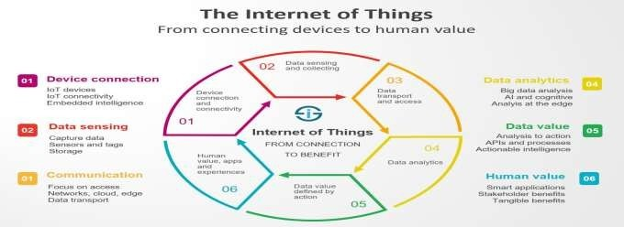

HowanIoTSystemActuallyWorks

As you saw in the previous chapter, the applications for IoT extend across a broadvariety of use cases and verticals. However, all complete IoT systems are the same inthat they represent the integration of four distinct components: sensors/devices, connectivity, data processing, and a user interface.
We’ll outline what each one means in the sections below and how they come together to form acomplete IoT system. Each of these sections will also serve as the organizational structure of the rest of this ebook, and we’ll dive into these components more deeply in the chapters to follow.
- Sensors/Devices
  - First, sensors or devicescollect data from their environment. This data could be as simple as a temperature reading or as complex as a full video feed.
  - We use “sensors/devices,” because multiple sensors can be bundled together or sensors can be part of a device that does more than just sense things. For example, your phone is a device that has multiple sensors (camera, accelerometer, GPS, etc), but your phone is not just a sensor since it can also perform many actions.
  - However, whetherit’sa standalone sensor or a full device, in this first step data is being collected from the environment by something.

- Connectivity
  - Next,thatdataissenttothecloud,butitneedsawaytogetthere!
  - The sensors/devices can be connected to the cloud through a variety of methods including: cellular, satellite, WiFi, Bluetooth, low-power wide-area networks (LPWAN), connectingvia agateway/routerorconnectingdirectlytotheinternetvia ethernet (don’t worry, we’ll explain more about what these all mean in our connectivity section).
  - Each option has tradeoffs between power consumption, range, and bandwidth. Choosing which connectivity option is best comes down to the specific IoT application, but they all accomplish the same task: getting data to the cloud.
- DataProcessing
- Once the data gets to the cloud (we’ll cover what the cloud means in our data processing section)), software performs some kind of processing on it.
- This could be very simple, such as checking that the temperature reading is within an acceptable range. Or it could also be very complex, such as using computer vision on video to identify objects (such as intruders on a property).
- But whathappenswhenthe temperature istoohighorif there isanintruderonproperty? That’s wherethe user comes in.

- UserInterface
  - Next, the informationismadeusefultotheend-userin some way. Thiscouldbe via analertto the user (email, text, notification, etc). For example, a text alertwhen the temperature is too high in the company’s cold storage.
  - A user might have an interface that allows them to proactively check in on the system. For example, a user might want to check the video feeds on various properties via a phone app or a web browser.
  - However, it’s not always a one-way street. Depending on the IoT application, the user may also be able to perform an action and affect the system. For example, the user might remotely adjustthe temperature in the cold storage via an app on their phone.
  - Andsomeactionsareperformedautomatically.Ratherthanwaitingforyouto

adjust the temperature, the system could do it automatically via predefined rules. Rather than just call you to alert you of an intruder, the IoT system could also automatically notify security teams or relevant authorities.
  - Modern technology offers much interactive design to ease complex tasks into simple touch panels controls. Multicolor touch panels have replaced hard switches inourhouseholdappliancesandthe trendisincreasingforalmosteverysmarthome devices.
  - Userinterfacedesignhashighersignificanceintoday’scompetitive market,it often determines the userwhether to choose a particular device or appliance. Users willbe interested to buy new devices or smartgadgets if it is very user friendly and compatible with common wireless standards.

ComponentsofIoT

The basic three components of IoT includes “Things”, “Internet”, and “Connectivity”.
IoTComponents | Description | Example
Things | Physicalobjects
 | Sensors | Itsensethephysicalenvironment
 | Sensors | e.g.Speedofacar
 | Autuators | Itaffectthephysicalenvironment
 | Autuators | e.g.Brakecontrollerofcar
Internet | Platforms | Type of middleware used to connect IoT components (objects,people,services,etc)toIoT.Providenumerousfunctions:
Internet | Platforms | · Accesstodevices
Internet | Platforms | · Ensuringproperinstallation/behaviorofdevice

 |  | · Dataanalytics
· Interoperableconnectiontolocalnetwork,cloudorother
devices.
 | Services | e.g.Cloudservicescanbeusedto:
 | Services | · Processbigdataandturnitintovaluableinformation
 | Services | · Buildandruninnovativeapplications
 | Services | · Optimizebusinessprocessesbyintegratingdevicedata
Connectivity | Network | IoTcomponentsaretiedtogetherbynetworks,usingvarious wirelessandwirelinetechnologies,standards,andprotocolsto  providepervasiveconnectivity.
Connectivity | Network | · RFID

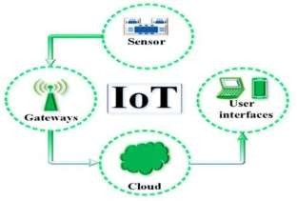

CHARACTERISTICSOFTHEINTERNETOFTHINGS:

TherearethefollowingcharacteristicsofIoTasfollows.
- Connectivity is an important requirement of the IoT infrastructure. Things of IoT should be connected to the IoT infrastructure. Anyone, anywhere, anytime can connectivity should be guaranteed at all times Without connection, nothing makes sense.
- IntelligenceandIdentity–
Theextractionofknowledgefromthegenerateddata isveryimportant. Forexample,

a sensor generates data, but that data will only be useful if it is interpreted properly. Each IoT device has a unique identity. This identification is helpful intracking the equipmentand at timesfor querying its status.
- EnormousScalability–
The number of elements connected to the IoT zone is increasing day by day. Hence, an IoT setup should be capable of handling the massive expansion. The data generated asan outcome is enormous, and it should be handled appropriately.
- DynamicandSelf-Adapting (Complexity)–
IoT devices should dynamically adapt themselves to the changing contexts and scenarios.Assume a camera meant for the surveillance. It should be adaptable to workindifferentconditionsanddifferentlightsituations(morning,afternoon,night).
- Architecture
IoT architecture cannot be homogeneous in nature. It should be hybrid, supporting different manufacturers ‘ products to function in the IoT network. IoT is not owned by anyone engineering branch. IoT is a reality when multiple domains cometogether.
- Safety
There is a danger of the sensitive personal details of the users getting compromised whenall his/her devices are connected to the internet. This can cause a loss tothe user.Hence,data security is themajor challenge.Besides, the equipment involvedis huge. IoT networks may also be at the risk. Therefore, equipment safety is also critical.

ApplicationsofIoT:
BeforegoingtoreadaboutIoTapplications,justwatchthis reference video-https://youtu.be/91aXs9E0qAI
The conceptof the Internetof Thingsenteredourlives in1999. However,infact, the first IoT application has entered our lives before. In 1991,asystem was designed to send images of the coffee machine to the computers of academics at the UniversityofCambridgethreetimesa minute. Duetothefactthatitis onlineandinreal time, thissystemisconsideredtobethefirstapplicationoftheInternetofThingsinthe

world.Someoftheapplicationsare-
- Wearables
- Connectedcars/smartcars
- Smartcities
- Smartindustries
- Smartagriculture
- Smartretail
- Energymanagement
- Smarthealthcare
- Smartpoultryandfarming
- Smartdust

SmartCityIoTApplications

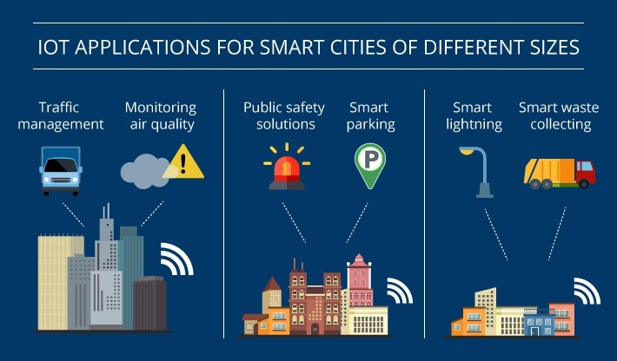
Smart city IoT applications aim to ensure that citizens live in maximum comfort and resource consumptionismadewisely.Itaimstoreduceandultimatelyeliminate traffic density, air pollution, polluted water resources, garbage and waste problems, population agglomeration, and crime rates. In short, the goal of smart city IoT applications is basically to put an end to allproblemsthat endangerhumansafety, health and well-being. Smart cities that solve thetrafficproblemwith smart traffic lightsor end thedirty waterproblem with cleanwater projectsgetveryefficient results.

SmartFarmingIoTApplications
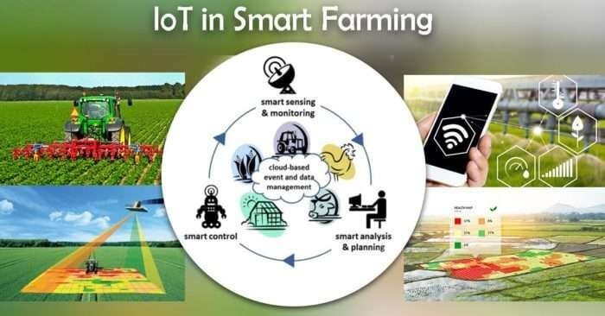

SmartFarmingIoTApplications

To understand smart farming IoT applications, first, let’s define the concept of smart farming. Combining many advanced technologies andusingtheminagricultureis called smart farming. Smart farming and smart agriculture use modern informatics methods in agriculture and aim to increase productivity. Thanks to smart agriculture, the life of both producers and farmers is much easier.
Thanks to IoT applications in agriculture, control of agricultural areas can be done remotely. This saves time for everyone working in the agricultural sector. The simultaneousoperationof agricultural machinery is one of the factors that save timeand speed.
The use of IoT based applications in agriculture is also an action aimed at protecting the environment. With the spread of smart farming practices all over the world, it is aimed to prevent problems such as water scarcity and drought in time.
It is aimed to reduce the chemical products used in agriculture andthustoproduce healthier products. Thus, the cost of such chemical products will be eliminated and savings will be provided.

IoT based applications in agriculture, which ensure that each natural resource is used only in the required amount, aim to avoid waste.

SmartGridsIoTApplications

It is aimed to establish mutual electronic communication between the supplier and the consumer through smart grids. Smart grids IoT and its applications work intertwined witheachother.SmartgridsIoTapplicationsareencounteredinmanyfields especially intheenergysystems.It isaimedto add smart meters and monitoring systems to the electricity networks and thus to monitor a more reliable, quality and safe process.
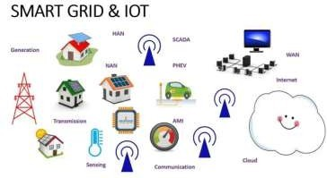

SmartHomeIoTApplications
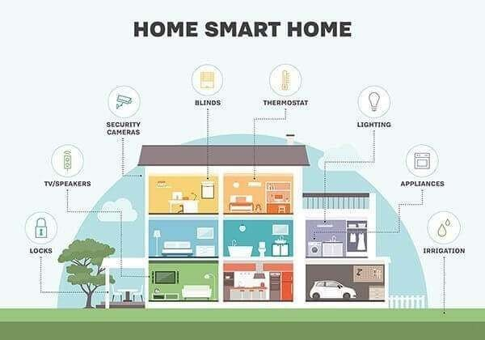

IoT applications used in smart homes and smart buildings are used to controlthe systemsinsidethesebuildingsandhomes.Itprovidescontrolofsystemsthatprovide

lighting,heating,security,alarm,entertainment systemsandsoon.

SmartRetailIoTApplications
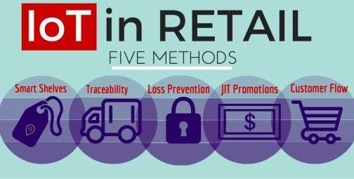

Internet of Things technology develops IoT applications to improve in-store customer experience and provide a higher quality service. It brings customers, objects, sales processesandtransactions to the digital platform.

SmartSupplyChainIoTApplications
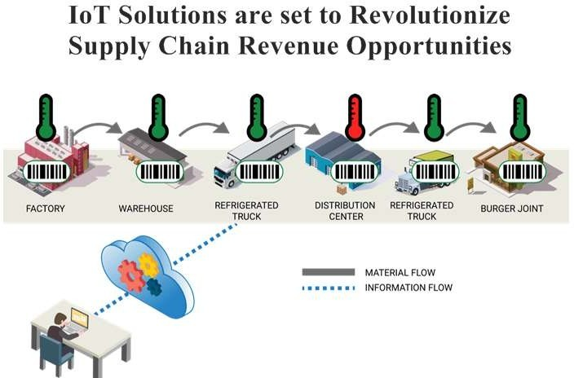

OneoftheareasthatIoTtechnologyhasenteredintothedigitalizationprocessis thesmartsupply chain IoT applications. IoT technology is able to control the complexity caused by theincreasing number of data and the increasing number of complex variables on a global scale.

WearablesIoTApplications

Wearable IoT applications are mainly used inthehealthandfitnesssectors.Thanksto the wearable devices manufactured with IoT technology, it is possible to make measurementsof people’s body, diseasefollow-up andmanyother measurementsatany time.Thenumberof wearables IoT applications that are causing serious and positive changesespeciallyinthehealth sector is increasing day by day.


ConnectedCarIoTApplications
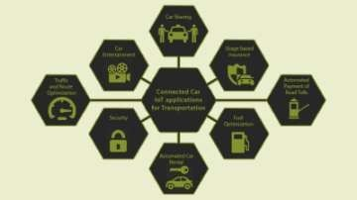

Connected car IoT based applications used in transportation have resulted in many solutionssuch as smarttraffic control, unmanned autonomous navigation, smart parking systems, and the establishment of digital communication between the vehicle and the driver.

ConnectedHealthIoTApplications


Connected health IoT applications ideas in health and fitness have contributed greatlyto the development of mobile digital medical systems. Many opportunities such as remote monitoring of patients ‘health status, emergency notification systems, wearable IoT devices and monitoring of patients’ body values have been realized thanks to the ideas of health and fitness IoT applications.

IndustrialInternetIoTApplications

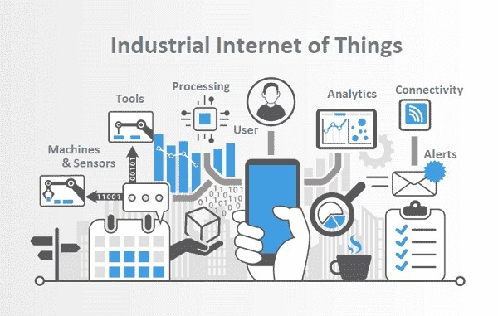
Industrial IoT applications, aka IIot Applications, are a set of applications that fundamentally restructure the industry. Therefore, these developments in technology are also called as a new industrial revolution.It is a systemwhere allthesmartdevices usedinproductionorother industrial fields can communicate with each other and control this communicationfromasingle device.
Industrial IoT applications can be seen in many areas. Frequently used in industrial automation, smart robot systems, smart sensors, wearable technology integration, logistics, software, security, energy management.

IOTCATEGORIES

DefiningIoTwithaconsumerpartandanindustrial/businesssegment

The first distinction people started to make was between a consumer IoT and an Internet of Things for industrial applications or Industrial IoT as a way to distinguish between many types of IoTuse cases and applications. Yet, as said and as with all terminology there were certainly overlaps in the definitionsof these forms of IoT.

This is why some organizations and individuals, for instance, rather talk about the Internet of Everything, while others opt to drop the term IoT alltogether and mention itin terms of specific use cases and contexts such as smart cities, smart metering, smart buildings, smartoffice, smartwearables, IndustrialInternetorsmarthomes, allof course with their own meaning and, again, with more subdivisions.
ConsumerIoT(CIoT)
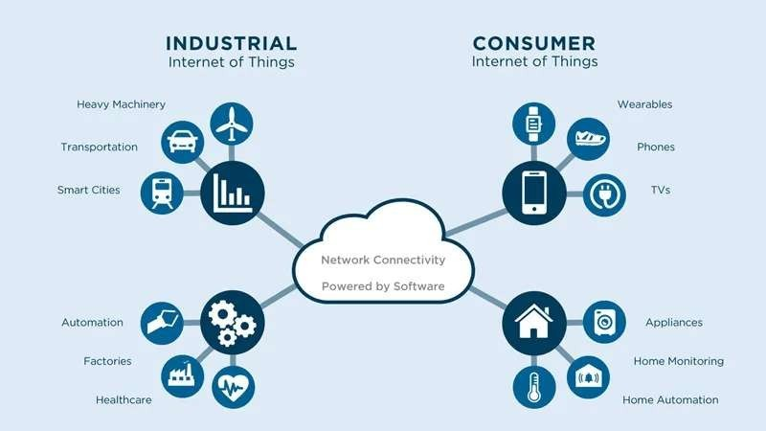

- The Consumer Internet of Things or CIoT is where you will find applications andusecasestotrackyourpersonal‘assets’(assettracking),fromyourpettoyour

skateboard. Or where you will find the connected ‘smart appliances’ such as connected refrigerators, washing machines, light bulbs, etc.
- Also wearables for consumer use (wearables are also used in healthcare and in factories, to name just two) and all sorts of consumer electronics such as smart wristwear belong to this category, along with all sorts of smart home applianceslike thermostats or connected parking door openers.
- The applications get better and smarter. Theyalso get more independentfrom other devices such as smartphones. This is certainly the case with smart wearables.
- A simple definition of the Consumer Internet of Things is all we need: the Internet of Things as it’s used for consumer applications and consumer-oriented services.

WhatisConsumerInternetofThings(IoT)?

- Consumer IoT (CIoT) refers to the use of IoT for consumer applications anddevices. Common CIoT products include smartphones, wearables, smart assistants, home appliances, etc.

- Typically, CIoT solutions leverage Wi-Fi, Bluetooth, and ZigBee to facilitate connectivity. These technologies offer short-range communication suitable for deployments in smaller venues, such as homes and offices.
- Typically, in Consumer IoT, data volumes and data communication needs are low and limited. That’s why there are many technologies of which some are specifically designed for consumer applications, ranging from smart home connectivitystandards to special operating systems for wearables.
IIoT(Industry4.0)

  - TheIndustrialInternetofThingsorIIoT describestypicalindustryusecasesacross a range of sectors. Two examples of Industrial IoT use cases: predictivemaintenanceand asset management. Some people see the Industrial Internetof Thingsmoreinacontextof‘heavy’industrieslikemanufacturingor

utilities.Butitisalsousedforusecasesin,forexamplesmartcities.
  - If we look at it as a sort of ‘Business Internet of Things’ it is clear that there are some overlaps with the Consumer Internet of Things. For instance: if you have a smart thermostat and smart energy consumption meter in your house they are on one hand consumer applications because they are for personal usage.
  - But from the perspective of the company that uses it to send you invoices and to help optimize energy consumption it is a business matter (e.g., ‘smart grid‘). So,the terms are not that good but that’s how it is and it’s better to look at use cases than at these broad categories because just as there are many different applications in theConsumer Internet of Things,thereare also manyin IIoT and some are hard to compare. Most industrial IoT applications relatetothe digitaltransformationof manufacturing or to the rise of smart industry though.

IoTEnablersandconnectivitylayers

IoTEnablers:
- RFIDs:usesradiowavesinordertoelectronicallytrackthetagsattachedtoeach physical object.
- Sensors:devicesthatareabletodetectchangesinanenvironment(ex:motion detectors).
- Nanotechnology:asthenamesuggests,theseareextremelysmalldeviceswith dimensionsusually less than a hundred nanometers.
- Smartnetworks:(ex:meshtopology).

Themostbasicarchitectureisathree-layer

It was introduced in the early stages of research in this area. It has three layers, namely, the perception, network, and application layers.
  - The perceptionlayeristhe physicallayer, whichhassensorsforsensingandgathering information about the environment. It senses some physical parameters or identifiesother smart objects in the environment.
  - Thenetworklayerisresponsibleforconnectingtoothersmartthings,network

devices, and servers. Its features are also used for transmitting and processing sensor data.
  - The applicationlayer isresponsible for delivering application specific services to the user. It definesvarious applications in which the Internet of Things can be deployed, for example, smart homes, smart cities, and smart health.
WhatarethemajorcomponentsofInternetofThings?

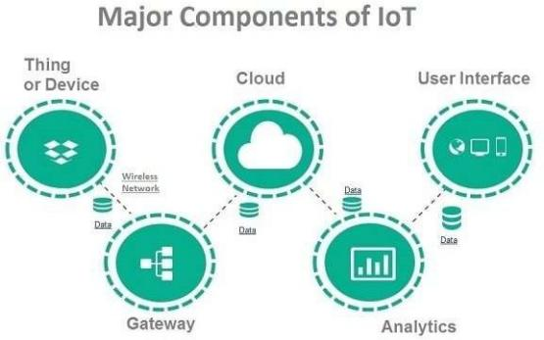

Howthedevicesareconnected?
    - Most of the modern smart devices and sensors can be connected to low power wireless networks like Wi-Fi, ZigBee, Bluetooth, Z-wave, LoRAWAN etc… Each of these wireless technologies has its own pros and cons in terms of power, data transfer rate and overall efficiency.
    - Developments in the low power, low cost wireless transmitting devices are promising in the area of IoT due to its long battery life and efficiency. Latest protocols like 6LoWPAN- IPv6 over LowPower Wireless Personal AreaNetworks have been adapted by many companies to implement energy efficientdata transmission for IoT networks.
    - 6LoWPANusesreducedtransmissiontime(typicallyshorttime pulses)andthussaves energy.

